Aquaculture Modelling Screening & Risk Identification Report: FISH HOLM (FISH1)
Report date February, 2024

Scope of report
As part of the SEPA Aquaculture Regulatory Framework it is recommended that a proposed application for a marine fin fish aquaculture site should undergo a Screening Modelling and Risk Identification process. SEPA carries out this work and this is described on the SEPA aquaculture website Pre-application section.
This report presents information arising from that process. Screening modelling methods are outlined and maps and tables describing the modelled impacts are shown. Risks arising from consideration of the model output are listed. Conclusions and recommendations are made regarding the proposed site.

Executive summary
SEPA has received a proposal to vary an existing marine fin fish aquaculture site called Fish Holm (FISH1). The site is located to Shetland, at location: 448381, 1173899 (Easting, Northing). The existing maximum biomass is 1910t at this location and the proposed weight of fish to be farmed is 6000t.
Following screening modelling and risk identification we have concluded the following:
- It is possible that discharges from Fish Holm (FISH1) will be able to comply with the relevant aspects of the SEPA Aquaculture Regulatory Framework.
- Due to the identified risks, 2D marine modelling should be carried out.
- The size of the marine model should include discharges from all sites identified in this report. Cumulative modelling including these identified sites will be required for solids, but not baths.
- Due to the large biomass, Maerl and identified Cat 2. waterbodies, dye and drogues are required for model calibration.
- The resolution of the marine model should be relatively fine around the proposed site and identified features at risk.
- Baths modelling should also be used as a proxy for nutrients, to demonstrate the nutrients from this farm do not pose risk to Swinster Voe, or any of the other nearby Marine Scotland Cat 2. waterbodies (Fig.5). An ECE calculation should also be undertaken.
- NewDepomod modelling should be undertaken for the proposed site. It is strongly recommended that default NewDepomod modelling is undertaken prior to any marine modelling, to ensure the local impacts of the proposed biomass are acceptable.

List of abbreviations
SEPA Scottish Environment Protection Agency

List of chemical abbreviations
AZA Azamethiphos

Contents

Aquaculture Modelling Screening & Risk Identification Report: FISH HOLM (FISH1) 0
Scope of report 1
Executive summary 1
List of abbreviations 3
List of chemical abbreviations 3
List of Figures 6
List of Tables 7
Introduction 7
The objectives of screening modelling and risk identification 7
Screening modelling methods 9
Screening modelling 11
Site proposal 11
Risk Identification 16
Identified features which require attention 16
Additional comments on identified features 20
Risks identified from contextual site data 22
Conclusions of screening modelling and risk identification 24
Conclusions 24
Recommendations 26
References 28
Appendices – Responses to pre-app consultation. 29
Appendix 1 – Local Authority 30
Appendix 2 – Nature.Scot 37
Appendix 3 – Marine Directorate-Licensing Operations Team 44
Appendix 4 – Historic Environment Scotland 46
Appendix 5 – Northern Lighthouse Board 47
Appendix 6 – Maritime and Coastguard Agency 48
Appendix 7 – Marine Directorate - FF Planning 49

List of Figures
Figure 1. Proposed pen location for Fish Holm (FISH1). 14
Figure 2. Proposed pen centres for Fish Holm (FISH1). 15
Figure 3. Identified sensitive PMFs around the proposed site (Fish Holm (FISH1)). 20
Figure 4. Figure showing locations of nearby Active Shellfish sites 21
Figure 5. Figure showing locations of nearby Cat 2. (yellow) and Cat 3. (green) waterbodies. 23
Figure 6. GeoView GeMs layer of known PMFs at Fish Holm. 43

List of Tables
Table 1. Table of identified features 17
Table 2. Table of licenced biomass from farms identified as likely to add to cumulative risks. 24
Table 3: Table showing summary of sites stocking information. 41

Introduction
Screening Modelling and Risk Identification are important steps in the SEPA regulatory framework for marine pen fish farms. They are carried out by SEPA at the pre-application stage.
This document briefly describes the objectives of screening and risk identification and summarises the methods used. Screening output for the proposed site is then presented with comments. Risks identified from the screening output are detailed. Conclusions and recommendations about the suitability of the proposed site are then made.

The objectives of screening modelling and risk identification
A summary of the modelling methods employed during screening modelling is outlined in section 1.2. The objectives of screening modelling and risk identification are outlined below.

Screening modelling
Marine Modelling technology can be used to simulate and predict the potential influence of discharges on the marine environment. SEPA will require the majority of proposed farms to conduct detailed marine modelling, as outlined in our Aquaculture Modelling guidance [1] and on the SEPA Website.
Marine modelling can also be used at an earlier stage to provide an initial estimate of the influence of material discharged from a proposed site.
SEPA will carry out marine modelling at the screening and risk identification stage. This is a simplified version of the detailed modelling required of the applicant. However, it will be sufficient to perform an initial risk assessment of a proposal. Screening marine modelling will also include discharges from other relevant aquaculture sites and major sources.

The objectives of the simplified screening modelling are to:
- Produce maps of the predicted dispersive and erosive capacity of the sea areas in the vicinity of aquaculture sites.
- Produce maps of the predicted spread of sediment discharged from aquaculture sites.
- Produce maps of the predicted spread of bath treatment medicines from aquaculture sites.
- Present an analysis of the potential influence of sediment and bath treatment discharges from the proposed site alongside existing sites within the surrounding sea area.
- Present information on the sensitive features and sites of interest within the surrounding sea area, which must be addressed during pre-application work.
- Present a summary of the suitability of the proposal with respect to the dispersal of waste and how this may be modelled.

Risk identification
Maps and analysis of screening output will be compared to information relating to sensitive features and relevant areas of interest. These may include:
- Marine Protected Area (MPA).
- Special Area of Conservation (SAC).
- Priority Marine Feature (PMF).
- Any site identified via consideration of other permitted or regulatory activities.
SEPA Staff will meet to discuss screening model output and the relevant sensitive features information. Following this meeting, a list of identified risks will be added to this report.

Conclusion of screening modelling and risk identification
Following the identification of risks, SEPA will present a summary of the suitability of the proposal with respect to the:
- Dispersal of waste from the proposed site and other sources.
- Risks posed to sensitive features.
- Likely level of modelling that will be required to address the risks identified.

Screening modelling methods
Marine models divide the sea up into a “grid” of boxes or triangles (often called cells). Each of these is given a water depth. This grid has been set up within a marine modelling software package called MIKE 21 which is manufactured by the company DHI A/S.
Marine models carry out calculations across a grid to work out how seawater moves and mixes in response to tidal and weather forces. Marine models can also be used to simulate how seawater moves and mixes due to salinity and temperature differences across an area, particularly in response to inputs of freshwater from rivers. For pollutant influence assessments the mixing (dispersion) of dissolved (bath medicine) and particulate (sediment) pollutants can also be estimated. Calculations within a marine model can be performed in three dimensions (3D), where the grid is split into layers to better represent how properties of the sea change with depth. Two dimensional (2D) models can also be created where processes over the water depth are simplified. The amount of mixing in a marine model can be varied using settings in the software.
Screening modelling is currently carried out with 2D models using average mixing settings in the model software. In many areas, this approach will be sufficient to make an initial estimate of the influence of a proposed site. Our screening assessment will take into account factors which may limit a 2D approach. We will also consider whether a particular location is adequately represented by the available models.

Water movement and mixing modelling
Water movement and mixing modelling (hydrodynamics) has been carried out to generate one month of results. The boundaries (edge(s) of) the model have been driven using the “wider domain” Scottish Shelf Model [2]. Wind forces and freshwater inputs have been applied to the model from the same source. The results generated are an estimate of the average water movement and mixing conditions within the model area.

Sediment waste modelling
Screening modelling provides a precautionary and indicative estimate of the size, location and intensity of waste organic material released from aquaculture sites.
The release of sediment from sources within the model area is simulated using one month of hydrodynamic results along with particle tracking modelling technology. Virtual particles are continually introduced to the model grid to represent the potential dispersion of sediment from the sources. Particles in the model are moved and mixed by the hydrodynamics. Additionally, particles are assigned simplified properties, which allow them to settle through the water and be re-suspended (eroded and lifted) from the seabed.

Bath medicine modelling
Screening modelling provides a precautionary and indicative estimate of the size, location and concentration of bath medicine releases.
The release of bath treatment medicine from sources within the model area is simulated using hydrodynamic results along with particle tracking modelling technology. Virtual particles are introduced to the model grid to represent the potential dispersion of bath medicines from the sources. Particles in the model are moved and mixed by the hydrodynamics. Releases of bath medicines are simulated under worst case mixing (dispersion) conditions, which occur under neap tides. The maximum treatment amount likely to be used at each site is released into the model at the same time and plumes are tracked over the following 96 hours (4 days). Treatment amounts used at screening have been derived from an analysis of historical data. Additionally, all bath medicine particles are concentrated within the top 5 m of the sea area. As all bath medicines are likely to disperse in a similar way, only Azamethiphos (AZA) has been modelled at the screening stage.

Nutrient assessment
Whilst nutrients are not directly modelled during screening, the dispersion of bath medicine releases will give an indication of the likely level of nutrient dispersion. This will be considered alongside any pre-existing nutrient assessment information that may be available.

Analysis of modelling output
SEPA processes the screening modelling output and places it into a standard analysis application built in TIBCO Spotfire. The application allows for the production of standard maps and tables, which are presented below.

Screening modelling

Site proposal
A risk assessment has been carried out for a proposal to vary an existing farm: Fish Holm (FISH1)). The proposal is to site the farm at location: 448381, 1173899 (Easting, Northing). The existing maximum biomass is 1910t at this location and the proposed weight of fish to be farmed is 6000t.
For the risk assessment presented here all relevant licenced sites and current applications have been modelled in conjunction with the proposed site.
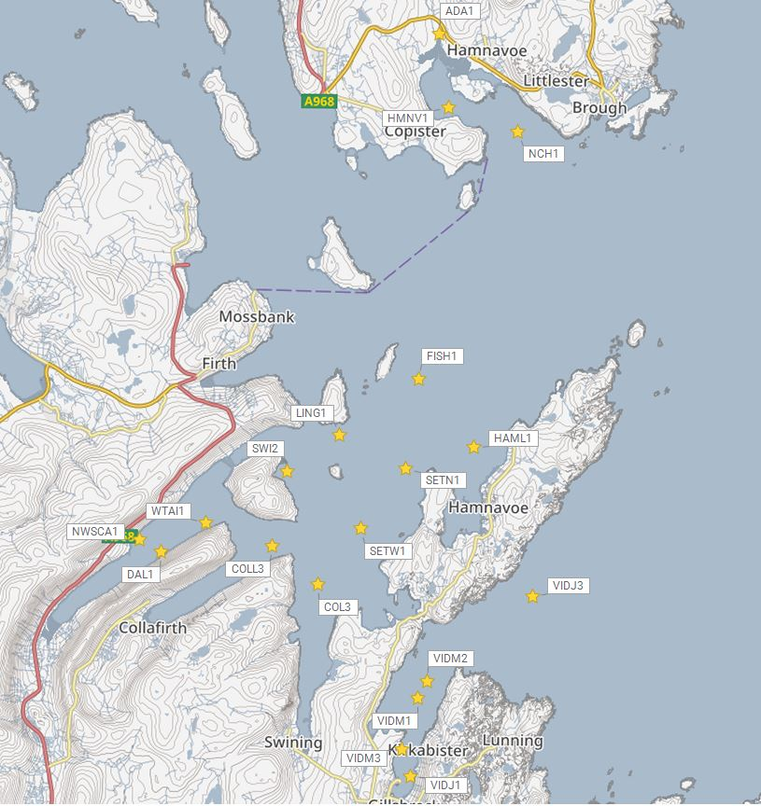
©Crown copyright. All rights reserved. SEPA lic. no. 100016991 (2019).
Figure 1. Proposed pen location for Fish Holm (FISH1).
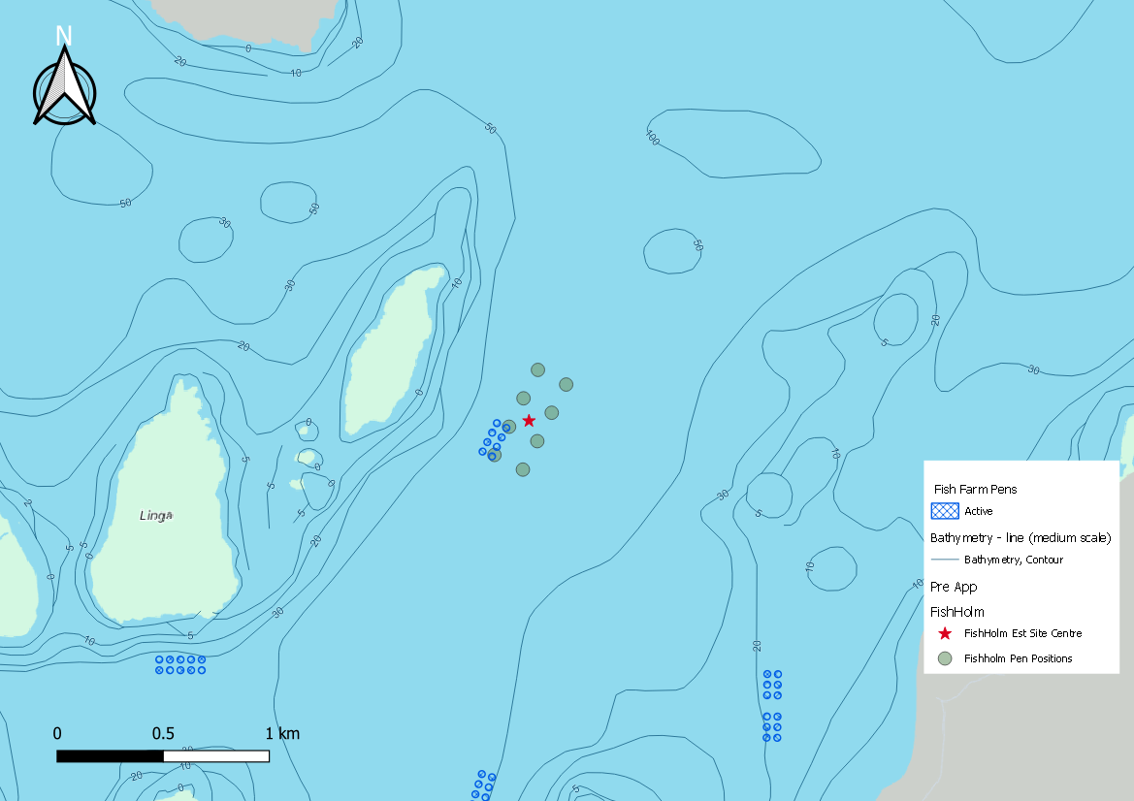

Figure 2. Proposed pen centres for Fish Holm (FISH1).

Accuracy of model in the area surrounding the proposal
The Pentland Firth and Orkney Waters (PFOW) model which covers this area, has very low resolution over the entirety of Shetland, making it unusable for the purposes of screening modelling. A new Shetland model is currently in development, however for this application, screening modelling has not been undertaken, and other evidence has been considered.

Marine fin fish aquaculture farms using open-net pens will benefit from operating in locations where there are strong, repeating, water currents to erode and disperse waste.
For the purposes of screening we consider locations which meet the following water flow criteria to be generally suitable for larger farms:
Locations with average water flow speeds of greater than, or equal to, 0.12 metres per second (0.23 knots)
Locations where water flow speeds are often above the threshold of 0.095 meters per second (0.18 knots).
Locations with these properties are likely to disperse discharged material rapidly, and regularly erode sediment discharged to the seabed. In general, we would look for these properties to be maintained over a large area around a proposed site.
The thresholds stated above are indicative.
Based on previously submitted current meter data and knowledge of this area we can make the following observations about the proposed site location:
• It lies in a high dispersion area.
• It lies in an area where water flow has a high capacity to erode material on the seabed.

Risk Identification
The screening modelling output summarised in section 2 is compared against available information on features of interest (see section 1.1.2). Features which require attention are presented with any additional comments. Identified features will need to be considered during the pre-application phase.
These should be addressed in the applicant “Method Statement”. Please refer to the Modelling Method Statement section on the SEPA Website.

Identified features which require attention

Table of identified features
Based on screening output the following features of interest have been identified.
Table 1. Table of identified features
 | Feature  Name | Feature  Type | Location (Easting, Northing) | Brief Reason for Identification
1 | Horse Mussel | PMF | (444602, 1178546) | At risk from sediment and bath influence
2 | Kelp and seaweed communities | PMF | (447475, 1170225) | At risk from sediment influence
3 | Kelp and seaweed communities | PMF | (449785.1, 1173842.9  (449757.3, 1173916.0  (453142.2, 1173820.3 | At risk from sediment and bath influence
4 | Kelp beds | PMF | (452216.9, 1172463.5)  (452383.8, 1172908.8)  (453274.4, 1173493.3)  (453434.4, 1173660.3)  (453114.4, 1173743.8)  (453708.4, 1177497.9)  (453587.8, 1179613.0) | At risk from sediment and bath influence
5 | Tide swept algal communities | PMF | (449747.8, 1173925.5)  (449768.0, 1173893.8)  (449825.4, 1173828.9) | At risk from sediment and bath influence
6 | Maerl or coarse shell gravel with burrowing sea cucumbers | PMF | (450540.3, 1173772.0)  (450609.9, 1173760.4) | At risk from sediment influence
7 | Maerl or coarse shell gravel with burrowing sea cucumbers | PMF | (453107.7, 1173703.6) | At risk from sediment and bath influence
8 | Flapper Skate and Blue Skate | PMF | (453367, 1173477.1) | At risk from sediment influence
9 | Maerl | PMF | (Figure 3) | At risk from sediment and bath influence
10 | Cul Ness | Shellfish site | (447700, 1169300)  (Figure 4) | At risk from sediment and bath influence
11 | North West of Cul Houb | Shellfish site | (446500, 1168200)  (Figure 4) | At risk from sediment and bath influence
12 | Inner Collafirth, Delting | Shellfish site | (443600, 1169400)  (Figure 4) | At risk from sediment and bath influence
13 | West Taing | Shellfish site | (444000 1170900)  (Figure 4) | At risk from sediment and bath influence
14 | South Side, Dales Voe | Shellfish site | (443000, 1170200)  (Figure 4) | At risk from sediment and bath influence
15 | Scarva Ayre 1 | Shellfish site | (442100,1169900)  (Figure 4) | At risk from sediment and bath influence
16 | Scarva Ayre 2 | Shellfish site | (442800, 1170600)  (Figure 4) | At risk from sediment and bath influence

  - 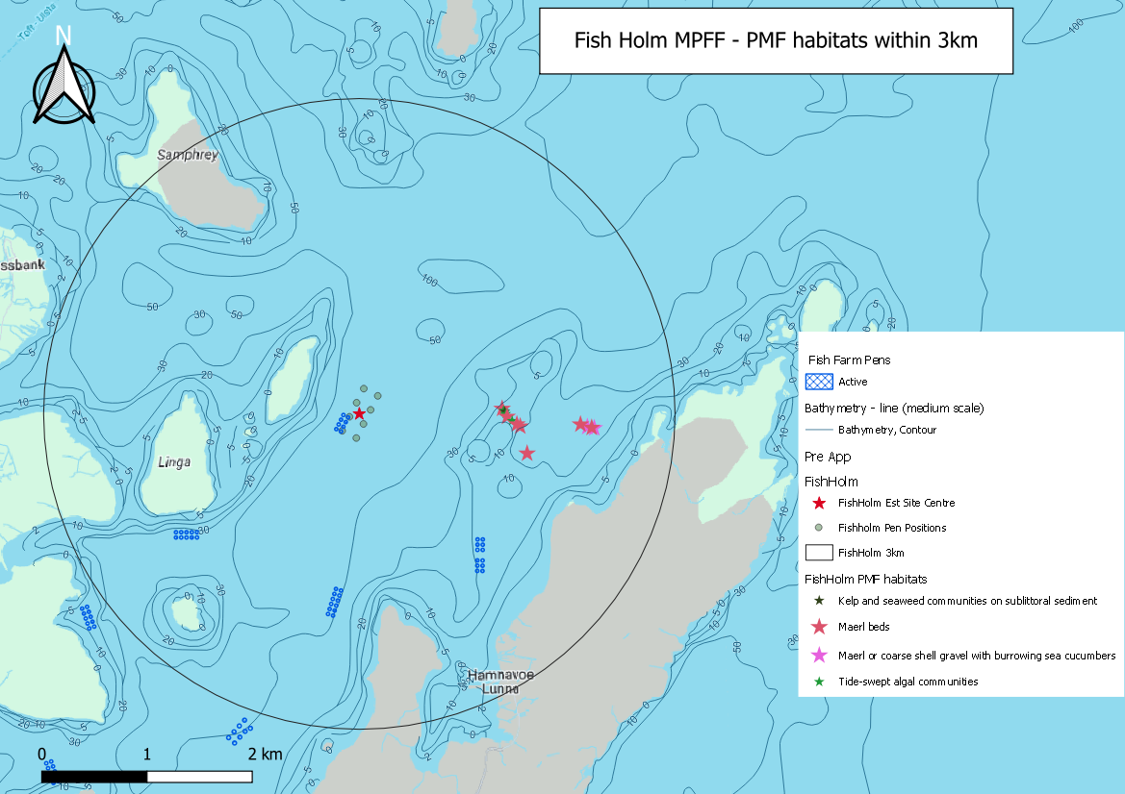
Figure 3. Identified sensitive PMFs around the proposed site (Fish Holm (FISH1)).
Description of Figure 3: Sensitive feature locations, as identified in table 3. Maerl beds approximately less than 2km from Fish Holm site.

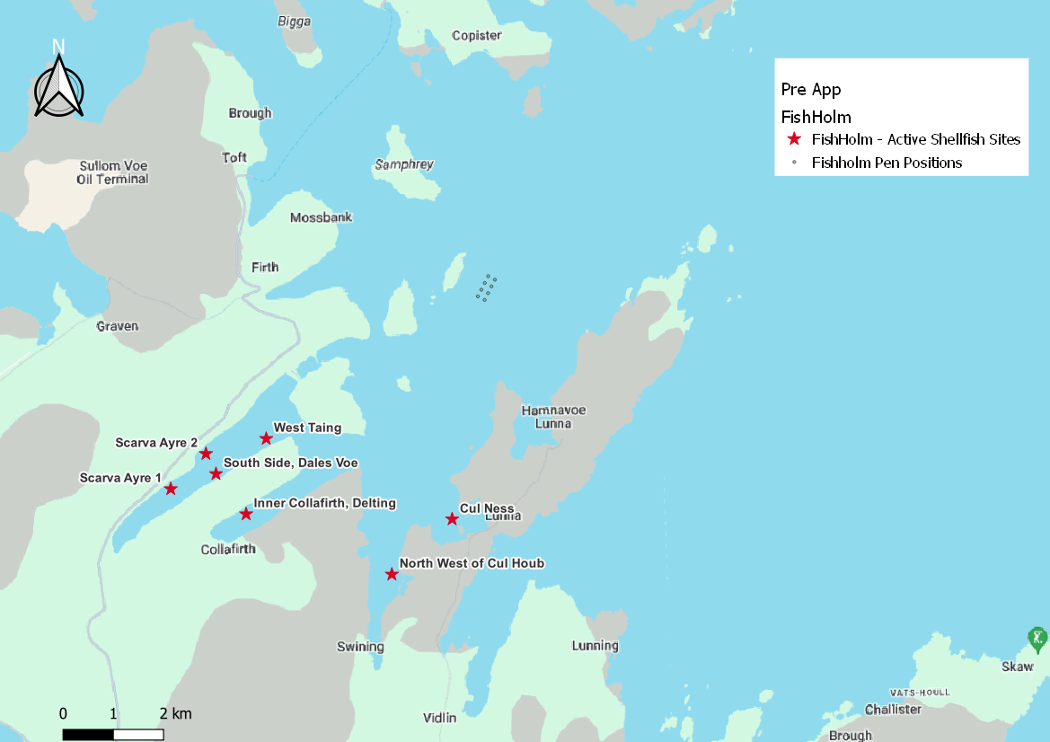
Figure 4. Figure showing locations of nearby Active Shellfish sites

Additional comments on identified features
This site (FISH1) is near to several PMFs which are deemed to be at risk from sediment and bath influence. As SEPA has the responsibility of ensuring the national status of the PMFs are not significantly affected by the proposed site. This proximity combined with the high proposed biomass, and the lack of screening model for this area, means higher resolution marine modelling of sediment will be required. Particular focus should be on the identified features. Discharges of sediment from all identified sites will need to be included in this modelling, to determine the combined risk on these features.
The proposed farm is close to Lunna (Swinning Voe) and Dales Voe Shellfish Water Protected Area (SWPA). Within these areas, the water quality must be of a standard to ensure shellfish are safe for consumption. While the proposed application is deemed unlikely to affect the SWPA designations the potential impacts from sediments and bath chemicals on the identified active shellfish farms within these areas should be assessed (table 1).
This proposed site is close to a Marine Scotland Cat 2. Waterbody (Swinster Voe) (Fig. 5). Must ensure that any increase in nutrients does not cause degradation to the Cat 2. waterbody, causing it to be recategorized as a Cat 1. waterbody.
An ECE calculation should be carried out to ensure nutrient enhancement levels from this new farm are acceptable. Baths modelling should also be used as a proxy for nutrients, to demonstrate that soluble nutrient discharges from Fish Holm do not pose a risk to any of the nearby Marine Scotland Cat 2. waterbodies (Fig.5).
Calibration with dye and drogues should be undertaken. Calibrating against observed advection patterns measured by drogues will particularly benefit the risk assessment of material entering the Cat 2. waterbody.
It is recommended that marine modelling of baths is undertaken to get a less conservative and therefore viable bath medicine quantity. Cumulative modelling of baths is however not required.
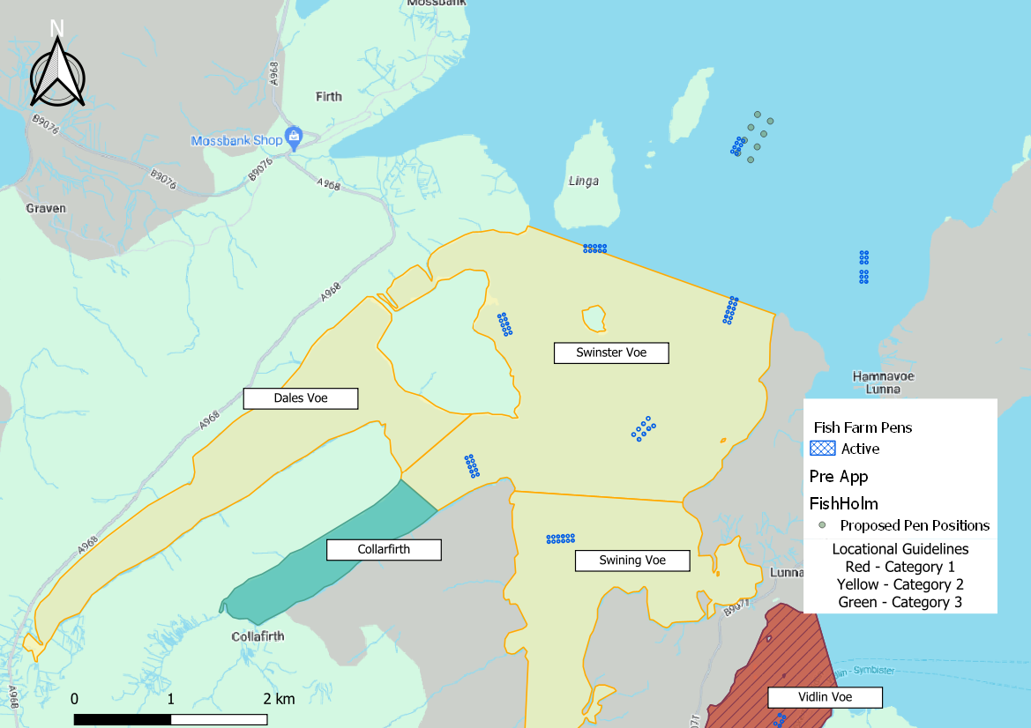
Figure 5. Figure showing locations of nearby Cat 2. (yellow) and Cat 3. (green) waterbodies.

Risks identified from contextual site data
Should this application proceed, the total licenced biomass in this area would be 25,662.1t.

Table 2. Table of licenced biomass from farms identified as likely to add to cumulative risks.
Site Name | Location (Easting, Northing) | Biomass (Tonnes) | Last Production Cycle
FISH1 | 448381, 1173899 | 6000 | Proposed  Fish last on site 2012  (Current licenced biomass 1910t)
LING1 | 446777, 1172750 | 2299 | Currently Stocked (Dec 2023)
HAML1 | 449519, 1172542 | 1910 | Fish last on site 2016
SETN1 | 448136, 1172099 | 2500 | Currently Stocked (Dec 2023)
SWI2 | 445724, 1172004 | 2100 | Currently Stocked (Dec 2023)
SETW1 | 447236, 1170873 | 2357.6 | Currently Stocked (Dec 2023)
COL3 | 446380, 1169735 | 1920 | Currently Stocked (Dec 2023)
COLL3 | 445455, 1170490 | 1200 | Currently Stocked (Dec 2023)
WATI1 | 444100, 1170950 | 500 | Fish last on site 2003
NWSCA1 | 442750, 1170600 | 250 | Not stocked since records began (2002)
DAL1 | 443200, 1170350 | 100 | Fish last on site 2004
NCH1 | 450308, 1178936 | 2420.5 | Currently Stocked (Dec 2023)
HMNV1 | 448900, 1179400 | 190 | Not stocked since records began (2002)
VIDJ3 | 450750, 1169550 | 99 | Not stocked since records began (2002)
VIDM2 | 448622, 1167794 | 916 | Currently Stocked (Dec 2023)
VIDM1 | 448445, 1167446 | 900 | Currently Stocked (Dec 2023)

Default NewDepomod modelling will be required. It is highly recommended that NewDepomod modelling is undertaken prior to proceeding further with this application.

Conclusions of screening modelling and risk identification
Following screening modelling and risk identification we make a number of conclusions and recommendations.

Conclusions

Screening Modelling
- According to screening modelling, the proposed site (Fish Holm (FISH1)) is in an area of high dispersion and has a relatively high capacity for erosion of material on the sea bed.
- From sediment and bath treatment modelling:
    - Information presented in section 3 indicates that the relative influence of Fish Holm (FISH1) is likely to be high due to the large tonnage.
    - There is likely to be influence on the surrounding sea area from Fish Holm (FISH1).
    - The areas of influence from Fish Holm (FISH1), and other existing sites do not appear to interact.
    - It is likely that discharges of bath medicines from Fish Holm (FISH1) will be dispersed to low levels over a moderate area.
    - Fish Holm (FISH1) is likely to result in a moderate/large increase in the total influence of all sites modelled. This is mostly separate from areas of influence generated by existing sites.
- This proposed site is close to a Marine Scotland Cat 2. Waterbody (Swinster Voe) (Fig. 5). Must ensure that any increase in nutrients does not cause degradation to the Cat 2. waterbody, causing it to be recategorized as a Cat 1. waterbody.
- Baths modelling should be used as a proxy (calibrated with dye and drogues), to demonstrate that there will be no net gain of nutrients to this waterbody, or any of the other nearby Marine Scotland Cat 2. locational guideline areas (Figure 5). An ECE calculation should also be undertaken.

Risk identification
This proposed site is close to a Marine Scotland Cat 2. Waterbody (Swinster Voe) (Fig. 5). Must ensure that any increase in nutrients does not cause degradation to the Cat 2. waterbody, causing it to be recategorized as a Cat 1. waterbody. Baths modelling should be used as a proxy (calibrated with dye and drogues), to demonstrate that there will be no net gain of nutrients to this waterbody, or any of the other nearby Marine Scotland Cat 2. locational guideline areas (Figure 5). An ECE calculation should also be undertaken.
Although screening modelling has not been undertaken, due to the large tonnage of proposed Fish Holm (FISH1), there is potential for interactions with PMFs and between existing farms, as well as cumulative influence. Several features of interest have been identified, which require further attention during pre-application work. These are outlined in section 3. Further detailed modelling will need to demonstrate that the influence on these features is low and the additional biomass from this site would create no additional risk to the area.
The conservative nature of the simple BathAuto model means quantities of bath medicines may be limited to impractical amounts for this site. Use of marine modelling of bath influence will enable more realistic bath medicine treatment quantities to be determined. Cumulative modelling of identified sites will be required for solids but not for baths.
Calibration with drogues should also be undertaken. Calibrating against observed advection patterns measured by drogues will particularly benefit the risk assessment of material entering the Cat 2. waterbody, interaction with Mearl beds and due to the large tonnage.

Recommendations

Site suitability
Consideration of screening modelling and risk identification suggests that it is possible that discharges from the proposed site will be able to comply with the relevant aspects of the SEPA Aquaculture Regulatory Framework. This must be demonstrated with a detailed marine model.
It is also possible that the site will be able to comply with our mixing zone regulatory framework. This will need to be demonstrated using the NewDepomod model.
Features at risk, identified at this stage, do not appear to influence the feasibility of the proposed site, with respect to the regulatory framework. These risks should be examined using a detailed marine model.
Following the engagement meeting(s), this report will be revised and this should allow to the applicant to submit a method statement which address the issues raised in this document.

Further modelling
- Due to the identified risks, 2D marine modelling should be carried out.
- The size of the marine model should include discharges from all sites identified in this report. Cumulative modelling including these identified sites will be required for solids, but not baths.
- Due to the large biomass, Maerl and identified Cat 2. waterbodies, dye and drogues are required for model calibration.
- The resolution of the marine model should be relatively fine around the proposed site and identified features at risk.
- Baths modelling should also be used as a proxy for nutrients, to demonstrate the nutrients from this farm do not pose risk to Swinster Voe, or any of the other nearby Marine Scotland Cat 2. waterbodies (Fig.5). An ECE calculation should also be undertaken.
- NewDepomod modelling should be undertaken for the proposed site. It is strongly recommended that default NewDepomod modelling is undertaken prior to any marine modelling, to ensure the local impacts of the proposed biomass are acceptable.

References
[1] Regulatory Modelling Guidance For The Aquaculture Sector. Published on SEPA website.
[2] http://marine.gov.scot/information/wider-domain-scottish-shelf-model.

Appendices – Responses to pre-app consultation.
For the avoidance of doubt the SEPA Aquaculture Modelling Screening & Risk Identification report has been assessed on the number of marine pens and biomass proposed to SEPA for the purposes of application for authorisation under the Water Environment (Controlled Activities) (Scotland) Regulations 2011.
The number of marine pens and biomass included in the application to the local authority for planning permission may be different.

Appendix 1 – Local Authority

Shetland Isles Council, Coastal and Marine Planning Department

PILOT Pre-App - Fish Holm, Shetland
Having carried out an initial constraints check, we are not aware of any potential “showstoppers”. We do, however, wish to highlight the following pertinent matters with regards to this pre-application:

Proximity to Oil and Gas Pipelines
There are two pipelines which run to the north of the proposed site before landfall in Firths Voe. The most northerly extent of the proposed fish farm planning boundary is located approximately 460m and 520m respectively to the south of the charted positions of these pipelines. It is our understanding that the most southerly pipeline is the SIRGE gas pipeline and the most northerly pipeline is the Brent oil pipeline. Depending upon when the application is submitted, any future planning application will be assessed against the current Marine Spatial Plan Policy, or the soon to be adopted Regional Marine Plan Policy. Namely, the current policy used is Policy MSP ACBP1 of the adopted Shetland Islands Marine Spatial Plan Supplementary Guidance (2015). Policy MP ACBP1, which forms part of the Shetland Islands Regional Marine Plan is currently with Scottish Ministers for adoption; both policies are included for reference below.
Whilst we are not, to the best of our knowledge, aware of any statutory 500m safety zones which apply to these aforementioned pipelines under the Petroleum Act 1987 we recommend that the applicant contacts the owners of the pipelines to seek clarity and confirmation of this matter given the location and distances involved. We also recommend that the applicant commences discussions around any proximity agreements that may be required. It is further recommended that they also contact Crown Estate Scotland to discuss this matter with regards to seabed leasing and proximity agreements.

Adopted Marine Spatial Plan 2015 - Policy MSP ACBP1: Avoidance of Cables and Pipelines
Activities that could damage any cable or pipeline (e.g. dredging or mooring attachments to the seabed) must not be carried out in the following situations:
a) within the 500m exclusion zone(s) established under the Petroleum Act 1987 around oil and gas platforms, well heads and associated pipelines; and
b) within a 250m exclusion zone either side of utility (telecommunications, electricity or water supply) cables or pipelines.

Amended Draft* Regional Marine Plan (Amended Draft May 2021) - Policy MP ACBP1: Avoidance of Cables and Pipelines
Activities that could damage any cable or pipeline (e.g. dredging or mooring attachments to the seabed) must not be carried out in the following situations:
a) within the 500m exclusion zone(s) established under the Petroleum Act 1987 around oil and gas platforms, well heads and associated pipelines; and
b) within a 250m exclusion zone either side of utility (telecommunications, electricity or water supply) cables or pipelines, unless there is a proximity agreement in place with the asset owner.
(*note this Plan is currently before Scottish Ministers for adoption and finalised wording of this policy may be subject to change. We shall inform the applicant, and others, once the Regional Marine Plan is adopted).

Separation Distance Policy
Although not regarded in essence as a “showstopper”, we wish to raise the issue of separation distance to adjacent consented fish farms at this early stage. The existing consented Fish Holm planning boundary is located approximately 1,120m and 920m from the consented planning boundaries of the South of Linga and Setterness North fish farms respectively. The proposed expanded Fish Holm planning boundary will reduce these distances to approximately 870m and 650m respectively. The proposal is therefore contrary to Policy F1 of the Council’s Aquaculture Supplementary Guidance (2017). Furthermore, the Policy G2 waiver that allows Policy F1 to be set aside will not apply in this instance given the proposal involves both an increase to the existing consented planning boundary area and increased environmental impact (owing to the significant proposed increase in maximum biomass). Both policies are pasted below. Any future planning application will therefore have to be accompanied by a supporting statement which includes reasoning/mitigation to support a departure from the Council’s separation distance policies. The Planning Authority would only be able to make a determination on such supporting information at an advanced stage of the planning application when weighing up all other information and issues as part of reaching a balanced decision.
F1: Planning permission will not be granted for finfish developments situated within 1,000m (measured as the water flows) of the extents of any other approved finfish farm or any water intakes/outfalls associated with shore based finfish rearing facilities, or within 500m (measured as the water flows) of the extent of any approved shellfish farm or any water intakes/outfalls associated with shore based shellfish washing and/or depuration facilities.
G2: For the avoidance of doubt, the Council may be minded to grant applications to vary existing farms closer than the relevant separation distance required by policy where the original permission was granted under previous policy and provided the proposed variation does not result in any increase to the existing consented planning boundary area or increased environmental impact.

Designated Sites
The proposed site falls within:
- East Mainland Coast, Shetland Special Protection Area (SPA) selected because it supports important wintering populations of great northern diver, common eider, Slavonian grebe, long-tailed duck and red-breasted merganser in addition to an important breeding population of red-throated diver.
The proposed site is also close to:
- Yell Sound Coast Special Area of Conservation (SAC) designated for its populations of otter and harbour seal; and
- Yell Sound Coast Site of Special Scientific Interest (SSSI) notified for its population of otter.
NatureScot, who will be consulted on any future planning application, will advise on the information that will be necessary to support a detailed assessment of the likely impacts on the above designations at the planning application stage.

Priority Marine Features (PMFs)
The proposed site is within 700m of known Priority Marine Features for Maerl Beds, Maerl or coarse shell gravel with burrowing sea cucumbers, Tide-swept algal communities and Kelp and seaweed communities on sublittoral sediment off the west coast of Lunna Ness. NatureScot, who will be consulted on any future planning application, will advise on the information that will be necessary to support a detailed assessment of the likely impacts on these PMFs arising from deposition from the proposed salmon farm.

Wild Salmonids
The proposal has the potential to adversely impact wild salmonids including local sea trout populations. SEPA’s Sea Lice Framework covering protection of sea trout populations from sea lice is expected to be implemented from March 2025 covering the West Coast, Western Isles and Northern Isles. Any planning consent granted for the proposal before March 2025 will need to be subject to an Environmental Management Plan (EMP) to monitor and manage the interactions between the operation of the proposed fish farm and the wild fish environment. It is noted that the SGMD has suggested an option for the Fish Holm site would be to include an appropriate review date for any EMP that allows for its removal in favour of including the site in SEPA’s Sea Lice Framework covering wild sea trout on its implementation.

Biosecurity
Developers are required to demonstrate that the potential risks of spreading Invasive Non-Native Species (INNS) has been adequately considered in their proposal. To assist with this, you may wish to consult “A Biosecurity Plan for the Shetland Islands” (NAFC Marine Centre, 2015).

Historic Environment
There are no known historic environment assets of national or local importance in the immediate vicinity of the proposed site that are capable of being affected.

Landscape and Visual Impact
The proposed site is not located within any national or local landscape designations. The proposal however relates to a very large marine fish farm development and will be visible from the Lunna Ness and Lunning proposed Local Landscape Area (pLLA) and from other receptors surrounding the site. Any planning application/EIA will therefore need to be accompanied by a detailed Landscape and Visual Impact Assessment (LVIA) which assesses the level of impacts on the aforementioned pLLA and on receptors in the wider surrounding area. The Planning Authority has already been given the opportunity to comment on the proposed Zones of Theoretical Visibility (ZTV) and proposed viewpoints which the Fish Holm LVIA will cover and we are content with the applicant’s proposed approach in this regard.

Safety of Navigation
The Northern Lighthouse Board (NLB) will advise the Planning Authority at the planning application stage of the required navigational marks to be applied to the proposed development to ensure navigational safety is maintained. Such navigational marks will be attached as a planning condition to any planning consent granted.
The proposed site is close to the southeast approach to the Sullom Voe Harbour Area which is a busy marine traffic route. Pre-application consultation with Shetland Islands Council’s Ports & Harbours Team, who will be consulted on any planning application, is therefore strongly advised.

Inshore Fishing
The proposed site falls within shellfish dredging and shellfish creeling areas as identified in the Shetland Islands’ Marine Spatial Plan (SIMSP). Pre-application consultation with the Shetland Shellfish Management Organisation (SSMO) and the Shetland Fishermen’s Association (SFA), who will be consulted on any planning application, is therefore strongly advised.

Marine Recreation
The proposed site does not conflict with any marine recreational activity identified in the SIMSP.

Community Consultation
You should also consider carrying out pre-application consultation with any other community groups you may consider relevant including the Delting, Nesting & Lunnasting and Yell Community Councils who will be consulted on any planning application.

Relevant Planning Policy
Any planning application should have due regard to all relevant policies contained in:
· Shetland Islands Council Supplementary Guidance Aquaculture 2017
· Shetland Islands Marine Spatial Plan 2015
· The soon to be adopted Shetland Islands Regional Marine Plan
· Shetland Local Development Plan 2014
· Scotland’s National Marine Plan 2015
· National Planning Framework 4
We trust the above information is of use to you, however it should be noted that this is informal advice only which shall not prejudice the consideration of any application which you subsequently make, nor any decision taken by the Planning Authority.

Appendix 2 – Nature.Scot
Our advice is as follows:

Summary
Our advice is, on the basis of the available information, that there are no definite ‘show-stoppers’ with regards to natural heritage interests within our remit, but there are a number of potentially significant issues that will require detailed assessment to support EIA/HRA for any future planning application.

East Mainland Coast SPA
The site is within the East Mainland Coast Shetland SPA (note this is incorrectly listed as SAC in the Proposal Details document) designated for great northern diver (non-breeding), Slavonian grebe (non-breeding) and red-throated diver(breeding).

General
All future assessments should refer to the Conservation Objectives and associated details in the East Mainland Coast Shetland Conservation and Management Advice document.
Clarification is required to establish what the baseline is, in terms of the consented and active fish farms in the area at site designation, and how the baseline is defined in Natura guidance.

Consideration of impact pathways
Potential pathways for impact on the SPA qualifying features are:
Entanglement/entrapment in cage or predator nets
The relevant indicative details provided by the applicant are:
- Pole-mounted top nets are proposed Indicative Grey with Sidewall Mesh Size 75x75 and Ceiling Mesh Size 100x100 mounted on 24 5.8m length poles per cage
- Double-net pen nets are proposed. Indicative pen nets inner mesh 22mm and outer mesh 75mm.
The proposed ceiling mesh size of 100 x 100mm for the top nets should reduce risk of entanglement or entrapment to gannets. However, we would require implementation of strict consenting conditions around monitoring, reporting and potential for adaptive management, noting in particular proximity to several gannet SPA breeding colonies and also wider context of recent severe declines in gannet populations associated with the Highly Pathogenic Avian Influenza (HPAI) epidemic in 2022. A report just published by RSPB found that the total number of Gannet AOS/AON recorded across all sites surveyed in 2023 (representing 65% of sites and 75% of the UK breeding population of Gannet as recorded by the Seabirds Count census) declined by 25% compared with the pre-HPAI baseline count for these colonies. These included declines of 37% at Hermaness, Saxa Vord and Valla Field SPA from 2021 and 10% at Noss SPA from 2019 (actual decline from 2021 likely to have been greater as the colony was previously expanding). The proposed farm location is not in proximity to SPA colonies of large gulls, shags or cormorants, but any entanglement risk in side panels for such species could potentially be reduced by including smaller mesh panels in vicinity of the rails.
The proposed adoption of outer sub-surface predator nets with a mesh size of 75mm could present an entanglement (and hence mortality) risk to diving birds that might be attracted to the farm by aggregations of wild fish in the farm vicinity. The particular concern here would be the very large area of netting associated with such a large development given its location within an SPA with diver qualifying species. This is an aspect that would require detailed assessment, supported by bespoke ornithological surveys (see below) to support any application. Without prejudging conclusions of any such assessment, any permissions, if granted, would require implementation of strict consenting conditions around monitoring and reporting of entanglement and scope for adaptive management. The applicant would need to be able to demonstrate that the approaches to monitoring were robust with respect to ability to detect and quantify any mortality to wild birds arising from deployment of these sub-surface nets. Given the size of the cages and overall scale of the site there could be substantial technical challenges around this (e.g. potential need to develop, test and deploy bespoke camera systems and to analyse footage in close to real time).

Disturbance or displacement associated with presence of the farm and/or vessel movements
It is stated there will be no change to the vessel transit route for site vessels from the Setterness Shore Base and also that “Frequency and number of movements for other vessels such as well boats for treatments and harvesting TBC.” As noted above, clarification is required to establish what the baseline is, in terms of the consented and active fish farms in the area at site designation, and how the baseline is defined in Natura guidance. Full assessment may be required with respect to potential disturbance or displacement of the qualifying features of the SPA.
Given proposed farm footprint and VTR, the information underpinning site selection suggests that there is in particular potential for significant numbers of breeding red-throated diver to forage along parts of the VTR. The bathymetry around the proposed site, as shown in the attached, suggests that red-throated divers are unlikely to forage (naturally) within the site footprint given preferred foraging depth of 10m and maximum dive depth of 21m (derived from Robbins et al. (in prep)). However, actual distributions are unknown and bespoke surveys will be required to establish how many birds might be displaced or disturbed and the significance of such impacts. Survey and assessment will also be needed for wintering great northern divers as the proposed farm and VTR fall within the species-specific maximum curvature threshold, although modelled densities are relatively low. Potential for disturbance or displacement of Slavonian grebes is low given their recorded distributions and preference for very sheltered nearshore waters.

Impacts on supporting habitats (relevant to Conservation Objective 2c)
Indicative biomass for the proposed new farm is circa 6000 tonnes. In addition, it is stated: “If proposed development consented, it is proposed to relinquish consents for Collafirth (1200 tonnes) which is within Swinister Voe (to the south). Additionally, SSF propose to surrender existing consents for Boatsroom Voe and Hamnavoe such that the overall increase of tonnage at the location and within the waterbody is 764 tonnes – noting this is an expansion to the existing Fish Holm farm”. The Hamnavoe site, licensed in 2011 for 1910t, is also shown as currently inactive but the CAR returns data suggest it was last stocked in September 2016, and as such would be included in the SPA baseline. We are not clear from records at if the Boatsroom Voe site was ever active and there is no CAR licence showing for it. I presume by Collafirth, they mean the active site named Collafirth 3 in the database, which, as stated is licenced for 1200t and last stocked in August 2022. Taken together, and as summarised below, this information would suggest that a 6000t site at Fish Holm would represent an increase of 4800t on current operations and 2900t on the July 2016 baseline (rather than 764t as stated by the applicant), but this also relates to the wider question of baseline (see above). In biological terms, this is a very substantial increase on the actual (if not consented) baseline situation and as such particular attention would need to be given to potential for adverse impacts on supporting habitats, including in combination with other operational farms in the wider area. In addition, the hydrographic report concludes “This suggests that a large proportion of deposited solid waste from the site will be resuspended and transported away from its initial deposition position; what movement there may be is likely to be to the west”, i.e. further into the SPA.
Table 3: Table showing summary of sites stocking information.
Site | Proposed | Current (Feb 2024) | July 2016 (pSPA Baseline)
Fish Holm | 6000 | 0 | 0
Hamnavoe | 0 | 0 | 1910
Collafirth | 0 | 1200 | 1200
Boatsroom | 0 | 0 | 0
Total | 6000 | 1200 | 3100

References
Robbins AMC, Thaxter, C, Cook ASCP, Furness RW, Daunt, F, Masden EA, In prep. Marine bird diving behaviour to inform underwater collision risk with tidal stream turbines; a synthesis and data gaps.
Tremlett, C.J., Morley, N., and Wilson, L.J. (2024). UK seabird colony counts in 2023 following the 202122 outbreak of Highly Pathogenic Avian Influenza. RSPB Research Report 76. RSPB Centre for Conservation Science, RSPB, The Lodge, Sandy, Bedfordshire, SG19 2DL

Yell Sound Coast SAC
The proposal is close to Yell Sound Coast SAC, protected for common / harbour seal and otter. The EIA/HRA should assess impacts on site features, including by disturbance by boat traffic, impacts on prey species, and risks of entanglement / entrapment in nets.

Priority Marine Features
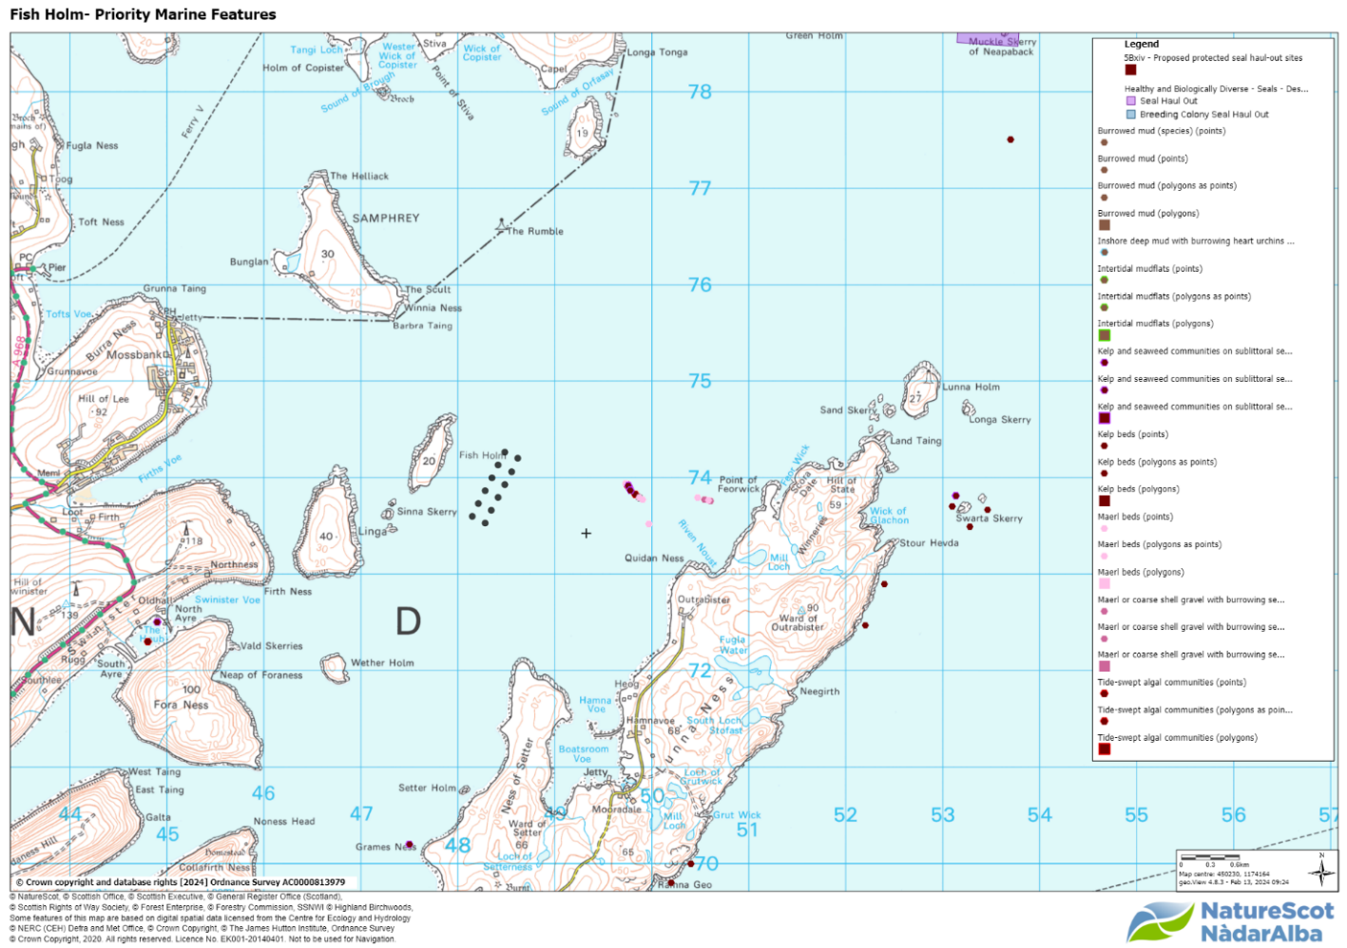
Figure 6. GeoView GeMs layer of known PMFs at Fish Holm.
The activity is within 700m of known Priority Marine Features for Mearl Beds, Maerl or coarse shell gravel with burrowing sea cucumbers, Tide-swept algal communities and Kelp and seaweed communities on sublittoral sediment (Fig 1).
The depth of the site is >43m within the mooring grid (Fig 1). Although Maerl beds have been found at depths of 40m, they are typically found at less than 30 m depth^{[1]}. The pre-application information does not provide information on any recent surveys undertaken by the applicant. However, based on the bathymetry of the proposed site, it is unlikely that there will be an impact on Maerl beds within the direct footprint of the moorings.
Out with the direct footprint of the site, there are PMF’s including Maerl Beds identified in the survey at Lunna Ness^{[2]}. The 2019 survey identified six Maerl beds and two potential Maerl beds with a depth range of between 16-31m and covering an area of 116 644m². The depositional footprint of likely impact of the finfish farm is unclear and to assess any likely impacts, we need sight of:
- The deposition modelling report.
- An appropriate seabed survey in and around the farm’s predicted area of impact which details the extent of any PMFs and the qualification of the composition and quality of any PMFs that will potentially be affected by the proposal, e.g. assessment of density and biodiversity.
- If necessary, a description of measures to avoid, prevent, reduce or offset significant adverse effects on PMF habitat.

Appendix 3 – Marine Directorate-Licensing Operations Team

Scottish Sea Farms – Fish Holm – Yell Sound, Shetland

Thank you for contacting Marine Directorate – Licensing Operations Team (MD-LOT), the regulator of licensable marine activities on behalf of the Scottish Ministers under the Marine (Scotland) Act 2010. Under the Marine (Scotland) Act 2010 s. 21, it is a licensable marine activity to deposit any substance or object within the Scottish marine area, either in the sea or on or under the seabed, from any of the following (a) a vehicle, vessel, aircraft or marine structure, (b) a container floating in the sea, or (c) a structure on land constructed or adapted wholly or mainly for the purpose of depositing solids in the sea. This includes deposit of fish farm equipment.

Article 12 “Propagation and cultivation of fish – deposits” of the Marine Licensing (Exempted Activities) (Scottish Inshore Region) Order 2011 however states that the deposit of any trestle, raft, cage, pole, rope, line or within controlled waters, any substance which is liable to cause pollution of the water environment, in the course of the propagation or cultivation of fish is an exempted activity, provided that the relevant conditions are met. The conditions are that the deposit is not made for the purpose of disposal; not made for the purpose of creating, altering or maintaining an artificial reef; or that it causes or is likely to cause obstruction or danger to navigation. It is the applicant's responsibility to ensure they meet the conditions if they intend to apply the exemption to their activities.

MD-LOT does not carry out any assessments about the suitability of the location for a fish farm, nor does it assess impacts on environment, human health or legitimate uses of the sea during the pre-application stage. Any such assessments are carried out at marine licence application determination stage, if required, and rely on stakeholder consultation. A marine licence can only be granted after planning permission for the farm has been granted.

To facilitate the pilot pre-application process and to advise other relevant authorities and the developer, MD-LOT has carried out a Geographic Information System (GIS) check for sensitivities and features of interest in the vicinity of the proposed farm. The results of the GIS check are shown below and are based on the data currently available to MD-LOT. This is not an exhaustive list of all relevant sensitivities and this information alone should not be used to determine what issues the developer may need to consider during the application process. MD-LOT is providing this information to the other relevant authorities and the developer in good faith and without pre-judgement of any potential application. MD-LOT does not intend to carry out further analysis of the suitability of the proposal based on these findings.

We hope this information is helpful.

Kind regards,

Summary of GIS checks:

Previously licensed sites: 0
Seal haul out sites: 0
Sea deposit sites: 0
Wrecks: 0
No other issues identified

Appendix 4 – Historic Environment Scotland

Fish Holm Fish Farm, Yell Sound, Shetland
Pre-application consultation
We have received the above consultation on 05 February 2024 from the applicant under the fish farm consenting pilots. We have reviewed the information in terms of our historic environment interests. This covers world heritage sites, scheduled monuments and their settings, category A-listed buildings and their settings, inventory gardens and designed landscapes, inventory battlefields and historic marine protected areas (HMPAs).
The Shetland Islands Council’s archaeological and conservation advisors will also be able to offer advice for their interests. This may include undesignated archaeological sites, category B- and C-listed buildings and conservation areas.

Our Advice
From the current information provided we have not identified any likely significant effects or “showstoppers” on our interests as a result of the proposals. The nearest heritage asset within our remit to this existing fish farm is Infield, broch 215m SE of (SM2058), which is c. 3km away, and the small island of Fish Holm would largely screen the fish farm from view.
We hope this is helpful.

Appendix 5 – Northern Lighthouse Board

To whom it may concern,
The NLB have reviewed the initial documents sent through draft plans for Fish Holm, Yell Sound, Shetland as attached. Barring any changes to the plans, should permission be granted for this site by the local authority, we don’t see any issues from a navigation point of view that cannot be mitigated by the development of a lighting and marking solution and submission of the site design and coordinates to the UKHO for inclusion in appropriate charts of the area.
Therefore, at the point when we are consulted as part of the planning process, if no material changes to the plans have been introduced there should be no issue in providing you with a lighting and marking stipulation for the site.
Regards

Appendix 6 – Maritime and Coastguard Agency

Thank you for the opportunity to comment on the pre-application documents for the pilot at Fish Holm, Shetland. The Maritime and Coastguard Agency (MCA) has an interest in the works associated with the marine environment, and the potential impact on safety of navigation, access to ports, harbours and marinas and any impact on our search and rescue obligations.
I can confirm that the MCA has no concerns to raise at this stage on the proposals from the shipping and safe navigation perspective. We are content that any increase in risk to other marine users can be mitigated through suitably worded conditions and/or advisories at formal marine licence application stage or exemption notification stage.
It would be useful if the applicant could just confirm the reference to Fish Holm VTR in the attached image. I assume this is just showing the route to access the feed barge from the shore base and nothing else.

Appendix 7 – Marine Directorate - FF Planning

Pre-application request through the new consenting pilot for new site at Fish Holm, Yell Sound, Shetland by Scottish Sea Farms Ltd.
Scottish Government’s Marine Directorate (SGMD) (previously known as Marine Scotland) have reviewed the pre-application request submitted and offer the following comment:
Based on the information currently available, SGMD does not highlight any specific “showstoppers”.
We include information below that the applicant may wish to be aware of.

Environmental Impacts
Further information may be requested covering the following:
· Benthic impacts.
· Water column impacts – Information may also be requested to cover any future biomass increase that could be accommodated in the equipment being applied for through the planning system.
· Sea lice efficacy.

Aquaculture Animal Health
The proposed Fish Holm site located at E448389 N1173907 (centre point calculated from the corner coordinates provided) will be located in disease management area (DMA) 2c NE Shetland mainland, as currently designated, however on activation this site will extend the
current boundary of the 2c DMA north, resulting in it rejoining with the adjacent 2d Yell south DMA. Merging of these DMA’s is permitted in this context, as these areas were previously considered as one DMA, but recently split following the inactivation of sites in 2021.
In addition to the usual information requirements, the applicant will also be required to provide;
details of the infrastructure in place for handling 200m pens including details of staff knowledge and experience
Furthermore, the suggested approach of applying for 12 pens at planning whilst only having CAR consent for 8 pens may influence the information required, to allow adequate assessment of the application. For example, this may impact equipment suitability assessments and permitted quantities of chemotherapeutants being aligned to the biomass and amount of pens that permission is being sought for.
As further details of the proposal are confirmed, more specific information may be required.

Wild Fisheries
The proposed site has the potential to adversely affect local sea trout populations. Therefore an Environment Management Plan will be requested. The applicant will note that from March 2025 SEPA expect to implement an adaptive approach to manage interactions between sea lice from fish farms and sea trout. An option here is to include an appropriate review date for the EMP that allows for its removal in favour of including the site in the national framework on its implementation.
Notes to applicants:
The Aquatic Animal Health (Scotland) Regulations 2009 requires the authorisation of all Aquaculture Production Businesses (APB's) in relation to animal health requirements for aquaculture animals and products thereof, and on the prevention and control of certain diseases in aquatic animals. The authorisation procedure is undertaken on behalf of the Scottish Ministers by the Fish Health Inspectorate (FHI) at the Marine Directorate Marine Laboratory. To apply for authorisation for an APB or to amend details of an existing APB or any site that an APB is authorised to operate at, you are advised to contact the FHI as follows: Fish Health Inspectorate, Marine Directorate Marine Laboratory, 375 Victoria Road, Aberdeen, AB11 9DB. Tel: 0131 244 3498; Email: ms.fishhealth@gov.scot
All marine farms, whether finfish, shellfish or algal, are required to apply for a marine licence under Part 4 of the Marine (Scotland) Act 2010. To apply for a marine licence, or to amend details of an
existing marine licence (formally Coast Protection Act 1949 – Section 34 consent), please visit the Scottish Government’s website at http://www.gov.scot/Topics/marine/Licensing/marine/Applications where application forms and guidance can be found. Alternatively you can contact the Marine Directorate Licensing Operations Team (MD-LOT) by emailing MS.MarineLicensing@gov.scot; or calling 0300 244 5046.
Yours sincerely
Marine Directorate of the Scottish Government

For information on accessing this document in an alternative format or language, please contact SEPA by emailing equalities@sepa.org.uk
If you are a user of British Sign Language (BSL), the Contact Scotland BSL service gives you access to an online interpreter, enabling you to communicate with us using sign language. contactscotland-bsl.org

