Water Scarcity Report

27th June 2024

The Dee (Aberdeen) catchment is now at Early Warning of water scarcity.

Early Warnings remain in place for the Esk river catchments in Angus and the Kintyre area.

Normal Conditions remain in place for the rest of the country.

Figure 1: Larger map of Scotland showing this week's water scarcity levels. Smaller map showing the previous reports water scarcity levels.

Link to Accessible national water scarcity map
The overall risk of water scarcity takes account of the individual water scarcity indices, relevant water use, sectors in each region, and forecast weather conditions. The areas shown in this map represent major river catchments. Details on how levels are set and actions required can be found in SEPA’s National Water Scarcity Plan.

Situation Summary
The last week has been largely dry, and ground conditions across much of the country have continued to dry out.

Increasingly dry soils in the Dee river catchment, coupled with recent low flows, mean that an early warning of water scarcity is now in place here.

In the Esk river catchments in Angus, and in the Kintyre area, Early Warnings remain in place.

Elsewhere across the country the level remains at Normal.

Groundwater levels at most monitoring locations range between normal and very high for the time of year.

SEPA is monitoring the situation and coordinating steps to manage water resources in line with Scotland's National Water Scarcity Plan which is available on SEPA’s water scarcity website.

You can help us by reporting any evidence you see of water scarcity. For details of information that would be useful to us and where to send it see: Water scarcity in your area | Scottish Environment Protection Agency (SEPA).

Advice for water users
We advise water users, including those with private water supplies, to be aware of the potential risk of water scarcity this summer, and for businesses to plan ahead where possible. Water scarcity - plan ahead and use water wisely (sepa.org.uk)

Weather forecast (27/06/24)

Area of rain extending from the west through Thursday, most persistent across western hills. Rain gradually waning from the south through Friday. Scattered showers for the weekend, focused in the Highlands. Area of rain crossing the country from the west on Monday.

The rainfall outlook for the June-August period suggests that across the UK the chances of a wet or dry summer are fairly balanced. The chance of a hot summer is higher than normal, but similar to recent years.

© Crown copyright [2024], Met Office

Supporting information

Rainfall and river flows:
These maps show rainfall (top row) and river flow (bottom row) relative to the long-term average, for this time of year, over 30 days, 90 days, and 180 days.

Short-term rainfall maps show normal conditions across most of the country.

Over the last month, river flows have been low across parts of Angus and in the upper reaches of the River Dee. River flows elsewhere remain mainly normal to very high.

In the longer term, the east and south have generally been wetter than average, with normal conditions prevailing across the west and north, and in parts of Aberdeenshire. River flows have been very high in the south and east due to the wet winter/spring. North of the Great Glen, and in parts of the Cairngorms, river flows have been normal to low.

Figure 2: Maps of Scotland showing rainfall from each rainfall monitoring station relative to the long-term average, for this time of year, over 30 days (left), 90 days (middle) and 180 days (right).
Figure 3: Maps of Scotland showing river flows from each river monitoring station relative to the long-term average, for this time of year, over 30 days (left), 90 days (middle) and 180 days (right).

Soil moisture deficit:
These maps show this week’s soil moisture deficit, alongside our previous report for comparison. This is obtained from the Met Office Rainfall and Evaporation Calculation System (MORECS). There is no soil moisture deficit across most of the west and north-west. However, ground conditions are quite dry across much of the east and south, and are now dry in the Ythan area.

Figure 4: Maps of Scotland showing this week’s soil moisture deficit. A smaller map of Scotland shows the previous reports soil moisture deficit.

Natural water storage
In each river catchment there is some degree of natural water storage, which can maintain river flows even when it is not raining. This natural water storage is mainly held in lochs and groundwater. When storage has been depleted it will take a lot of rainfall for levels to recover.

The maps below show recent groundwater and loch level compared to the long-term record at each individual station. Level is reported as high or low compared to the typical (‘normal’) level range for the time of year. Level ranges are specific to each station and based on the long-term (minimum 10 years) record of mean monthly level values recorded at individual stations.

Groundwater levels:
May groundwater levels were normal or above at all monitoring locations.
Figure 5: A map of Scotland showing how the mean monthly groundwater level for May compares to the long-term record at each individual station. A smaller map of Scotland shows the groundwater levels for April.

Loch levels:

May loch levels were low or very low in the north. All other monitored lochs were within the typical range for this time of year.

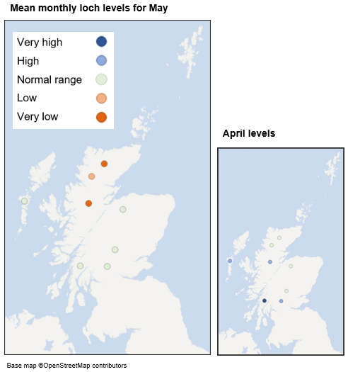
Figure 6: A map of Scotland showing how the mean monthly loch level for May compares to the long-term record at each individual station. A smaller map of Scotland shows the loch levels for April.

Flow, rainfall and groundwater data are accessed via SEPA’s time series data service (API). SEPA's live data are subject to ongoing quality control and periodic review.

Appendix

Accessible national water scarcity map
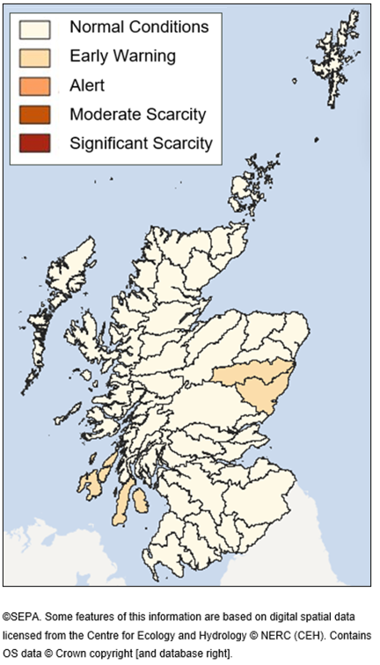

Figure 7: A map of Scotland showing the current water scarcity level in each catchment coloured with accessible colours.
The above Situation Summary describes the conditions in more detail.

For information on accessing this document in an alternative format or language, please contact SEPA by emailing equalities@sepa.org.uk
If you are a user of British Sign Language (BSL), the Contact Scotland BSL service gives you access to an online interpreter, enabling you to communicate with us using sign language. contactscotland-bsl.org

