

# Aquaculture Modelling Screening & Risk Identification Report: Little Colonsay (LCLS1) Addendum

Report date: November 2024

## Scope of report

As part of the SEPA Aquaculture Regulatory Framework it is recommended that a proposed application for a marine fin fish aquaculture site should undergo a Screening Modelling and Risk Identification process. SEPA carries out this work and this is described on the SEPA aquaculture website [**Pre-application section**](https://www.sepa.org.uk/regulations/water/aquaculture/pre-application/)

This report presents information arising from that process. Screening modelling methods are outlined and maps and tables describing the modelled impacts are shown. Risks arising from consideration of the model output are listed. Conclusions and recommendations are made regarding the proposed site.

## Executive summary

SEPA has received a revised proposal for a new marine fin fish aquaculture site called Little Colonsay (LCLS1). The revised site location has moved by 481m to the south and is now to be located at: 138391E, 735945N (Easting, Northing). The originally proposed location was at 138374, 736426 (Easting, Northing). The proposed weight of fish to be farmed is 3170t. This is an increase by 397t compared to the previous proposed biomass (2773t). Furthermore, the fin fish site Inch Kenneth (FFMC24) with 270t is to be relinquished should this proposal be accepted. SEPA does not think the move and increase in biomass is such that it increases the risk that new screening modelling should be conducted. Hence, the previous screening report [3] from 2022 is still valid.

The 2022 screening modelling and risk identification concluded the following:

* It is possible that discharges from Little Colonsay (LCLS1) will be able to comply with the relevant aspects of the SEPA Aquaculture Regulatory Framework.
* Features at risk, identified at this stage, do not appear to influence the feasibility of the proposed site with respect to the regulatory framework. These risks should be examined using a detailed marine model. Due to the identified risks, 2D marine modelling of baths and sediment should be carried out. Cumulative solids modelling is required for all sites identified including Inch Kenneth (FFMC24), unless it is to be relinquished.
* Little Colonsay (LCLS1) is suitable to progress to the next stage of the pre-application process outlined on the SEPA website.
* Contextual site information suggests Little Colonsay (LCLS1) may be able to comply with mixing zone standards. NewDepomod modelling should be (and has already been) undertaken for the proposed site. It is strongly recommended that default NewDepomod modelling is undertaken prior to any marine modelling, to ensure the proposed biomass can be supported If marine modelling of baths is undertaken, the resolution of the marine model should be relatively fine around the proposed site and identified features at risk.
* Sea lice screening has been undertaken for this proposed site and has shown minimal effect on the wild salmon lice exposure risk. No criteria for further work have been triggered and the site does not need a permit condition at this time.

## List of abbreviations

SEPA Scottish Environment Protection Agency

CAR Controlled Activities Regulations

WSPZ Wild Salmon Protection Zone

Contents

Aquaculture Modelling Screening & Risk Identification Report: Little Colonsay (LCLS1) Addendum 1

Scope of report 2

Executive summary 2

List of abbreviations 4

Introduction 6

Screening modelling 7

Sea Lice Screening 7

References 12

## Introduction

Screening Modelling and Risk Identification are important steps in the SEPA regulatory framework for marine pen fish farms. They are carried out by SEPA at the [**pre-application stage**](https://www.sepa.org.uk/regulations/water/aquaculture/pre-application/)**.**

This document briefly describes the objectives of screening and risk identification and summarises the methods used. Screening output for the proposed site is then presented with comments. Risks identified from the screening output are detailed. Conclusions and recommendations about the suitability of the proposed site are then made.

### The objectives of screening modelling and risk identification

A summary of the modelling methods employed during screening modelling is outlined in the screening modelling methods section. The objectives of screening modelling and risk identification are outlined below.

#### Screening modelling

Marine Modelling technology can be used to simulate and predict the potential influence of discharges on the marine environment. Marine modelling can also be used at an earlier stage to provide an initial estimate of the influence of material discharged from a proposed site, which is discussed in this report.

SEPA will require the majority of proposed farms to conduct detailed marine modelling, as outlined in our Aquaculture Modelling guidance [1] and on the SEPA Website. The screening and risk identification stage will assess the need for detailed modelling.

SEPA will carry out marine modelling at the screening and risk identification stage. This is a simplified version of the detailed modelling required of the applicant. However, it will be sufficient to perform an initial risk assessment of a proposal. Screening marine modelling will also include discharges from other relevant aquaculture sites and major sources.

## Screening modelling

### Site proposal

SEPA has received a revised proposal for a new marine fin fish aquaculture site called Little Colonsay (LCLS1). The revised site location has moved by 481m to the south and is now to be located at: 138391E, 735945N (Easting, Northing). The originally proposed location was at 138374, 736426 (Easting, Northing). The proposed weight of fish to be farmed is 3170t. This is an increase by 397t compared to the previous proposed biomass (2773t). Furthermore, the fin fish site Inch Kenneth (FFMC24) with 270t is to be relinquished should this proposal be accepted. SEPA does not think the move and increase in biomass is such that it increases the risk that new screening modelling should be conducted. Hence, the previous screening report from February 2022 is still valid. Please see screening report [2] for more detailed information.

## Sea Lice Screening

Sea lice screening was carried out using our standard method with the translated Scottish Shelf WLLS (Wider Loch Linnhe System) sub area model. This method is outlined in in Appendix 4 of the May 2023 second consultation document: [Managing interactions between sea lice from finfish farms and wild salmonids, Proposed new regulatory framework, May 2023.](https://consultation.sepa.org.uk/regulatory-services/detailed-proposals-for-protecting-wild-salmon/)

### Modelled Sea Lice Concentration Map – LCLS1

Figure 1 shows a map of the average modelled lice concentration over the simulated April and May period (in lice/m2) within the top two meters of the sea area. Model grid cells (triangles) are coloured according to the amount of sea lice particles within them.

#### Indicative Influence

The map serves as an indicative influence under average tidal and weather conditions. The focus is on areas of potential high influence for further fish track analysis within WSPZs.

#### Exclusion of Low Concentrations

Any grid cells with concentrations below 0.01 lice/m² are not shown on the map. This exclusion helps focus on more influential concentrations on the fish track analysis and WSPZs. However, these concentrations are not excluded from fish track exposure analysis below.

#### Colour Intensity, 90th Percentile and Median Concentrations

The more intense the colour in the grid cells, the closer the concentration is to the 90th percentile of all concentrations within the model cells. This brings attention to areas of higher modelled influence. The 90th percentile of sea lice concentrations is 0.11 lice/m², meaning that 90% of the concentrations are below this value. At baseline (before the introduction of the proposed site), the average 90th percentile concentration across modelled sites was 0.04 lice/m². The median concentration is 0.02 lice/m², suggesting that half of the values are below this number.

#### Focus Area

The fish track exposure assessment, on which the screening outcome is based, is on the zone where the influence is highest. In this case, the highest modelled influence occurs in the Loch na Keal WSPZ. However, this does not mean the actual modelled exposure will be high.

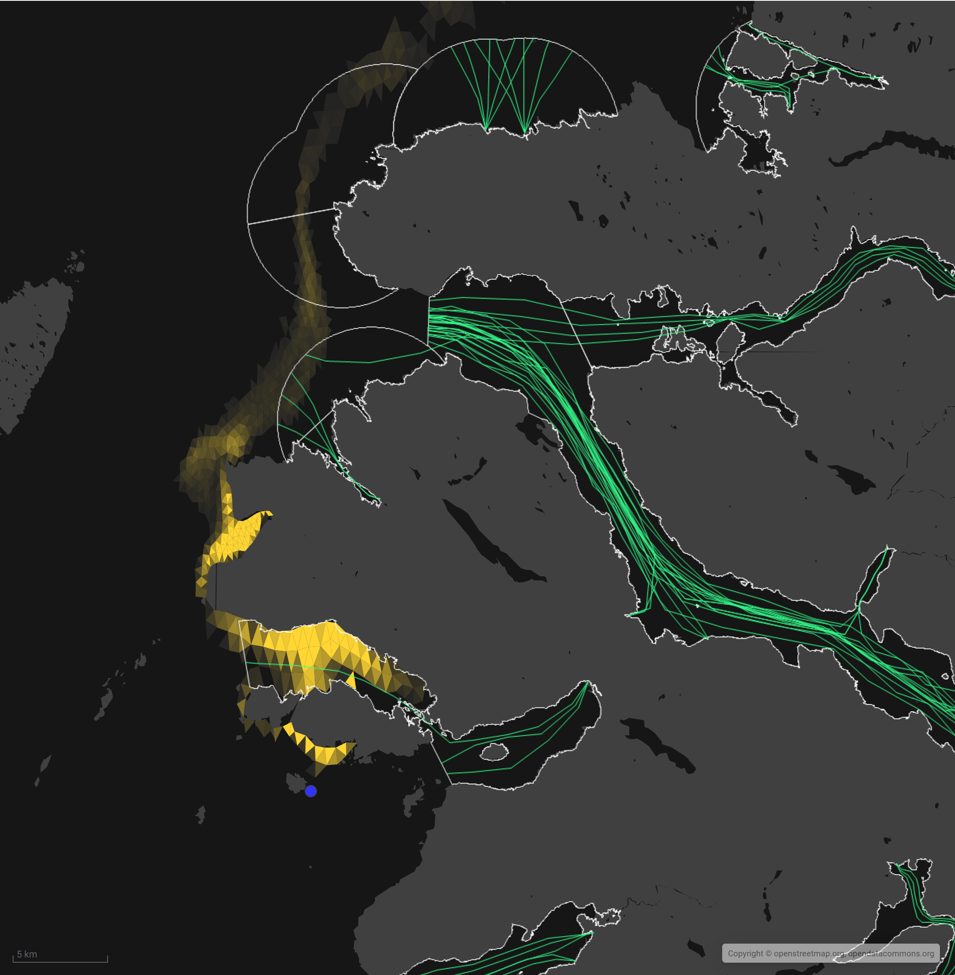

Figure 1: Map of the average modelled lice concentration over the simulated April and May period (in lice/m2) within the top two meters of the sea area. LCLS1 site location shown as a blue circle. Fish tracks are shown as green lines with the WSPZs, which are highlighted by a white boundary.

### Modelled Sea Lice Concentrations – Single Site Influence on Exposure – LCLS1

Table 1 shows information relating to the influence of modelled lice concentrations, from LCLS1 alone, on fish track exposure levels within the relevant WSPZs.

Table 1:Influence of modelled sea lice from LCLS1 on exposure in the relevant affected WSPZs.

| **Wild Salmon Protection Zone (WSPZ)** | **95th %ile of Fish Track Exposure (lice/m2 days)** | **% of Exposure Threshold (0.7 lice/m2 days)** |
| --- | --- | --- |
| Loch na Keal | 0.06 | 7.75 |
| West Mull | 0.01 | 1.56 |

#### WSPZ Influence

Two WSPZs are influenced to a low degree. Four other WSPZs are influenced to an extremely low degree. Exclusion of these from the table brings focus on the areas of highest influence. However, these influences are included in the combined exposure analysis below.

#### Exposure Threshold

The percentage of the exposure threshold is shown to illustrate the scale of a single site influence. The exposure influence of all sites is not simply the sum of the individual site percentages. The overlapping influence of all sites on modelled screening exposure is shown below.

#### Assessment Matrix

An assessment matrix is presented on page 57 of the SEPA December 2023 response to consultation feedback: Managing interactions between sea lice from finfish farms and wild salmonids, SEPA response to [consultation feedback](https://consultation.sepa.org.uk/regulatory-services/detailed-proposals-for-protecting-wild-salmon/), December 2023.

Using the fish track exposure method, we establish the location of LCLS1 within the assessment matrix framework of WSPZ screening capacity and site contribution. To assess the capacity influence, we take the WSPZ which experiences the greatest influence, in this case it is Loch na Keal. Table 2 shows that LCLS1 lies within cell A1 (Negligible, Large).

Table 2: Location of LCLS1 within the assessment matrix framework of WSPZ capacity and site contribution.

| **Contribution to infective-stage sea lice exposure** | **Remaining available capacity in WSPZ** | | |
| --- | --- | --- | --- |
| **Large (1)** | **Intermediate (2)** | **Little or none (3)** |
| **Negligible (A)** | A1 **LCLS1** | A2 | A3 |
| **Small (B)** | B1 | B2 | B3 |
| **Moderate (C)** | C1 | C2 | C3 |
| **Substantial (D)** | D1 | D2 | D3 |
| **Table Cell Colour Key (Permit conditions controlling on farm sea lice levels (19th March to 31st May)** | | | |
| A1 to A3, B1 to B2, C1 | No sea lice limit conditions. | | |
| B3, C2, D1 | Sea lice limits proposed by the developer and used in the screening assessment. | | |
| C3, D2 | Sea lice limits derived from an appropriate modelling assessment demonstrating that the farm will not compromise achievement of the sea lice exposure threshold. | | |
| D3 | Sea lice limits derived from an appropriate modelling assessment demonstrating that the farm will not compromise achievement of the sea lice exposure threshold. | | |

### Combined Influence of LCLS1 on all Wild Salmon Protection Zones

Using the fish track exposure method, we can calculate the latest combined influence of all sources on the exposure threshold within all WSPZs, including the proposed at the time of its submission. LCLS1 mainly affects the Loch na Keal WSPZ. Its inclusion has reduced some of the remaining capacity in Loch na Keal, but does not, on its own, cause the exposure threshold upper limit to be exceeded. LCLS1 has also reduced the screening capacity in a number of nearby WSPZs, but to a very small degree.

### Conclusion of Sea Lice Screening

The outcome of current screening is that this site will not require a lice permit condition. No further modelling work is required, at this time.

## References

[1] *Marine Modelling Guidance for Aquaculture Applications*. *Published on SEPA website.*

[2] Little Colonsay (LCLS1) Screening and Risk Identification Report, February 2022 [lcls1_screenmodriskid.pdf](https://www.sepa.org.uk/media/594187/lcls1_screenmodriskid.pdf)

For information on accessing this document in an alternative format or language, please contact SEPA by emailing [equalities@sepa.org.uk](mailto:equalities@sepa.org.uk)

If you are a user of British Sign Language (BSL), the Contact Scotland BSL service gives you access to an online interpreter, enabling you to communicate with us using sign language. contactscotland-bsl.org