

# Aquaculture Pre-Application Risk Identification Report: HYSKEIR (HYSK1)

Report date: November 2024

## Scope of report

As part of the SEPA Aquaculture Regulatory Framework it is recommended that a proposed application for a marine fin fish aquaculture site should undergo a Screening Modelling and Risk Identification process. SEPA carries out this work and this is described on the SEPA aquaculture website [**Pre-application section**](https://www.sepa.org.uk/regulations/water/aquaculture/pre-application/).

This report presents information arising from that process. Screening modelling methods are outlined and maps and tables describing the modelled impacts are shown. Risks arising from consideration of the model output are listed. Conclusions and recommendations are made regarding the proposed site.

## Executive summary

SEPA has received a proposal for a new marine fin fish aquaculture site called Hyskeir (HYSK1). The site is located to the East of the Isle of Hyskeir, at location: 116180, 796557 (Easting, Northing). The proposed weight of fish to be farmed is 3000t.

Following screening modelling and risk identification we have concluded the following:

It is possible that discharges from Hyskeir (HYSK1) will be able to comply with the relevant aspects of the SEPA Aquaculture Regulatory Framework.

* Features at risk, identified at this stage, may influence the feasibility of the proposed site with respect to the regulatory framework. These risks should be examined using a detailed marine model.
* Hyskeir (HYSK1) is suitable to progress to the next stage of the pre-application process outlined on the SEPA website.
* Contextual site information suggests Hyskeir (HYSK1) may be able to comply with mixing zone standards. It is strongly recommended that default NewDepomod modelling is undertaken prior to any marine modelling, to ensure the proposed biomass can be supported.
* Sea lice screening has been undertaken for this proposed site and has shown no material effect on the exposure risk. Therefore, no further modelling or permit conditions will be required for this site.
* We strongly recommend detailed baseline sample plans be submitted to ensure any survey work will assess the extent of protected features within the immediate vicinity of the proposed site.

## List of abbreviations

SEPA Scottish Environment Protection Agency

CAR Controlled Activities Regulations

WSPZ Wild Salmon Protection Zone

## List of chemical abbreviations

AZA Azamethiphos

Contents

Aquaculture Pre-Application Risk Identification Report: HYSKEIR (HYSK1) 1

Scope of report 2

Executive summary 2

List of abbreviations 4

List of chemical abbreviations 4

List of Figures 6

List of Tables 7

Introduction 8

Screening modelling 13

Sea Lice Screening 26

Risk Identification 30

Conclusions of screening modelling and risk identification 36

References 39

Appendices – Responses to pre-app consultation. 40

## List of Figures

Figure 1. East Coast, Lewis and Harris model grid 12

Figure 2: Modelled average water speed (metres per second – m/s) in the sea area surrounding the proposed site (Hyskeir (HYSK1)). 20

Figure 3: Modelled percentage of time the water flow speed is above 0.095 m/s in the sea area surrounding the proposed site (Hyskeir (HYSK1)). 21

Figure 4: Modelled average sediment intensity over one month for the proposed site only (Hyskeir (HYSK1)). 22

Figure 5: Modelled average sediment intensity over one month for the proposed site (Hyskeir (HYSK1)) and other relevant sites. 23

Figure 6: Modelled average Azamethiphos concentration over four days from neap tide release for the proposed site only (Hyskeir (HYSK1)). 24

Figure 7: Modelled average Azamethiphos concentration over four days from neap tide release for the proposed site (Hyskeir (HYSK1)) and other relevant sites. 25

Figure 8: Map of the average modelled lice concentration over the simulated April and May period (in lice/m2) within the top two meters of the sea area. HYSK1 site location shown as a blue circle. Fish tracks are shown as green lines with the WSPZs, which are highlighted by a white boundary. 27

Figure 9. Identified sensitive PMFs (found within the Small Isles MPA). 32

Figure 10. Identified sensitive features (in addition to those in Figure 8) 33

Figure 11: Figure showing known PMFs in the vicinity of Hyskeir 52

## **List of Tables**

Table 1: Sediment influence information for each site. 16

Table 2: Azamethiphos influence information for each site. 19

Table 3: Influence of modelled sea lice from HYSK1 on exposure in the relevant affected WSPZs. 28

Table 4: Location of HYSK1 within the assessment matrix framework of WSPZ capacity and site contribution. 29

Table 5: Table of identified features 30

Table 6: Table of licenced biomass from farms identified as likely to add to cumulative risks. 35

## Introduction

Screening Modelling and Risk Identification are important steps in the SEPA regulatory framework for marine pen fish farms. They are carried out by SEPA at the [**pre-application stage**](https://www.sepa.org.uk/regulations/water/aquaculture/pre-application/)**.**

This document briefly describes the objectives of screening and risk identification and summarises the methods used. Screening output for the proposed site is then presented with comments. Risks identified from the screening output are detailed. Conclusions and recommendations about the suitability of the proposed site are then made.

### The objectives of screening modelling and risk identification

A summary of the modelling methods employed during screening modelling is outlined in the screening modelling methods section. The objectives of screening modelling and risk identification are outlined below.

#### Screening modelling

Marine Modelling technology can be used to simulate and predict the potential influence of discharges on the marine environment. Marine modelling can also be used at an earlier stage to provide an initial estimate of the influence of material discharged from a proposed site, which is discussed in this report.

SEPA will require the majority of proposed farms to conduct detailed marine modelling, as outlined in our Aquaculture Modelling guidance [1] and on the SEPA Website. The screening and risk identification stage will assess the need for detailed modelling.

SEPA will carry out marine modelling at the screening and risk identification stage. This is a simplified version of the detailed modelling required of the applicant. However, it will be sufficient to perform an initial risk assessment of a proposal. Screening marine modelling will also include discharges from other relevant aquaculture sites and major sources.

The objectives of the simplified screening modelling are to:

* Produce maps of the predicted dispersive and erosive capacity of the sea areas in the vicinity of aquaculture sites
* Produce maps of the predicted spread of sediment discharged from aquaculture sites
* Produce maps of the predicted spread of bath treatment medicines from aquaculture sites
* Present an indication of the potential influence of sediment and bath treatment discharges from the proposed site alongside existing sites within the surrounding sea area
* Present the locations of sensitive features and sites of interest within the surrounding sea area, which must be addressed during pre-application work
* Present a summary of the suitability of the proposal with respect to the dispersal of waste and how this may be modelled.

#### Risk identification

Maps and analysis of screening output will be compared to information relating to sensitive features and relevant areas of interest. These may include:

* Marine Protected Area (MPA)
* Special Area of Conservation (SAC)
* Priority Marine Feature (PMF)
* Any site identified via consideration of other permitted or regulatory activities.

SEPA staff will meet to discuss screening model output and the relevant sensitive features information; this will also be discussed with NatureScot. Following this meeting, a list of identified risks will be added to this report.

#### Conclusion of screening modelling and risk identification

Following the identification of risks, SEPA will present a summary of the suitability of the proposal with respect to the:

* Dispersal of waste from the proposed site and other sources
* Risks posed to sensitive features
* Likely level of modelling that will be required to address the risks identified.

### Screening modelling methods

Marine models divide the sea up into a “grid” of boxes or triangles (often called cells). Each of these is given a water depth. For the screening modelling presented in this report the Marine Scotland “East Coast, Lewis and Harris” (ECLH) has been used. An image of the ECLH model grid is shown in Figure 1. This grid has been set up within a marine modelling software package called MIKE 21 which is manufactured by the company DHI A/S (https://www.dhigroup.com/).

Marine models carry out calculations across a grid to work out how seawater moves and mixes in response to tidal and weather forces. Marine models can also be used to simulate how seawater moves and mixes due to salinity and temperature differences across an area, particularly in response to inputs of freshwater from rivers. For pollutant influence assessments the mixing (dispersion) of dissolved (bath medicine) and particulate (sediment) pollutants can also be estimated. Calculations within a marine model can be performed in three dimensions (3D), where the grid is split into layers to better represent how properties of the sea change with depth. Two dimensional (2D) models can also be created where processes over the water depth are simplified. The amount of mixing in a marine model can be varied using settings in the software.

Screening modelling is currently carried out with 2D models using average mixing settings in the model software. In many areas, this approach will be sufficient to make an initial estimate of the influence of a proposed site. Our screening assessment will take into account factors which may limit a 2D approach. We will also consider whether a particular location is adequately represented by the available models.

#### Water movement and mixing modelling

Water movement and mixing modelling (hydrodynamics) has been carried out to generate one month of results. The boundaries (edge(s) of) the model have been driven using the “wider domain” Scottish Shelf Model [2]. Wind forces and freshwater inputs have been applied to the model from the same source. The results generated are an estimate of the average water movement and mixing conditions within the model area.

#### Sediment waste modelling

Screening modelling provides a precautionary and **indicative** estimate of the size, location and intensity of waste organic material released from aquaculture sites.

The release of sediment from sources within the model area is simulated using one month of hydrodynamic results along with particle tracking modelling technology. Virtual particles are continually introduced to the model grid to represent the potential dispersion of sediment from the sources. Particles in the model are moved and mixed by the hydrodynamics. Additionally, particles are assigned simplified properties, which allow them to settle through the water and be re-suspended (eroded and lifted) from the seabed.

#### Bath medicine modelling

Screening modelling provides a precautionary and **indicative** estimate of the size, location and concentration of bath medicine releases.

The release of bath treatment medicine from sources within the model area is simulated using hydrodynamic results along with particle tracking modelling technology. Virtual particles are introduced to the model grid to represent the potential dispersion of bath medicines from the sources. Particles in the model are moved and mixed by the hydrodynamics. Releases of bath medicines are simulated under worst case mixing (dispersion) conditions, which occur under neap tides. The maximum treatment amount likely to be used at each site is released into the model at the same time and plumes are tracked over the following 96 hours (4 days). Treatment amounts used at screening have been derived from an analysis of historical data. Additionally, all bath medicine particles are concentrated within the top 5 m of the sea area. As all bath medicines are likely to disperse in a similar way, only Azamethiphos (AZA) has been modelled at the screening stage.

#### Nutrient assessment

Whilst nutrients are not directly modelled during screening, the dispersion of bath medicine releases will give an indication of the likely level of nutrient dispersion. This will be considered alongside any pre-existing nutrient assessment information that may be available.

#### Analysis of modelling output

SEPA processes the screening modelling output and places it into a standard analysis application built in TIBCO Spotfire. The application allows for the production of standard maps and tables, which are presented below.

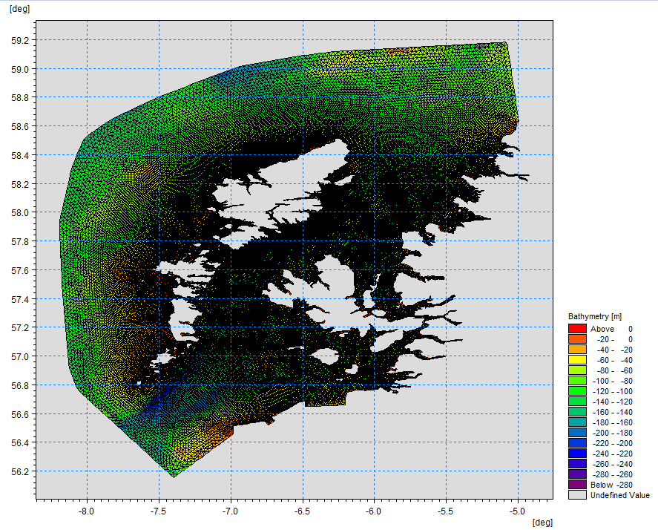

Figure 1. East Coast, Lewis and Harris model grid

## Screening modelling

### Site proposal

Screening modelling has been carried out for a proposal for a new farm: Hyskeir (HYSK1). The proposal is to site the farm at location: 116180, 796557 (Easting, Northing). The proposed weight of fish to be farmed is 3000t. For the screening modelling presented here all relevant licenced sites and current applications have been modelled in conjunction with the proposed site.

#### Accuracy of model in the area surrounding the proposal

The East Coast, Lewis and Harris model used for screening modelling has a relatively low resolution in this area and does not include the island of Hyskeir. Comparison against various sources of observed current meter data indicates that the model provides a moderate description of the physical processes in the vicinity of the proposed site.

### Dispersion and erosion capacity maps

Modelled water movement in a sea area can be analysed and presented to show the capacity of the water to move and disperse discharged substances. It is also possible to show the capacity available to erode substances from the seabed. This information is a useful guide to the potential size of a marine fin fish aquaculture farm at a particular location.

Marine fin fish aquaculture farms using open-net pens will benefit from operating in locations where there are strong, repeating, water currents to erode and disperse waste.

For the purposes of screening, we consider locations which meet the following water flow criteria to be generally suitable for larger farms:

Locations with average water flow speeds of greater than, or equal to, 0.12 metres per second (0.23 knots)

Locations where water flow speeds are often above the threshold of 0.095 meters per second (0.18 knots).

Locations with these properties are likely to disperse discharged material rapidly, and regularly erode sediment discharged to the seabed. In general, we would look for these properties to be maintained over a large area around a proposed site.

The thresholds stated above are indicative.

A map of modelled average water flow speed for the area surrounding the proposed site is shown in Figure 2. The average water flow speed in each cell of the model grid (see section 1.2) has been assigned a shade. The key for the shading is shown in the top left of the figure. Grid cells that have average speeds less than 0.12 m/s (metres per second) are marked on the figure. The greater the shading, the slower the average current speed and the lower the capacity for dispersion.

Figure 3 is a map of the percentage of time the modelled water flow speed in a grid cell is above 0.095 m/s (metres per second). The greater the shading, the lower the capacity for material to be eroded from the seabed.

Licenced aquaculture farms in the vicinity of the proposed site are also marked on Figure 2 and Figure 3. Discharges of material from these sites have been included in the screening modelling.

Based on the maps of the modelled water flow properties we can make the following observations about the proposed site location:

* It lies in a high dispersion area.
* It lies in an area where water flow has a high capacity to erode material on the seabed.

### Sediment influence maps and analysis

Modelled particles in a sea area can be analysed for each modelled grid cell and presented to show the potential influence of discharged sediment on the surrounding sea area.

Figure 4 shows a map of the modelled average sediment intensity over one month (time average) for the proposed site only. Grid cells within the model that are influence by modelled sediment are shaded according to the intensity of the influence in grams per square metre (g/m2).

Values less than 1 g/m2 have been excluded from the map and subsequent calculations. These low concentration cells are produced by the particle tracking approach, but they are not considered to be representative of the main influence of a discharge.

* The shading key is shown in the top left of the figure. Cells which are shaded black are similar to the average intensity in the total area of influence shown in the map. Cells shaded pink are similar to the median (middle value in the range) intensity value shown on the map. White shaded cells are similar to the minimum intensity value shown on the map.
* The average and median sediment intensity over the area of influence is <1 g/m2 and <1 g/m2 respectively.
* Cells influenced by the proposed site do not appear to lie close to other modelled farm sites.

Figure 5 shows a map of the modelled average sediment intensity over one month for the proposed site and other relevant sites. Grid cells within the model that are influenced by modelled sediment are shaded according to the intensity of the influence in grams per square metre (g/m2). The shading key is shown in the top left of the figure and is in a similar format as that shown in Figure 4. The average sediment intensity, after including all relevant sites, is increased.

* The average and median sediment intensity over the area of influence is 4.04 g/m2 and 2.10 g/m2 respectively.
* Cells influenced by other modelled sites do not appear to lie close to the proposed site.

#### Sediment influence analysis

Model grid cells can be analysed to estimate the size and concentration of the potential sediment influence from the modelled sites.

* The total area of sediment influenced by the eight sites modelled is estimated to be 2.40 square kilometres (km2).
* As shown in Figure 5, the average and median intensity over this area is 4.04 and 2.10 g/m2 respectively.
* The total weight of fish that generates this modelled influence is 13994 tonnes.

Table 1 shows the information for each individual site modelled. It is important to note that the total area of influence for all sites is not the sum of the numbers in Table 1. The total area of influence worked out above takes into account that the individual areas of influence from different sites will overlap.

Table 1: Sediment influence information for each site.

| **Site Name** | **Average Intensity (g/m2)** | **Area of Influence (km2)** | **Median Intensity (g/m2)** | **Max Weight of Fish (Tonnes)** |
| --- | --- | --- | --- | --- |
| HYSK1 | Less than1 | 0 | Less than1 | 3000 |
| AMM1 | 2.31 | 1.00 | 1.32 | 4069 |
| CARO1 | 13.34 | 0.27 | 13.34 | 275 |
| HARL1 | 2.50 | 0.59 | 2.69 | 300 |
| PORL1 | Less than1 | 0 | Less than1 | 2000 |
| RUM1 | Less than1 | 0 | Less than1 | 2850 |
| TARI1 | 4.11 | 0.26 | 4.11 | 500 |
| WBRA1 | 1.54 | 0.77 | 1.29 | 1000 |

There are no Environmental Standards for sediment intensity. However, we consider that:

• underneath farm pens, an intensity of 2000 g/m2 or less is likely to lead to an acceptable seabed ecological outcome

• at the edge of the mixing zone, an intensity of 250 g/m2 or less is likely to lead to an acceptable se bed mixing zone outcome

The estimate of influence detailed above is indicative. The values presented are lower than the sediment intensity values given above. However, we recognise that low sediment concentrations may be useful for the identification of risks.

### Bath medicine influence maps and analysis

Modelled particles in a sea area can be analysed for each modelled grid cell and presented to show the potential influence of discharged bath medicine on the surrounding sea area. Results presented are for the AZA medicine (see section 1.2.3).

Figure 6 shows a map of the modelled average AZA concentration over four days for the proposed site only. Grid cells within the model which experience an AZA influence are shaded according to the concentration of AZA in nanograms per litre (ng/l).

Values less than 10 ng/l have been excluded from the map and subsequent calculations. These low concentration cells are produced by the particle tracking approach, but they are not considered to be representative of the main influence of a discharge.

Please note that the Environmental Standard for Azamethiphos with the lowest concentration is 40 ng/l. This must be met 72 hours after the material has been discharged. The estimate of influence detailed here is precautionary. In the information presented below areas of influence above 40 ng/l have been quoted. However, the average and median concentrations are quoted for the entire area of influence above 10 ng/l.

The shading key is shown in the top left of the figure. Cells which are shaded black are similar to the average concentration in the total area of influence shown in the map. Cells shaded pink are similar to the median (middle value in the range) concentration shown on the map. White shaded cells are similar to the minimum concentration value shown on the map.

* The average and median concentration over the total area of influence is <10 ng/l and <10 ng/l respectively.
* Cells influenced by the proposed site do not appear to lie close to other modelled farm sites.

Figure 7 shows a map of the modelled average AZA influence over four days for the proposed site and other relevant sites. The average AZA influence, after including all relevant sites, is increased.

* The average and median AZA concentration over the total area of influence is 49.73 ng/l and 14.49 ng/l respectively.
* Cells influenced by other modelled sites do not appear to lie close to the proposed site.

#### Bath medicine influence analysis

Model grid cells can be analysed to estimate the size and concentration of the potential AZA influence from the modelled sites.

* The area of AZA influenced above 40 ng/l from all sites modelled is estimated to be 0.60 square kilometres (km2).
* As shown in Figure 7, the average and median concentration over the total area of influence is 49.73 and 14.49 ng/l respectively.
* The total weight of fish that generates this modelled influence is 13994 tonnes.

Table 2 shows the information for each individual site modelled. It is important to note that the total area of influence above 40ng/l for all sites quoted above is not the sum of the numbers in Table 2. The total area of influence worked out above takes into account that the individual areas of influence above 40 ng/l from different sites will overlap.

Table 2: Azamethiphos influence information for each site.

| **Site Name** | **Average Concentration (ng/l)** | **Area of Influence Above 40 ng/l (km2)** | **Median Concentration (ng/l)** | **Weight of Fish (Tonnes)** |
| --- | --- | --- | --- | --- |
| HYSK1 | Less than10 | 0 | Less than10 | 3000 |
| AMM1 | 15.53 | 0 | 15.62 | 4069 |
| CARO1 | 194.71 | 0.60 | 208.82 | 275 |
| HARL1 | 0 | 0 | 0 | 300 |
| PORL1 | Less than10 | 0 | Less than10 | 2000 |
| RUM1 | 16.50 | 0 | 14.56 | 2850 |
| TARI1 | Less than10 | 0 | Less than10 | 500 |
| WBRA1 | 13.33 | 0 | 13.05 | 1000 |

Please note that the Environmental Standard for Azamethiphos with the lowest concentration is 40 ng/l. This must be met 72 hours after the material has been discharged. The estimate of influence detailed above is precautionary. The values presented are close to the 40 ng/l standard. Detailed modelling will be required to demonstrate compliance with all Environmental Standards.

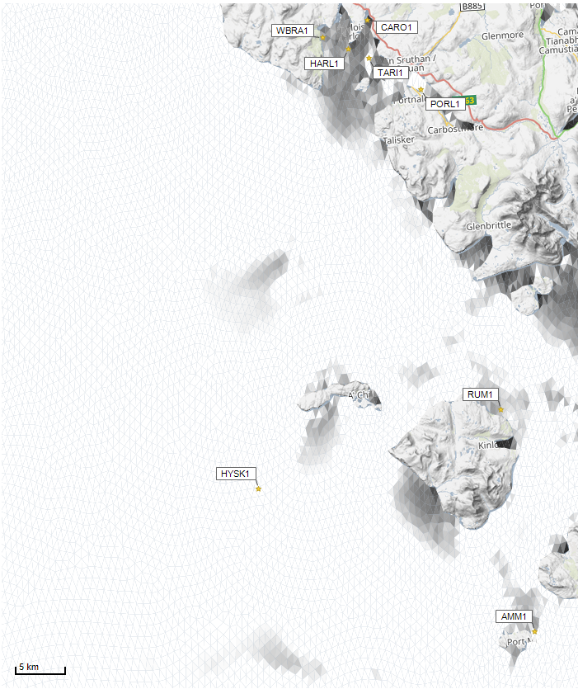



Average water speed (m/s)

©Crown copyright. All rights reserved. SEPA lic. no. 100016991 (2019).

Figure 2: Modelled average water speed (metres per second – m/s) in the sea area surrounding the proposed site (Hyskeir (HYSK1)).

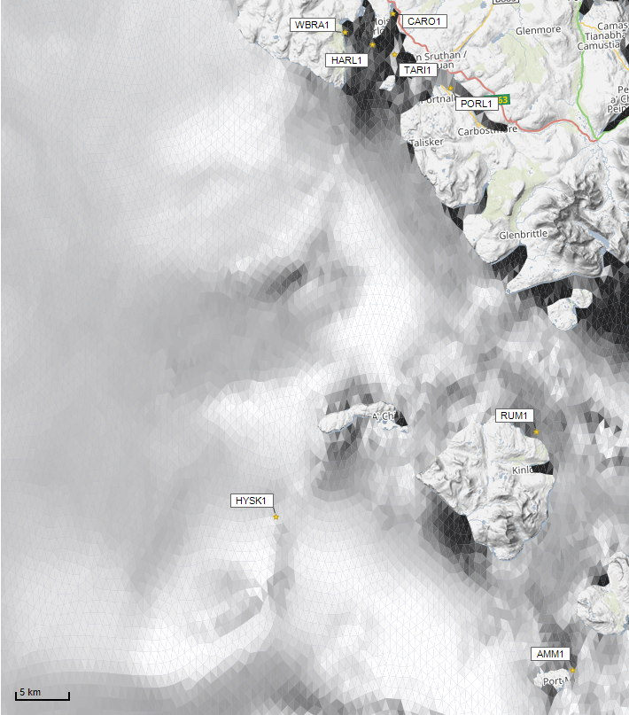

Percentage time (%)

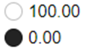

©Crown copyright. All rights reserved. SEPA lic. no. 100016991 (2019).

Figure 3: Modelled percentage of time the water flow speed is above 0.095 m/s in the sea area surrounding the proposed site (Hyskeir (HYSK1)).

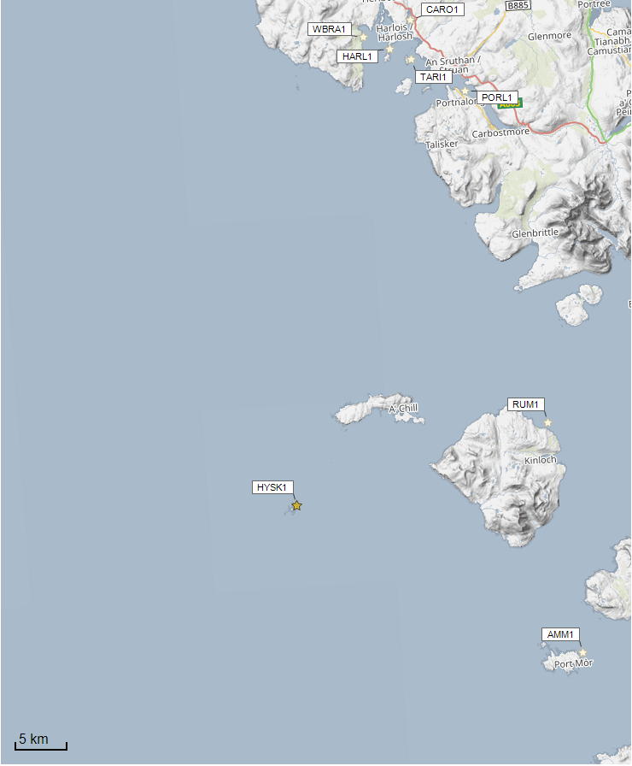Figure 4: Modelled average sediment intensity over one month for the proposed site only (Hyskeir (HYSK1)).

Sediment intensity values presented on this map are low and are presented for information only.

Sediment Intensity (g/m2)

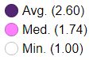

©Crown copyright. All rights reserved. SEPA lic. no. 100016991 (2019).

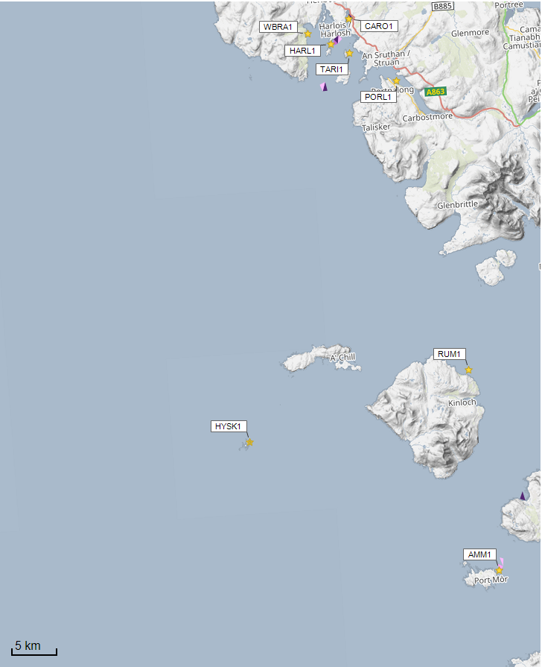

Sediment intensity values presented on this map are low and are presented for information only.

Sediment Intensity (g/m2)

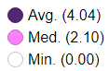

©Crown copyright. All rights reserved. SEPA lic. no. 100016991 (2019).

Figure 5: Modelled average sediment intensity over one month for the proposed site (Hyskeir (HYSK1)) and other relevant sites.

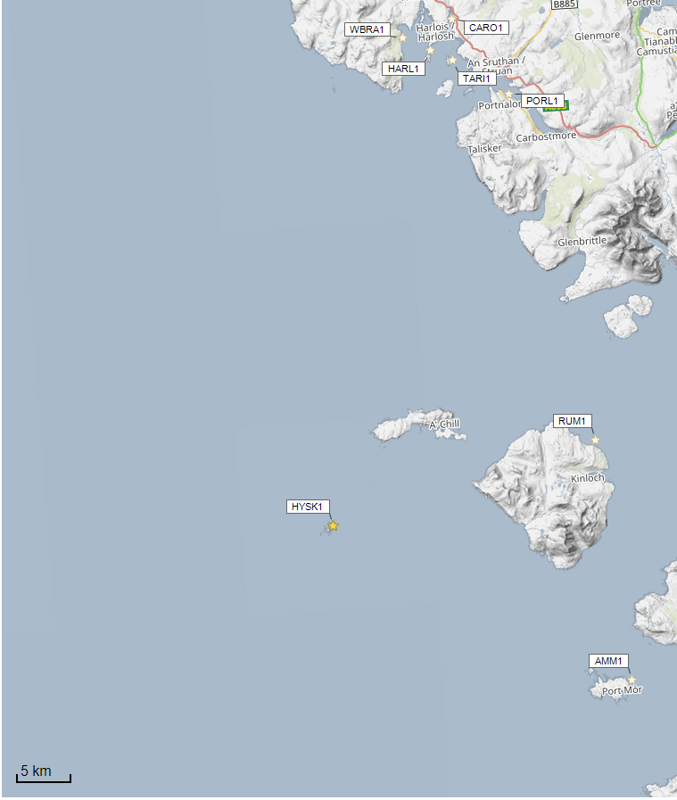

Concentrations of AZA presented on this map are less than the 40 ng/l Environmental Standard and are presented for information only.

©Crown copyright. All rights reserved. SEPA lic. no. 100016991 (2019).

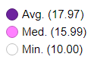

Azamethiphos Conc. (ng/l)

Figure 6: Modelled average Azamethiphos concentration over four days from neap tide release for the proposed site only (Hyskeir (HYSK1)).

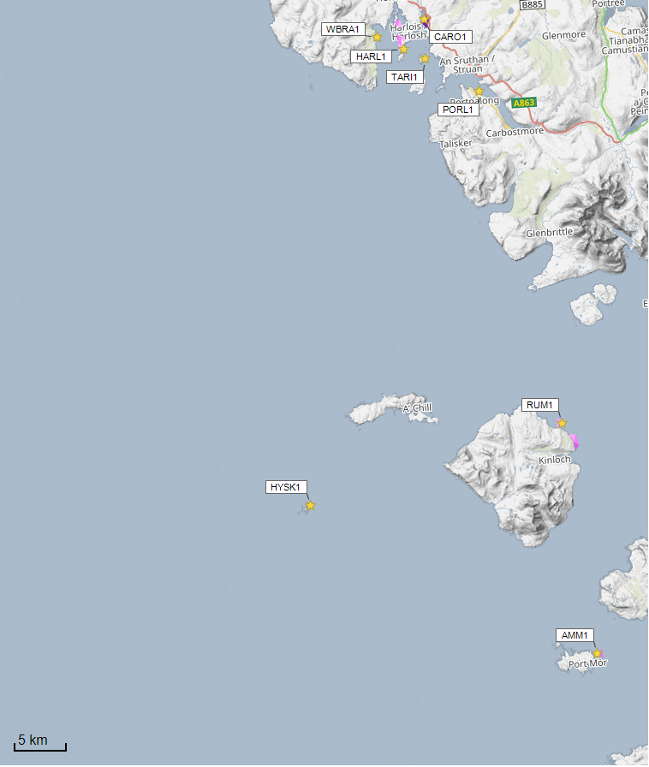

Azamethiphos Conc. (ng/l)

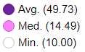

Concentrations of AZA presented on this map are generally less than the 40 ng/l Environmental Standard and are presented for information only.

©Crown copyright. All rights reserved. SEPA lic. no. 100016991 (2019).

Figure 7: Modelled average Azamethiphos concentration over four days from neap tide release for the proposed site (Hyskeir (HYSK1)) and other relevant sites.

## Sea Lice Screening

Sea lice screening was carried out using our standard method with the translated Scottish Shelf ECLH (East Coast Lewis & Harris) sub area model. This method is outlined in in Appendix 4 of the May 2023 second consultation document: [Managing interactions between sea lice from finfish farms and wild salmonids, Proposed new regulatory framework, May 2023.](https://consultation.sepa.org.uk/regulatory-services/detailed-proposals-for-protecting-wild-salmon/)

### Modelled Sea Lice Concentration Map – HYSK1

Figure 8 shows a map of the average modelled lice concentration over the simulated April and May period (in lice/m2) within the top two meters of the sea area. Model grid cells (triangles) are coloured according to the amount of sea lice particles within them.

#### Indicative Influence

The map serves as an indicative influence under average tidal and weather conditions. The focus is on areas of potential high influence for further fish track analysis within WSPZs.

#### Exclusion of Low Concentrations

Any grid cells with concentrations below 0.01 lice/m² are not shown on the map. This exclusion helps focus on more influential concentrations on the fish track analysis and WSPZs. However, these concentrations are not excluded from fish track exposure analysis below.

#### Colour Intensity, 90th Percentile and Median Concentrations

The more intense the colour in the grid cells, the closer the concentration is to the 90th percentile of all concentrations within the model cells. This brings attention to areas of higher modelled influence. The 90th percentile of sea lice concentrations is 0.01 lice/m², meaning that 90% of the concentrations are below this value. At baseline (before the introduction of the proposed site), the average 90th percentile concentration across modelled sites was 0.04 lice/m². The median concentration is 0.01 lice/m², suggesting that half of the values are below this number. Note, the median and 90th percentile are not identical, the values are quoted to two decimal places.

Figure 8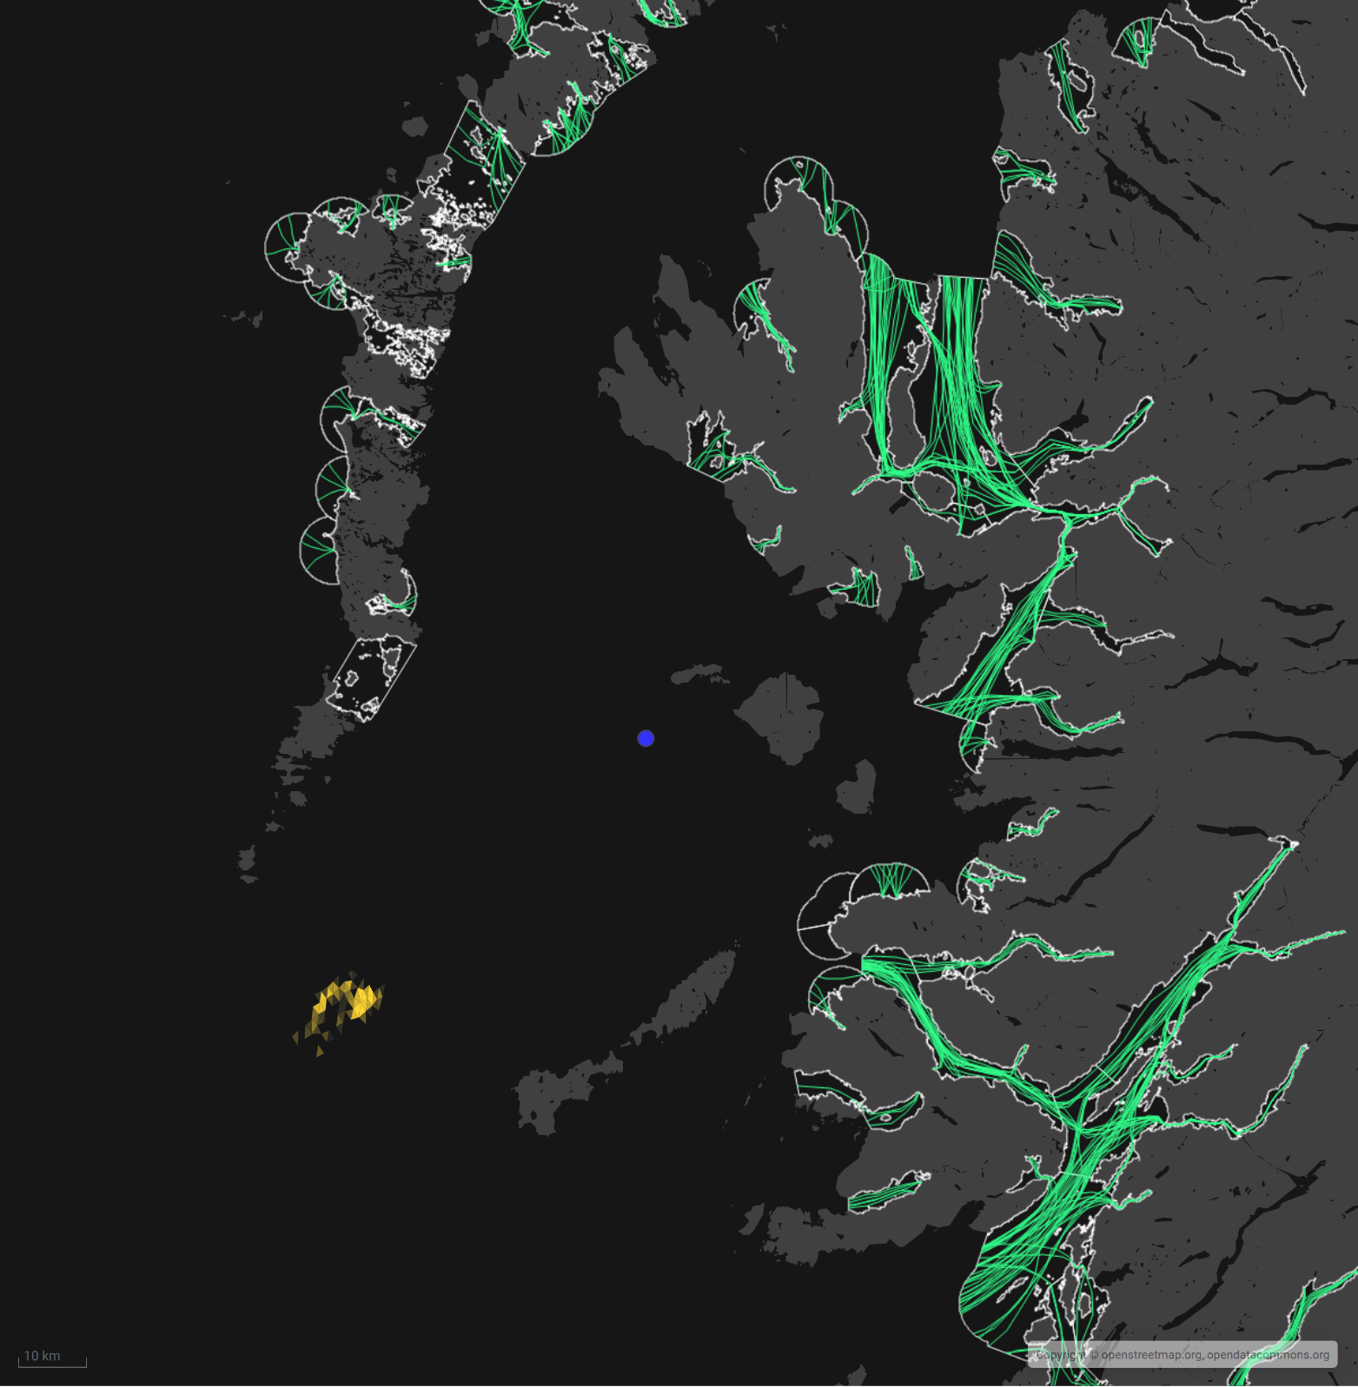: Map of the average modelled lice concentration over the simulated April and May period (in lice/m2) within the top two meters of the sea area. HYSK1 site location shown as a blue circle. Fish tracks are shown as green lines with the WSPZs, which are highlighted by a white boundary.

Sea Lice Conc. (lice/m2)



90th %ile (0.01)

Min. (0.01)

### Modelled Sea Lice Concentrations – Single Site Influence on Exposure – HYSK1

Table 3 shows information relating to the influence of modelled lice concentrations, from HYSK1 alone, on fish track exposure levels within the relevant WSPZs.

Table 3: Influence of modelled sea lice from HYSK1 on exposure in the relevant affected WSPZs.

| **Wild Salmon Protection Zone (WSPZ)** | **95th %ile of Fish Track Exposure (lice/m2 days)** | **% of Exposure Threshold (0.7 lice/m2 days)** |
| --- | --- | --- |
| None | 0 | 0 |

#### WSPZ Influence

No WSPZs are influenced above 0.01 lice/m^2 days. Five other WSPZs are influenced to an extremely low degree. Exclusion of these from the table brings focus on the areas of highest influence. However, these influences are included in the combined exposure analysis below.

#### Exposure Threshold

The percentage of the exposure threshold is shown to illustrate the scale of a single site influence. The exposure influence of all sites is not simply the sum of the individual site percentages. The overlapping influence of all sites on modelled screening exposure is shown below.

#### Assessment Matrix

An assessment matrix is presented on page 57 of the SEPA December 2023 response to consultation feedback: Managing interactions between sea lice from finfish farms and wild salmonids, SEPA response to [consultation feedback](https://consultation.sepa.org.uk/regulatory-services/detailed-proposals-for-protecting-wild-salmon/), December 2023.

Using the fish track exposure method, we establish the location of HYSK1 within the assessment matrix framework of WSPZ screening capacity and site contribution. To assess the capacity influence, we take the WSPZ which experiences the greatest influence, in this case there is no material increase in any WSPZ. Table 4 shows that HYSK1 lies within cell A1 (Negligible, Large), the lowest influence possible.

Table 4: Location of HYSK1 within the assessment matrix framework of WSPZ capacity and site contribution.

| **Contribution to infective-stage sea lice exposure** | **Remaining available capacity in WSPZ** | | |
| --- | --- | --- | --- |
| **Large (1)** | **Intermediate (2)** | **Little or none (3)** |
| **Negligible (A)** | A1 **HYSK1** | A2 | A3 |
| **Small (B)** | B1 | B2 | B3 |
| **Moderate (C)** | C1 | C2 | C3 |
| **Substantial (D)** | D1 | D2 | D3 |
| **Table Cell Colour Key (Permit conditions controlling on farm sea lice levels (19th March to 31st May)** | | | |
| A1 to A3, B1 to B2, C1 | No sea lice limit conditions. | | |
| B3, C2, D1 | Sea lice limits proposed by the developer and used in the screening assessment. | | |
| C3, D2 | Sea lice limits derived from an appropriate modelling assessment demonstrating that the farm will not compromise achievement of the sea lice exposure threshold. | | |
| D3 | Sea lice limits derived from an appropriate modelling assessment demonstrating that the farm will not compromise achievement of the sea lice exposure threshold. | | |

### Combined Influence of HYSK1 on all Wild Salmon Protection Zones

Using the fish track exposure method, we can calculate the latest combined influence of all sources on the exposure threshold within all WSPZs, including the proposed at the time of its submission. HYSK1 does not appear to a have a material effect on exposure within any nearby WPSZs. HYSK1 has reduced the screening capacity in several remote WSPZs but to a very small degree.

## Risk Identification

The screening modelling output summarised in section 2 is compared against available information on features of interest (see section 1.1.2). Features which require attention are presented with any additional comments. Identified features will need to be considered during the pre-application phase.

These should be addressed in the applicant “Method Statement”. Please refer to the [Modelling Method Statement section](https://www.sepa.org.uk/regulations/water/aquaculture/pre-application/) on the SEPA Website.

### Identified features which require attention

#### Table of identified features

Based on screening output the following features of interest have been identified.

Table 5: Table of identified features

|  |  |  |  |  |
| --- | --- | --- | --- | --- |
|  | **Feature Name** | **Feature Type** | **Location (Easting, Northing)** | **Brief Reason for Identification** |
| 1 | Small Isles MPA | Protected features of MPA are:  Horse mussel beds  White cluster anemone  Burrowed mud  Fan mussel  Northern sea fan and sponge communities  Northern feather star aggregations on mixed substrata | Shapefile 1 (Figure 8)  116267 796528  118334 794497  118334 794497  118334 794497  118300 794430  118275 794375 | At risk from sediment and or bath influence |
| 2 | Kelp beds | PMF | 116013 796618  115970 796791  115946 796780 | At risk from baths influence |
| 4 | Hyskeir | Oigh-sgeir and Garbh Sgeir designated common and grey seal haul out | 115624 797189  116584 796582  115651 795105  114691 795712  (corner points of protected feature) | At risk from baths influence |

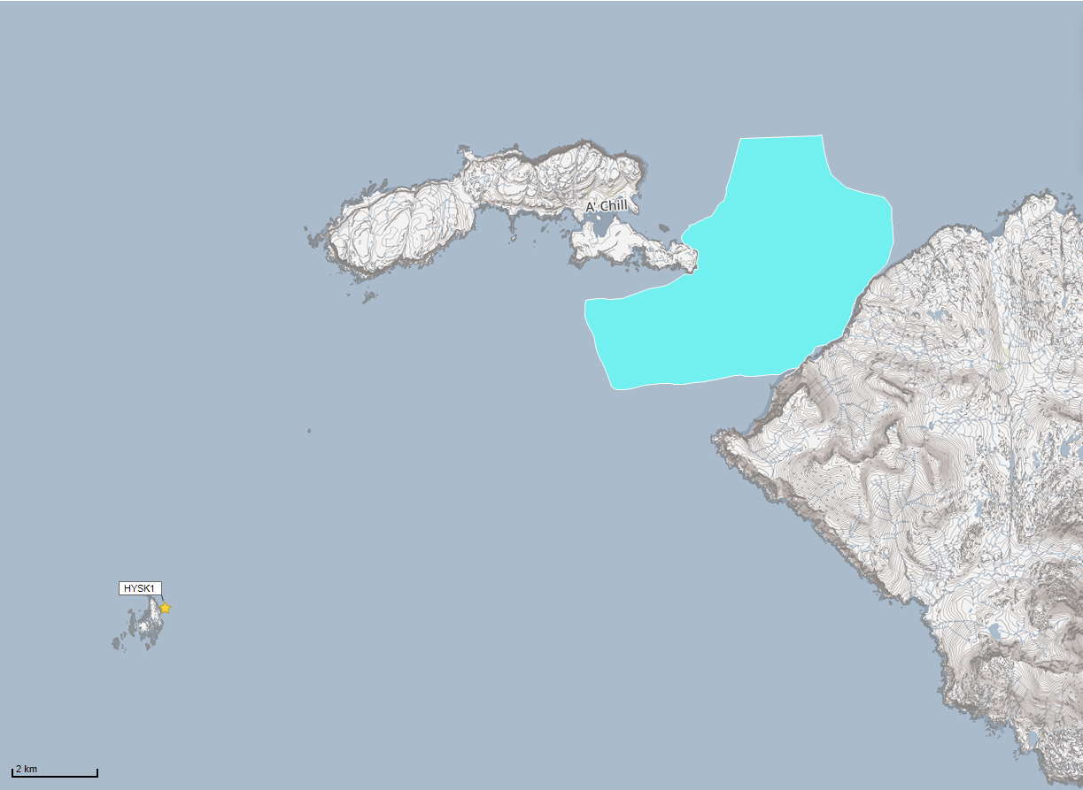

Sensitive Features Shapefiles:



1.

©Crown copyright. All rights reserved. SEPA lic. no. 100016991 (2019).

Figure . Identified sensitive PMFs (found within the Small Isles MPA).

©Crown copyright. All rights reserved. SEPA lic. no. 100016991 (2019).Q

Figure . Identified sensitive features (in addition to those in Figure 8)

### Additional comments on identified features

Whilst screening modelling does not predict any significant sediment influence from Hyskeir (HYSK1), this site is within the Small Isles MPA. SEPA has the responsibility of ensuring the proposed site is not capable of hindering the achievement of the conservation objectives of a MPA by significantly affecting any of the protected features. Therefore, combined with the large, proposed tonnage and the relatively low screening model resolution in this area, this means higher resolution marine modelling of sediment will be required to ensure the risk to the wider environment is low.

Baseline surveys will be required to assess the extent of protected features in the immediate vicinity of the proposed site. We recommend detailed plans be submitted to SEPA (and NatureScot where applicable) to ensure that sufficient coverage is provided. It is recommended that visual work is completed before any grab sampling to minimise any potential damage to any protected features.

This site also falls within the Hyskeir designated common and grey seal haul out protecting these species all year round. The use of chemicals within this designated site will require further investigation to determine any likely impacts on protected species along with issues of disturbance highlighted by NatureScot.

The conservative nature of the simple BathAuto model in areas of high current speeds, and large proposed tonnage, means quantities of bath medicines may be limited to impractical amounts for this site. Use of marine modelling of bath influence will enable more realistic bath medicine treatment quantities to be determined.

Particular focus should be on the identified features. Due to the dispersive nature of this area, discharges of sediment from AMM1 and RUM1 will need to be included in the sediment modelling to determine the combined risk on these features. However, neither cumulative modelling of baths, nor dye/drogue calibration will be required.

### Risks identified from contextual site data

Should this application proceed, the total authorised biomass under CAR in this area would be 13994t.

Table 6: Table of licenced biomass from farms identified as likely to add to cumulative risks.

| **Site Name** | **Location (Easting, Northing)** | **Biomass (Tonnes)** | **Last Production Cycle** |
| --- | --- | --- | --- |
| HYSK1 | 116180, 796557 | 3000 | Proposed |
| AMM1 | 143201, 780365 | 4069 | Pending Biomass  Currently Active Biomass 3500t  Currently Stocked (since Oct 2023) |
| CARO1 | 130300, 842800 | 275 | Not stocked since records began (2002) |
| HARL1 | 128200, 840100 | 300 | Not stocked since records began (2002) |
| PORL1 | 135170, 835570 | 2000 | Fish last on site Aug 23 |
| RUM1 | 141171, 802939 | 2850 | Pending Biomass  Currently Active Biomass 2500t  Currently Stocked (since Oct 2023) |
| TARI1 | 130182, 839007 | 500 | Fish last on site Feb 07 |
| WBRA1 | 125715, 841421 | 1000 | Fish last on site May 07 |

## 

## Conclusions of screening modelling and risk identification

Following screening modelling and risk identification we make a number of conclusions and recommendations.

### Conclusions

#### Screening Modelling

* According to screening modelling, the proposed site (Hyskeir (HYSK1)) is in an area of high dispersion and has a relatively high capacity for erosion of material on the seabed.
* From sediment and bath treatment modelling:
  + - Information presented in section 2 indicates that the relative influence of Hyskeir (HYSK1) is likely to be lower than other sites for a similar tonnage.
    - The influence on the surrounding sea area from Hyskeir (HYSK1) is likely to be low.
    - The areas of influence from Hyskeir (HYSK1), and other sites modelled do not appear to interact.
    - It is likely that discharges of bath medicines from Hyskeir (HYSK1) will be dispersed to low levels over a large area.
    - Hyskeir (HYSK1) is likely to result in a small increase in the total influence of all sites modelled. This is mostly separate from areas of influence generated by existing sites.
* Due to the relatively high dispersion nature of the waters surrounding the site, nutrient discharges from Hyskeir (HYSK1) are unlikely to have a strong influence on the surrounding sea area.

#### Sea Lice Screening Modelling

Detailed information has been provided in the section called Sea Lice Screening, above.

* Sea lice screening was carried out using our standard method with the translated Scottish Shelf ECLH (East Coast Lewis &Harris) sub area model.
* The outcome of current screening is that this site will not require a lice permit condition. No further modelling work is required, at this time.

#### Risk identification

Although the modelled influence from Hyskeir (HYSK1) appears to be low, the large tonnage proposed and its location within the Small Isles MPA, means the risk to the wider environment from sediment influence needs to be assessed using further detailed marine modelling. Given the predicted low risk from screening, a 2D model will suffice.

The conservative nature of the simple BathAuto model in areas of high current speeds, means quantities of bath medicines may be limited to impractical amounts for this site. Use of marine modelling of bath influence will enable more realistic bath medicine treatment quantities to be determined. Cumulative modelling including AMM1 and RUM1 will be required for solids but not for baths.

### Recommendations

#### Site suitability

Consideration of screening modelling and risk identification suggests that it is possible that discharges from the proposed site will be able to comply with the relevant aspects of the SEPA Aquaculture Regulatory Framework. This must be demonstrated with a detailed marine model.

It is also possible that the site will be able to comply with our mixing zone regulatory framework. This will need to be demonstrated using the NewDepomod model.

The proposed site lies within the Small Isles MPA. Features at risk, identified at this stage, should be examined using a detailed marine model.

Following the engagement meeting(s), this report will be revised, and this should allow to the applicant to submit a method statement which address the issues raised in this document.

#### Further modelling

* Due to the risks associated with the large tonnage proposed at this site, and the overly conservative nature of BathAuto at sites with high current speeds, 2D marine modelling of sediment and bath medicine plumes should be carried out.
* The size of the marine model should include discharges from all sites identified in this report. Cumulative modelling including AMM1 and RUM1 will be required for solids, but not baths.
* The resolution of the marine model should be relatively fine around the proposed site and identified features at risk.
* This marine modelling will also help with the calibration of NewDepomod, should this site wish to expand in the future. Due to the very high dispersion at this site, calibration of marine modelling with dye/drogue data is not required.
* NewDepomod modelling must be undertaken for the proposed site. It is strongly recommended that default NewDepomod modelling is undertaken prior to any marine modelling, to ensure the local impacts of the proposed biomass are acceptable.
* Sea lice screening has been undertaken for this proposed site and has shown no material effect on the exposure risk. Therefore, no further modelling or permit conditions will be required for this site.

## References

[1] [Pre-application | Scottish Environment Protection Agency (SEPA)](https://www.sepa.org.uk/regulations/water/aquaculture/pre-application/) (Hydrographic Data Guidance for Aquaculture, New Depomod Modelling Guidance, Marine Modelling Guidance for Aquaculture Applications).

[2] [The wider domain Scottish Shelf Model](http://marine.gov.scot/information/wider-domain-scottish-shelf-model).

## Appendices – Responses to pre-app consultation.

For the avoidance of doubt the SEPA Aquaculture Modelling Screening & Risk Identification report has been assessed on the number of marine pens and biomass proposed to SEPA for the purposes of application for authorisation under the Water Environment (Controlled Activities) (Scotland) Regulations 2011.

The number of marine pens and biomass included in the application to the local authority for planning permission may be different.

**As part of the consenting task group pre-application pilot process the stakeholder responses to pre-application information have been submitted without seeing the SEPA modelling and risk identification report. Therefore some comments from stakeholders may seem to contradict, cross-over or raise potential issues already highlighted by SEPA.**

**The next phase of the pre-application pilot process will ensure that stakeholders have a draft copy of SEPA’s report in order to help inform their comments.**

### Appendix 1 – Highland Council, Planning Department

#### Description of Proposal and Summary of Key Points

This is a proposal for a 3000T+ fish farm consisting of 5 x 200m circumference cages off the eastern shore of the small rocky island of Hyskeir some 16 km due west of the western coast of the Isle of Rùm. Based on the information submitted it is likely that a case officer recommendation for approval could be made. However the site is within an area of significant nature conservation designations and protected habitats and any application will need to show that the farm can be installed and operated in the long term without harm to these qualifying interests.

You are advised that the following consent(s) will be required for the proposed development:

* Planning Permission

#### Planning History

 None apparent

#### Planning Policy

National Planning Framework 4 (NPF4) (2023):

Policy 1 - Tackling the Climate and Nature Crises

Policy 2 - Climate Mitigation and Adaptation

Policy 3 - Biodiversity

Policy 4 - Natural Places

Policy 25 - Community Wealth Building

Policy 29 - Rural Development

Policy 32 - Aquaculture

Highland-wide Local Development Plan (HwLDP) (2012):

28 - Sustainable Design

29 - Design Quality & Place-making

36 - Development in the Wider Countryside

50 - Aquaculture

57 - Natural, Built & Cultural Heritage

58 - Protected Species

59 - Other important Species

60 - Other Importance Habitats

61 - Landscape

72 – Pollution

#### West Highland and Islands Local Development Plan (WestPlan) (2019)

No specific policies

#### Highland Council Supplementary Guidance

Aquaculture

Biodiversity Enhancement Planning Guidance (May 2024)

Highland's Statutorily Protected Species (March 2013)

### Assessment

**Policy Position**

The proposal is likely to gain solid ‘in principle’ support from the most relevant development plan policies – NPF4 Policy 32 Aquaculture (+ HwLDP Policy 50). Policy 32 is heavily caveated in respect of impacts upon marine biology, of course, and this ties in with the thrust of Policies 1 and 3 in terms of addressing the nature crisis and the need for biodiversity enhancement. Further advice from SEPA, NatureScot and the Marine Directorate will be definitive in this respect, although it is recognised that impacts upon wild fish populations now fall within the regulatory remit of SEPA.

Siting, Design and External Appearance

The farm infrastructure is being introduced to a setting almost completely devoid of manmade physical influence. The island represents the sort of remote coastline that guidance suggests should be avoided for aquaculture development. However, the site is in such a very remote area that it has almost no potential for public amenity impact. These differing factors will have to be balanced, and apportioning weight to them will be made easier if the application is accompanied by a comprehensive LSVIA and high quality visualisations from viewpoints chosen as the most likely for the site to be seem from. It is considered probable that the pens

will be less visible against the coastline when seen from the east, less visible from north and south due to

their linear arrangement and not visible at all from the west when masked by the island itself. Significant

visual impact seems inevitable from the island itself but with very few likely receptors.

Neighbour Amenity, Noise, Lighting and Operating Hours

With almost no public amenity connectivity, these issues of amenity impact will be given very little weight in any assessment it is suggested.

Community Wealth Building

To the extent that there are negative amenity impacts on the local population and community, this new concept in NPF4 offers the prospect of ‘off-setting’ harm against other positive impacts on the community as a whole. As examples of what might be taken into account it states, *“…This could include for example improving community resilience and reducing inequalities; increasing spending within communities; ensuring the use of local supply chains and services; local job creation; supporting community led proposals, including creation of new local firms and enabling community led ownership of buildings and assets…”*.

Although it is difficult to make a connection between this site and a ‘local’ community, any application should still embrace this new emphasis on the advantages of the development and include a range of possible positive outcomes from the farm. This might be relevant to whatever community provides a shore base for this farm.

Protected Species and Biodiversity Enhancement

The response from NatureScot flags up the large number of protected species and habitats in the local terrestrial and marine environments;

Canna and Sanday Special Protection Area & Rum Special Protection Area (SPA)

Inner Hebrides and the Minches Special Area of Conservation (SAC)

Gannet SPAs

Small Isles Nature Conservation Marine Protected Area (NC MPA)

Sea of the Hebrides Nature Conservation Marine Protected Area (NC MPA)

The Oigh-sgeir and Garbh Sgeir designated common and grey seal haul outs

Benthic PMFs

The potential for disturbance and entanglement are the main issues identified. Equipment and net design and operational practices will need to be detailed in any application to show how such negative interactions can be minimised. Biosecurity measures to avoid the introduction of invasive species will also be necessary. In respect of sea-lice and wild fish interactions, SEPA are likely to be the lead regulator in respect of their new risk assessment framework. It appears unlikely that an EMP of the type recommended in Marine Directorate’s response will be required at this site given likely timescales for development. SEPA may introduce their own wild fish monitoring proposals in the future. The planning authority is more likely to focus upon proposals for biodiversity enhancement. Again, this is a new NPF4 concept although not a new concept in its own right. Identification of negative biodiversity impacts associated with the proposal will help to characterise concomitant potential enhancements. Further guidance may be available by the time any application is made. Riparian wild salmonid breeding habitat improvements are a possibility – perhaps in respect of Rùm rivers rather than Hyskeir itself. The Skye Rivers Trust may be able to assist in this regard.

Navigation Risk Assessment

Both the Northern Lighthouse Board and the Maritime and Coastguard Agency have suggested that any application should be accompanied by a Navigation Risk Assessment.

Environmental Impact Assessment (EIA)

Given the remoteness of the site and the number of sensitive ecological considerations in the vicinity of the site it seems likely that the project will be considered EIA development. In this regard an EIA Screening request should be made at the earliest opportunity so that this matter can be formally determined before any follow-on work is started. The authority is aware that the requirements of EIA in the context of aquaculture developments is currently under discussion at government level.

Consultees For Any Future Application

The following will likely be consulted on any planning application submitted. On occasion it may be necessary to involve consultees who are not listed below as an application progresses.

Highland Council Consultees:

Environmental Health

External Consultees:

SEPA

Marine Directorate

NatureScot

Northern Lighthouse Board/Maritime and Coastguard Agency

Skye and Lochalsh Rivers Trust

Additional Information Required For Any Future Application

Based on the information provided, you are advised to submit the following additional information with any future application for formal permission. If you choose not to follow our advice and do not submit one or more of the documents, then you should provide a clear justification for doing so.

Noise Impact Assessment

Making a Formal Application via eDevelopment.scot

[Online application Forms and Guidance:](https://www.eplanning.scot/ePlanningClient/default.aspx)

Disclaimer

This advice is based on the information submitted and is given without prejudice to the future consideration of and decision on any application received by The Highland Council. Pre-application case files are not publicly available but can be the subject of Freedom of Information and Environmental Information Regulations requests.

### Appendix 2 – Nature.Scot

Please find below our advice regarding the proposed new marine finfish site to the east of Hyskeir, initially proposing 5 x 200m circumference pens, with biomass to be confirmed but expected to be approximately 3000T.

### Initial response received 29/03/24

Please note that our advice will come in two separate responses. This is due to a tight time window for bird surveys and we wanted to get this information to you early.

#### Seal Haul Out

The proposal is immediately adjacent to a large mixed seal haul out. Common seals haul out closest to the development site, and would be within disturbance distance. **This is a potential show stopper due to potential disturbance and predator protection issues.** We will provide more details in our full pre-app response, but please note that advice will also need to be sought from Marine Directorate as they lead on Designated seal haul out sites.

#### Small Isles NC MPA

The proposal is located within the Small Isles NC MPA which is designated for Black guillemot amongst other features.

Unfortunately, we do not hold detailed data for this area and we therefore advise that **Black guillemot surveys are required.** This should cover a minimum of one full breeding season and one wintering season (the latter, assuming there is potential for overlap with farm activity initially or in the future), including covering the area impacted by vessel movements. The survey methodology **should include a complete pre-breeding count (during first three weeks of April), as per methods described in the**[**Seabird Monitoring Handbook**](https://eur01.safelinks.protection.outlook.com/?url=https%3A%2F%2Fdata.jncc.gov.uk%2Fdata%2Fbf4516ad-ecde-4831-a2cb-d10d89128497%2Fseabird-monitoring-handbook.pdf&data=05%7C02%7Caquaculture.pre-app%40sepa.org.uk%7C49ba6c5d291541de08bc08dc500e3e80%7C5cf26d65cf464c72ba827577d9c2d7ab%7C0%7C0%7C638473269476537560%7CUnknown%7CTWFpbGZsb3d8eyJWIjoiMC4wLjAwMDAiLCJQIjoiV2luMzIiLCJBTiI6Ik1haWwiLCJXVCI6Mn0%3D%7C0%7C%7C%7C&sdata=dsQCbaN%2Bnn%2Bn5nYDdIfaY4PvE2sPxfjd0TdoaNqQGpY%3D&reserved=0). Whilst carrying out the Black guillemot surveys it would be expected that all bird species using the area are recorded.

Please also be aware of potential disturbance to seals, and especially pupping seals when planning surveys, should you choose to undertake them.

The habitat of the proposed fish farm area also needs to be presented in the assessment. For black guillemots, we are particularly interested in whether there is seaweed habitat in the proposed area. This may be relevant in terms of designing your benthic surveys.

### Further response received 16/04/24

#### Background

We sent an initial response on Friday 29th March 2024, focussing on the Black Guillemot feature of the Small Isles NC MPA, due to the tight time window for completing bird surveys. We also noted that the proposal’s location immediately adjacent to a large mixed seal haul out could be a potential show stopper due to potential disturbance and predator protection issues. Following discussion with the Marine Directorate, please find below updated advice regarding the designated seal haul out, and potential impacts on other Protected Areas in the locality of the proposed farm.

#### Summary

Considering all of the currently available information at this stage we advise that impacts on common and grey seals is not a potential ‘show stopper’.  However, the seal distribution data indicates a risk of disturbance to seals during sensitive periods which is coincident with Mowi’s proposed seasonal stocking/management of the site.

 In addition, there are a number of potentially significant issues/constraints that will require detailed assessment to support EIA/HRA for any future planning application.

#### Seals (and Designated seal haul out)

The entire islands of Oigh-sgeir and Garbh Sgeir and associated rocky outcrops are a designated seal haul out for harbour and grey seals, supporting hundreds of individuals of both species during August counts. Marine Directorate lead on designated seal haul outs under The Protection of Seals (Designation of Haul-out Sites) (Scotland) Act 2014.  Section 117 of The Marine Scotland Act (2010) (the Act) introduced a new offence of intentional or reckless harassment of seals at haul-out sites. [MD guidance on what would constitute harassment](https://consult.gov.scot/marine-environment/possible-designation-of-a-seal-haul-out-site/user_uploads/guidance-on-the-offence-of-harassment-at-seal-haul-out-sites.pdf-1) is available.

While Marine Directorate lead on the policy and legislative aspects, we would advise on possible effects of the proposals on seals and any mitigation.

At this stage, we know that this is a very well used haul-out but don’t know how sensitive seals using this remote site are likely to be in response to activities associated with the installation/operation of the farm.

Potential disturbance and predator management impacts on seals at this remote site require further consideration.  We advise that Mowi need to consider and/or provide the following:

* A review of available data on seal use of the haul out site relative to the location of the proposed farm.  This should consider both common and grey seal data.
* Consideration of disturbance distances for the types of activities proposed and likely sensitivity/habituation.
* Consideration of sensitive periods for both species of seals (breeding, pupping and moulting) and how these relate to periods of activity at the farm, differentiating between day to day management of the farm and periods of more intensive activity (e.g. installation/removal of equipment and stocking/harvesting). In addition, potential disturbance of seals should be taken into account when planning all surveys required to inform the proposals.
* A robust predator management plan for the fish farm.  This should consider the high level of seal activity around the site and physical exposure of the site.  We will need to be able to assess the risk of entanglement/entrapment of seals in nets etc.as well as risks to other species (e.g. diving birds, cetaceans, basking shark).  It is assumed from *Annexe 2 Mowi-Hyskeir_indicativeEquipmentPlansElevations_vF*that submerged secondary anti predator nets are not being proposed at this location, but this should be confirmed.
* Outline appropriate robust mitigation against disturbance. In principle the aim should be to maximise the distance between the farm and the haul outs. A detailed Vessel Management Plan should be provided for all types of boat activity at the site.

In order to achieve this, we would recommend Mowi seek appropriate expertise from SMRU or other similarly qualified consultants to fully evaluate the impacts on seals and how impacts will be monitored/assessed, as well as considering the guidance from MD with respect to the designated seal haul out.

#### Canna and Sanday Special Protection Area & Rum Special Protection Area (SPA)

The proposed site is approximately 6.5km from Canna and Sanday SPA, and approximately 9.25km from Rum SPA.  These distances are within the typical foraging range of all [Canna and Sanday SPA species](https://sitelink.nature.scot/site/8480) and the Kittiwake, Common guillemot and Manx shearwater protected features of [Rum SPA](https://sitelink.nature.scot/site/8574). A Habitats Regulations Appraisal (HRA) will need to be completed by the competent authority and the application will need to contain sufficient detail for the assessment.  As noted in our Top net guidance (linked below), where a fish farm is located in proximity to SPAs with Cormorant, Shag or Gull features, our advice will consider potential entanglement risk. We advise that entanglement risk in side panels for Herring gull and Shags could potentially be reduced by including smaller mesh panels in vicinity of the rails.

#### Gannet SPAs

Gannets have been recorded becoming entrapped/entangled in pole mounted top nets at fish farms in Scotland.  The foraging distance of gannets means there is connectivity with a number of SPAs (e.g. Seas off St Kilda).  Guidance on top net mesh sizes and reporting is provided in our [briefing note](https://www.nature.scot/doc/interim-technical-briefing-note-pole-mounted-top-nets-and-birds-finfish-farms). This guidance is currently being reviewed but in the meantime the interim guidance should continue to be used.

#### Inner Hebrides and the Minches Special Area of Conservation (SAC)

The study area lies within the Inner Hebrides and the Minches SAC, designated for Harbour porpoise.  A Habitats Regulations Appraisal (HRA) will need to be completed by the competent authority and the application will need to contain sufficient detail for the assessment.  [Conservation and Management Advice (CMA)](https://apps.snh.gov.uk/sitelink-api/v1/sites/10508/documents/59) for this site including the current Conservation Objectives is available

 We advise that the new farm should be designed to reduce or limit pressures including entanglement and the use of acoustic deterrent systems.  The CMA refers to ADD deployment plans, however it would be useful to establish whether ADDs are proposed at this site.  Contingency plans for recapturing any escaped farmed fish should also consider the risk of entanglement of Harbour porpoise.  We recommend excluding the use of drift nets and nets set on the seabed (tangle, trammel, gill) to avoid the risk of entanglement/bycatch of Harbour porpoise (and SPA/MPA birds).  Opportunities to reduce or limit risk of collisions and disturbance associated with boat use should also be considered.

#### Sea of the Hebrides Nature Conservation Marine Protected Area (NC MPA)

The proposal would be located within the Sea of the Hebrides NC MPA, designated for Basking shark, Minke whale, Marine Geomorphology of the Scottish Shelf Seabed (inner Hebrides Carbonate Production Area) and Fronts.

Habitat modelling of Basking sharks within the MPA highlights that the area surrounding Hyskeir may support high densities of basking shark. Risks to Basking sharks could include risk of collision, entanglement and disturbance, alongside indirect impacts such as loss of habitat through avoiding organically enriched areas.  An appropriate impact assessment on this feature may be required. General advice on mitigation is available in our [Conservation and Management Advice document](https://sitelink.nature.scot/site/10474), but our advice regarding the Harbour porpoise of the Inner Hebrides and the Minches SAC is also relevant for the Basking shark and Minke whale features of this Protected Area.

#### Small Isles Nature Conservation Marine Protected Area (NC MPA)

The proposal would be located within the [Small Isles NC MPA](https://sitelink.nature.scot/site/10422), designated for Black guillemot, a range of Inshore sublittoral marine sediments, a number of marine invertebrates and its geology and geomorphology.  Black guillemot surveys were covered in our previous advice, but Black guillemot and other birds nesting on the island are also vulnerable to the introduction or spread of non-native and invasive species (e.g. mink, rats). In addition, Black Guillemot are at risk of net entanglement.  We would therefore advise:

* A Biosecurity Plan is drafted, incorporating mitigation to prevent any biosecurity breach on vessels/at Hyskeir.
* Application of best practice, monitoring and reporting of incidences of bird entanglement
* Ensuring cage mesh sizes and tensioning are appropriate, as Black guillemots may approach the nets from the below the surface.

The protected features Burrowed Mud, Northern sea fan and sponge communities and Northern feather star aggregations on mixed substrata are located in close proximity to the site, and White cluster anemones are found within the site’s footprint and to the north west and south east of the site.  More details on what is required to assess likely impacts on benthic features can be found in the section below.

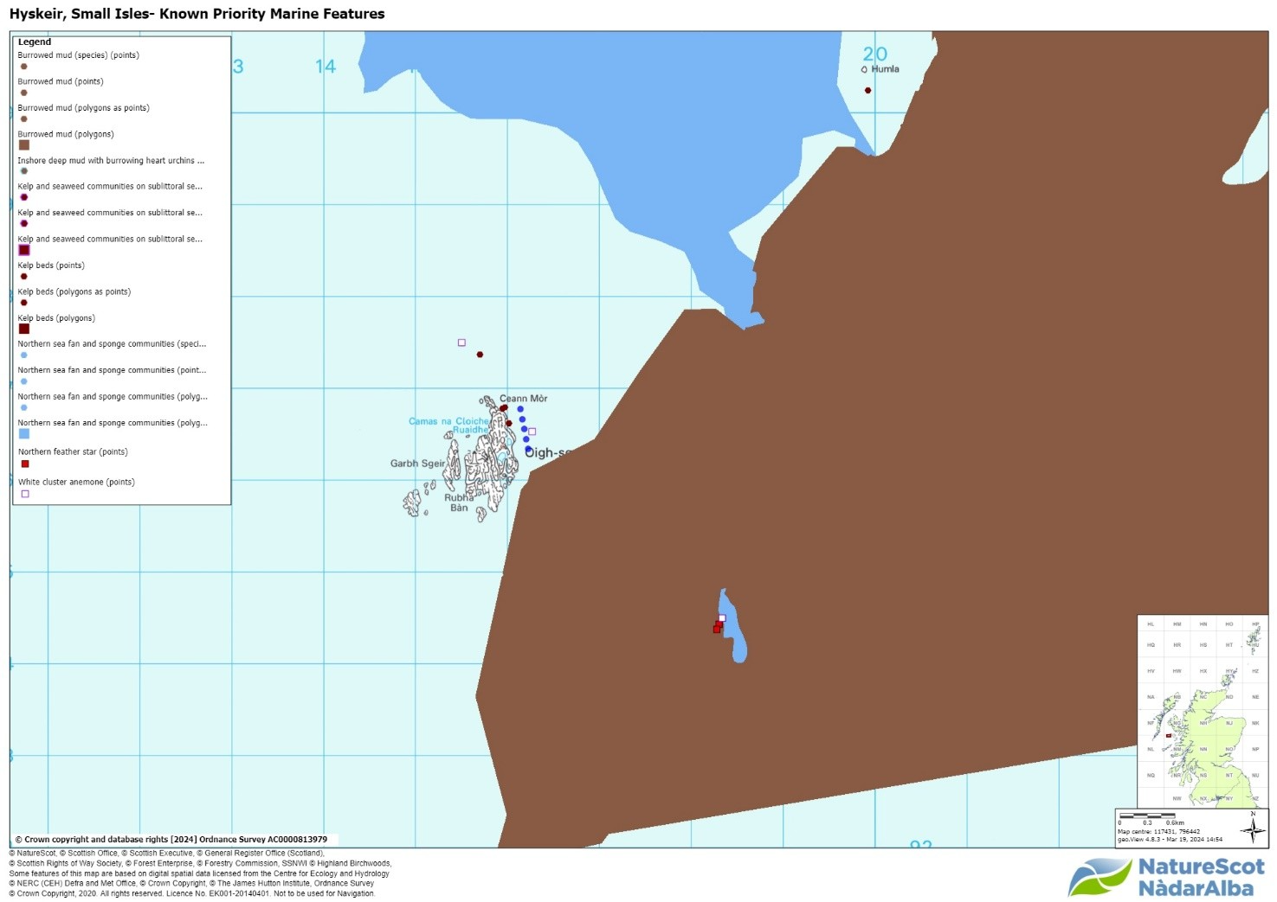

Figure 11: Figure showing known PMFs in the vicinity of Hyskeir

#### Benthic - PMFs

In addition, the proposed farm would also be in the vicinity of the following PMF features: Kelp beds and Seapens and burrowing megafauna in circalittoral fine mud.

To assess the application and its likely impacts on benthic habitats and species, we will require the following information:

* The deposition modelling report
* An appropriate seabed survey in and around the farm’s predicted area of impact which details the extent of any PMFs and MPA features and the qualification of the composition and quality of any PMFs/MPA features that will potentially be affected by the proposal e.g. assessment of density and biodiversity.
* If necessary, a description of measures to avoid, prevent, reduce, or offset significant adverse effects on PMF/ MPA habitats or species.

#### Landscape/Visual

We would defer to The Highland Council to advise on Landscape but please find below our published guidance:

* [The siting and design of aquaculture in the landscape: visual and landscape considerations](https://digital.nls.uk/pubs/e-monographs/2020/216586078.23.pdf)
* [Guidance on Landscape/Seascape Capacity for Aquaculture](https://digital.nls.uk/pubs/e-monographs/2020/216588446.23.pdf)

 Please let me know if you require any clarification.

### Final response received 05/09/2024

In relation to the request for feedback in relation to the interactions between the seal haul out and the release of bath treatments, please see the below comments.

Seals at designated haulout sites are protected under the [Protection of Seals (Designation of Haul-Out Sites) (Scotland) Order 2014](https://eur01.safelinks.protection.outlook.com/?url=https%3A%2F%2Fwww.legislation.gov.uk%2Fssi%2F2014%2F185%2Fintroduction%2Fmade&data=05%7C02%7Clucy.gregson%40sepa.org.uk%7C36561eb0c60748aad75c08dccd71f887%7C5cf26d65cf464c72ba827577d9c2d7ab%7C0%7C0%7C638611136792007503%7CUnknown%7CTWFpbGZsb3d8eyJWIjoiMC4wLjAwMDAiLCJQIjoiV2luMzIiLCJBTiI6Ik1haWwiLCJXVCI6Mn0%3D%7C0%7C%7C%7C&sdata=BS9TR4LzKu%2BGFEF2fdaeCTRlXCMhCma3wvnO%2F%2BeTWgo%3D&reserved=0). Under this Order, the only offence is one of harassment, as defined [in the Guidance](https://eur01.safelinks.protection.outlook.com/?url=https%3A%2F%2Fconsult.gov.scot%2Fmarine-environment%2Fpossible-designation-of-a-seal-haul-out-site%2Fuser_uploads%2Fguidance-on-the-offence-of-harassment-at-seal-haul-out-sites.pdf-1%23%3A~%3Atext%3DSection%2520117%2520of%2520the%2520Marine%2Cat%2520a%2520haul-out%2520site.&data=05%7C02%7Clucy.gregson%40sepa.org.uk%7C36561eb0c60748aad75c08dccd71f887%7C5cf26d65cf464c72ba827577d9c2d7ab%7C0%7C0%7C638611136792019299%7CUnknown%7CTWFpbGZsb3d8eyJWIjoiMC4wLjAwMDAiLCJQIjoiV2luMzIiLCJBTiI6Ik1haWwiLCJXVCI6Mn0%3D%7C0%7C%7C%7C&sdata=hT2HeHE2aKQuG2kWzxD4b%2By2eOeYqz69tnT4J2G3ndg%3D&reserved=0) and there are no offences relating to chemicals or other potential harms to the seals. In addition, the order only applies to areas of land above the mean low water spring tide lying within any specified area. So, chemicals in the surrounding waters will be outside the designation.

Under the Marine Scotland Act 2010, it is an offence to intentionally or recklessly kill, injure or take a live seal. The use of chemicals could potentially result in injuring or killing of a seal, in which case it could be an offence. This would be the case for any seals, not just those at/near designated haul out sites. A key consideration, in the case, is the designation of the site indicates that there is likely to be a higher density of seals here than elsewhere, so impacts may be greater. The risk of seals entering water at the haul-out may also increase the risk of exposure.

SEPA are the lead regulator, responsible for the discharge of medicines and should consider the risk to the water environment. Suitable dispersion modelling should support any decision.

If SEPA are concerned that there is a risk to seals caused by the release of medicines, it may be recommended that the developer is requested to undertake a review of the potential risk of the medicines to seals. The Sea Mammal Research Unit (SMRU) may be able to provide support.

### Appendix 3 – Marine Directorate - Licensing Operations Team (MD-LOT)

Thank you for contacting Marine Directorate – Licensing Operations Team (MD-LOT), the regulator of licensable marine activities on behalf of the Scottish Ministers under the Marine (Scotland) Act 2010. Under the Marine (Scotland) Act 2010 s. 21, it is a licensable marine activity to deposit any substance or object within the Scottish marine area, either in the sea or on or under the seabed, from any of the following (a) a vehicle, vessel, aircraft or marine structure, (b) a container floating in the sea, or (c) a structure on land constructed or adapted wholly or mainly for the purpose of depositing solids in the sea. This includes deposit of fish farm equipment.

Article 12 “Propagation and cultivation of fish – deposits” of the Marine Licensing (Exempted Activities) (Scottish Inshore Region) Order 2011 however states that the deposit of any trestle, raft, cage, pole, rope, line or within controlled waters, any substance which is liable to cause pollution of the water environment, in the course of the propagation or cultivation of fish is an exempted activity, provided that the relevant conditions are met. The conditions are that the deposit is not made for the purpose of disposal; not made for the purpose of creating, altering or maintaining an artificial reef; or that it causes or is likely to cause obstruction or danger to navigation. It is the applicant's responsibility to ensure they meet the conditions if they intend to apply the exemption to their activities.

MD-LOT does not carry out any assessments about the suitability of the location for a fish farm, nor does it assess impacts on environment, human health or legitimate uses of the sea during the pre-application stage. Any such assessments are carried out at marine licence application determination stage, if required, and rely on stakeholder consultation. A marine licence can only be granted after planning permission for the farm has been granted.

To facilitate the pilot pre-application process and to advise other relevant authorities and the developer, MD-LOT has carried out a Geographic Information System (GIS) check for sensitivities and features of interest in the vicinity of the proposed farm. The results of the GIS check are shown below and are based on the data currently available to MD-LOT. This is not an exhaustive list of all relevant sensitivities and this information alone should not be used to determine what issues the developer may need to consider during the application process. MD-LOT is providing this information to the other relevant authorities and the developer in good faith and without pre-judgement of any potential application. MD-LOT does not intend to carry out further analysis of the suitability of the proposal based on these findings.

We hope this information is helpful.

Kind regards,

Summary of GIS checks

Previously licensed sites: 0

Seal haul out sites: 1 Site Code WSC-005

Sea deposit sites: 0

Wrecks: 0

No other issues identified

### Appendix 4 – Historic Environment Scotland

New marine finfish site adjacent to Hyskeir

#### Pre-application consultation

We have received the above consultation on 12 March 2024 from the applicant under the

fish farm consenting pilots. We have reviewed the information in terms of our historic

environment interests. This covers world heritage sites, scheduled monuments and their

settings, category A-listed buildings and their settings, inventory gardens and designed

landscapes, inventory battlefields and historic marine protected areas (HMPAs).

The Highland Council’s archaeological and conservation advisors will also be able to

offer advice for their interests. This may include undesignated archaeological sites,

category B- and C-listed buildings and conservation areas.

#### Our Advice

From the current information provided we have not identified any likely significant effects

or “showstoppers” on our interests as a result of the proposals. We therefore have no

comments to make regarding the proposals.

We hope this is helpful. Please contact us if you have any questions about this

response.

### Appendix 5 – Northern Lighthouse Board

The NLB have reviewed the initial documents sent through for the plans for a Marine Fish Farm on the East of Hyskeir as attached.  As you will no doubt be aware any equipment put into the water needs to be fully considered in terms of navigational risk, for many lightly travelled inshore sites this is often relatively easy to make a determination on.  However, for this particular site we would be looking for an in-depth Navigational Risk Assessment to have been put together before we can make any formal response.  Amongst other things the NRA would need to confirm the AIS traffic data that has been used to inform the site choice.  Along with an NRA it would be useful to know what if any responses have been received from other regular users of this area.  If you can confirm if this is something that will be part of an EIA in terms of being scoped into planned work relating to this site it would be much appreciated.

Whilst it is not yet fully finalised, it may be of use for you to consult the draft guidance that is coming out from the MCA (MGN687).  This Marine Guidance Note relates to the production of an NRA for an aquaculture site.  The MCA are planning on applying this proportionately in terms of not expecting a too exhaustive NRA for a small mussel farm tucked up a voe, but given the location and nature of this site, I would suggest that this would warrant a detailed NRA to allow for formal navigational risk responses and also to allow the NLB to design an appropriate lighting and marking response should the site progress to the submission of a full planning application.

### Appendix 6 – Maritime and Coastguard Agency

The Maritime and Coastguard Agency (MCA) has received a pre-application form under the pilot scheme for a new marine finfish site adjacent to Hyskeir. The MCA has an interest in the works associated with the marine environment, and the potential impact on the safety of navigation, access to ports, harbours and marinas and any impact on our search and rescue obligations.

On this occasion, the MCA would expect the marine licence application to be accompanied by a Navigation Risk Assessment as there must be consideration of the impact on other marine users, taking account of current traffic within the area, and local consultation with those operating in the vicinity.

Essentially, the applicant would need to consider the following at Marine Licensing stage:

* what is the baseline environment there already –
  + vessel traffic information (recreational, commercial, fishing)
  + Navigations features (look at charts for features such as anchorage, water dept, cables and pipelines (base case)
  + What is then being placed into the marine environment?
* What hazards this then introduces or changes – concrete blocks, ropes and lines.
* What risks does this introduce – prop fouling, collision, allision, entanglement, grounding etc.
* What controls then need to be put in place – charting, NtM, local consulation/notification, lighting and marking agreed with NLB; and
* What is the tolerability of that residual risk.

The NRA should therefore include:

* A description of what is being deployed.
* An idea of the levels of vessel activity at the location – (AIS and local consultation)
* What consideration has been given to other marine users – e.g. do the locations impede vessels in any way and has any local consultation with other marine users taken place?
* Have they consulted the Northern Lighthouse Board with regards to the lighting and marking of the site?
* What arrangements are in place to ensure the structures stay in position for the met ocean conditions expected in the area?
* Any monitoring of the site should any components break free – recovery
* The ability to self-rescue.

The MCA is in the process for drafting a [Marine Guidance Note](https://www.gov.uk/government/consultations/consultation-on-methodology-for-assessing-navigation-safety-risk-of-aquaculture-sites) to support applicants with their NRAs. In the meantime, we would be happy to discuss further with the applicant as required.

I hope this is helpful for now.

Kind regards

### Appendix 7 – Marine Directorate – FF Planning

Pre-application request through the new consenting pilot for a potential new marine finfish site adjacent to Hyskeir by Mowi Scotland Ltd.

Scottish Government’s Marine Directorate (SGMD) (previously known as Marine Scotland) have reviewed the application submitted and offer the following comment:

Based on the limited information available, no specific showstoppers have been identified.

Should a planning application be submitted in the future, it is likely that we would request information covering the following:

#### Environmental Impacts

Benthic impacts – appropriate benthic modelling.

Water column impacts – appropriate nutrient assessment.

#### Aquaculture Animal Health

The proposed Hyskeir site located at E116181, N796557 falls out with current disease management area (DMA) boundaries and on activation will create a new DMA.

In addition to the usual information requirements, the applicant will also be required to provide;

* details of the mooring design
* details of the environmental survey undertaken detailing conditions expected to be experienced on site
* details of the infrastructure in place for handling 200m pens including details of staff knowledge and experience
* additional consideration of equipment and procedures to minimise interaction with predators, in particular seals, given the proximity to a seal colony
* due to the remote, exposed location; details should be provided on how staff will access, service and monitor the site, including information on any shorebase proposed or remote technologies. This should also include details of how visitors such as the FHI or veterinarians will access the site.
* the impact of the remote/high energy location on routine operations (e.g. husbandry, mortality removal, sea lice monitoring, treatments) should also be considered and details provided

As further details of the proposal are confirmed, more specific information may be required.

#### Wild Fisheries

The proposed site has the potential to adversely affect local sea trout populations. Therefore an Environment Management Plan will be requested. The applicant will note that from March 2025 SEPA expect to implement an adaptive approach to manage interactions between sea lice from fish farms and sea trout. An option here is to include an appropriate review date for the EMP that allows for its removal in favour of including the site in the national framework on its implementation.

Sea lice efficacy – sea lice efficacy statement / appropriate chemotherapeutant modelling.

#### Notes to applicants:

The Aquatic Animal Health (Scotland) Regulations 2009 requires the authorisation of all Aquaculture Production Businesses (APB's) in relation to animal health requirements for aquaculture animals and products thereof, and on the prevention and control of certain diseases in aquatic animals.  The authorisation procedure is undertaken on behalf of the Scottish Ministers by the Fish Health Inspectorate (FHI) at the Marine Directorate Marine Laboratory.  To apply for authorisation for an APB or to amend details of an existing APB or any site that an APB is authorised to operate at, you are advised to contact the FHI as follows:  Fish Health Inspectorate, Marine Directorate Marine Laboratory, 375 Victoria Road, Aberdeen, AB11 9DB.  Tel: 0131 244 3498;  Email:  [ms.fishhealth@gov.scot](mailto:ms.fishhealth@gov.scot)

All marine farms, whether finfish, shellfish or algal, are required to apply for a marine licence under Part 4 of the Marine (Scotland) Act 2010. To apply for a marine licence, or to amend details of an existing marine licence (formally Coast Protection Act 1949 – Section 34 consent), please visit the [Scottish Government’s website](http://www.scotland.gov.uk/Topics/marine/Licensing/marine/Applications) where application forms and guidance can be found. Alternatively you can contact the Marine Directorate Licensing Operations Team (MD-LOT) by emailing [MS.MarineLicensing@gov.scot](mailto:MS.MarineLicensing@gov.scot); or calling 0300 244 5046.

Yours sincerely

Marine Directorate of the Scottish Government

### Appendix 8 – Skye and Lochalsh Rivers Trust (in absence of DSFB)

#### Re: Hyskeir Pre Application Response

Dear Mowi Scotland Environment Team,

Thank you for the opportunity to comment on the pre-application stage of a potential future salmon farm site on the Isle of Hyskeir.

I have looked over the proposed site drawings and equipment designs and have some concerns that I hope you will be able to address in your Environmental Impact Assessment.

After an initial desktop assessment of the island and its history, it is unlikely that there is a substantial amount of salmonid habitat available in any freshwater systems on Hyskeir, however we would ask that a fish survey be conducted to confirm the presence or absence of wild salmonids. SLRT would be happy to discuss the logistics of this survey further. If there are no salmonids present, there is little risk of a salmon farm negatively impacting on populations of wild fish in the immediate vicinity, which is a positive aspect of this proposed location.

However, migrating salmonids passing through the area from the nearby Small Isles and the mainland coastline could still be impacted by the development of a 3000-tonne site on Hyskeir. My main concerns about this site location are outlined below.

Firstly, could you please provide information regarding sea lice dispersal from the site and how increased lice levels emanating from the cages will impact lice densities in the surrounding water column? Please also provide information about changes in cumulative sea lice densities when taking into account the surrounding farms in the Small Isles and any relevant mainland sites that could be contributing to the accumulation of lice around the Small Isles and the southern coast of Skye.

Secondly, what precautions are being taken to achieve a zero-escapee standard with the new 200m cages? SLRT is concerned about the risk of genetic introgression between farmed salmon and native salmonid populations and there is a possibility that any escaped farmed fish could contribute to this problem in rivers in the Lochaber and Skye areas.

Finally, what additional infrastructure will be put into place to ensure that staff and appropriate equipment are available to manage the 200m cages proposed at this site? This is the largest net circumference used in the SLRT area and is substantially larger than the existing 160m cages at many other Mowi sites. How will the increase in cage size impact the amount of time it takes to deliver sea lice treatments to all cages? Will specialist equipment be needed to handle the nets and deliver treatments to fish on site? If a special boat and staff are required to deliver treatments or maintain the nets, what protocols are in place to ensure that the problems are resolved quickly given the remote location of the site? If lice levels are left untreated for extended periods of time because treatment boats are not nearby, it could result in high

cumulative lice densities in migration zones of salmon or sea trout and ultimately leave to harmful lice burdens on wild fish.

SLRT would like to continue to engage with the planning process for this proposed site and we are happy to discuss our concerns further with your team. We look forward to seeing your EIA.

Kind regards,

For information on accessing this document in an alternative format or language, please contact SEPA by emailing [equalities@sepa.org.uk](mailto:equalities@sepa.org.uk)

If you are a user of British Sign Language (BSL), the Contact Scotland BSL service gives you access to an online interpreter, enabling you to communicate with us using sign language. [contactscotland-bsl.org](http://contactscotland-bsl.org/)