

**WAS-G-11**

**SEPA Guidance: Materials Facility Return Form**

Version 1.0 - April 2025

Contents

Aim of this guidance 2

Defined terms 2

Completing your data return 3

Submitting returns 3

Entering data in the form 4

Summary of the returns form 5

Cover page 6

Waste suppliers 8

Waste destinations 10

Input samples 11

Waste received 16

Output samples 18

Specified output 22

Waste removed 23

How we use your information 26

Further help with your materials facility return form 26

Disclaimer 26

If you would like this document in an accessible format, such as large print, audio recording or braille, please contact SEPA by emailing [equalities@sepa.org.uk](mailto:equalities@sepa.org.uk)

# Aim of this guidance

This guidance provides advice for anyone who requires to report data to SEPA under the [Scottish Government’s Code of Practice on Sampling and Reporting at Materials Facilities (“the Code”)](https://www.gov.scot/publications/code-practice-sampling-reporting-materials-facilities-june-2024/documents/). If you operate a material facility in England, Wales or Northern Ireland you must comply with the regulations or codes of practice in that country.

The Code replaces the 2015 Code of Practice on Sampling and Reporting at Materials Recovery Facilities (“the 2015 Code”). From 1st April 2025, the 2015 Code, associated data return form and all accompanying guidance will be obsolete.

This guidance is intended to assist you with the interpretation of the Code and should be read in conjunction with the Code which, in the event of any conflict, supersedes the information provided in this guidance.

The term MF is used to refer to in-scope material facilities throughout this document. The definition of material facility is set out in the Code.

This guidance is designed to help you complete SEPA’s Data Return Form for Sampling and Reporting at MFs (Material Facility Return Form), and details:

* What you need to report to SEPA.
* How to complete and submit your quarterly data return.

There is supporting SEPA guidance which provides details to:

* Help you determine the category of material facility and whether your facility is in scope of the Code.
* Explain whether you need to conduct only input sampling or input and output sampling.
* Help you understand the sampling, recording and reporting requirements that apply.

## Defined terms

Many of the terms used in this guidance are defined in the Code, these are: authorised MF operator, buyer, drink, drink container, dry recyclable waste, dry recyclable waste stream, EPR scheme administrator, fibre-based composite material, input material, material fragments, materials facility (MF), mixed dry recyclable waste, non-recyclable material, non-target material, output material, packaging, PPC permit, recycling, reporting year, SEPA, separately collected waste, single stream, supplier, target material, waste management licence.

# Completing your data return

This guidance is designed to help you complete SEPA’s Data Return Form for Sampling and Reporting at MFs (Materials Facility Return Form). Please note that this is guidance only, and it is the responsibility of the operator to ensure that they are sampling and reporting in accordance with requirements specified in the Code

Note, this does not replace any existing guidance or mechanisms of reporting waste data to SEPA (e.g. Quarterly/Annual Licensed/Permitted Site Returns, Annual Exempt Activities Returns), the submission of which are separate requirements. You still have an obligation to report waste data separately to SEPA in terms of these other requirements.

Your facility may also carry out other waste activities not in scope of the Code. For example, if you are a landfill operator with a MF or carry out construction and demolition waste activities at the same facility, you do not need to include the outputs from any other waste activities in this section. Only dry recyclable waste relevant to your MF should be reported in this form, including in the ’Waste Received‘ and ’Waste Removed‘ sheets.

All information obtained and recorded under the Code must be kept for a minimum of seven years from the date it was recorded.

## Submitting returns

The Materials Facility Return Form must be submitted to SEPA every three months. You must submit one return for each authorisation held. The reporting periods and deadlines for submission of returns, as stated in the Code are:

Quarter 1: (1st April to 30th June): submission deadline 31st July.

Quarter 2: (1st July to 30th September): submission deadline 31st October.

Quarter 3: (1st October to 31st December): submission deadline 31st January.

Quarter 4: (1st January to 31st March): submission deadline 30th April.

This guidance is designed for use with the Excel version of the return form. Returns should be submitted using the most recent version of the form which will be available on SEPA’s website.

To contact SEPA regarding the submission of your return, email [waste.data@sepa.org.uk](mailto:waste.data@sepa.org.uk)

Completed forms should be emailed to [waste.data@sepa.org.uk](mailto:waste.data@sepa.org.uk)

Not complying with your requirements under the Code, including submitting returns after the deadline, could adversely affect your compliance category and may result in SEPA taking enforcement action in line with our Enforcement Policy and Guidance.

## Entering data in the form

There are parts of your return form that need text input and parts which need selection from a dropdown list. This is to ensure the data is consistent and accurate and helps subsequent data processing. You can copy and paste data into areas where there is a dropdown list if the copied text matches exactly to the value present in the corresponding dropdown list and you paste ’values’ only.

Check there are no unnecessary spaces in any of the cells in the form or blank rows.

#### Using a copy from a previous return

You may find it convenient to create a copy from a previous return and amend the individual lines of data for the current reporting period.

If you do this, first check the SEPA website to ensure you are using the most up-to-date version of the form.

Make sure you do not leave any blank cells in each line of data and that sampling data from the previous quarter is not reported twice. This ensures the data is consistent and helps SEPA process the return efficiently.

Please note that sheets such as ‘Waste Suppliers’ and ‘Waste Destinations’ should remain generally unchanged across quarters, with only new suppliers and destinations being added as required. This is to make sure data entries are consistent across all time periods, supporting efficient data analysis.

## Summary of the returns form

A return form should be submitted for each quarterly period, with information in each return related only to that relevant reporting quarter. The reporting requirements for each section of your return form are as follows, with a more detailed breakdown provided later in this guidance:

‘Information’: No data input is required for this section as it is purely for your information.

‘Cover Page : Provide general site and contact details, commercial confidentiality statement and declaration.

‘Waste Suppliers’: Report each supplier from which waste is accepted.

‘Waste Destinations’: Report each facility/company/buyer the waste is sent to.

‘Input Samples’: Report sample data for relevant inputs by supplier.

‘Waste Received’: Report total waste inputs to site by supplier and summary of sample results by supplier.

‘Output Samples’: Report sample data for relevant outputs by material grade.

‘Specified Output’: Report total sampled waste outputs by material.

‘Waste Removed’: Report waste sent off-site, including next/end destination information, and information on rejected and transferred waste.

Throughout the form there are auto populated ’check’ columns. You do not need to enter any data in these columns. They are there to help you complete the return as accurately as possible and improve processing, these are not necessarily indicative of compliance issues. The columns are shaded light blue and have “check” in the naming convention (i.e. “Added to list check” or “Sample weight check”) to make them easier to identify, as shown in Figure 1. If a check is flagged and you are aware of additional information that will help us understand why this is occurring, then please detail this in your covering email when submitting your data return.

Please note that these checks are only indicative that something is not as expected, it is the responsibility of the operator to ensure that they are sampling in accordance with requirements specified in the Code.

Figure 1: Example of auto - populated validation check.

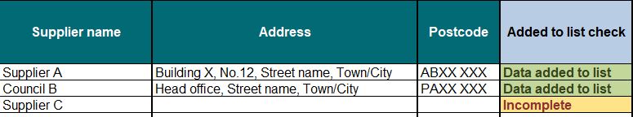

## Cover page

This section is applicable to all material facilities within scope of the Code, Section A is shown in Figure 2.

Figure 2: Cover page (Section A) screenshot.

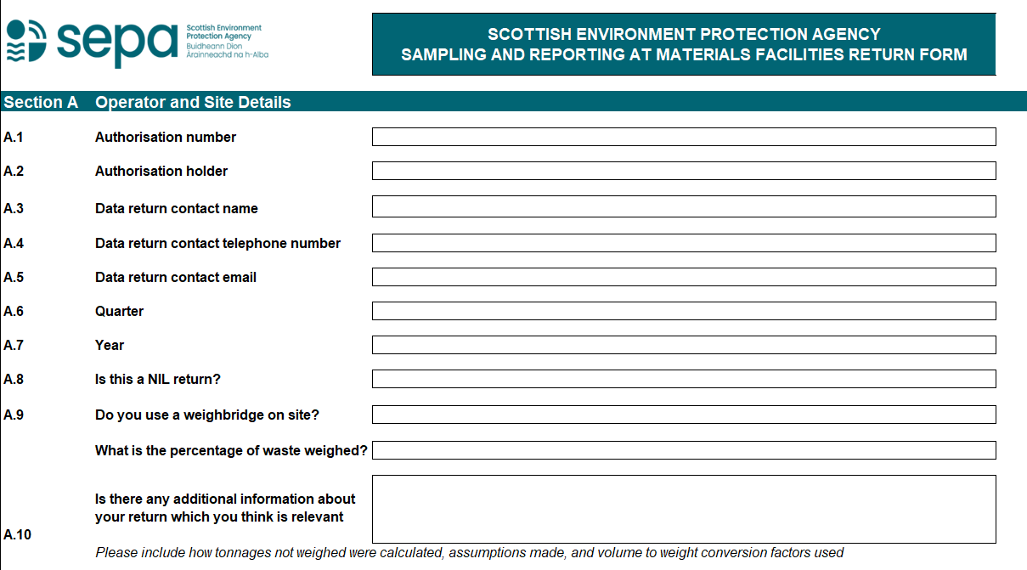

Complete this section by choosing from the dropdown lists where available or entering text.

#### Section A: Operator and site details

A.1: Enter the authorisation number of your facility obligated to report data to SEPA. The correct format for your authorisation number is as it is specified in your authorisation e.g. XXX/X/1234567.

A.2: Enter the details of the authorisation holder as detailed in your authorisation.

A.3 to A.5: Enter the contact details (contact name, contact number and E-mail address) of the person whom SEPA may contact in relation to changes in reporting requirements or for further information on reported data during the SEPA data verification process.

A.6 - 7: Select reporting quarter and year from the drop down.

A.8: Select from the drop down if this is a NIL return.

A.9: If you use a weighbridge on site, select ‘Yes’ from the dropdown menu and the percentage of waste weighed. If no weighbridge is used, select ‘No’, there is no requirement to state that 0% was weighed.

A.10: Enter any additional information.

#### Section B: Commercial confidentiality

Section B of the ‘Cover Page’ covers disclosing information and if relevant, your declaration to apply for commercial confidentiality.

B.1 – B.3: Generally, information provided to comply with licence conditions will be considered by SEPA as Public Register information, unless you request otherwise. If you wish to apply to have the next/end destination information excluded from the register on the grounds of commercial confidentiality, select ‘Yes’ from the dropdown list and explain why the details are deemed confidential in the associated text box. If there is any other information in the return form, which you believe should be excluded from the Public Register, you should clearly mark it as ‘Confidential’ and enclose or attach a letter with the completed form explaining why.

**Section C: Personal information**

C.1: If you have confirmed there is no personal information in the return, please select ‘Yes’ from the dropdown menu.

#### Section D: Declaration

Section D of the ‘Cover Page’ covers a declaration of the returns accuracy.

D.1: Enter the details of the person responsible for certifying the accuracy of your data return. This may or may not be the same person of the details you have provided as the ‘Contact’ in Section A.

## Waste suppliers

This section is applicable to all material facilities within scope of the Code.

Complete this section by entering your text. This will be used to automatically form a dropdown list that will be available for you to select in the ‘Input Samples’ and ‘Waste Received’ sheets of the form. This section has been simplified and only supplier details should be recorded, the description of waste received by each supplier is entered elsewhere in the form. Figure 3 shows a screenshot of the ’Waste Suppliers’ sheet.

The process for defining a supplier is detailed in the Code, and further information is available in the main guidance document.

Figure 3: Waste suppliers screenshot.

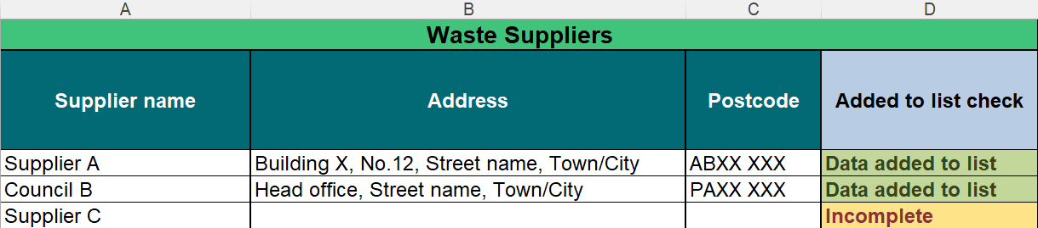

Columns A – C: Enter the relevant supplier’s name (and site authorisation number if applicable), address and postcode. The details given here should include the specific site waste has come from, not, for example, the registered head office address of the supplier (except in instances such as direct delivery from kerbside collections).

Column D: “Added to list check” is an auto – populated column that does not require data entry. This column highlights if all data has been entered correctly for the purpose of forming the supplier dropdown list. “Incomplete” means an entry is missing and it won’t be added to the dropdown list for selection. Make sure the data is entered correctly in this sheet so that the expected suppliers are available in this list.

Note: As commercial situations can change on quarterly basis, you should only update the supplier list if new suppliers or additional waste streams are brought in. If no material has been received from a supplier for a quarter, leave this in the supplier list instead of deleting this out. This allows entries to be consistent across all time periods, which supports efficient data analysis.

Where a Local Authority supplier’s load comprises material from both commercial and household sources, you should provide only the Local Authority name in the ‘Supplier name’ column.

For example, if you have a supplier whose vehicle delivered 90% of material from a local authority household route that also includes 10% commercial waste then please name this supplier according to the Local Authority route the collection came from.

## Waste destinations

This section is applicable to all material facilities within the scope of the Code.

Complete this section by entering your text. This will be used to automatically form a dropdown list that will be available for you to select in the ‘Waste Removed’ sheet of the form.

Figure 4: Waste destinations screenshot.

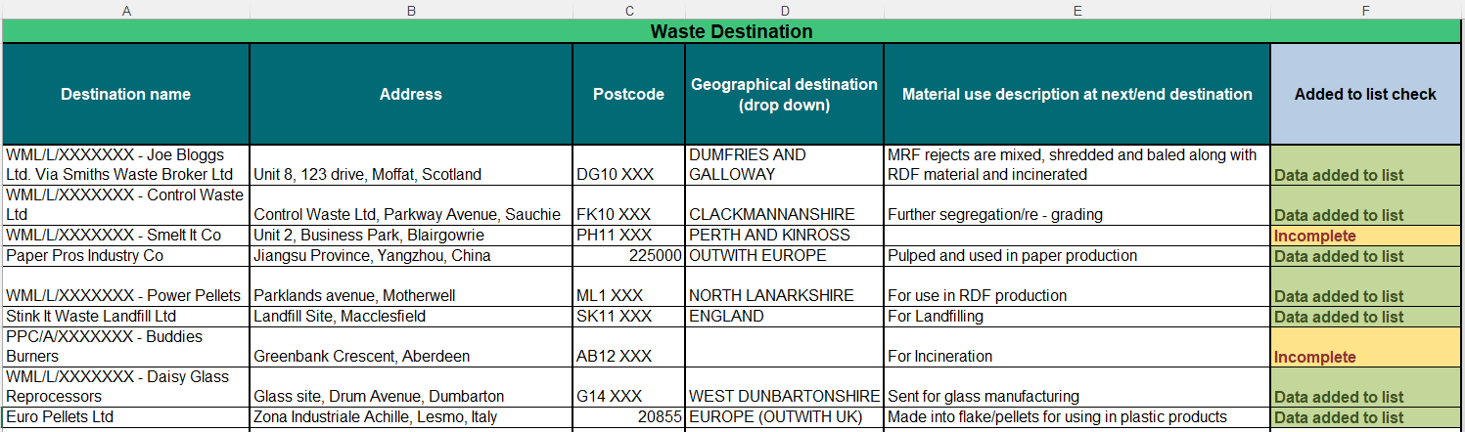

Columns A - D: Enter the next/end destination details, including site authorisation number where relevant in the “Destination name” column. Enter the address, postcode, and select the geographical destination from the drop downs in the following columns.

The end destination should be entered or, if this is not known, then the last known destination should be provided. The details given here should be the specific site the waste has gone to, not, for example, the registered head office address of your buyer. Where a broker or dealer has been used, you should also include this information in the destination name (e.g. Joe Bloggs Ltd., via Smiths Waste Broker Ltd)

Column E: Provide a brief description of the material use at the next/end destination, some examples for data entry can be seen in Figure 4.

Column F: “Added to list check” is an auto – populated column that does not require data entry. This column highlights if all data has been entered correctly for the purpose of forming the supplier dropdown list. “Incomplete” means an entry is missing and it won’t be added to the dropdown list for selection. Make sure the data is entered correctly in this sheet so that the expected destinations are available in this list.

Note: Like the supplier details, it is recommended that you only update the destination details if new destinations are added. If a specific destination has not been used for the quarter, leave the destination details in the list instead of deleting this out. This allows entries to be consistent across all time periods which supports efficient data analysis.

## Input samples

This section is applicable to all material facilities within scope of the Code.

Enter data for samples of waste received at the facility from each named supplier during each reporting period. Complete these sections by choosing from the dropdown menus where available or entering required text. Examples are given in the screenshot in Figure 5.

Figure 5: Input samples screenshot.

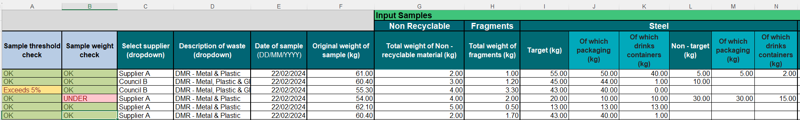

Column A: You do not have to enter anything here; this is an auto – populated column. Once the initial weight and breakdown weights have been entered the rows here will either flag:

* “OK” – where the difference between the initial weight and the sum of the breakdown weights is within 5%,
* “Exceeds 5%” – where the difference between the initial weight and the sum of the breakdown weights is exceeding the 5% allowance, or
* “0% Check” – this is when the difference between the initial weight and the sum of the breakdown weight is equal to 0. This check should help you understand whether best practise has been followed when weighing materials (i.e. we do not expect there to be an exact match between initial weight and the sum of the breakdown weights).

You should check the data in the row if you get anything other than “OK”. If you have any supporting information as to why this check is flagged, then please provide this along with your data return as this is one of the checks SEPA will do on the data. Any returns which we receive with these flags will likely be queried back with you to check.

Column B: You do not have to enter anything here, this is an auto – populated column, once the initial weight of the sample has been entered the rows in this column will either flag:

* “OK” – Where the initial weight of the sample is greater than or equal to 55kg.
* “Under” – Where the initial weight of the sample is less than 55kg.

Again, check the data in the row if you get anything other than “OK”, and provide supporting information if available. This is one of the checks SEPA will do on the data. Any returns which we receive with these flags will likely be queried back with you to check. Note that 55kg is the minimum weight per sample, the average weight across all samples per supplier per quarter must be 60kg.

Column C: Select the supplier of the sample data to be entered from the dropdown menu (this list is populated with information you provided in the ‘Waste Suppliers’ sheet of the form). If the supplier is not in this list, then you will need to enter the information in a new row in the Waste Suppliers sheet.

Column D: Select a waste description for the sample from the dropdown menu. We have provided a comprehensive list of waste descriptions for you to select. You should select the most appropriate for the suppliers waste you are sampling. This helps provide consistent reporting of the sampling data. If you do not see your material type listed here, email [waste.data@sepa.org.uk](mailto:waste.data@sepa.org.uk).

Column E: Enter the date of when the sample was taken. You should ensure this is in the format “DD/MM/YYYY”.

Column F: Enter the original weight of the waste being sampled in kilograms and rounded to 2 decimal places.

Column G: Enter the total weight of non-recyclable material of the sample in kilograms. This does not need to be broken down any further.

Column H: Enter the total weight of the fragment element of the sample in kilograms. Fragments will be deemed to contain the same proportions of material grades as those making up the non-fragment section of the input sample. This will be apportioned automatically by SEPA.

Columns I - BB: The composition of your sample must be recorded in each section, as follows, an example is provided in Figure 6:

* + The weight in kilograms of target material and non-target material that is contained in the sample.
  + The weight in kilograms of packaging that is contained in the (i) target material and (ii) non-target parts of the sample. This value should not exceed the values in the target or non-target columns.
  + The weight in kilograms of drinks containers that is contained in the (i) target material and (ii) non-target material parts of the sample. This must include any label applied to them and their lid or other closures. This value should not exceed the values in the target or non-target ‘of which packaging’ columns.

Figure 6: Compositional breakdown example.

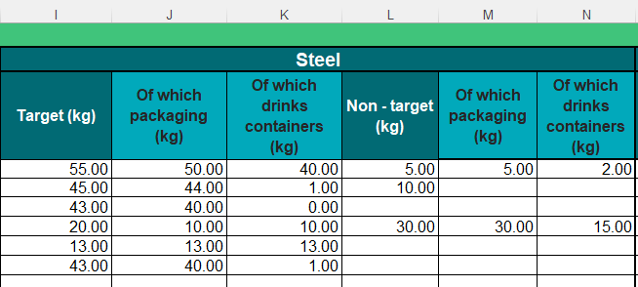

The data provided from parts (a) to (c) above must be broken down further for (i) target material and (ii) non-target material, in each case, by (at a minimum) the following material types:

1. Glass.
2. Paper.
3. Carboard.
4. Steel.
5. Aluminium.
6. Plastic pots, tubs and trays.
7. Plastic bottles.
8. Plastic film and other flexible plastic.
9. Other plastic not falling within (f), (g) or (h)
10. Fibre-based composite material.

For the purposes of the Code, only drinks containers made of PET, steel or aluminium need to be recorded.

You do not need to identify glass separately as drinks containers or packaging. You do not need to breakdown non – recyclable material into packaging.

An example is provided as follows.

The initial weight of a dry recyclable waste input sample is 60.0kg and constitutes primarily plastics.

Step 1.

The material is recorded as target, non-target and non-recyclable fractions. In this example the total weight of the target plastics is 55.0kg, with 1.5kg reported in the “non-recyclable” column, and a total of 3.0kg non-target material. The weight of fragments in this example is 0.6kg.

The 55.0kg of target plastics constitutes 25.0kg ‘Plastic bottles’, 20.0kg ‘Plastic pots, tubs and trays’, and 10.0kg ‘Other plastic’, the 3.0kg of non-target material constitutes 1.2kg ‘Plastic bottles’, 0.8kg ‘Plastic pots, tubs and trays’ and 1.0kg ‘Other plastic’. These weights should be reported in the relevant material specific columns. If no specific material is identified in a sample, then just leave the relevant columns blank.

Step 2.

Packaging is recorded for relevant target and non-target fractions and recorded in the appropriate column(s). In this example 48.0kg of the target material is packaging.

25.0kg of ‘Plastic bottles’ are packaging, 19.5kg ‘Plastic pots, tubs and trays’ are packaging, and 3.5kg of ‘Other plastic’ is packaging.

Note: Target material that is not packaging (i.e. the 7.0kg) is not recorded individually, this can be deduced.

2.0kg of the non-target material is packaging, 1.0kg of non-target ‘Plastic bottles’ are packaging, 0.8kg of non-target ‘Plastic pots, tubs and trays’ are packaging, and 0.2kg of non-target ‘Other plastic’ is packaging.

Step 3.

Drinks containers are recorded for relevant target and non-target fractions, these are then reported in the appropriate column(s), in this example 25.0kg of the identified packaging is drinks containers.

25.0kg of ‘Plastic bottles’ are drinks containers, there are no drinks containers in the ‘Other plastic’ fraction

Note: Target material that is packaging but is not drinks containers (i.e. the 23.0kg) is not recorded individually, this can be deduced.

0.9kg of the non-target material is drinks containers, 0.9kg of non-target ‘Plastic bottles’ are drinks containers, and none of non-target ‘Other plastic’ is drinks containers.

Note, the total breakdown weight in this example is 60.1kg, which is slightly more than the original weight of the sample. This is still considered a valid sample as it is within the expected 5% threshold. This will be automatically calculated in the form and indicate whether the sample weights are considered within tolerances.

## Waste received

This section is applicable to all material facilities within scope of the Code.

Your ‘Waste Received’ sheet should contain details of all relevant waste that has entered the MF site during the quarter from each supplier. This can include:

* Material that has not been sorted,
* Any rejected loads, or
* Loads of dry recyclables which are not sorted on site but are instead transferred to another MF for the purpose of separating it.

You do not need to include waste from any other activities carried out at your site. Only waste relevant to your materials facility should be reported in this form, including in the ’Waste Received‘ and ’Waste Removed‘ sheets. For residual waste from sorting processes at your materials facility, if this is mixed with residual waste from any of your non-MF activities, an estimate of the proportion derived from the materials facility will suffice.

Complete these sections by choosing from the dropdown menus where available or entering text, as shown in Figure 7.

Figure 7: Waste received example

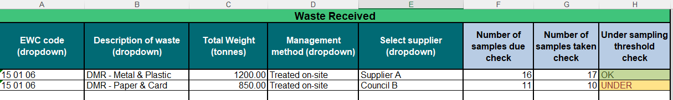

Column A: Select the most accurate EWC code for the type of waste you managed, from the dropdown list.

Column B: Select an option from the "Description of the waste” dropdown list. If you do not see your material type listed here, please email [waste.data@sepa.org.uk](mailto:waste.data@sepa.org.uk).

Column C: Enter the total weight of waste in tonnes (rounded to 2 decimal places).

Note: If you need to calculate from another unit of measurement into tonnes, provide the details of any estimations or calculations in Section A.9 on the front sheet of the form.

Column D: Select the management method of the waste from the dropdown list:

* “Treated on-site” - All waste received from the supplier which is taken on-site for treatment.
* “Sent off-site” – All waste received from the supplier which enters, and then leaves the site with no treatment, this should include waste that has been consolidated or stored on site.
* “Transferred” - All waste received from the supplier which is sent directly off site with no treatment, this does not include waste that has been consolidated or stored on site. The reason for transfer can then be recorded in the ‘Waste Removed’ sheet under “Reason for transfer / rejection”.
* “Rejected waste” – this is waste that’s been downgraded due to contamination issues and sent offsite for this reason. The reason for rejection can then be recorded in the ‘Waste Removed’ sheet under “Reason for transfer / rejection”.

Column E: Select the supplier from the dropdown list. If the supplier is not in this list, then you will need to enter the information in a new row in the ‘Waste Suppliers’ sheet.

Columns F – H: You do not need to enter any data, these are auto – populated columns. Once data is entered into columns B – E some basic validation checks will run to calculate the number of samples due and whether there is under sampling based on treated tonnage. The under-sampling threshold check in column H checks if the number of samples taken is enough based on the number of samples due. As shown in Figure 7, it will flag either “OK” or “Under”.

This is one of the checks SEPA will do on the data, so please provide any supporting information as to why the check may be flagged. Any returns which we receive marked with under sampling may be queried back with you.

## Output samples

This section is only applicable to those material facilities who are required to undertake output sampling. If you are not required to undertake output sampling, you do not need to complete this section of the reporting form.

If you have output sampling requirements, you must take samples of the output material leaving your facility in a reporting period and measure the composition of those samples.

Complete these sections using dropdown menus where available or entering text, as shown in Figure 8.

Figure 8: Output sample example

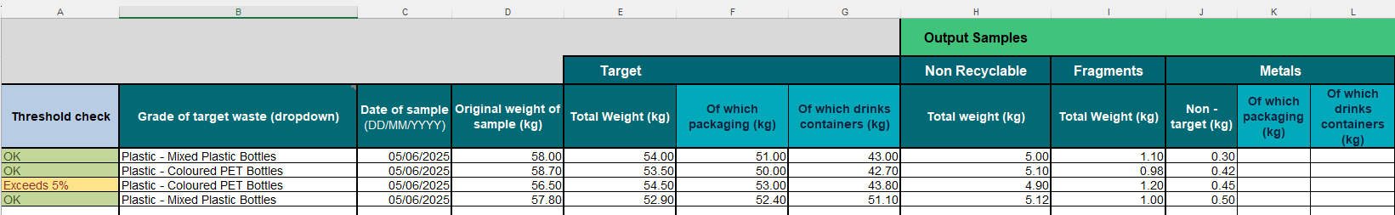

Column A: You do not have to enter anything here, this is an auto – populated column. Once the initial weight and breakdown weights have been entered the rows here will either flag:

* “OK” – where the difference between the initial weight and the sum of the breakdown weights is within 5%,
* “Exceeds 5%” – where the difference between the initial weight and the sum of the breakdown weights is exceeding the 5% allowance, or
* “0% Check” – this is when the difference between the initial weight and the sum of the breakdown weight is equal to 0. This check will help you understand whether best practise has been followed when weighing materials (i.e. we do not expect there to be an exact match between initial weight and the sum of the breakdown weights).

You should check the data in the row if you get anything other than “OK”. This is one of the checks SEPA will do on the data, so please provide any supporting information as to why the check has flagged. Any returns which we receive with these flags will likely be queried back with you to check.

Column B: Select the “Grade of target waste” from the dropdown menu. If you do not see your material grade listed here, please contact SEPA. The column “Grade of target waste” refers to the grades under each of the following main material types: Card and paper, plastics, metals, glass and fibre – based composite. This list is given in Table 1.

Table 1: List of material types and grades for output sampling (Same as Table 4 in the Code).

| **Material category** | **Grades** |
| --- | --- |
| Card and paper. | Cardboard.  Newspapers and magazines.  Mixed paper. |
| Plastics. | High density polyethylene (HDPE) bottles.  Natural HDPE bottles.  Coloured HDPE bottles.  Polyethylene terephthalate (PET).  Clear and light blue PET bottles.  Coloured PET bottles.  Polypropylene (PP).  Mixed plastic bottles.  Mixed rigid plastic.  Mixed plastic.  Plastic film. |
| Metals. | Aluminium.  Steel. |
| Glass. | Mixed coloured glass (container / glass fibre).  Mixed coloured glass (aggregate*/sand) *while status as recyclate remains.  Green glass.  Clear (flint) glass.  Brown (amber) glass. |
| Fibre-based composite. | Fibre-based cups.  Fibre-based food containers.  Fibre-based drinks cartons. |

Column C: Enter the date the sample was taken. You should ensure this is in the format “DD/MM/YYYY”.

Column D: Enter the original weight of the waste being sampled. The weight must be reported in kilograms and rounded to 2 decimal places. Minimum sample weights by material grade must be in accordance with Table 3 of the Code.

Column E: Enter the weight in kilograms of target material for the specific material grade of the sample. Your “Target material” weight must be for only the material grade you have identified in Column B and only needs one value entered. The weight of all other material identified in the sample must be recorded under “Non-target” or “Non-recyclable”. Note, if you consider that there is more than one target material in your output sample (for example, mixed coloured glass rather than clear glass), then a different grade of target waste should be selected in Column B to more appropriately describe the waste.

Column F: Enter the weight in kilograms of the target material that is packaging. This value should be the same or less that the value recorded in column E.

Column G: Enter the weight in kilograms of the target material that is packaging that consists of drinks containers. This value should be the same or less that the value recorded in column F.

Column H: Enter the weight of the total non-recyclable material of the sample. This is not broken down any further.

Column I: Enter the weight of the fragment element of the sample. Fragments will be deemed to contain the same proportions of material grades as those making up the non-fragment section of the output sample. This will be apportioned automatically by SEPA.

Columns J-U: Enter the weight in kilograms of any non-target material contained in the sample that falls into the categories detailed in the first column of Table 1. Any material that is not considered target for the sample grade is either non-target or non-recyclable.

Enter the weight in kilograms of non-target material contained in the sample that is packaging. As with the target columns this value should be the same or less than the value in the “Non-target” column.

Enter the weight in kilograms of non-target material contained in the sample that is drink containers (including any label applied and any lid or other closure). As with the target columns this value should be the same or less than the value in the “Of which packaging” column.

Glass does not need to be identified separately as packaging.

## Specified output

This section is only applicable to those material facilities who are required to undertake output sampling. If you are not required to undertake output sampling, you do not need to complete this section of the reporting form.

The ‘Specified Output’ sheet should contain the total weight of all waste streams segregated on site and subject to sampling requirements for the reporting quarter. All such waste streams should be detailed within this sheet, even if no associated samples were recovered in that quarter due to low sample volumes.

Column A: Select the “Grade of target waste” from the dropdown list. This is the same material as selected in the Output samples.

Column B: Enter the total weight in tonnes of the material, rounded to 2 decimal places.

Columns (C – E): You do not need to enter any data into these columns. Once data is entered into columns A and B these columns will auto – populate to provide some basic validation.

The number of samples taken, and sample balance checks are calculated from sample data entered in the ‘Output Samples’ sheet. When the output material has then been selected in Column A and total weight entered in Column B, if this material has been sampled, a count of samples (Column C) and under sampling check is applied.

The “Under sampling check” in column E highlights whether this is within the frequency of sampling dictated by the Code for that material grade. This will then flag in column E as “OK” or “Under” (Figure *9*).

This is one of the checks SEPA will do on the data, so please provide any supporting information as to why the check has flagged. Any returns which we receive with these flags will likely be queried back with you to check.

Figure 9: Auto-populated waste sample breakdown table

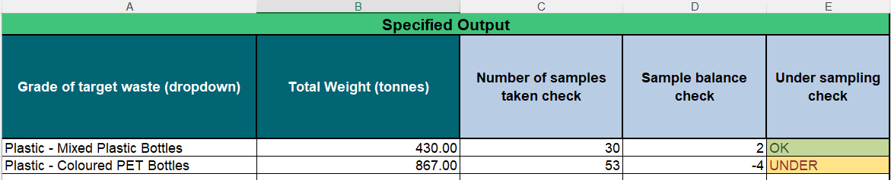

## Waste removed

This section is applicable to all material facilities within scope of the Code.

The ‘Waste Removed’ sheet of the form should contain details of all waste that has left your materials facility during the current quarter, including details of the waste destination. This is shown in Figure 10.

During a given quarter you may take in waste but not send that waste off-site until the next quarter (sometimes referred to as “stockpiling”). For example, you take in dry recyclable waste, sort it on-site and then store target materials for 4 months before sending to your buyers. In this case, report the tonnage leaving the site as a waste output in the quarter that it leaves the site.

Complete this section by selecting from dropdown lists and entering the weight and date of the output material or bulked DMR that left the site during each quarter.

Figure 10: Waste removed screenshot.

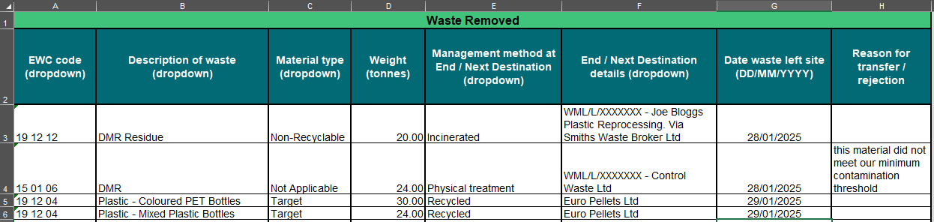

Column A: Select the most accurate EWC code for the type of waste you managed, from the dropdown list.

Column B: Select the “Description of waste” from the dropdown list. Please use the most appropriate description for the material i.e. if you have bulked DMR or rejected DMR you can just use the “DMR” description here.

Column C: Select the “Material type” from the dropdown list. We have included “Not Applicable” here as an option to use if transferring for example “unsorted mixed recyclate” to another facility for sorting.

Column D: Enter the weight in tonnes of the material, rounded to 2 decimal places.

Column E: Select the management method that will occur at the site recorded in Column F (i.e. the next/end destination). The various management methods are as follows:

* “Landfilled”: Any waste sent off-site for landfill.
* “Incinerated”: Any waste sent off-site for incineration.
* “Biological treatment”: Any waste undergoing biological treatment, e.g. anaerobic digestion, treatment of sludges.
* “Chemical treatment”: Any waste undergoing chemical treatment, e.g. neutralisation, oil regeneration.
* “Composted”: Any waste composted (including in-vessel and windrow).
* “Crushed and screened”: Any waste crushed or screened e.g. rubble or glass into aggregate.
* “Physical treatment”: Any waste undergoing primarily physical treatment, e.g. manual or mechanical sorting of mixed waste, stripping vehicles, fragmentising waste, mechanical biological treatment (MBT), centrifugation, autoclaving/pyrolysis.
* “Recycled”: Any waste recycled to a final product or end-of waste criteria.
* “Other treatment”: Any waste undergoing any other kind of treatment not specified above. If this is the case, please ensure the details of the management method at this site are comprehensive in the “Material use description” column in the “Waste Destination” sheet.
* “Transferred off-site”: Any waste sent to a transfer station where it does not undergo treatment, or waste where the management method at the next site is not known. If the management method is not known at the next site, please endeavour to find out and detail this in the “Material use description” column in the ‘Waste Destination’ sheet.

Column F: Select the end/next destination from the dropdown list. The information in the dropdown list is prepopulated from the data entries in the ‘Waste Destination’ sheet. Make sure the data is entered correctly in this sheet, so the expected destinations are available in this list.

Column G: Enter the date the waste left the site in the format DD/MM/YYYY.

Column H: A free text area where you provide the reason for rejection/transfer from the site.

## How we use your information

The information collected by SEPA in terms of the Code will help support future policy considerations of measures required to improve recyclate quality.

As stated in the code, next and end destination data reported to SEPA will be treated by SEPA as confidential, in keeping with its commercially sensitive nature. This notwithstanding, SEPA may share information reported under this Code with the Scottish Government, Zero Waste Scotland, and the EPR scheme administrator (or any person who is exercising functions on the scheme administrator’s behalf), who will continue to treat the information as commercially confidential. SEPA will comply with any legal requirement to release data, including under the Freedom of Information (Scotland) Act 2002 and/or the Environmental Information (Scotland) Regulations 2004.

## Further help with your materials facility return form

If you need any help with completing the form or have any questions about your facility returns, contact SEPA’s Data Unit by email: [waste.data@sepa.org.uk](mailto:waste.data@sepa.org.uk).

## Disclaimer

Whilst every effort has been made to ensure the accuracy of this guidance, SEPA gives no warranty, covenant or undertaking (express or implied) regarding the fitness for purpose of, or any error, omission or discrepancy in this guidance. Reliance on its contents and the contents of any websites that are linked to or from this guidance is entirely at the user’s own risk. SEPA is not liable for any loss or damage that may come from using this guidance. This includes:

* any direct, indirect and consequential losses
* any loss or damage caused by civil wrongs, breach of contract or otherwise