

# Aquaculture Modelling Screening & Risk Identification Report:

Report date: February 2025

# CAIRIDH (CAIR1)

# VERSION 1

## Scope of report

As part of the SEPA Aquaculture Regulatory Framework it is recommended that a proposed application for a marine fin fish aquaculture site should undergo a Screening Modelling and Risk Identification process. SEPA carries out this work and this is described on the SEPA aquaculture website [**Pre-application section**](https://www.sepa.org.uk/regulations/water/aquaculture/pre-application/)

This report presents information arising from that process. Screening modelling methods are outlined and maps and tables describing the modelled impacts are shown. Risks arising from consideration of the model output are listed. Conclusions and recommendations are made regarding the proposed site.

## Executive summary

SEPA has received a proposal to vary an existing marine fin fish aquaculture site called Cairidh (CAIR1), at location: 156081.3 828929.2 (Easting, Northing). The existing maximum biomass is 1800t at this location. The application seeks to increase the Azamethiphos amount from 325.6 to 900g.

Following screening modelling and risk identification we have concluded the following:

* It is possible that discharges from Cairidh (CAIR1) will be able to comply with the relevant aspects of the SEPA Aquaculture Regulatory Framework.
* Due to the large increase in Azamethiphos and identified PMFs of interest, detailed marine modelling of baths is required. Identified Priority Marine Features should be considered. Dye/drogue calibration will be required.

## List of abbreviations

SEPA Scottish Environment Protection Agency

MPFF Marine Pen Fish Farm

CTG Consenting Task Group

AMZ Allowable Mixing Zone

PMF Priority Marine Feature

EIA Environmental Impact Assessment

HRA Habitats Regulations Appraisals

SAC Special Area of Conservation

SPA Special Protected Area

SSSI Site of Special Scientific Interest

MPA Marine Protected Area

AZA Azamethiphos

Contents

Aquaculture Modelling Screening & Risk Identification Report: 1

CAIRIDH (CAIR1) 1

VERSION 1 1

Scope of report 2

Executive summary 3

List of abbreviations 4

List of Figures 6

List of Tables 7

SEPA: Introduction 8

SEPA: Screening modelling 9

SEPA: Risk Identification 14

SEPA: Conclusions 17

## List of Figures

Figure 1. East Coast Lewis and Harris model grid 9

Figure 2: Modelled average water speed (metres per second – m/s) in the sea loch around the proposed site (Cairidh (CAIR1)). 11

Figure 3: Modelled average Azamethiphos concentration over four days from neap tide release for the proposed site only (Cairidh (CAIR1)). 13

Figure 4: Map of all Priority Marine Features in the sea loch around the proposed site (Cairidh (CAIR1)). 14

## **List of Tables**

Table 1: Table of identified features of interest 15

Table 2: Table of farms which should be included in any cumulative modelling. 16

## SEPA: Introduction

Screening Modelling and Risk Identification are important steps in the SEPA regulatory framework for marine pen fish farms. SEPA carries out this work and this is described on the SEPA aquaculture website [**Pre-application section**](https://www.sepa.org.uk/regulations/water/aquaculture/pre-application/)

This section presents screening output for the proposed site with comments. Risks identified from the screening output are detailed. Conclusions and recommendations about the suitability of the proposed site are then made.

A summary of the modelling methods employed during screening modelling can be found alongside this document on the SEPA website.

## SEPA: Screening modelling

#### Accuracy of model in the area surrounding the proposal

The East Coast Lewis and Harris model used for screening modelling has a relatively low resolution in this area.

Comparison against observational current meter data indicates that the model provides a reasonable performance of the physical processes in the vicinity of the proposed site.

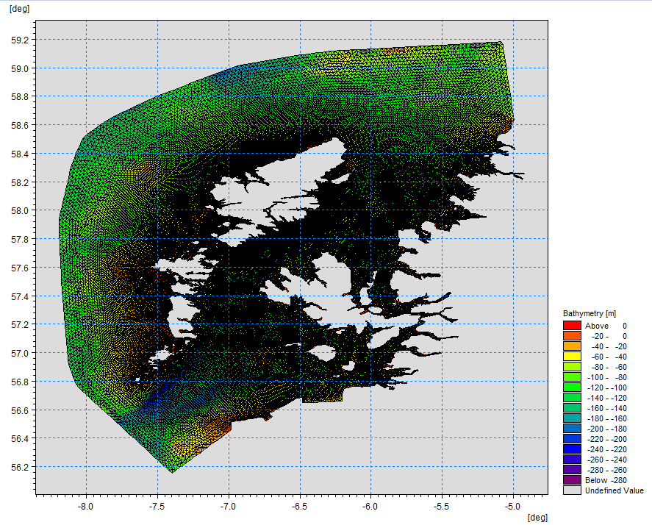

Figure 1. East Coast Lewis and Harris model grid

### Dispersion and erosion capacity maps

Modelled water movement in a sea area can be used to show the capacity of the water to move and disperse discharged substances. It is also possible to show the capacity available to erode substances from the seabed. This information is a useful guide to the potential size of a marine pen fish farm at a particular location.

Marine pen fish farms using open-net pens will benefit from operating in locations where there are strong, repeating, water currents to erode and disperse waste.

Locations with average water flow speeds of greater than, or equal to, 0.12 metres per second (0.23 knots) are for screening purposes, considered generally suitable for larger farms.

A map of modelled average water flow speed for the area surrounding the proposed site is shown in Figure 2. The average water flow speed in each cell of the model grid has been assigned a shade. The darker the shading, the slower the average current speed and the lower the capacity for dispersion.

Licenced aquaculture farms in the vicinity of the proposed site are shown and discharges of material from these sites have been included in the screening modelling.

#### Modelled flow properties

Based on the maps of the modelled water flow properties we can make the following observations about the proposed site location:

* It lies in a relatively low dispersion area.
* It lies in an area where water flow has a relatively low capacity to erode material on the seabed.

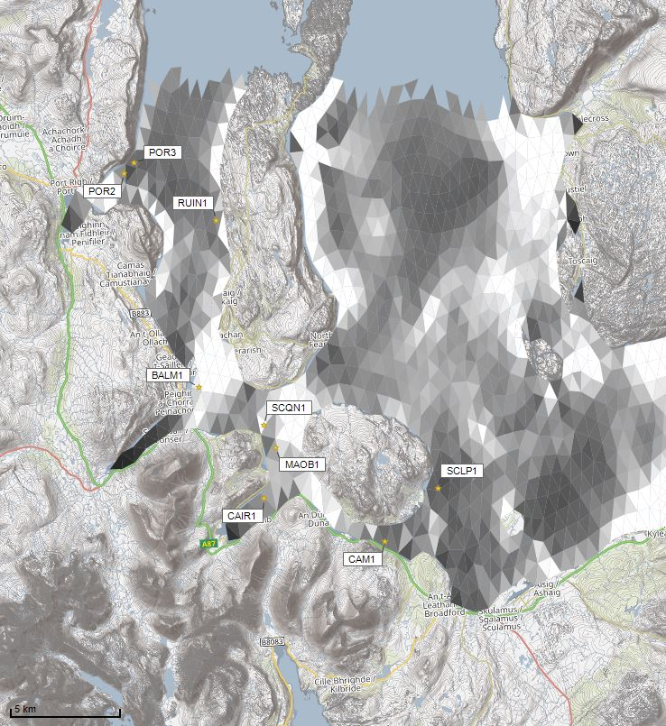



Average water speed (m/s)

©Crown copyright. All rights reserved. SEPA lic. no. 100016991 (2019).

Figure 2: Modelled average water speed (metres per second – m/s) in the sea loch around the proposed site (Cairidh (CAIR1)).

©Crown copyright. All rights reserved. SEPA lic. no. 100016991 (2019).

### Bath medicine influence maps and analysis

Modelled particles in a sea area can be analysed for each modelled grid cell and presented to show the potential influence of discharged bath medicine on the surrounding sea area. Results presented are for the Azamethiphos medicine.

Figure 3 shows a map of the modelled average AZA concentration over four days for the proposed site only. Grid cells within the model which experience an AZA influence are shaded according to the concentration of AZA in nanograms per litre (ng/l). Cells which are shaded purple are similar to the average and those shaded pink are similar to the median (middle value in the range) intensity value shown on the map.

Values less than 10 ng/l have been excluded from the map. These low concentration cells are produced by the particle tracking approach but they are not considered to be representative of the main influence of a discharge.

Please note that the Environmental Standard for Azamethiphos with the lowest concentration is 40 ng/l. This must be met 72 hours after the material has been discharged. The estimate of influence detailed here is precautionary.

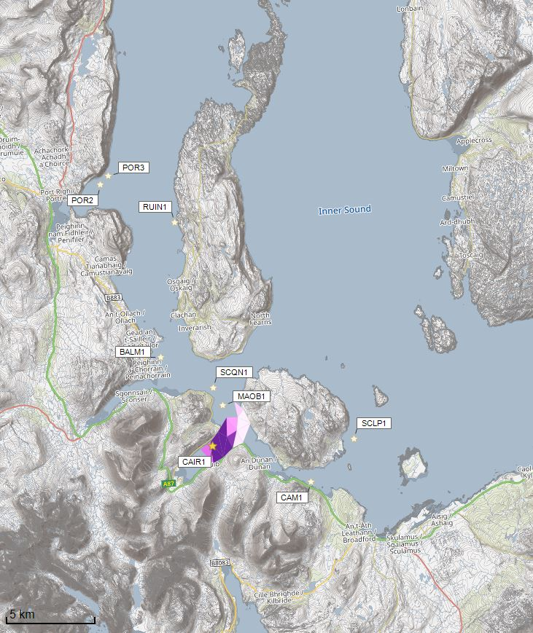

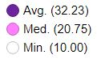

Azamethiphos Conc. (ng/l)

Concentrations of AZA presented on this map are less than the 40 ng/l Environmental Standard and are presented for information only.

©Crown copyright. All rights reserved. SEPA lic. no. 100016991 (2019).

Figure 3: Modelled average Azamethiphos concentration over four days from neap tide release for the proposed site only (Cairidh (CAIR1)).

©Crown copyright. All rights reserved. SEPA lic. no. 100016991 (2019).

## SEPA: Risk Identification

The screening modelling output summarised in the screening modelling section is compared against available information on features of interest. Features which require attention are presented with any additional comments and will need to be considered during the pre-application phase.

### Features of Interest which require attention

Sensitive features in the area have been assessed, those considered at risk and therefore requiring additional consideration, can be found in the table below.

Figure 4: Map of all Priority Marine Features in the sea loch around the proposed site (Cairidh (CAIR1)).

Table 1: Table of identified features of interest

|  | **Feature Name** | **Feature Type** | **Location (Easting, Northing)** | **Brief Reason for Identification** |
| --- | --- | --- | --- | --- |
| 1 | Maerl Beds | PMF | 156801 828597  156806 829005  156946 829115  157045 830238  156965 829167  156768 829099  156803 829130 | At risk from bath influence |
| 2 | Flame Shell Beds | PMF | 156810 829148  156757 829118  156772 829101 | At risk from bath influence |
| 3 | Seagrass Beds | PMF | 158301 828897  156801 828597 | At risk from bath influence |
| 4 | Native Oysters | PMF | Within model domain  (Location cannot be disclosed. Modelled output will be assessed against specific location.) | At risk from bath influence |

### Additional comments on bath influence

The conservative nature of the simple BathAuto model in areas of high current speeds, means quantities of bath medicines may be limited to impractical amounts for this site. Use of marine modelling of bath influence will enable more realistic bath medicine treatment quantities to be determined. Features identified as at risk within this area will need to be addressed in any marine modelling, however cumulative modelling of baths is not required. Dye/drogue calibration will be required.

### Risks identified from contextual site data

Table 2: Table of farms which should be included in any cumulative modelling.

| **Site Name** | **Location (Easting, Northing)** | **Biomass (Tonnes)** | **Last production Cycle** | **Include in solids marine modelling?** |
| --- | --- | --- | --- | --- |
| CAIR1 | 156081.3, 828929.2 | 1800 | Pre-application. Currently Stocked (Since Oct 22) | N/A |
| MAOB1 | 156777, 831197 | 2500 | Proposed. Currently Stocked (Since Apr 22) | N/A |
| SCQN1 | 136749, 860700 | 2500 | Currently Stocked (Since Mar 22) | N/A |
| BALM1 | 137900, 855500 | 1500 | Fish last on site Aug 2021 | N/A |
| CAM1 | 161524, 826590 | 405 | Fish last on site Sep 04 | N/A |
| SCLP1 | 164120, 828730 | 2500 | Pre-application. Currently Stocked (Since Feb 22) | N/A |
| RUIN1 | 154676, 841714 | 2222.6 | No record of fish on site since they began in January 2011 | N/A |
| POR2 | 150600, 844120 | 2021.7 | Fish last on site Apr 2024 | N/A |
| POR3 | 151083, 844572 | 2192 | Fish last on site Feb 2024 | N/A |

## SEPA: Conclusions

### Conclusions

* According to screening modelling, the proposed site (Cairidh (CAIR1)) is in an area of low dispersion and has a relatively low capacity for erosion of material on the seabed.
* The screening model provides a reasonable performance in the vicinity of the site when compared to observational data.

### Recommendations and Further Modelling

Following the engagement meeting(s), this report may be revised and this should allow the applicant to submit a method statement which address the issues raised in this document.

Due to the large increase in Azamethiphos and identified PMFs of interest, detailed marine modelling of baths is required. Identified Priority Marine Features should be considered. Dye/drogue calibration will be required.

For information on accessing this document in an alternative format or language, please contact SEPA by emailing [equalities@sepa.org.uk](mailto:equalities@sepa.org.uk)

If you are a user of British Sign Language (BSL), the Contact Scotland BSL service gives you access to an online interpreter, enabling you to communicate with us using sign language. [contactscotland-bsl.org](http://contactscotland-bsl.org/)