

# Aquaculture Modelling Screening & Risk Identification Report: LOCH SNIZORT WEST (SNZW1)

Report date: November 2024

## Scope of report

As part of the SEPA Aquaculture Regulatory Framework it is recommended that a proposed application for a marine fin fish aquaculture site should undergo a Screening Modelling and Risk Identification process. SEPA carries out this work and this is described on the SEPA aquaculture website [**Pre-application section**](https://www.sepa.org.uk/regulations/water/aquaculture/pre-application/)

This report presents information arising from that process. Screening modelling methods are outlined and maps and tables describing the modelled impacts are shown. Risks arising from consideration of the model output are listed. Conclusions and recommendations are made regarding the proposed site.

## Executive summary

SEPA has received a proposal for a new marine fin fish aquaculture site called Loch Snizort West (SNZW1). The site is located to the west of Loch Snizort on the Isle of Skye, at location: 131362, 857969 (Easting, Northing). Pre-application advice has been requested early in the process and consequently the proposal is still in development and subject to change, however the maximum proposed weight of fish to be farmed is 2500t.

Following screening modelling and risk identification we have concluded the following:

* Standard default NewDepomod modelling is required.
* Marine modelling is not required for solids.
* BathAuto is the default assessment approach for bath medicines, however marine modelling is an option that the applicant may choose to use instead to get a less conservative bath medicine quantity.
* If marine modelling of baths is undertaken, the resolution of the marine model should be relatively fine around the proposed site and identified features at risk.
* Cumulative modelling is not required for either solids or bath medicines.
* Flow speeds are slow at this location and standard default NewDepomod must be undertaken prior to any marine modelling to demonstrate the proposed biomass can be supported. Due to the conditions at this site, low wave exposure modelling standards (impact area no bigger than 100% of the Allowable Mixing Zone and the under-cage deposition not more than 2000g/m2/year) should be met.
* The presence of very fine sediment in this area means the standard IQI monitoring may not be representative of this site. Therefore, the applicant should investigate alternative monitoring approaches and continue engagement with SEPA on this matter during the pre-application process.
* Sea lice screening has been undertaken, no further modelling or permit conditions are required for this site, at this time.

## List of abbreviations

SEPA Scottish Environment Protection Agency

CAR Controlled Activities Regulations

WSPZ Wild Salmon Protection Zone

## List of chemical abbreviations

AZA Azamethiphos

Contents

Aquaculture Modelling Screening & Risk Identification Report: LOCH SNIZORT WEST (SNZW1) 1

Scope of report 2

Executive summary 2

List of abbreviations 4

List of chemical abbreviations 4

List of Figures 6

List of Tables 7

Introduction 8

Screening modelling 14

Sea Lice Screening 28

Risk Identification 32

Conclusions of screening modelling and risk identification 34

References 38

Appendices – Responses to pre-app consultation. 39

## List of Figures

Figure 1. East Coast Lewis and Harris model grid 13

Figure 2: Modelled average water speed (metres per second – m/s) in the sea loch around the proposed site (Loch Snizort West (SNZW1)). 22

Figure 3: Modelled percentage of time the water flow speed is above 0.095 m/s in the sea area surrounding the proposed site (Loch Snizort West (SNZW1)). 23

Figure 4: Modelled average sediment intensity over one month for the proposed site only (Loch Snizort West (SNZW1)). 24

Figure 5: Modelled average sediment intensity over one month for the proposed site (Loch Snizort West (SNZW1)) and other relevant sites. 25

Figure 6: Modelled average Azamethiphos concentration over four days from neap tide release for the proposed site only (Loch Snizort West (SNZW1)). 26

Figure 7: Modelled average Azamethiphos concentration over four days from neap tide release for the proposed site (Loch Snizort West (SNZW1)) and other relevant sites. 27

Figure 8: Map of the average modelled lice concentration over the simulated April and May period (in lice/m2) within the top two meters of the sea area. SNZW1 site location shown as a blue circle. Fish tracks are shown as green lines with the WSPZs, which are highlighted by a white boundary. 30

Figure 9. PMFs in the vicinity of the proposed farm. 48

## List of Tables

Table 1: Sediment influence information for each site. 18

Table 2: Azamethiphos influence information for each site. 21

Table 3: Influence of modelled sea lice from SNZW1 on exposure in the relevant affected WSPZs. 30

Table 4: Location of SNZW1 within the assessment matrix framework of WSPZ capacity and site contribution. 31

Table 5: Table of identified features 32

Table 6: Table of licenced biomass from farms identified as likely to add to cumulative risks. 33

Table 7: Table showing planning history 40

## Introduction

Screening Modelling and Risk Identification are important steps in the SEPA regulatory framework for marine pen fish farms. They are carried out by SEPA at the [**pre-application stage**](https://www.sepa.org.uk/regulations/water/aquaculture/pre-application/)**.**

This document briefly describes the objectives of screening and risk identification and summarises the methods used. Screening output for the proposed site is then presented with comments. Risks identified from the screening output are detailed. Conclusions and recommendations about the suitability of the proposed site are then made.

### The objectives of screening modelling and risk identification

A summary of the modelling methods employed during screening modelling is outlined in the screening modelling methods section. The objectives of screening modelling and risk identification are outlined below.

#### Screening modelling

Marine Modelling technology can be used to simulate and predict the potential influence of discharges on the marine environment. SEPA will require the majority of proposed farms to conduct detailed marine modelling, as outlined in our Aquaculture Modelling guidance [1] and on the SEPA Website.

Marine modelling can also be used at an earlier stage to provide an initial estimate of the influence of material discharged from a proposed site.

SEPA will carry out marine modelling at the screening and risk identification stage. This is a simplified version of the detailed modelling required of the applicant. However, it will be sufficient to perform an initial risk assessment of a proposal. Screening marine modelling will also include discharges from other relevant aquaculture sites and major sources.

The objectives of the simplified screening modelling are to:

* Produce maps of the predicted dispersive and erosive capacity of the sea areas in the vicinity of aquaculture sites
* Produce maps of the predicted spread of sediment discharged from aquaculture sites
* Produce maps of the predicted spread of bath treatment medicines from aquaculture sites
* Present an analysis of the potential influence of sediment and bath treatment discharges from the proposed site alongside existing sites within the surrounding sea area
* Present information on the sensitive features and sites of interest within the surrounding sea area, which must be addressed during pre-application work
* Present a summary of the suitability of the proposal with respect to the dispersal of waste and how this may be modelled.

#### Risk identification

Maps and analysis of screening output will be compared to information relating to sensitive features and relevant areas of interest. These may include:

* Marine Protected Area (MPA)
* Special Area of Conservation (SAC)
* Priority Marine Feature (PMF)
* Any site identified via consideration of other permitted or regulatory activities.

SEPA Staff will meet to discuss screening model output and the relevant sensitive features information. Following this meeting, a list of identified risks will be added to this report.

#### Conclusion of screening modelling and risk identification

Following the identification of risks, SEPA will present a summary of the suitability of the proposal with respect to the:

* Dispersal of waste from the proposed site and other sources
* Risks posed to sensitive features
* Likely level of modelling that will be required to address the risks identified.

### Screening modelling methods

Marine models divide the sea up into a “grid” of boxes or triangles (often called cells). Each of these is given a water depth. For the screening modelling presented in this report the Marine Scotland “East Coast Lewis and Harris” (ECLH) has been used. An image of the ECLH model grid is shown in Figure 1. This grid has been set up within a marine modelling software package called MIKE 21 which is manufactured by the company DHI A/S (https://www.dhigroup.com/).

Marine models carry out calculations across a grid to work out how seawater moves and mixes in response to tidal and weather forces. Marine models can also be used to simulate how seawater moves and mixes due to salinity and temperature differences across an area, particularly in response to inputs of freshwater from rivers. For pollutant influence assessments the mixing (dispersion) of dissolved (bath medicine) and particulate (sediment) pollutants can also be estimated. Calculations within a marine model can be performed in three dimensions (3D), where the grid is split into layers to better represent how properties of the sea change with depth. Two dimensional (2D) models can also be created where processes over the water depth are simplified. The amount of mixing in a marine model can be varied using settings in the software.

Screening modelling is currently carried out with 2D models using average mixing settings in the model software. In many areas, this approach will be sufficient to make an initial estimate of the influence of a proposed site. Our screening assessment will take into account factors which may limit a 2D approach. We will also consider whether a particular location is adequately represented by the available models.

#### Water movement and mixing modelling

Water movement and mixing modelling (hydrodynamics) has been carried out to generate one month of results. The boundaries (edge(s) of) the model have been driven using the “wider domain” Scottish Shelf Model [2]. Wind forces and freshwater inputs have been applied to the model from the same source. The results generated are an estimate of the average water movement and mixing conditions within the model area.

#### Sediment waste modelling

Screening modelling provides a precautionary and indicative estimate of the size, location and intensity of waste organic material released from aquaculture sites.

The release of sediment from sources within the model area is simulated using one month of hydrodynamic results along with particle tracking modelling technology. Virtual particles are continually introduced to the model grid to represent the potential dispersion of sediment from the sources. Particles in the model are moved and mixed by the hydrodynamics. Additionally, particles are assigned simplified properties, which allow them to settle through the water and be re-suspended (eroded and lifted) from the seabed.

#### Bath medicine modelling

Screening modelling provides a precautionary and indicative estimate of the size, location and concentration of bath medicine releases.

The release of bath treatment medicine from sources within the model area is simulated using hydrodynamic results along with particle tracking modelling technology. Virtual particles are introduced to the model grid to represent the potential dispersion of bath medicines from the sources. Particles in the model are moved and mixed by the hydrodynamics. Releases of bath medicines are simulated under worst case mixing (dispersion) conditions, which occur under neap tides. The maximum treatment amount likely to be used at each site is released into the model at the same time and plumes are tracked over the following 96 hours (4 days). Treatment amounts used at screening have been derived from an analysis of historical data. Additionally, all bath medicine particles are concentrated within the top 5 m of the sea area. As all bath medicines are likely to disperse in a similar way, only Azamethiphos (AZA) has been modelled at the screening stage.

#### Nutrient assessment

Whilst nutrients are not directly modelled during screening, the dispersion of bath medicine releases will give an indication of the likely level of nutrient dispersion. This will be considered alongside any pre-existing nutrient assessment information that may be available.

#### Analysis of modelling output

SEPA processes the screening modelling output and places it into a standard analysis application built in TIBCO Spotfire. The application allows for the production of standard maps and tables, which are presented below.

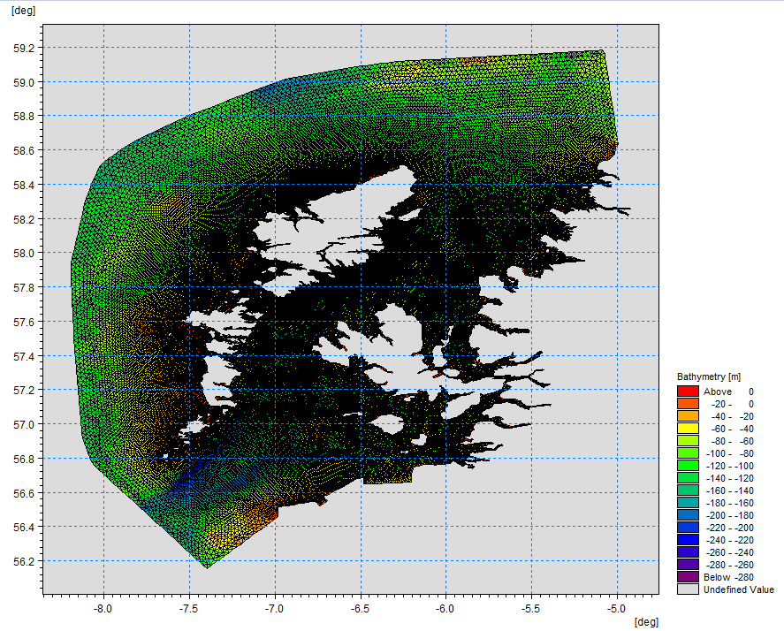

Figure 1. East Coast Lewis and Harris model grid

## Screening modelling

### Site proposal

Screening modelling has been carried out for a proposal for a new farm: Loch Snizort West (SNZW1). The proposal is to site the farm at location: 131362, 857969 (Easting, Northing). The proposed weight of fish to be farmed is 2500t. For the screening modelling presented here all relevant licenced sites and current applications have been modelled in conjunction with the proposed site.

#### Accuracy of model in the area surrounding the proposal

The East Coast Lewis and Harris model used for screening modelling has a relatively low resolution in this area. Comparison against observational current meter data indicates that the model provides a reasonable performance of the physical processes in the vicinity of the proposed site.

### Dispersion and erosion capacity maps

Modelled water movement in a sea area can be analysed and presented to show the capacity of the water to move and disperse discharged substances. It is also possible to show the capacity available to erode substances from the seabed. This information is a useful guide to the potential size of a marine fin fish aquaculture farm at a particular location.

Marine fin fish aquaculture farms using open-net pens will benefit from operating in locations where there are strong, repeating, water currents to erode and disperse waste.

For the purposes of screening we consider locations which meet the following water flow criteria to be generally suitable for larger farms:

Locations with average water flow speeds of greater than, or equal to, 0.12 metres per second (0.23 knots)

Locations where water flow speeds are often above the threshold of 0.095 meters per second (0.18 knots).

Locations with these properties are likely to disperse discharged material rapidly, and regularly erode sediment discharged to the seabed. In general, we would look for these properties to be maintained over a large area around a proposed site.

The thresholds stated above are indicative.

A map of modelled average water flow speed for the area surrounding the proposed site is shown in Figure 2. The average water flow speed in each cell of the model grid (see section 1.2) has been assigned a shade. The key for the shading is shown in the top left of the figure. Grid cells that have average speeds less than 0.12 m/s (metres per second) are marked on the figure. The greater the shading, the slower the average current speed and the lower the capacity for dispersion.

Figure 3 is a map of the percentage of time the modelled water flow speed in a grid cell is above 0.095 m/s (metres per second). The greater the shading, the lower the capacity for material to be eroded from the seabed.

Licenced aquaculture farms in the vicinity of the proposed site are also marked on Figure 2 and Figure 3. Discharges of material from these sites have been included in the screening modelling.

Based on the maps of the modelled water flow properties we can make the following observations about the proposed site location:

* It lies in a low dispersion area.
* It lies in an area where water flow has a low capacity to erode material on the seabed.

### Sediment influence maps and analysis

Modelled particles in a sea area can be analysed for each modelled grid cell and presented to show the potential influence of discharged sediment on the surrounding sea area.

Figure 4 shows a map of the modelled average sediment intensity over one month (time average) for the proposed site only. Grid cells within the model that are influence by modelled sediment are shaded according to the intensity of the influence in grams per square metre (g/m2).

Values less than 1 g/m2 have been excluded from the map and subsequent calculations. These low concentration cells are produced by the particle tracking approach, but they are not considered to be representative of the main influence of a discharge.

* The shading key is shown in the top left of the figure. Cells which are shaded black are similar to the average intensity in the total area of influence shown in the map. Cells shaded pink are similar to the median (middle value in the range) intensity value shown on the map. White shaded cells are similar to the minimum intensity value shown on the map.
  + The average and median sediment intensity over the area of influence is 120.32 g/m2 and 120.32 g/m2 respectively.
  + Cells influenced by the proposed site do not appear to lie close to other modelled farm sites.

Figure 5 shows a map of the modelled average sediment intensity over one month for the proposed site and other relevant sites. Grid cells within the model that are influenced by modelled sediment are shaded according to the intensity of the influence in grams per square metre (g/m2). The shading key is shown in the top left of the figure and is in a similar format as that shown in Figure 4. The average sediment intensity, after including all relevant sites, is decreased.

* The average and median sediment intensity over the area of influence is 15.56 g/m2 and 4.97 g/m2 respectively.
* A small number of cells influenced by other modelled sites appear to lie close to the proposed site.

#### Sediment influence analysis

Model grid cells can be analysed to estimate the size and concentration of the potential sediment influence from the modelled sites.

* The total area of sediment influenced by the five sites modelled is estimated to be 6.31 square kilometres (km2).
* As shown in Figure 5, the average and median intensity over this area is 15.56 g/m2 and 4.97 g/m2, respectively.
* The total weight of fish that generates this modelled influence is 8945 tonnes.

Table 1 shows the information for each individual site modelled. It is important to note that the total area of influence for all sites is not the sum of the numbers in Table 1. The total area of influence worked out above takes into account that the individual areas of influence from different sites will overlap.

Table 1: Sediment influence information for each site.

| **Site Name** | **Average Intensity (g/m2)** | **Area of Influence (km2)** | **Median Intensity (g/m2)** | **Max weight of fish (Tonnes)** |
| --- | --- | --- | --- | --- |
| **SNZW1** | 120.32 | 0.28 | 120.32 | 2500 |
| **GRE1** | 7.22 | 3.17 | 2.89 | 2195 |
| **RCHO1** | 10.40 | 1.69 | 4.78 | 2124.6 |
| **SNIZ1** | 2.69 | 0.96 | 2.53 | 500 |
| **UIG1** | 22.53 | 0.96 | 27.45 | 1625.4 |
|  |  |  |  |  |

There are no Environmental Standards for sediment intensity. However, we consider that:

• underneath farm pens, an intensity of 2000 g/m2 or less is likely to lead to an acceptable seabed ecological outcome

• at the edge of the mixing zone, an intensity of 250 g/m2 or less is likely to lead to an acceptable seabed mixing zone outcome

The estimate of influence detailed above is indicative. The values presented are lower than the sediment intensity values given above. However, we recognise that low sediment concentrations may be useful for the identification of risks.

### Bath medicine influence maps and analysis

Modelled particles in a sea area can be analysed for each modelled grid cell and presented to show the potential influence of discharged bath medicine on the surrounding sea area. Results presented are for the AZA medicine (see section 1.2.3).

Figure 6 shows a map of the modelled average AZA concentration over four days for the proposed site only. Grid cells within the model which experience an AZA influence are shaded according to the concentration of AZA in nanograms per litre (ng/l).

Values less than 10 ng/l have been excluded from the map and subsequent calculations. These low concentration cells are produced by the particle tracking approach, but they are not considered to be representative of the main influence of a discharge.

Please note that the Environmental Standard for Azamethiphos with the lowest concentration is 40 ng/l. This must be met 72 hours after the material has been discharged. The estimate of influence detailed here is precautionary. In the information presented below areas of influence above 40 ng/l have been quoted. However, the average and median concentrations are quoted for the entire area of influence above 10 ng/l.

The shading key is shown in the top left of the figure. Cells which are shaded black are similar to the average concentration in the total area of influence shown in the map. Cells shaded pink are similar to the median (middle value in the range) concentration shown on the map. White shaded cells are similar to the minimum concentration value shown on the map.

* The average and median concentration over the total area of influence is 17.89 ng/l and 19.12 ng/l respectively.
* Cells influenced by the proposed site do not appear to lie close to other modelled farm sites.

Figure 7 shows a map of the modelled average AZA influence over four days for the proposed site and other relevant sites. The average AZA influence, after including all relevant sites, is decreased.

* The average and median AZA concentration over the total area of influence is 16.96 ng/l and 16.06 ng/l respectively.
* Cells influenced by other modelled sites do not appear to lie close to the proposed site.

#### Bath medicine influence analysis

Model grid cells can be analysed to estimate the size and concentration of the potential AZA influence from the modelled sites.

* The area of AZA influenced above 40 ng/l from all sites modelled is estimated to be 4.18 square kilometres (km2).
* As shown in Figure 7, the average and median concentration over the total area of influence is 16.96 and 16.06 ng/l respectively.
* The total weight of fish that generates this modelled influence is 8945 tonnes.

Table 2 shows the information for each individual site modelled. It is important to note that the total area of influence above 40ng/l for all sites quoted above is not the sum of the numbers in Table 2. The total area of influence worked out above takes into account that the individual areas of influence above 40 ng/l from different sites will overlap.

Table 2: Azamethiphos influence information for each site.

| **Site Name** | **Average Concentration (ng/l)** | **Area of Influence Above 40 ng/l (km2)** | **Median Concentration (ng/l)** | **Weight of Fish (Tonnes)** |
| --- | --- | --- | --- | --- |
| **SNZW1** | 17.89 | 1.54 | 19.12 | 2500 |
| **GRE1** | 24.32 | 0.38 | 24.46 | 2195 |
| **RCHO1** | 15.08 | 2.26 | 14.70 | 2124.6 |
| **SNIZ1** | 0 | 0 | 0 | 500 |
| **UIG1** | 0 | 0 | 0 | 1625.4 |

Please note that the Environmental Standard for Azamethiphos with the lowest concentration is 40 ng/l. This must be met 72 hours after the material has been discharged. The estimate of influence detailed above is precautionary. Detailed modelling will be required to demonstrate compliance with all Environmental Standards.

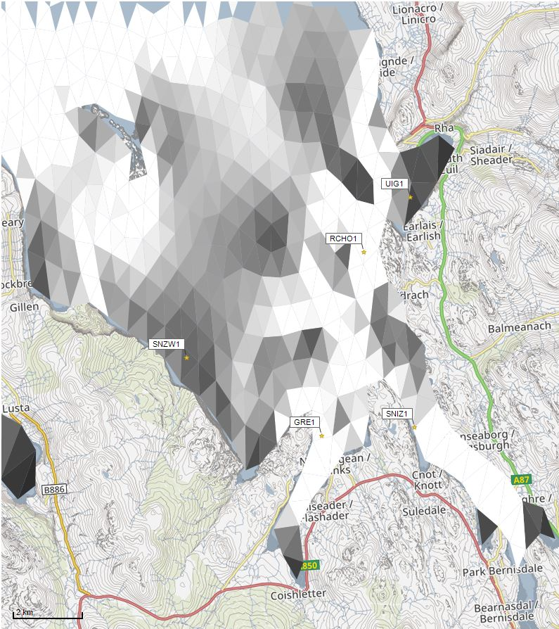

Average water speed (m/s)

©Crown copyright. All rights reserved. SEPA lic. no. 100016991 (2019).

Figure 2: Modelled average water speed (metres per second – m/s) in the sea loch around the proposed site (Loch Snizort West (SNZW1)).

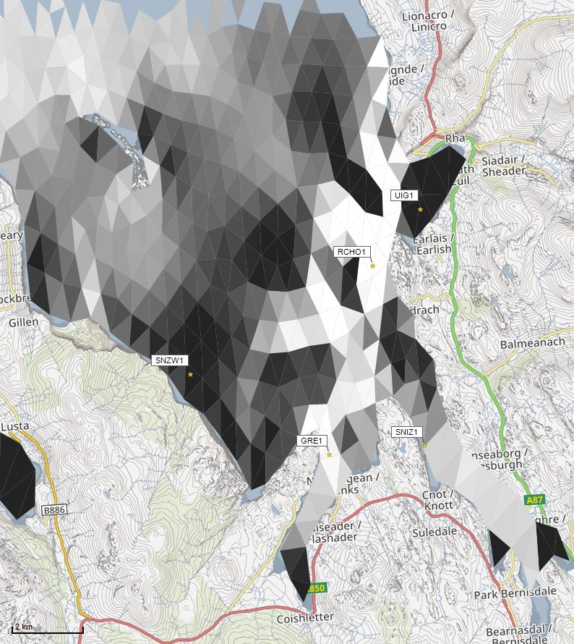

©Crown copyright. All rights reserved. SEPA lic. no. 100016991 (2019).

Percentage time (%)

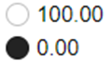

Figure 3: Modelled percentage of time the water flow speed is above 0.095 m/s in the sea area surrounding the proposed site (Loch Snizort West (SNZW1)).

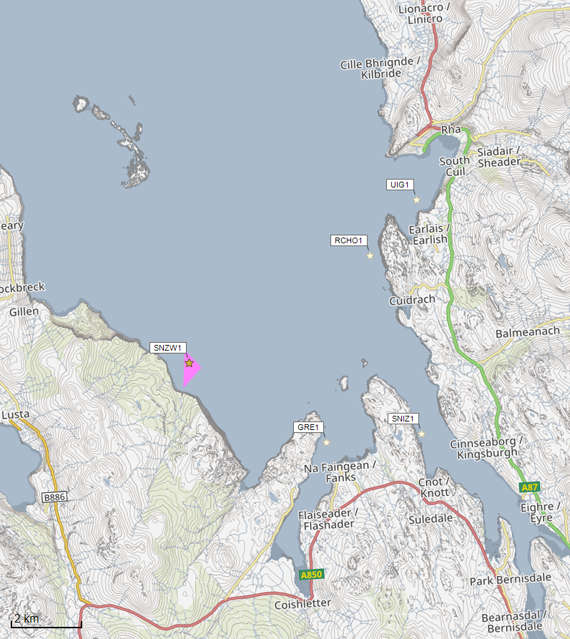

Sediment intensity values presented on this map are moderate and are presented for information only.

Sediment Intensity (g/m2)

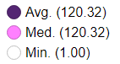

©Crown copyright. All rights reserved. SEPA lic. no. 100016991 (2019).

Figure 4: Modelled average sediment intensity over one month for the proposed site only (Loch Snizort West (SNZW1)).

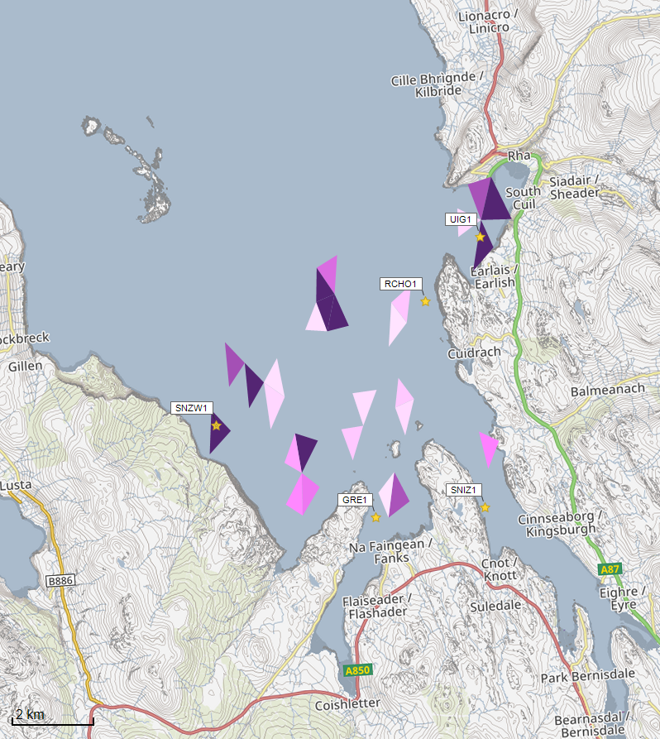Figure 5: Modelled average sediment intensity over one month for the proposed site (Loch Snizort West (SNZW1)) and other relevant sites.

Sediment intensity values presented on this map are low and are presented for information only.

Sediment Intensity (g/m2)

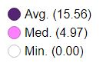

©Crown copyright. All rights reserved. SEPA lic. no. 100016991 (2019).

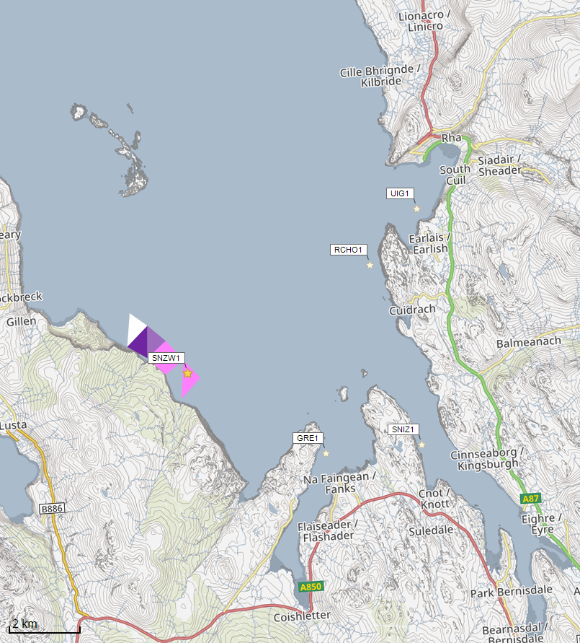Figure 6: Modelled average Azamethiphos concentration over four days from neap tide release for the proposed site only (Loch Snizort West (SNZW1)).

Concentrations of AZA presented on this map are less than the 40 ng/l Environmental Standard and are presented for information only.

©Crown copyright. All rights reserved. SEPA lic. no. 100016991 (2019).

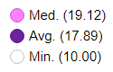

Azamethiphos Conc. (ng/l)

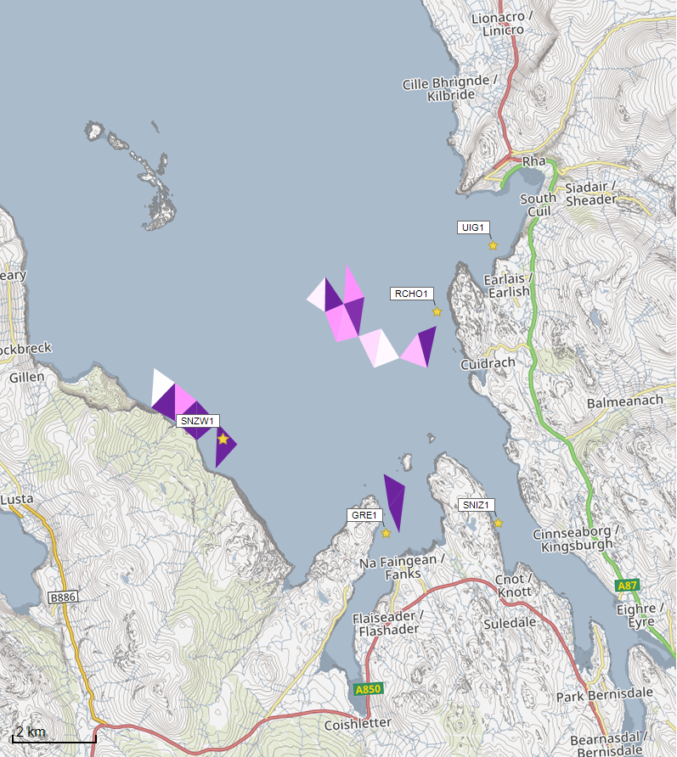Figure 7: Modelled average Azamethiphos concentration over four days from neap tide release for the proposed site (Loch Snizort West (SNZW1)) and other relevant sites.

Concentrations of AZA presented on this map are less than the 40 ng/l Environmental Standard and are presented for information only.

Azamethiphos Conc. (ng/l)

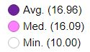

©Crown copyright. All rights reserved. SEPA lic. no. 100016991 (2019).

## Sea Lice Screening

Sea lice screening was carried out using our standard method with the translated Scottish Shelf ECLH (East Coast Lewis & Harris) sub area model. This method is outlined in in Appendix 4 of the May 2023 second consultation document: [Managing interactions between sea lice from finfish farms and wild salmonids, Proposed new regulatory framework, May 2023.](https://consultation.sepa.org.uk/regulatory-services/detailed-proposals-for-protecting-wild-salmon/)

### Modelled Sea Lice Concentration Map – SNZW1

Figure 8 shows a map of the average modelled lice concentration over the simulated April and May period (in lice/m2) within the top two meters of the sea area. Model grid cells (triangles) are coloured according to the amount of sea lice particles within them.

#### Indicative Influence

The map serves as an indicative influence under average tidal and weather conditions. The focus is on areas of potential high influence for further fish track analysis within WSPZs.

#### Exclusion of Low Concentrations

Any grid cells with concentrations below 0.01 lice/m² are not shown on the map. This exclusion helps focus on more influential concentrations on the fish track analysis and WSPZs. However, these concentrations are not excluded from fish track exposure analysis below.

#### Colour Intensity, 90th Percentile and Median Concentrations

The more intense the colour in the grid cells, the closer the concentration is to the 90th percentile of all concentrations within the model cells. This brings attention to areas of higher modelled influence. The 90th percentile of sea lice concentrations is 0.09 lice/m², meaning that 90% of the concentrations are below this value. At baseline (before the introduction of the proposed site), the average 90th percentile concentration across modelled sites was 0.04 lice/m². The median concentration is 0.04 lice/m², suggesting that half of the values are below this number.

#### Focus Area

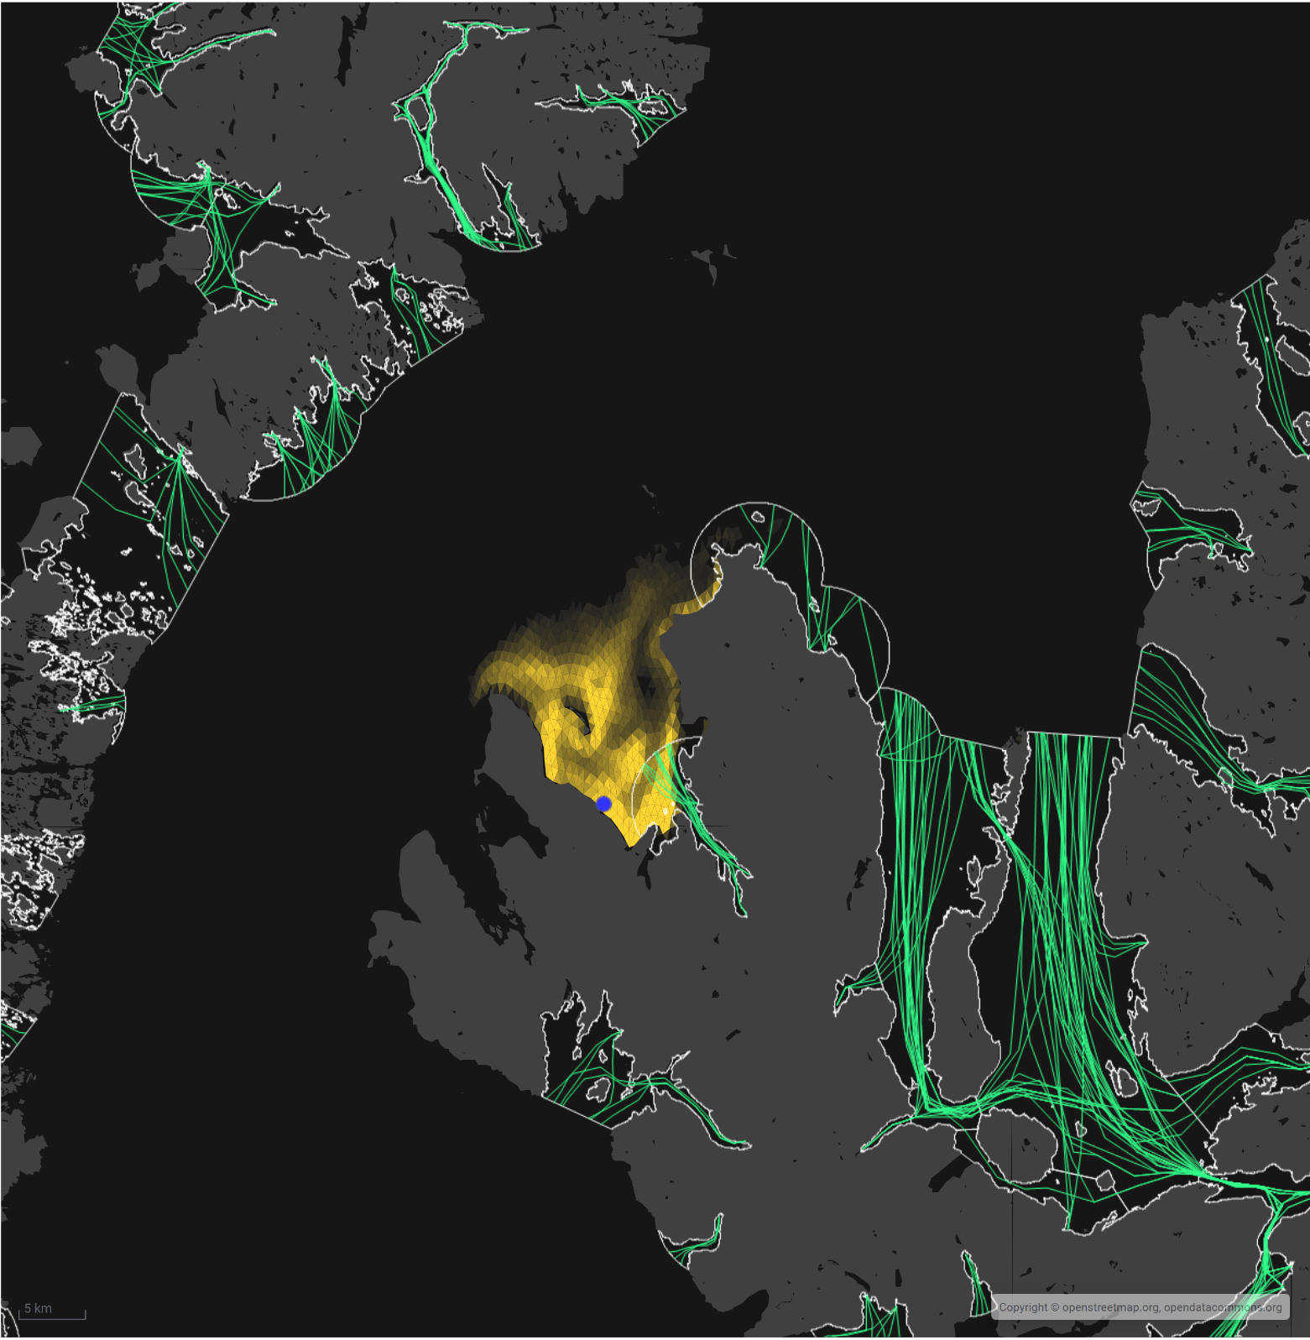The fish track exposure assessment, on which the screening outcome is based, is on the zone where the influence is highest. In this case, the highest modelled influence occurs in the Loch Snizort Beag WSPZ. This does not mean the actual modelled exposure will be high.

Figure 8: Map of the average modelled lice concentration over the simulated April and May period (in lice/m2) within the top two meters of the sea area. SNZW1 site location shown as a blue circle. Fish tracks are shown as green lines with the WSPZs, which are highlighted by a white boundary.

### Modelled Sea Lice Concentrations – Single Site Influence on Exposure – SNZW1

Table 3 shows information relating to the influence of modelled lice concentrations, from SNZW1 alone, on fish track exposure levels within the relevant WSPZs.

Table 3: Influence of modelled sea lice from SNZW1 on exposure in the relevant affected WSPZs.

| **Wild Salmon Protection Zone (WSPZ)** | **95th %ile of Fish Track Exposure (lice/m2 days)** | **% of Exposure Threshold (0.7 lice/m2 days)** |
| --- | --- | --- |
| Loch Snizort Beag | 0.14 | 18.87 |

#### WSPZ Influence

One WSPZ is influenced to a medium degree. Four other WSPZs are influenced to an extremely low degree. Exclusion of these from the table brings focus on the areas of highest influence. However, these influences are included in the combined exposure analysis below.

#### Exposure Threshold

The percentage of the exposure threshold is shown to illustrate the scale of a single site influence. The exposure influence of all sites is not simply the sum of the individual site percentages. The overlapping influence of all sites on modelled screening exposure is shown below.

#### Assessment Matrix

An assessment matrix is presented on page 57 of the SEPA December 2023 response to consultation feedback: Managing interactions between sea lice from finfish farms and wild salmonids, SEPA response to [consultation feedback](https://consultation.sepa.org.uk/regulatory-services/detailed-proposals-for-protecting-wild-salmon/), December 2023.

Using the fish track exposure method, we establish the location of SNZW1 within the assessment matrix framework of WSPZ screening capacity and site contribution. To assess the capacity influence, we take the WSPZ which experiences the greatest influence, in this case it is Loch Snizort Beag. Table 4 shows that SNZW1 lies within cell B2 (Small, Intermediate).

Table 4: Location of SNZW1 within the assessment matrix framework of WSPZ capacity and site contribution.

| **Contribution to infective-stage sea lice exposure** | **Remaining available capacity in WSPZ** | | |
| --- | --- | --- | --- |
| **Large (1)** | **Intermediate (2)** | **Little or none (3)** |
| **Negligible (A)** | A1 | A2 | A3 |
| **Small (B)** | B1 | B2  **SNZW1** | B3 |
| **Moderate (C)** | C1 | C2 | C3 |
| **Substantial (D)** | D1 | D2 | D3 |
| **Table Cell Colour Key (Permit conditions controlling on farm sea lice levels (19th March to 31st May)** | | | |
| A1 to A3, B1 to B2, C1 | No sea lice limit conditions. | | |
| B3, C2, D1 | Sea lice limits proposed by the developer and used in the screening assessment. | | |
| C3, D2 | Sea lice limits derived from an appropriate modelling assessment demonstrating that the farm will not compromise achievement of the sea lice exposure threshold. | | |
| D3 | Sea lice limits derived from an appropriate modelling assessment demonstrating that the farm will not compromise achievement of the sea lice exposure threshold. | | |

### Combined Influence of SNZW1 on all Wild Salmon Protection Zones

Using the fish track exposure method, we can calculate the latest combined influence of all sources on the exposure threshold within all WSPZs, including the proposed at the time of its submission. SNZW1 mainly affects the Loch Snizort Beag WSPZ. Its inclusion has reduced some of the remaining capacity in Loch Snizort Beag, but does not, on its own, cause the exposure threshold upper limit to be exceeded. SNZW1 has also reduced the screening capacity in a number of nearby WSPZs but to a very small degree.

## Risk Identification

The screening modelling output summarised in the *Screening modelling* section is compared against available information on features of interest (see section *Identified features which require attention*). Features which require attention are presented with any additional comments. Identified features will need to be considered during the pre-application phase.

These should be addressed in the applicant “Method Statement”. Please refer to the [Modelling Method Statement section](https://www.sepa.org.uk/regulations/water/aquaculture/pre-application/) on the SEPA Website.

### Identified features which require attention

#### Table of identified features

Sensitive features in the area have been assessed, those considered at risk and therefore requiring additional consideration, can be found in the table below.

Table 5: Table of identified features

| **Feature Name** | **Feature Type** | **Location (Easting, Northing)** | **Brief Reason for Identification** |
| --- | --- | --- | --- |
| None | None | None | None |

Several PMFs were identified, however, as these features are not known to be of national importance in this area, marine modelling will not be required.

NewDepomod Modelling will be used to set the biomass of this site and determine area of impact on surroundings.

### Additional comments on identified features

Screening modelling predicts solids will be deposited immediately below the pens and is unlikely to significantly impact the wider environment. Should marine modelling be used instead of BathAuto to get a less conservative bath medicine quantity, then the sensitive features identified in the table above should be included in the modelling. Cumulative modelling of baths is however not required.

### Risks identified from contextual site data

Should this application proceed, the total licenced biomass (approved under CAR regulatory controls) in this area would be 8945t.

Table 6: Table of licenced biomass from farms identified as likely to add to cumulative risks.

| **Site Name** | **Location (Easting, Northing)** | **Biomass (Tonnes)** | **Last Production Cycle** |
| --- | --- | --- | --- |
| **SNZW1** | 131362, 857969 | 2500 | Proposed |
| **GRE1** | 135159, 855432 | 2195 | Currently stocked (since December 2023) |
| **RCHO1** | 136749, 860700 | 2124.6 | Fish last on site December 2020 |
| **SNIZ1** | 137900, 855500 | 500 | No record of fish on site since they began in January 2011 |
| **UIG1** | 138200, 862200 | 1625.4 | Fish last on site August 2020 |

Standard default NewDepomod modelling will be required at this site.

## Conclusions of screening modelling and risk identification

Following screening modelling and risk identification we make a number of conclusions and recommendations.

### Conclusions

#### Screening Modelling

* According to screening modelling, the proposed site (Loch Snizort West (SNZW1)) is in an area of low dispersion and has a relatively low capacity for erosion of material on the seabed.
* The screening model provides a reasonable performance in the vicinity of the site when compared to observational data.
* From sediment and bath treatment modelling:
  + - Information presented in section 2 indicates that the relative influence of Loch Snizort West (SNZW1) is likely to be more intense but less widespread than other sites for a similar tonnage.
    - The influence on the surrounding sea area from Loch Snizort West (SNZW1) is likely to be moderate.
    - The areas of influence from Loch Snizort West (SNZW1), and other sites modelled do not appear to interact.
    - It is likely that discharges of bath medicines from Loch Snizort West (SNZW1) will be dispersed to low levels over a moderate area.
    - Loch Snizort West (SNZW1) is likely to result in a small increase in the total influence of all sites modelled. Any impact is expected to remain separate from areas of influence generated by existing sites.
* The proximity to locational guidelines waterbodies has been assessed and not considered a risk, however the standard ECE calculation will still be required.

#### Sea Lice Screening Modelling

Detailed information has been provided in the section called Sea Lice Screening, above.

* Sea lice screening was carried out using our standard method with the translated Scottish Shelf ECLH (East Coast Lewis &Harris) sub area model.
* The outcome of current screening is that this site will not require a lice permit condition. No further modelling work is required, at this time.

#### Risk identification

While the modelled influence on the wider environment from Loch Snizort West (SNZW1) appears to be low, with sensitive features identified as at low risk from solids due to low flow speeds at the proposed site, mean impact below the pens is likely to be the limiting factor NewDepomod Modelling at the low wave exposure thresholds (impact area no bigger than 100% of the Allowable Mixing Zone and the under-pen deposition not more than 2000g/m2/year) has to be used to set the biomass of this site and determine area of impact on surroundings.

SEPA has the responsibility of ensuring the national status of the PMFs are not significantly affected by the proposed site, therefore special attention should be given to the identified features if marine modelling is undertaken for a higher bath chemical consent than allowed by BathAuto. However, as these features are not known to be of national importance in this area, and screening modelling has predicted they are at low risk from solids, marine modelling of solids will not be required.

### Recommendations

#### Site suitability

The results presented in this report suggest that it is possible that discharges from the proposed site will be able to comply with the relevant aspects of the SEPA Aquaculture Regulatory Framework.

It is also possible that the site will be able to comply with our mixing zone regulatory framework. This will need to be demonstrated using the NewDepomod model, using the low wave exposure thresholds (impact area no bigger than 100% of the Allowable Mixing Zone and the under cage deposition not more than 2000g/m2/year).

Due to few features at risk being identified at this stage, the feasibility of the proposed site is not expected to be impacted, with respect to the regulatory framework.

The presence of very fine sediment in this area means the standard IQI monitoring may not be representative. Therefore, the applicant should investigate alternative monitoring approaches and continue engagement with SEPA on this matter during the pre-application process.

Following the engagement meeting(s), this report will be revised and this should allow to the applicant to submit a method statement which address the issues raised in this document.

#### Further modelling

* Due to the size of this farm and lack of identified risks, marine modelling is not required for this site, unless marine modelling for baths is to be undertaken.
* The resolution of the marine model, if used, should be relatively fine around the proposed site and identified features at risk.
* Flow speeds are slow at this location and standard default NewDepomod must be undertaken prior to any marine modelling to demonstrate the proposed biomass can be supported. Conditions at this site, mean low wave exposure modelling standards (impact area no bigger than 100% of the Allowable Mixing Zone and the under-cage deposition not more than 2000g/m2/year) should be met.
* The presence of very fine sediment in this area means the standard IQI monitoring may not be representative of this site. Therefore, the applicant should investigate alternative monitoring approaches and continue engagement with SEPA on this matter during the pre-application process.
* Sea lice screening has been undertaken, no further modelling or permit conditions are required for this site, at this time.

## References

[1] *Marine Modelling Guidance for Aquaculture Applications*. *Published on SEPA website.*

[2] http://marine.gov.scot/information/wider-domain-scottish-shelf-model.

## Appendices – Responses to pre-app consultation.

For the avoidance of doubt the SEPA Aquaculture Modelling Screening & Risk Identification report has been assessed on the number of marine pens and biomass proposed to SEPA for the purposes of application for authorisation under the Water Environment (Controlled Activities) (Scotland) Regulations 2011.

The number of marine pens and biomass included in the application to the local authority for planning permission may be different.

### Appendix 1 – Highland Council, Planning Department

#### Description of Proposal and Summary of Key Points

This proposal is for a new marine finfish farm site off the east coast of the Waternish peninsula in Loch Snizort in the north of Skye. It is roughly halfway between the coastal settlement of Geary/Gillen to the north and the Greshornish peninsula to the south and off a very remote, isolated and uninhabited stretch of coastal cliffs. The finite location of the farm will be dependent on feedback from this pre-application process.

The final form of the farm has also yet to be finalised but will either be an 8 x 120m or 6 x 160m cage configuration with top nets and a feed barge. Biomass is proposed at between 1000t and 2500t. Farmed species could be either Rainbow Trout or Atlantic Salmon.

Based on the information submitted it is likely that officer support for such a proposal will be forthcoming. Assuming ornithological impacts can be addressed satisfactorily, the main area of concern for the planning authority will be seascape impacts experienced from within the Greshornish Special Landscape Area and, to a lesser extent, coastal views south from the Geary settlement.

You are advised that the following consent will be required for the proposed development:

* Planning Permission

#### Planning History

Table 7: Table showing planning history

| **Reference** | **Description** | **Date of Decision** | **Outcome** |
| --- | --- | --- | --- |
| 12/01699/FUL | New salmon farm to substitute for production at Lochs Greshornish and Snizort Beag | 29.09.2014 | Withdrawn |

#### Planning Policy

National Planning Framework 4 (2023):

Policy 1 - Tackling the Climate and Nature Crises

Policy 2 - Climate Mitigation and Adaptation

Policy 3 - Biodiversity

Policy 10 - Coastal Development

Policy 29 – Rural Development

Policy 32 – Aquaculture

Highland-wide Local Development Plan (2012) (HwLDP):

Policy 28 - Sustainable Design

Policy 49 - Coastal Development

Policy 50 - Aquaculture

Policy 58 - Protected Species

Policy 61 - Landscape

Policy 72 – Pollution

.

#### Highland Council Supplementary Guidance

Aquaculture (non-statutory guide)

Highland's Statutorily Protected Species (March 2013)

Special Landscape Areas (June 2011)

#### Assessment

#### Policy Position

The proposal is likely to gain solid ‘in principle’ support from the most relevant development plan policies – NPF4 Policy 32 Aquaculture (+ HwLDP Policy 50). NPF4 Policy 29 Rural Development is also supportive in respect of the proposal’s potential contribution to local employment and the rural economy in general.

Policy 32 is heavily caveated in respect of impacts upon marine biology, of course, and this ties in with the thrust of Policies 1 and 3 in terms of addressing the nature crisis and the need for biodiversity enhancement. Further advice from SEPA, NatureScot and the Marine Directorate will be definitive in this respect, although it is recognised that impacts upon wild fish populations now fall within the regulatory remit of SEPA.

#### Siting, Design and External Appearance

The location of the proposal is remote and isolated from any extensive public views or numbers of receptors. The pre-app submission includes a set of potential viewpoint locations on which the visualisations of the proposed farm submitted with a planning application could be based. The viewpoints confirm that the farm is likely to be visible from both the Geary settlement to the north and the Greshornish SLA to the south.

In terms of views from the north where there are likely to be the most receptors (viewpoint 4), it appears likely that the farm will be seen just off the coast. However, a combination of distance and the landforms to the rear are likely to greatly reduce visual impacts and mitigate against any perception of landscape harm.

Views of the farm from Greshornish peninsula and the SLA are likely to be given more weight in any planning decision than those from a non-designated location. Viewpoints 2, 3 and 5 indicate that the farm will be visible from these SLA locations. One of the sensitivities to change identified in the SLA citation is that of “…Seaward development which would introduce man-made features in long range views…”. The existing farm off the south-eastern coast of the peninsula is regarded as a negative visual element of the SLA.

However, again, any views of the farm are going to be over significant separations distances which will limit impacts and allow the surrounding land and seascapes to absorb the visual impact of the farm. Furthermore, from viewpoints 3 and 5 it appears likely that the farm will merge into the backdrop of coastal cliffs. Only from viewpoint 2, more directly south of the proposal, might the farm have a more impactful appearance. It will sit off the coast against the open horizon as the only man-made feature in the wider seascape. However, it is not considered that this effect, taking into account distance, would be enough to justify a refusal.

#### Neighbour Amenity, Noise, Lighting and Odour

All of the above have come to the fore in dealing with planning matters at new and existing fish farms in recent years. However, given the isolation of this proposal from residential properties, it seems very unlikely that any of these considerations will feature heavily within the assessment of a future application for this proposal.

#### Protected Species

It is understood that the applicant has had extensive discussions with NatureScot regarding the potential for the proposal to impact upon the habitat of protected birds. Confidentiality in respect of this matter is required, but the planning authority understands that locations for the farm are available which both sit beyond the minimum disturbance distances for the relevant species, and which avoid a location so distant from the coast that the visual concerns identified above could become much more negative.

The proposal lies within the Inner Hebrides and the Minches SAC designated for Harbour Porpoise. However, it is not considered likely that the operations of the farm will be capable of undermining the qualifying interests of the designation.

#### Other Users of the Loch

The proposal has the potential to displace or impact upon other commercial and leisure users of these inland waters. Local information should be sought to identify whether other individuals or bodies make commercial or recreational use of these waters. The application should address this issue and any mitigation available.

#### Environmental Impact Assessment (EIA)

It is very likely that the proposal will be considered EIA development and that an Environmental Impact Assessment Report will be required to accompany any application. A screening application should be submitted as soon as the proposal is finalised into a fixed form and location.

If the application is considered EIA development the authority will be open to discussion at the scoping stage as to which environmental impacts might be scoped out and which must be fully addressed.

#### Consultees For Any Future Application

The following will likely be consulted on any planning application submitted. On occasion it may be necessary to involve consultees who are not listed below as an application progresses.

Highland Council Consultees:

* Environmental Health
* Coastal Planning Officer

External Consultees:

* SEPA
* NatureScot
* Marine Directorate
* Northern Lighthouse Board

#### Additional Information Required For Any Future Application

Based on the information provided, you are advised to submit the following additional information with any future application for formal permission. If you choose not to follow our advice and do not submit one or more of the documents, then you should provide a clear justification for doing so.

* Ecological/Species Survey
* Environmental Impact Assessment (EIA)

#### Making a Formal Application

[Online application forms and guidance](https://www.eplanning.scot/ePlanningClient/default.aspx)

#### Disclaimer

This advice is based on the information submitted and is given without prejudice to the future consideration of and decision on any application received by The Highland Council.

Pre-application case files are not publicly available but can be the subject of Freedom of Information and Environmental Information Regulations requests.

### Appendix 2 – Nature.Scot

In addition to your request to identify ‘show-stoppers’, the developer requested that we advise on headline issues, data sources and suggestions for next steps. Where possible, these are included below.

#### Summary

On the basis on the information provided to date there are no obvious ‘show-stoppers’, however provision of new data will be required in relation to a number of natural heritage sensitivities. It is too early to determine whether it will be possible to address all the constraints within the initial study area. We look forward to continuing dialogue regarding the sensitivities highlighted below.

#### Ascribs Isay and Dunvegan SAC

The boundary of the ‘Red box initial study area’ is ~3.5km from the boundary Acscrib, Isay and Dunvegan SAC, designated for harbour seals. Foraging distances vary between individuals but some seals forage close inshore within a few kilometres of haul-out sites, so seals encountered at the fish farm site are likely to be ‘SAC’ seals. Significant numbers of harbour seals have been recorded hauling out along the coast within study area. Due to this connectivity, a Habitats Regulations Appraisal (HRA) will need to be completed by the competent authority in due course and the application will need to contain sufficient detail to inform that assessment. We are currently reviewing the Conservation and Management Advice for this site, which includes revised [Conservation Objectives](https://sitelink.nature.scot/site/8193), and this will be published within the next few weeks.

We advise that the new farm should be designed to remove or avoid pressures including entanglement, the lethal control of predators, and the use of acoustic deterrent systems. Contingency plans for recapturing any escaped farmed fish should also consider the risk of entanglement of seals. Opportunities to reduce or limit pressures associated with new boat use should also be considered (e.g. avoiding haul outs and/or reducing boat speed).

#### Inner Hebrides and the Minches SAC

The study area lies within the Inner Hebrides and the Minches SAC, designated for harbour porpoise. A Habitats Regulations Appraisal (HRA) will need to be completed by the competent authority and the application will need to contain sufficient detail for that assessment to be completed. [Conservation and Management Advice](https://apps.snh.gov.uk/sitelink-api/v1/sites/10508/documents/59) (CMA) for this site including the current Conservation Objectives.

We advise that the new farm should be designed to reduce or limit pressures including entanglement and the use of acoustic deterrent systems. The CMA refers to ADD deployment plans, however it would be useful to establish whether ADDs are proposed. Contingency plans for recapturing any escaped farmed fish should also consider the risk of entanglement of harbour porpoise. We recommend excluding the use of drift nets and nets set on the seabed (tangle, trammel, gill) to avoid the risk of entanglement/bycatch of harbour porpoise. Opportunities to reduce or limit risk of collisions and disturbance associated with boat use should also be considered.

#### Gannet and seabird SPAs

Gannets have been recorded becoming entrapped/entangled in pole mounted top nets at fish farms in Scotland. The foraging distances of gannets means there is connectivity with a number of SPAs (e.g. St Kilda). Guidance on top net mesh sizes and reporting is provided in our [briefing note](https://www.nature.scot/doc/interim-technical-briefing-note-pole-mounted-top-nets-and-birds-finfish-farms). This guidance is currently being reviewed but in the meantime the interim guidance should continue to be used.

#### Benthic

Little existing marine survey data is available for outer Loch Snizort (summarised below).

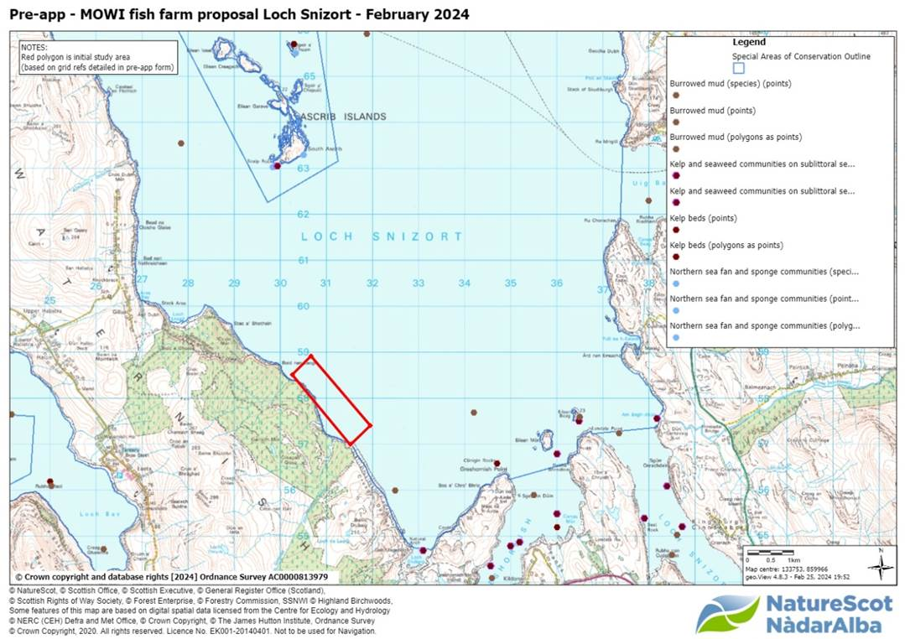

Figure 9. PMFs in the vicinity of the proposed farm.

The closest MNCR survey site is located at NG 325560, approximately 1.4km SE of the Red box boundary. This is described as ‘steep and vertical bedrock from 17-25m bcd and boulder slope from 25-33m bcd. At 33m bcd a sediment plain of mud, shell gravel, fine sand and empty shells’. This is an example of burrowed mud habitat which is a Priority Marine Feature but screening modelling has shown the proposal unlikely to influence this.

To assess the **application** and its likely impacts, we will require:

· The NewDepomod deposition modelling report

· Appropriate visual and grab surveys in and around the farm’s predicted area of impact which details the presence, extent and quality of any [PMFs](https://www.nature.scot/professional-advice/protected-areas-and-species/priority-marine-features-scotlands-seas)

· If necessary, consideration of measures to avoid or minimise significant adverse effects on PMF habitat.

#### Protected bird species

Protected species may be affected by these proposals. This aspect is covered in separate correspondence.

#### Landscape and Visual Impacts

We advise that site selection, siting and design of the proposed development should follow our published guidance and particularly:

· [The siting and design of aquaculture in the landscape: visual and landscape considerations](https://eur01.safelinks.protection.outlook.com/?url=https%3A%2F%2Fdigital.nls.uk%2Fpubs%2Fe-monographs%2F2020%2F216586078.23.pdf&data=05%7C02%7Caquaculture.pre-app%40sepa.org.uk%7Cce628e07b24f408f00d408dc36b13c85%7C5cf26d65cf464c72ba827577d9c2d7ab%7C0%7C0%7C638445382344815002%7CUnknown%7CTWFpbGZsb3d8eyJWIjoiMC4wLjAwMDAiLCJQIjoiV2luMzIiLCJBTiI6Ik1haWwiLCJXVCI6Mn0%3D%7C0%7C%7C%7C&sdata=SEO7Oqj28ihkZe4XdefR8eSNB2ABOQOmeHHUm7hCi%2FU%3D&reserved=0)

· [Guidance on Landscape/Seascape Capacity for Aquaculture](https://eur01.safelinks.protection.outlook.com/?url=https%3A%2F%2Fdigital.nls.uk%2Fpubs%2Fe-monographs%2F2020%2F216588446.23.pdf&data=05%7C02%7Caquaculture.pre-app%40sepa.org.uk%7Cce628e07b24f408f00d408dc36b13c85%7C5cf26d65cf464c72ba827577d9c2d7ab%7C0%7C0%7C638445382344820971%7CUnknown%7CTWFpbGZsb3d8eyJWIjoiMC4wLjAwMDAiLCJQIjoiV2luMzIiLCJBTiI6Ik1haWwiLCJXVCI6Mn0%3D%7C0%7C%7C%7C&sdata=n8h1b6n13wQtYuVHRLgQ0MuvdOAlVpXV6dyQFRPwt8Q%3D&reserved=0)

The guidance relating to ‘open and expansive coasts’ is likely to be most relevant in this location. Early production of a ZTV would assist with the identification of key viewpoints, and wirelines from agreed VPs would be useful in assessing the various siting and design options for both cages and feed barge (including considering coastal alignment). Early consideration of the colour of the feed barge is also recommended as this can draw attention to the farm and barges are difficult to repaint once installed.

Please let me know if you require any clarification.

Regards

### Appendix 3 – Marine Directorate - Licensing Operations Team (MD-LOT)

#### MOWI – Loch Snizort – Isle of Skye

Thank you for contacting Marine Directorate – Licensing Operations Team (MD-LOT), the regulator of licensable marine activities on behalf of the Scottish Ministers under the Marine (Scotland) Act 2010. Under the Marine (Scotland) Act 2010 s. 21, it is a licensable marine activity to deposit any substance or object within the Scottish marine area, either in the sea or on or under the seabed, from any of the following (a) a vehicle, vessel, aircraft or marine structure, (b) a container floating in the sea, or (c) a structure on land constructed or adapted wholly or mainly for the purpose of depositing solids in the sea. This includes deposit of fish farm equipment.

Article 12 “Propagation and cultivation of fish – deposits” of the Marine Licensing (Exempted Activities) (Scottish Inshore Region) Order 2011 however states that the deposit of any trestle, raft, cage, pole, rope, line or within controlled waters, any substance which is liable to cause pollution of the water environment, in the course of the propagation or cultivation of fish is an exempted activity, provided that the relevant conditions are met. The conditions are that the deposit is not made for the purpose of disposal; not made for the purpose of creating, altering or maintaining an artificial reef; or that it causes or is likely to cause obstruction or danger to navigation. It is the applicant's responsibility to ensure they meet the conditions if they intend to apply the exemption to their activities.

MD-LOT does not carry out any assessments about the suitability of the location for a fish farm, nor does it assess impacts on environment, human health or legitimate uses of the sea during the pre-application stage. Any such assessments are carried out at marine licence application determination stage, if required, and rely on stakeholder consultation. A marine licence can only be granted after planning permission for the farm has been granted.

To facilitate the pilot pre-application process and to advise other relevant authorities and the developer, MD-LOT has carried out a Geographic Information System (GIS) check for sensitivities and features of interest in the vicinity of the proposed farm. The results of the GIS check are shown below and are based on the data currently available to MD-LOT. This is not an exhaustive list of all relevant sensitivities, and this information alone should not be used to determine what issues the developer may need to consider during the application process. MD-LOT is providing this information to the other relevant authorities and the developer in good faith and without pre-judgement of any potential application. MD-LOT does not intend to carry out further analysis of the suitability of the proposal based on these findings.

We hope this information is helpful.

Kind regards,

**Summary of GIS checks**

Previously licensed sites: 0

Seal haul out sites: 0

Sea deposit sites: 0

Wrecks: 0

No other issues identified

### Appendix 4 – Historic Environment Scotland

#### Loch Snizort - Proposal to establish a new marine finfish site Pre-application consultation

We have received the above consultation on 30 January 2024 from the applicant under the fish farm consenting pilots. We have reviewed the information in terms of our historic environment interests. This covers world heritage sites, scheduled monuments and their settings, category A-listed buildings and their settings, inventory gardens and designed landscapes, inventory battlefields and historic marine protected areas (HMPAs).

The Highland Council’s archaeological and conservation advisors will also be able to

offer advice for their interests. This may include undesignated archaeological sites, category B- and C-listed buildings and conservation areas.

#### Our Advice

From the information provided we have not identified any likely significant effects on our interests as a result of the proposals. We therefore have no comments to make regarding the proposals.

We hope this is helpful. Please contact us if you have any questions about this response.

Yours sincerely

**Historic Environment Scotland**

### Appendix 5 – Northern Lighthouse Board

To whom it may concern,

The NLB have reviewed the initial documents sent through for the plans in Loch Snizort as attached. Barring any changes to the plans, should permission be granted for this site by the local authority, we don’t see any issues from a navigation point of view that cannot be mitigated by the development of a lighting and marking solution and submission of the site design and coordinates to the UKHO for inclusion in appropriate charts of the area.

At the point when we are consulted as part of the planning process, there should be no issues in providing you with a lighting and marking stipulation for the site.

Regards

#### Official - Northern Lighthouse Board Email

### Appendix 6 – Maritime and Coastguard Agency

Thank you for the opportunity to comment on the pre-application documents for the pilot at Loch Snizort West. The Maritime and Coastguard Agency (MCA) has an interest in the works associated with the marine environment, and the potential impact on the safety of navigation, access to ports, harbours and marinas and any impact on our search and rescue obligations.

I can confirm that the MCA has no concerns to raise at this stage on the proposals from the shipping and safe navigation perspective. We are content that any increase in risk to other marine users can be mitigated through suitably worded conditions and/or advisories at formal marine licence application stage or exemption notification stage.

Kind regards

### Appendix 7 – Marine Directorate - FF Planning

#### Pre-application request through the new consenting pilot for new site at Snizort, Loch Snizort, Isle of Skye by Mowi Scotland Ltd.

Scottish Government’s Marine Directorate (SGMD) (previously known as Marine Scotland) have reviewed the pre-application request submitted and offer the following comment:

Based on the information currently available, SGMD does not highlight any specific “showstoppers”.

We include information below that the applicant may wish to be aware of.

#### Environmental Impacts

Further information may be requested covering the following:

* Benthic impacts.
* Water column impacts.
* Sea lice efficacy.

#### Aquaculture Animal Health

The proposed Snizort site located at E131362, N857969 will be included in disease management area (DMA) 12a Snizort, and on activation will extend the current boundary of this existing DMA north west without resulting in joining of adjacent DMA’s.

In addition to the usual information requirements, the applicant will also be required to provide;

* detailed information of the stocking plan for both salmon and trout,
* details of the infrastructure in place for handling 160m pens including details of staff knowledge and experience.

As further details of the proposal are confirmed, more specific information may be required.

#### Wild Fisheries

The proposed site has the potential to adversely affect local sea trout populations. Therefore, an Environment Management Plan will be requested. The applicant will note that from March 2025 SEPA expect to implement an adaptive approach to manage interactions between sea lice from fish farms and sea trout. An option here is to include an appropriate review date for the EMP that allows for its removal in favour of including the site in the national framework on its implementation.

#### Notes to applicants:

The Aquatic Animal Health (Scotland) Regulations 2009 requires the authorisation of all Aquaculture Production Businesses (APB's) in relation to animal health requirements for aquaculture animals and products thereof, and on the prevention and control of certain diseases in aquatic animals.  The authorisation procedure is undertaken on behalf of the Scottish Ministers by the Fish Health Inspectorate (FHI) at the Marine Directorate Marine Laboratory.  To apply for authorisation for an APB or to amend details of an existing APB or any site that an APB is authorised to operate at, you are advised to contact the FHI as follows:  Fish Health Inspectorate, Marine Directorate Marine Laboratory, 375 Victoria Road, Aberdeen, AB11 9DB.  Tel: 0131 244 3498;  Email:  [ms.fishhealth@gov.scot](mailto:ms.fishhealth@gov.scot)

All marine farms, whether finfish, shellfish or algal, are required to apply for a marine licence under Part 4 of the Marine (Scotland) Act 2010. To apply for a marine licence, or to amend details of an existing marine licence (formally Coast Protection Act 1949 – Section 34 consent), please visit the Scottish Government’s website at [http://www.gov.scot/Topics/marine/Licensing/marine/Applications](http://www.scotland.gov.uk/Topics/marine/Licensing/marine/Applications) where application forms and guidance can be found. Alternatively you can contact the Marine Directorate Licensing Operations Team (MD-LOT) by emailing [MS.MarineLicensing@gov.scot](mailto:MS.MarineLicensing@gov.scot); or calling 0300 244 5046.

Yours sincerely

Marine Directorate of the Scottish Government

For information on accessing this document in an alternative format or language, please contact SEPA by emailing [equalities@sepa.org.uk](mailto:equalities@sepa.org.uk)

If you are a user of British Sign Language (BSL), the Contact Scotland BSL service gives you access to an online interpreter, enabling you to communicate with us using sign language. [contactscotland-bsl.org](http://contactscotland-bsl.org/)