

# Aquaculture Modelling Screening & Risk Identification Report: Vemetry (VMNT1)

Report date: July 2024

## Scope of report

As part of the SEPA Aquaculture Regulatory Framework it is recommended that a proposed application for a marine fin fish aquaculture site should undergo a Screening Modelling and Risk Identification process. SEPA carries out this work and this is described on the SEPA aquaculture website [**Pre-application section**](https://www.sepa.org.uk/regulations/water/aquaculture/pre-application/)

This report presents information arising from that process. Screening modelling methods are outlined and maps and tables describing the modelled impacts are shown. Risks arising from consideration of the model output are listed. Conclusions and recommendations are made regarding the proposed site.

## Executive summary

SEPA has received a proposal for a new marine fin fish aquaculture site called Vementry (VMNT1). The site is located within Swarbacks Minn, Shetland, at location: 430363, 1161477 (Easting, Northing). The proposed weight of fish to be farmed is 3000t.

Following screening modelling and risk identification we have concluded the following:

* As an additional new farm, Vementry (VMNT1), may be able to comply with the relevant aspects of the SEPA Aquaculture Regulatory Framework. Due to its proximity to a Cat 1. Waterbody (Northra Voe), modelling will need to demonstrate that there is no increase in solids/nutrient input into this waterbody. (In order to do this the relinquishment/ reduction in licenced biomass at the nearby NOR1 farm may be necessary.)
* Features at risk, identified at this stage, may influence the feasibility of the proposed site with respect to the regulatory framework. These risks should be examined using a detailed marine model.
* Vementry (VMNT1), may be suitable to progress to the next stage of the pre-application process outlined on the SEPA website.
* Contextual site information suggests Vementry (VMNT1), may be able to comply with mixing zone standards. NewDepomod modelling should be undertaken for the proposed site.
* Baseline information will also be required to assess the suitability of the new location. Most likely this will be provided in the form of a visual survey (as per [guidance](https://www.sepa.org.uk/regulations/water/aquaculture/pre-application/), unless similarly detailed information can be gathered from other sources

## List of abbreviations

SEPA Scottish Environment Protection Agency

## List of chemical abbreviations

AZA Azamethiphos

Contents

Aquaculture Modelling Screening & Risk Identification Report: VEMENTRY (VMNT1) 1

Scope of report 2

Executive summary 2

List of abbreviations 4

List of chemical abbreviations 4

List of Figures 6

List of Tables 7

Introduction 8

Screening modelling 13

Risk Identification 15

Conclusions of screening modelling and risk identification 23

References 27

## List of Figures

Figure 1. Proposed location of Vementry (VMNT1), and surrounding farms with an active CAR licence. 13

Figure 2. Shapefiles of identified features around the proposed site (Vementry (VMNT1)). 19

Figure 3. Figure showing locations of nearby Cat 1. (red) and Cat 2. (orange) waterbodies. 21

## **List of Tables**

Table 1: Table of identified features 15

Table 2: Table of licenced biomass from farms identified as likely to add to cumulative risks. 21

## Introduction

Screening Modelling and Risk Identification are important steps in the SEPA regulatory framework for marine pen fish farms. They are carried out by SEPA at the [**pre-application stage**](https://www.sepa.org.uk/regulations/water/aquaculture/pre-application/)**.**

This document briefly describes the objectives of screening and risk identification and summarises the methods used. Screening output for the proposed site is then presented with comments. Risks identified from the screening output are detailed. Conclusions and recommendations about the suitability of the proposed site are then made.

### The objectives of screening modelling and risk identification

A summary of the modelling methods employed during screening modelling is outlined in the screening modelling methods section. The objectives of screening modelling and risk identification are outlined below.

#### Screening modelling

Marine Modelling technology can be used to simulate and predict the potential influence of discharges on the marine environment. SEPA will require the majority of proposed farms to conduct detailed marine modelling, as outlined in our Aquaculture Modelling guidance [1] and on the SEPA Website.

Marine modelling can also be used at an earlier stage to provide an initial estimate of the influence of material discharged from a proposed site.

SEPA will carry out marine modelling at the screening and risk identification stage. This is a simplified version of the detailed modelling required of the applicant. However, it will be sufficient to perform an initial risk assessment of a proposal. Screening marine modelling will also include discharges from other relevant aquaculture sites and major sources.

The objectives of the simplified screening modelling are to:

* Produce maps of the predicted dispersive and erosive capacity of the sea areas in the vicinity of aquaculture sites
* Produce maps of the predicted spread of sediment discharged from aquaculture sites
* Produce maps of the predicted spread of bath treatment medicines from aquaculture sites
* Present an analysis of the potential influence of sediment and bath treatment discharges from the proposed site alongside existing sites within the surrounding sea area
* Present information on the sensitive features and sites of interest within the surrounding sea area, which must be addressed during pre-application work
* Present a summary of the suitability of the proposal with respect to the dispersal of waste and how this may be modelled.

#### Risk identification

Maps and analysis of screening output will be compared to information relating to sensitive features and relevant areas of interest. These may include:

* Marine Protected Area (MPA)
* Special Area of Conservation (SAC)
* Priority Marine Feature (PMF)
* Any site identified via consideration of other permitted or regulatory activities.

SEPA Staff will meet to discuss screening model output and the relevant sensitive features information. Following this meeting, a list of identified risks will be added to this report.

#### Conclusion of screening modelling and risk identification

Following the identification of risks, SEPA will present a summary of the suitability of the proposal with respect to the:

* Dispersal of waste from the proposed site and other sources
* Risks posed to sensitive features
* Likely level of modelling that will be required to address the risks identified.

### Screening modelling methods

Marine models divide the sea up into a “grid” of boxes or triangles (often called cells). Each of these is given a water depth. This grid has been set up within a marine modelling software package called MIKE 21 which is manufactured by the company DHI A/S (https://www.dhigroup.com/).

Marine models carry out calculations across a grid to work out how seawater moves and mixes in response to tidal and weather forces. Marine models can also be used to simulate how seawater moves and mixes due to salinity and temperature differences across an area, particularly in response to inputs of freshwater from rivers. For pollutant influence assessments the mixing (dispersion) of dissolved (bath medicine) and particulate (sediment) pollutants can also be estimated. Calculations within a marine model can be performed in three dimensions (3D), where the grid is split into layers to better represent how properties of the sea change with depth. Two dimensional (2D) models can also be created where processes over the water depth are simplified. The amount of mixing in a marine model can be varied using settings in the software.

Screening modelling is currently carried out with 2D models using average mixing settings in the model software. In many areas, this approach will be sufficient to make an initial estimate of the influence of a proposed site. Our screening assessment will take into account factors which may limit a 2D approach. We will also consider whether a particular location is adequately represented by the available models.

#### Water movement and mixing modelling

Water movement and mixing modelling (hydrodynamics) has been carried out to generate one month of results. The boundaries (edge(s) of) the model have been driven using the “wider domain” Scottish Shelf Model [2]. Wind forces and freshwater inputs have been applied to the model from the same source. The results generated are an estimate of the average water movement and mixing conditions within the model area.

#### Sediment waste modelling

Screening modelling provides a precautionary and indicative estimate of the size, location and intensity of waste organic material released from aquaculture sites.

The release of sediment from sources within the model area is simulated using one month of hydrodynamic results along with particle tracking modelling technology. Virtual particles are continually introduced to the model grid to represent the potential dispersion of sediment from the sources. Particles in the model are moved and mixed by the hydrodynamics. Additionally, particles are assigned simplified properties, which allow them to settle through the water and be re-suspended (eroded and lifted) from the seabed.

#### Bath medicine modelling

Screening modelling provides a precautionary and indicative estimate of the size, location and concentration of bath medicine releases.

The release of bath treatment medicine from sources within the model area is simulated using hydrodynamic results along with particle tracking modelling technology. Virtual particles are introduced to the model grid to represent the potential dispersion of bath medicines from the sources. Particles in the model are moved and mixed by the hydrodynamics. Releases of bath medicines are simulated under worst case mixing (dispersion) conditions, which occur under neap tides. The maximum treatment amount likely to be used at each site is released into the model at the same time and plumes are tracked over the following 96 hours (4 days). Treatment amounts used at screening have been derived from an analysis of historical data. Additionally, all bath medicine particles are concentrated within the top 5 m of the sea area. As all bath medicines are likely to disperse in a similar way, only Azamethiphos (AZA) has been modelled at the screening stage.

#### Nutrient assessment

Whilst nutrients are not directly modelled during screening, the dispersion of bath medicine releases will give an indication of the likely level of nutrient dispersion. This will be considered alongside any pre-existing nutrient assessment information that may be available.

#### Analysis of modelling output

SEPA processes the screening modelling output and places it into a standard analysis application built in TIBCO Spotfire. The application allows for the production of standard maps and tables, which are presented below.

## Screening modelling

### Site proposal

A risk assessment has been carried out for a new farm Vementry (VMNT1). The proposal is to site the farm at location: 430363, 1161477 (Easting, Northing) (Fig.1). The proposed weight of fish to be farmed is 3000t.

For the risk assessment presented here all relevant licenced sites and current applications have been considered in conjunction with the proposed site.

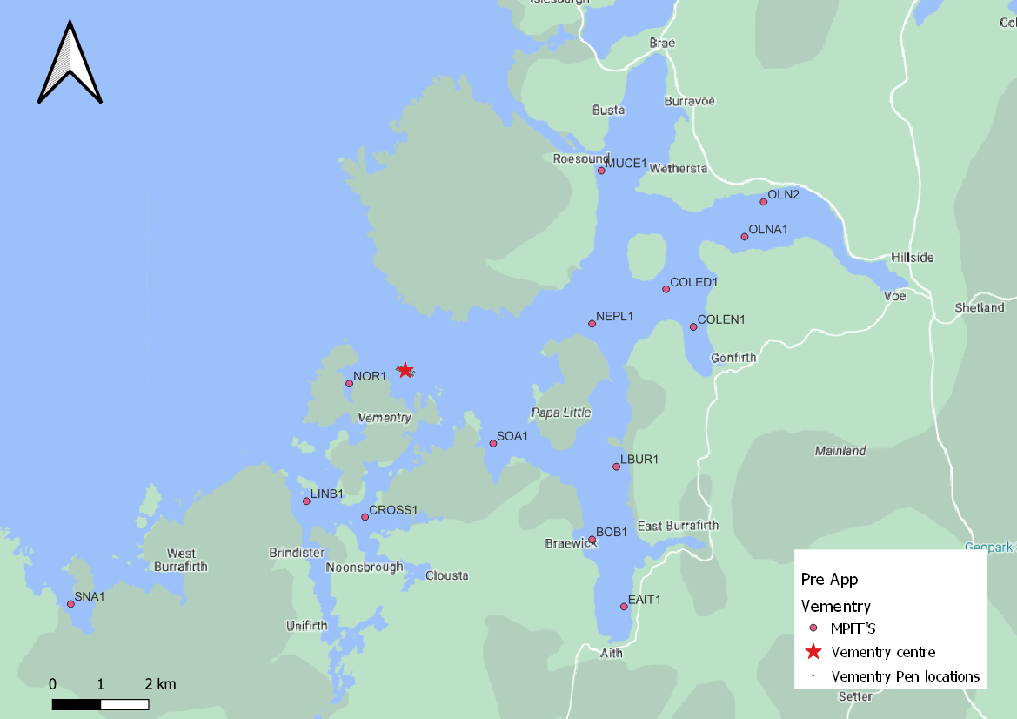

Figure 1. Proposed location of Vementry (VMNT1), and surrounding farms with an active CAR licence.

#### Accuracy of model in the area surrounding the proposal

The Pentland Firth and Orkney Waters model which covers this area, has very low resolution over the entirety of Shetland, making it unusable for the purposes of screening modelling. A new Shetland model is currently in development, however for this application, screening modelling has not been undertaken, and other evidence has instead been considered.

Marine fin fish aquaculture farms using open-net pens will benefit from operating in locations where there are strong, repeating, water currents to erode and disperse waste.

For the purposes of screening we consider locations which meet the following water flow criteria to be generally suitable for larger farms:

Locations with average water flow speeds of greater than, or equal to, 0.12 metres per second (0.23 knots)

Locations where water flow speeds are often above the threshold of 0.095 meters per second (0.18 knots).

Locations with these properties are likely to disperse discharged material rapidly, and regularly erode sediment discharged to the seabed. In general, we would look for these properties to be maintained over a large area around a proposed site.

The thresholds stated above are indicative.

Based on the maps of the modelled water flow properties we can make the following observations about the proposed site location:

* It lies in a moderate dispersion area.
* It lies in an area where water flow has a moderate capacity to erode material on the seabed.

## Risk Identification

The screening modelling output summarised in section 2 is compared against available information on features of interest (see section 1.1.2). Features which require attention are presented with any additional comments. Identified features will need to be considered during the pre-application phase.

These should be addressed in the applicant “Method Statement”. Please refer to the [Modelling Method Statement section](https://www.sepa.org.uk/regulations/water/aquaculture/pre-application/) on the SEPA Website.

### Identified features which require attention

#### Table of identified features

Sensitive features in the area have been assessed, those considered at risk and therefore requiring additional consideration, can be found in the table below.

Table 1: Table of identified features

| **No.** | **Feature Name** | **Feature Type** | **Location (Easting, Northing)** | **Brief Reason For Identification** |
| --- | --- | --- | --- | --- |
| **1** | AAC3 | Fish Farm | 178948.2, 837783  Fig. 1 | At risk from sediment interaction |
| **2** | BOB1 | Fish Farm | 434243, 1157972  Fig. 1 | At risk from sediment interaction |
| **3** | COLED1 | Fish Farm | 435782.1, 1163170  Fig. 1 | At risk from sediment interaction |
| **4** | COLEN1 | Fish Farm | 436350.9, 1162387  Fig. 1 | At risk from sediment interaction |
| **5** | CROSS1 | Fish Farm | 429526.9, 1158439  Fig. 1 | At risk from sediment interaction |
| **6** | EAIT1 | Fish Farm | 434906, 1156578  Fig. 1 | At risk from sediment interaction |
| **7** | LBUR1 | Fish Farm | 434749.1, 1159483  Fig. 1 | At risk from sediment interaction |
| **8** | LINB1 | Fish Farm | 428309.2, 1158767  Fig. 1 | At risk from sediment interaction |
| **9** | MUCE1 | Fish Farm | 434435, 1165632  Fig. 1 | At risk from sediment interaction |
| **10** | NEPL1 | Fish Farm | 434244.1, 1162453  Fig. 1 | At risk from sediment interaction |
| **11** | NOR1 | Fish Farm | 429200.2, 1161211  Fig. 1 | At risk from sediment interaction |
| **12** | OLN2 | Fish Farm | 437808.7, 1164984  Fig. 1 | At risk from sediment interaction |
| **13** | OLNA1 | Fish Farm | 437414.1, 1164260  Fig. 1 | At risk from sediment interaction |
| **14** | SOA1 | Fish Farm | 432188.9, 1159966  Fig. 1 | Risk from sediment and bath influence |
| **15** | SS0056 -The Strand | Shellfish Farm | 135700, 689700  Fig. 2 | Risk from sediment and bath influence |
| **16** | SS0186 - Westshore | Shellfish Farm | 429500, 1157500  Fig. 2 | Risk from sediment and bath influence |
| **17** | SS0312 - Bight of Kurkigarth | Shellfish Farm | 439700, 1163500  Fig. 2 | Risk from sediment and bath influence |
| **18** | SS0500 - Suthra Voe | Shellfish Farm | 429400, 1160400  Fig. 2 | Risk from sediment and bath influence |
| **19** | SS0588 - North Voe of Clousta | Shellfish Farm | 430200, 1158400  Fig. 2 | Risk from sediment and bath influence |
| **20** | SS0600 - Bight of Cliffs | Shellfish Farm | 439100, 1164600  Fig. 2 | Risk from sediment and bath influence |
| **21** | SS0601 - Park Gate | Shellfish Farm | 438500, 1165100  Fig. 2 | Risk from sediment and bath influence |
| **22** | SS0617 - East of Burki Taing | Shellfish Farm | 431800, 1162700  Fig. 2 | Risk from sediment and bath influence |
| **23** | SS0641 - Linga | Shellfish Farm | 435900, 1164000  Fig. 2 | Risk from sediment and bath influence |
| **24** | SS0642 - Quilse | Shellfish Farm | 438500, 1164300  Fig. 2 | Risk from sediment and bath influence |
| **25** | SS0650 - Seggi Bight | Shellfish Farm | 429700, 1159400  Fig. 2 | Risk from sediment and bath influence |
| **26** | SS0651 - Papa Little, Aith Voe | Shellfish Farm | 434100, 1160100  Fig. 2 | Risk from sediment and bath influence |
| **27** | SS0670 - Lee, Busta Voe | Shellfish Farm | 434500, 1164900  Fig. 2 | Risk from sediment and bath influence |
| **28** | SS0671 - Busta Voe | Shellfish Farm | 434600, 1166200  Fig. 2 | Risk from sediment and bath influence |
| **29** | SS0672 - Holm of East Burra Firth | Shellfish Farm | 435300, 1157800  Fig. 2 | Risk from sediment and bath influence |
| **30** | SS0677 - Foula Wick | Shellfish Farm | 437000, 1164800  Fig. 2 | Risk from sediment and bath influence |
| **31** | SS0679 - Wrawick | Shellfish Farm | 432700, 1167000  Fig. 2 | Risk from sediment and bath influence |
| **32** | SS0696 -West Side of Aith Voe | Shellfish Farm | 434400, 1157000  Fig. 2 | Risk from sediment and bath influence |
| **33** | SS0698 - Grunigill | Shellfish Farm | 428800, 1156700  Fig. 2 | Risk from sediment and bath influence |
| **34** | SS0699 - Pynch Dyke | Shellfish Farm | 436600, 1164700  Fig. 2 | Risk from sediment and bath influence |
| **35** | SS0704 - Point of Sletta Aith Voe | Shellfish Farm | 434200, 1158800  Fig. 2 | Risk from sediment and bath influence |
| **36** | SS0715 - Uyeasound, Vementry | Shellfish Farm | 430700, 1160200  Fig. 2 | Risk from sediment and bath influence |
| **37** | SS0723 - Treawick | Shellfish Farm | 428900, 1159200  Fig. 2 | Risk from sediment and bath influence |
| **38** | SS0724 - The Ham, Papa Little | Shellfish Farm | 433500, 1161600  Fig. 2 | Risk from sediment and bath influence |
| **39** | SS0725 - Boat Geo | Shellfish Farm | 433200, 1163100  Fig. 2 | Risk from sediment and bath influence |
| **40** | SS0726 - Braganess | Shellfish Farm | 431900, 1160600  Fig. 2 | Risk from sediment and bath influence |
| **41** | SS0727 - Cole Ness Shellfish | Shellfish Farm | 435400, 1162400  Fig. 2 | Risk from sediment and bath influence |
| **42** | SS0757 - Slyde (Aith Voe) | Shellfish Farm | 434800, 1158600  Fig. 2 | Risk from sediment and bath influence |
| **43** | SS0758 - North Knowe | Shellfish Farm | 434400, 1164200  Fig. 2 | Risk from sediment and bath influence |
| **44** | SS0768 | Shellfish Farm | 430500, 1160800  Fig. 2 | Risk from sediment and bath influence |
| **45** | SS0769 - North East of Aithness | Shellfish Farm | 433300, 1159500  Fig. 2 | Risk from sediment and bath influence |
| **46** | SS0778 - Longa Ness | Shellfish Farm | 428700, 1158300  Fig. 2 | Risk from sediment and bath influence |
| **47** | SS0781 - Budda Scord | Shellfish Farm | 434100, 1163600  Fig. 2 | Risk from sediment and bath influence |
| **48** | SS0782 - Hevden Ness | Shellfish Farm | 435700, 1165800  Fig. 2 | Risk from sediment and bath influence |
| **49** | SS0783 - North Linga | Shellfish Farm | 435500, 1164500  Fig. 2 | Risk from sediment and bath influence |
| **50** | SS0784 - Wetherstaness | Shellfish Farm | 435800, 1164700  Fig. 2 | Risk from sediment and bath influence |
| **51** | SS0808 - Holms of Uyeasound | Shellfish Farm | 431200, 1160700  Fig. 2 | Risk from sediment and bath influence |
| **52** | SS0838 - Brindister Inshore | Shellfish Farm | 428500, 1157500  Fig. 2 | Risk from sediment and bath influence |
| **53** | SS0843 - Mill Bight | Shellfish Farm | 431200, 1160000  Fig. 2 | Risk from sediment and bath influence |
| **54** | SS0855 - Bight of Warwick | Shellfish Farm | 434200, 1160900  Fig. 2 | Risk from sediment and bath influence |
| **55** | SS0856 - Houbanster | Shellfish Farm | 434700, 1162300  Fig. 2 | Risk from sediment and bath influence |
| **56** | SS0857 - Millburn | Shellfish Farm | 434700, 1160600  Fig. 2 | Risk from sediment and bath influence |
| **57** | SS0864 - Moo Ness | Shellfish Farm | 433000, 1160200  Fig. 2 | Risk from sediment and bath influence |
| **58** | SS0869 - Gruna | Shellfish Farm | 428500, 1159800  Fig. 2 | Risk from sediment and bath influence |
| **59** | SS0870 - Northra Voe | Shellfish Farm | 429100, 1161400  Fig. 2 | Risk from sediment and bath influence |
| **60** | SS0903 - Crossroads | Shellfish Farm | 429500, 1158500  Fig. 2 | Risk from sediment and bath influence |
| **61** | SS0904 - Skewart Holm (Linga) | Shellfish Farm | 428400, 1158700  Fig. 2 | Risk from sediment and bath influence |
| **62** | SS0906 - Aith Voe West | Shellfish Farm | 434500, 1156800  Fig. 2 | Risk from sediment and bath influence |
| **63** | SS0914 - West of Grobsness | Shellfish Farm | 436600, 1163400  Fig. 2 | Risk from sediment and bath influence |
| **64** | SS0915 - Brakkatun Beach | Shellfish Farm | 434400, 1156000  Fig. 2 | Risk from sediment and bath influence |
| **65** | Kelp Bed | PMF | 429492, 1164721  430730, 1162602  429092, 1162142  431190, 1160396  430527, 1167164 | Risk from sediment and bath influence |
| **66** | Horse Mussel | PMF | 434994, 1163509  435549, 1162602 | Risk from sediment and bath influence |
| **67** | Kelp and Seaweed Communities | PMF | 435062, 1163672  434994, 1163496  435299, 1163340 | Risk from sediment and bath influence |

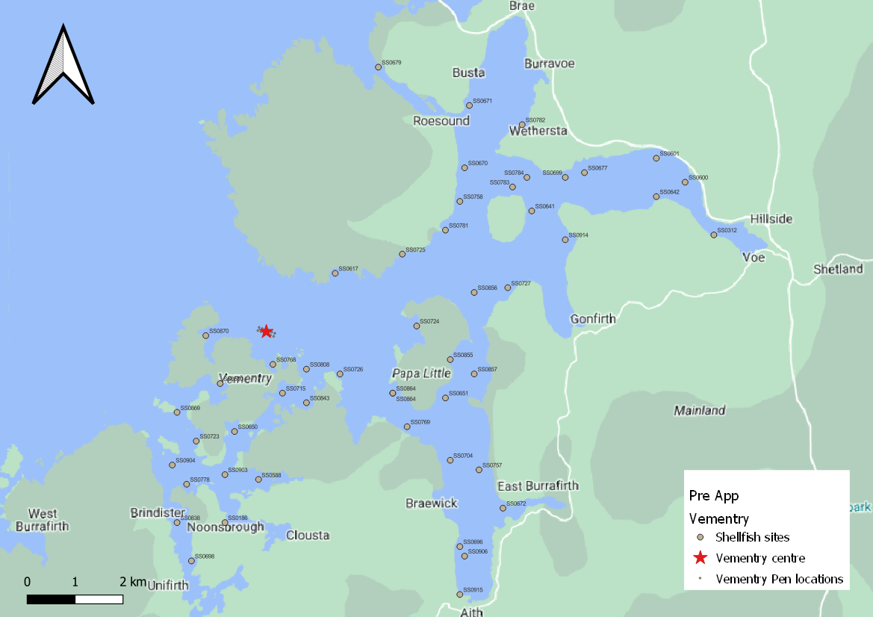

Figure 2. Shapefiles of identified features around the proposed site (Vementry (VMNT1)).

### Additional comments on identified features

Whilst screening modelling has not been undertaken for this site, its proximity to several sensitive features which are deemed to be at risk from sediment and bath influence, combined with its large tonnage, means higher resolution marine modelling of sediment and baths will be required. Particular focus should be on the identified features. Discharges of sediment from all identified sites will need to be included in this modelling, to determine the combined risk on these features.

The proposed farm is within Muckle Roe Shellfish Water Protected Area (SWPA). Within these areas, the water quality must be of a standard to ensure shellfish are safe for consumption. While the proposed application is deemed unlikely to affect the SWPA designations the potential impacts from sediments and bath chemicals on the identified active shellfish farms within these areas should be assessed (table 1/fig. 2).

This proposed site is also within a Marine Scotland Cat 2. Waterbody (Swarbacks Minn) (fig. 3). ECE calculations or nutrient modelling, should be undertaken to ensure nutrient enhancement levels added by this new farm do not degrade the waterbody to Cat 1.

Additionally, this proposed farm is approx. 1km from a Marine Scotland Cat 1. Waterbody (Northra Voe). As additional solid/nutrient load cannot be added to this waterbody, baths modelling should be used as a proxy for nutrients, to demonstrate that soluble nutrient discharges from Vementry (VMNT1) do not enter this Cat 1. Waterbody (fig.5). Farms within these waterbodies can be relinquished alongside this application in order to ensure there is no overall increase.

Calibration with drogues should be undertaken. Calibrating against observed advection patterns measured by drogues will particularly benefit the risk assessment of material entering the Cat 1. waterbody.

It is recommended that marine modelling of baths is undertaken to get a less conservative and therefore viable bath medicine quantity. Cumulative modelling of baths is however not required.

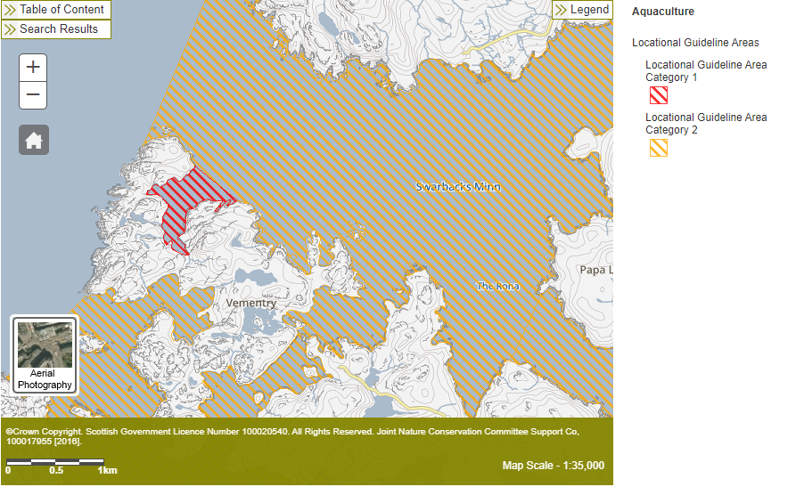

Figure 3. Figure showing locations of nearby Cat 1. (red) and Cat 2. (orange) waterbodies.

### Risks identified from contextual site data

Should this application proceed, the total licenced biomass in this area would be 19012.5t.

Table 2: Table of licenced biomass from farms identified as likely to add to cumulative risks.

| **Site Name** | **Location**  **(Easting, Northing)** | **Biomass (tonnes)** | **Last Production Cycle** |
| --- | --- | --- | --- |
| VMNT1 | (430363, 1161477) | 3000 | Proposed |
| AAC3 | (178948.2, 837783) | 1900 | Fish last on site Sep 2023 |
| BOB1 | (434243, 1157972) | 962 | Fish last on site May 08 |
| COLED1 | (435782.1, 1163170) | 2178 | Currently Stocked  (since Sep 22) |
| COLEN1 | (436350.9, 1162387) | 752 | Fish last on site Jul 14 |
| CROSS1 | (429526.9, 1158439) | 995 | Fish last on site Aug 12 |
| EAIT1 | (434906, 1156578) | 750 | Fish last on site Aug 09 |
| LBUR1 | (434749.1, 1159483) | 962 | Currently Stocked  (since Nov 23) |
| LINB1 | (428309.2, 1158767) | 1171 | Fish last on site Jul 12 |
| MUCE1 | (434435, 1165632) | 350 | Fish last on site Jan 09 |
| NEPL1 | (434244.1, 1162453) | 1750 | Currently Stocked  (since Mar 23) |
| NOR1 | (429200.2, 1161211) | 500 | Not stocked since records began (2002) |
| OLN2 | (437808.7, 1164984) | 300 | Fish last on site Mar 2013 |
| OLNA1 | (437414.1, 1164260) | 1000 | Currently Stocked  (since Aug 22) |
| SOA1 | (432188.9, 1159966) | 2442.5 | Currently Stocked  (since Sep 22) |

## Conclusions of screening modelling and risk identification

Following screening modelling and risk identification we make a number of conclusions and recommendations.

### Conclusions

#### Screening Modelling

* According to the risk assessment, the proposed site (Vementry (VMNT1)) is likely to be in an area of moderate dispersion and have a moderate for erosion of material on the seabed.
* From sediment and bath risk identification:
* The relative influence on the surrounding sea area from Vementry (VMNT1) is likely to be similar to other sites for a similar tonnage.
* It is likely that discharges of bath medicines from Vementry (VMNT1) will be dispersed to moderate levels over a moderate area.
* Vementry (VMNT1) is likely to result in a moderate increase in the total influence of all sites modelled. Bath medicine interactions are likely to occur between other existing sites in the area (highlighted in Figure 1.)
* The proposed site, Vementry (VMNT1) is near to a Cat 1. Waterbody (no increase in solids or nutrients are allowed within this area). Therefore, modelling needs to demonstrate that no material from the proposed farm enters this waterbody Should material from the proposed farm be shown to enter this waterbody, the proposal could be acceptable, only if the farm NOR1 was relinquished/licenced biomass reduced, and provided modelling showed it resulted in an overall decrease in solids/nutrient input to this waterbody. Additionally, the proposed farm is within a Cat 2. Waterbody and therefore an adequate assessment of eutrophication risks will be required. Baths modelling should be used as a proxy (calibrated with drogues), to demonstrate that there will be no net gain of nutrients to the Cat 1. Waterbody, and that the addition into the Cat 2. waterbody is insufficient to cause to be downgraded. An ECE calculation should be undertaken, and nutrient modelling may also be required.
* At this time the sea lice screening modelling is not undertaken for proposed sites on Shetland, as there are no identified salmon rivers in the Northern Isles. The risk assessment framework for managing interactions between sea lice from fish farms and wild salmon only applies on the West Coast and Western Isles. SEPA will manage sea lice interactions with sea trout on the West Coast, Western Isles and Northern Isles from March 2025.

#### Risk identification

As the proposed site, Vementry (VMNT1) is close to a Cat 1. waterbody (i.e. no increase in solids or nutrients are allowed within this area), it is unlikely that this proposal will be acceptable, unless the farm NOR1 is relinquished/licenced biomass reduced, resulting in a reduction of solids/nutrients into this waterbody. Baths modelling should be used as a proxy (calibrated with drogues), to demonstrate that there will be no net gain of nutrients to this Cat 1. waterbody, and that the Cat 2. Waterbody the farm is within, will not be downgraded. An ECE calculation should be undertaken, and dependent on the results, conservative tracer modelling of nutrients may be necessary.

Although screening modelling has not been undertaken, several features of interest have been identified, which require further attention during pre-application work. These are outlined in section 3. Further detailed modelling will need to demonstrate that the influence on these features is low and the additional biomass from this site would create no additional risk to the area.

As the proposed farm would be sited in a different location from existing, baseline information will be required to assess the suitability of the new location. Most likely this will be provided in the form of a visual survey (as per [SEPA guidance](https://www.sepa.org.uk/regulations/water/aquaculture/pre-application/), unless similarly detailed information can be gathered from other sources.

The conservative nature of the simple BathAuto model means quantities of bath medicines may be limited to impractical amounts for this site. Use of marine modelling of bath influence will enable more realistic bath medicine treatment quantities to be determined. Cumulative modelling of identified sites will be required for solids but not for baths.

Calibration with drogues should also be undertaken. Calibrating against observed advection patterns measured by drogues will particularly benefit the risk assessment of material entering the Cat 1 waterbody.

### Recommendations

#### Site suitability

Consideration of risk identification suggests that the current proposal may meet the Marine Scotland waterbody standards. However detailed marine modelling and ECE calculations should be undertaken to ensure the proposal is able to comply with the relevant aspects of the SEPA Aquaculture Regulatory Framework. (Dependent on the results, the relinquishment/reduction in licenced biomass at farm NOR1 may be required).

The site may be able to comply with our mixing zone regulatory framework. This will need to be demonstrated using the NewDepomod model.

Features at risk, identified at this stage are likely to influence the feasibility of the proposed site, with respect to the regulatory framework. These risks should be examined using a detailed marine model.

Following the engagement meeting(s), this report will be revised and this should allow to the applicant to submit a method statement which address the issues raised in this document.

#### Further modelling

* Due to the identified risks, 2D marine modelling should be carried out.
* The size of the marine model should include discharges from all sites identified in this report. Cumulative modelling including these identified sites will be required for solids, but not baths.
* Due to the large biomass and identified Cat 1. And 2. waterbodies, drogues are required for model calibration.
* The resolution of the marine model should be relatively fine around the proposed site and identified features at risk.
* Baths modelling should also be used as a proxy for nutrients, to demonstrate that nutrients from this farm do not pose risk to the Marine Scotland Cat 2. Waterbody (Swarback Minn) or the nearby Marine Scotland Cat 1. Waterbody (Northra Voe) (fig.3). An ECE calculation should be undertaken, and depending on the results, conservative tracer modelling of nutrients may also be required.
* NewDepomod modelling should be undertaken for the proposed site.
* Baseline information will also be required to assess the suitability of the new location. Most likely this will be provided in the form of a visual survey (as per [SEPA guidance](https://www.sepa.org.uk/regulations/water/aquaculture/pre-application/), unless similarly detailed information can be gathered from other sources.
* At this time the sea lice screening modelling is not undertaken for proposed sites on Shetland, as there are no identified salmon rivers in the Northern Isles. The risk assessment framework for managing interactions between sea lice from fish farms and wild salmon only applies on the West Coast and Western Isles. SEPA will manage sea lice interactions with sea trout on the West Coast, Western Isles and Northern Isles from March 2025.

## References

[1] *Marine Modelling Guidance for Aquaculture Applications*. *Published on SEPA website.*

[2] http://marine.gov.scot/information/wider-domain-scottish-shelf-model.

For information on accessing this document in an alternative format or language, please contact SEPA by emailing [equalities@sepa.org.uk](mailto:equalities@sepa.org.uk)

If you are a user of British Sign Language (BSL), the Contact Scotland BSL service gives you access to an online interpreter, enabling you to communicate with us using sign language. [contactscotland-bsl.org](http://contactscotland-bsl.org/)