Environmental Monitoring Plan
Permit Number: CAR/L/Click or tap here to enter text.
Marine Pen Fish Farm: Click or tap here to enter text.
Responsible company: Click or tap here to enter text.
Version: Click or tap here to enter text.
Date: Click or tap to enter a date.

The purpose of this EMP is to monitor seabed impacts from the marine fish farm in order to assess compliance with the seabed standards specified in schedule 4 of the permit.
This plan has been developed in accordance with SEPA guidance: “Version 1 May 2022 Seabed Environmental Standards - Demonstrating Compliance”.
Two environmental monitoring survey designs are required:
- Biological Sampling
- Chemical Residues Sampling

- Biological sampling
- This sampling is designed to collect the required seabed data that will allow an assessment of compliance against schedule 4.1 of the permit.
The default monitoring layout will be followed, with the direction of each transect as follows:
- Transect 1 - bearing * degrees.
- Transect 2 - bearing * degrees.
- Transect 3 - bearing * degrees.
- Transect 4 - bearing * degrees.
Guidance to be deleted and replaced – The 4 bullet points and sentecnce above can be deleted if you are not using the default monitoring layout, and replaced with proposed monitoring and justification for not using the default monitoring layout.
. 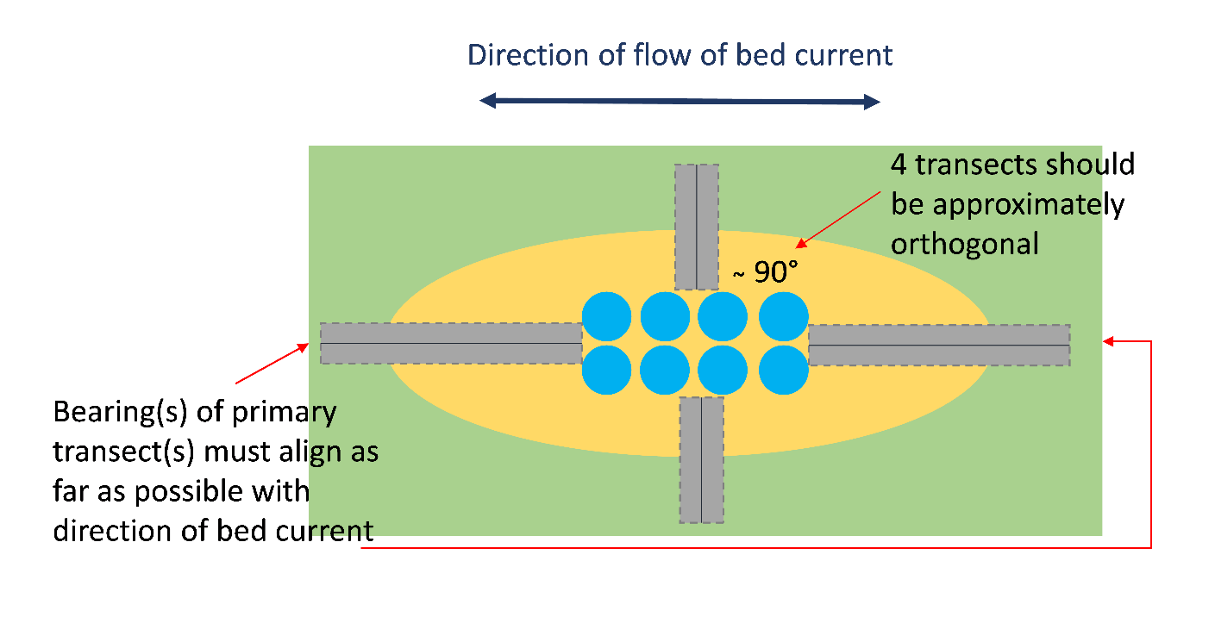
Figure 1 - This is an example monitoring diagram. Please delete and insert relevant site monitoring diagram.

At each sample station samples of sediment will be collected and analysed for:
- benthic infauna
- Particle size analysis (PSA).

- Chemical Residues Sampling

- This sampling is designed to collect the required seabed data that will allow an assessment of compliance against schedule 4.2 of the permit.
- Samples will be collected at the locations specified above.
Guidance to be deleted - The 2 bullet points above are not required if a site is on a single transect Emamectin Benzoate monitoring programme (0.736ug/kg standard), in which case monitoring location details will conditioned in the permit.
At each sample station samples of sediment will be collected and analysed for:
- Organic carbon
- Particle size analysis (PSA)
- Emamectin Benzoate

- Sampling and analyses, will be carried out in accordance with the following MACS documents:
- Performance Standard MACS-FFA-PSO1 - Version 1 March 2022
- Performance Standard MACS-FFA-PSO2 - Version 1 March 2022
- Performance Standard MACS-FFA-PSO3 - Version 1 March 2022

