Water Scarcity Report

17th October 2024

The Firth of Tay has recovered to Early Warning.

The Deveron and Dee, and Shetland, have recovered to Normal Conditions.

The rest of the country remains at Early Warning or Normal Conditions.

Figure 1: Larger map of Scotland showing this week's water scarcity levels. Smaller map showing the previous reports water scarcity levels.

Link to Accessible national water scarcity map
The overall risk of water scarcity takes account of the individual water scarcity indices, relevant water use, sectors in each region, and forecast weather conditions. The areas shown in this map represent major river catchments. Details on how levels are set and actions required can be found in SEPA’s National Water Scarcity Plan.

Situation Summary
The Firth of Tay has recovered from Moderate Scarcity to Early Warning, as river flows at a key location have recovered slightly since last week. In the north-east, the Deveron and Dee catchments have recovered from Early Warning to Normal Conditions, as soil moisture and river flows have increased. Shetland has also recovered from Early Warning to Normal Conditions, due to rainfall in the last week.

Some parts of the east remain at Early Warning, with the rest of the country at Normal Conditions. With no areas remaining at Alert status, and with forecast rainfall likely to lead to further recovery in those areas still at Early Warning, this will be the last weekly water scarcity report of 2024.

SEPA continues to monitor the situation and coordinate steps to manage water resources in line with Scotland's National Water Scarcity Plan which is available on SEPA’s water scarcity website.

You can help us by reporting any evidence you see of water scarcity. For details of information that would be useful to us and where to send it see: Water scarcity in your area | Scottish Environment Protection Agency (SEPA).

Advice for water users
We advise water users, including those with private water supplies, to be aware of the potential risk of water scarcity, and for businesses to plan ahead where possible. Water scarcity - plan ahead and use water wisely (sepa.org.uk).

Although the whole of Scotland is currently in Normal or Early Warning status for water scarcity, we are urging water users to take steps to keep supplies resilient, especially if taking water from burns and small rivers:
- Routinely check equipment isn’t leaking;
- Only abstract sufficient water for your requirements;
- Consider water saving and storage measures for the next irrigation season.
- If you operate a hydroscheme then ensure that weir structures are free from debris and passing the residual flow specified in your licence. You must cease abstracting water when the hands-off flow is reached.
- If you abstract and return water to the environment (from a fish farm, distillery or other cooling water process) then start to consider whether you can reduce or suspend abstraction, switch to an alternative source, or recirculate water.
For the most up to date advice please see: Advice for abstractors.

Weather forecast (17/10/2024)
Last of rain clearing Shetland by the end of Thursday morning then mainly dry across Scotland though a few scattered showers will break out in the afternoon. Another band of rain will move in from the Atlantic on Friday, heavy in the west with severe gales over the Hebrides for a time. Rain clearing Friday night then mainly dry on Saturday with the odd shower. Heavy rain then frequent showers on Sunday with severe gales likely. The showers becoming more scattered on Monday as the winds ease.

The rainfall outlook for the autumn (October - December) period suggests that across the UK the chances of a wet period are similar to normal, with only a small chance of the period being cold overall.
© Crown copyright [2024], Met Office

Appendix

Accessible national water scarcity map
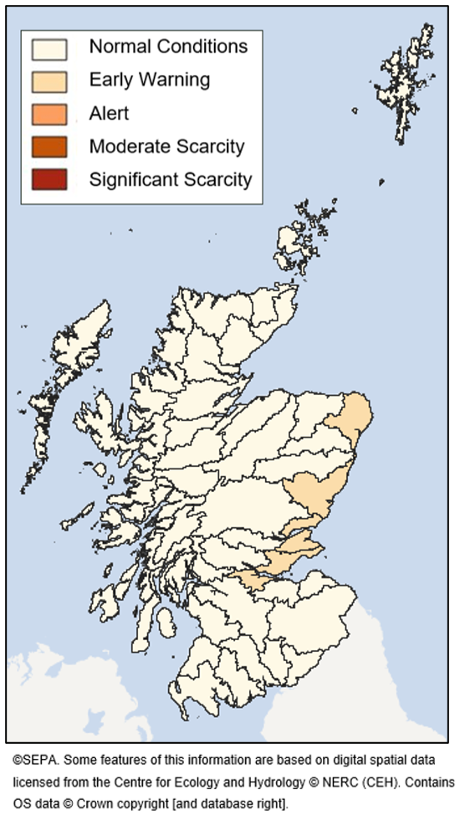

Figure 2: A map of Scotland showing the current water scarcity level in each catchment coloured with accessible colours.
The above Situation Summary describes the conditions in more detail.

For information on accessing this document in an alternative format or language, please contact SEPA by emailing equalities@sepa.org.uk
If you are a user of British Sign Language (BSL), the Contact Scotland BSL service gives you access to an online interpreter, enabling you to communicate with us using sign language. contactscotland-bsl.org

