Aquaculture Pre-App Risk Identification Report: STROME MOR (SMOR1)
Report date: November 2024

Scope of report
As part of the SEPA Aquaculture Regulatory Framework it is recommended that a proposed application for a marine fin fish aquaculture site should undergo a Screening Modelling and Risk Identification process. SEPA carries out this work and this is described on the SEPA aquaculture website Pre-application section.
This report presents information arising from that process. Screening modelling methods are outlined and maps and tables describing the modelled impacts are shown. Risks arising from consideration of the model output are listed. Conclusions and recommendations are made regarding the proposed site.

Executive summary
SEPA has received a proposal for a new marine fin fish aquaculture site called Strome Mor (SMOR1). The site is located in the inner Loch Carron Bay at the Northwest coast of Scotland, at location: 187614 836109 (Easting, Northing). The proposed weight of fish to be farmed is 2750t. The existing sites West Strome (WSTR1) with a biomass of 2000t and Strome (MSTR1) with a biomass of 687t, will be surrendered should this application be approved.
Following screening modelling and risk identification we have concluded the following:
- It is possible that discharges from Strome Mor (SMOR1) will be able to comply with the relevant aspects of the SEPA Aquaculture Regulatory Framework.
- Features at risk, identified at this stage, do not appear to influence the feasibility of the proposed site with respect to the regulatory framework. These risks should be examined using a detailed marine model.
- Strome Mor (SMOR1) is suitable to progress to the next stage of the pre-application process outlined on the SEPA website.
- Contextual site information suggests Strome Mor (SMOR1) should be able to comply with mixing zone standards, which was demonstrated by the submitted Default NewDepomod solids modelling.
- Sea lice screening has shown permit conditions will be required for this site to ensure lice levels are kept to the levels currently maintained at West Strome CAR/L/1100544. Alternatively, suitable lice permit conditions may be derived from a detailed sea lice modelling exercise.

List of abbreviations
SEPA Scottish Environment Protection Agency
CAR Controlled Activities Regulations
WSPZ Wild Salmon Protection Zone

List of chemical abbreviations
AZA Azamethiphos

Contents
Aquaculture Pre-App Risk Identification Report: STROME MOR (SMOR1) 1
Scope of report 2
Executive summary 2
List of abbreviations 4
List of chemical abbreviations 4
List of Figures 6
List of Tables 8
Introduction 9
Screening modelling 15
Sea Lice Screening 30
Risk Identification 34
Conclusions of screening modelling and risk identification 46
References 50
Appendices – Responses to pre-app consultation. 51
Appendix 1 – Highland Council, Planning Department 52
Appendix 2 – Nature.Scot 61
Appendix 3 – Marine Directorate - Licensing Operations Team (MD-LOT) 66
Appendix 4 – Historic Environment Scotland 68
Appendix 5 – Northern Lighthouse Board 70
Appendix 6 – Maritime and Coastguard Agency 71
Appendix 7 – Marine Directorate - FF Planning 72

List of Figures
Figure 1. East Coast Lewis and Harris (ECLH) model grid 13
Figure 2: Modelled average water speed (metres per second – m/s) in the sea area surrounding the proposed site Strome Mor (SMOR1); WSTR1 and MSTR1 are to be surrendered. 23
Figure 3: Modelled percentage of time the water flow speed is above 0.095m/s in the sea area surrounding the proposed site Strome Mor (SMOR1); WSTR1 and MSTR1 are to be surrendered. 24
Figure 4: Modelled average sediment intensity over one month for the proposed site only Strome Mor (SMOR1). 25
Figure 5: Modelled average sediment intensity over one month for the proposed site (Strome Mor (SMOR1)) and other relevant sites; WSTR1 and MSTR1 are to be surrendered. 26
Figure 6: Modelled average Azamethiphos concentration over four days from neap tide release for the proposed site Strome Mor (SMOR1) only. 27
Figure 7: Modelled average Azamethiphos concentration over four days from neap tide release for the proposed site (Strome Mor (SMOR1)) and other relevant sites; WSTR1 and MSTR1 are to be surrendered. 28
Figure 8. Map of the average modelled lice concentration over the simulated April and May period (in lice/m²) within the top two meters of the sea area. SMOR1 site location shown as a blue circle. Fish tracks are shown as green lines with the WSPZs, which are highlighted by a white boundary. 30
Figure 9. Identified sensitive PMFs of Flame Shell beds around the proposed site Strome Mor (SMOR1), in orange; WSTR1 and MSTR1 (in blue) are to be surrendered. 35
Figure 10. Identified sensitive PMFs of Horse Mussels around the proposed site Strome Mor (SMOR1), in orange; WSTR1 and MSTR1 (in blue) are to be surrendered. 36
Figure 11. Identified sensitive PMFs of Maerl Beds around the proposed site Strome Mor (SMOR1), in orange; WSTR1 and MSTR1 (in blue) are to be surrendered. 37
Figure 12. Identified sensitive PMFs of Northern Feather star near the proposed site Strome Mor (SMOR1), SMOR in green; WSTR1 and MSTR1 (in blue) are to be surrendered. 38
Figure 13. Identified sensitive PMFs of Kelp and seaweed communities close to the proposed site Strome Mor (SMOR1), in orange; WSTR1 and MSTR1 (in blue) are to be surrendered. 39
Figure 14. Figure showing locations of nearby Cat 2. (yellow) waterbody. Red star depicts SMOR1. WSTR1 and MSTR1 (in blue) are to be surrendered. 40
Figure 15. Left figure: modelled average sediment intensity over one month for the existing two sites (MSTR1 and WSTR1) and other relevant sites. Right figure: modelled average sediment intensity over one month for the proposed site (SMOR1) and other relevant sites. 44
Figure 16. Figure showing Loch Carron PMFs. 62

List of Tables
Table 1: Sediment influence information for each site. 19
Table 2: Azamethiphos influence information for each site. 22
Table 3. Influence of modelled sea lice from SMOR1 on exposure in the relevant affected WSPZs. 32
Table 4. Location of SMOR1 within the assessment matrix framework of WSPZ capacity and site contribution. 33
Table 5: Table of identified features 35
Table 6: Table of licenced biomass from farms identified as likely to add to cumulative risks. 43
Table 7. Table showing planning history 52

Introduction
Screening Modelling and Risk Identification are important steps in the SEPA regulatory framework for marine pen fish farms. They are carried out by SEPA at the pre-application stage.
This document briefly describes the objectives of screening and risk identification and summarises the methods used. Screening output for the proposed site is then presented with comments. Risks identified from the screening output are detailed. Conclusions and recommendations about the suitability of the proposed site are then made.

The objectives of screening modelling and risk identification
A summary of the modelling methods employed during screening modelling is outlined in the screening modelling methods section. The objectives of screening modelling and risk identification are outlined below.

Screening modelling
Marine Modelling technology can be used to simulate and predict the potential influence of discharges on the marine environment. SEPA will require the majority of proposed farms to conduct detailed marine modelling, as outlined in our Aquaculture Modelling guidance [1] and on the SEPA Website.
Marine modelling can also be used at an earlier stage to provide an initial estimate of the influence of material discharged from a proposed site.
SEPA will carry out marine modelling at the screening and risk identification stage. This is a simplified version of the detailed modelling required of the applicant. However, it will be sufficient to perform an initial risk assessment of a proposal. Screening marine modelling will also include discharges from other relevant aquaculture sites and major sources.

The objectives of the simplified screening modelling are to:
- Produce maps of the predicted dispersive and erosive capacity of the sea areas in the vicinity of aquaculture sites.
- Produce maps of the predicted spread of sediment discharged from aquaculture sites.
- Produce maps of the predicted spread of bath treatment medicines from aquaculture sites.
- Present an analysis of the potential influence of sediment and bath treatment discharges from the proposed site alongside existing sites within the surrounding sea area.
- Present information on the sensitive features and sites of interest within the surrounding sea area, which must be addressed during pre-application work.
- Present a summary of the suitability of the proposal with respect to the dispersal of waste and how this may be modelled.

Risk identification
Maps and analysis of screening output will be compared to information relating to sensitive features and relevant areas of interest. These may include:
- Marine Protected Area (MPA).
- Special Area of Conservation (SAC).
- Priority Marine Feature (PMF).
- Any site identified via consideration of other permitted or regulatory activities.
SEPA Staff will meet to discuss screening model output and the relevant sensitive features information. Following this meeting, a list of identified risks will be added to this report.

Conclusion of screening modelling and risk identification
Following the identification of risks, SEPA will present a summary of the suitability of the proposal with respect to the:
- Dispersal of waste from the proposed site and other sources.
- Risks posed to sensitive features.
- Likely level of modelling that will be required to address the risks identified.

Screening modelling methods
Marine models divide the sea up into a “grid” of boxes or triangles (often called cells). Each of these is given a water depth. For the screening modelling presented in this report the Marine Scotland “East Coast, Lewis and Harris” (ECLH) has been used. An image of the ECLH model grid is shown in Figure 1. This grid has been set up within a marine modelling software package called MIKE 21 which is manufactured by the company DHI A/S.
Marine models carry out calculations across a grid to work out how seawater moves and mixes in response to tidal and weather forces. Marine models can also be used to simulate how seawater moves and mixes due to salinity and temperature differences across an area, particularly in response to inputs of freshwater from rivers. For pollutant influence assessments the mixing (dispersion) of dissolved (bath medicine) and particulate (sediment) pollutants can also be estimated. Calculations within a marine model can be performed in three dimensions (3D), where the grid is split into layers to better represent how properties of the sea change with depth. Two dimensional (2D) models can also be created where processes over the water depth are simplified. The amount of mixing in a marine model can be varied using settings in the software.
Screening modelling is currently carried out with 2D models using average mixing settings in the model software. In many areas, this approach will be sufficient to make an initial estimate of the influence of a proposed site. Our screening assessment will take into account factors which may limit a 2D approach. We will also consider whether a particular location is adequately represented by the available models.

Water movement and mixing modelling
Water movement and mixing modelling (hydrodynamics) has been carried out to generate one month of results. The boundaries (edge(s) of) the model have been driven using the “wider domain” Scottish Shelf Model (The wider domain Scottish Shelf Model). Wind forces and freshwater inputs have been applied to the model from the same source. The results generated are an estimate of the average water movement and mixing conditions within the model area.

Sediment waste modelling
Screening modelling provides a precautionary and indicative estimate of the size, location and intensity of waste organic material released from aquaculture sites.
The release of sediment from sources within the model area is simulated using one month of hydrodynamic results along with particle tracking modelling technology. Virtual particles are continually introduced to the model grid to represent the potential dispersion of sediment from the sources. Particles in the model are moved and mixed by the hydrodynamics. Additionally, particles are assigned simplified properties, which allow them to settle through the water and be re-suspended (eroded and lifted) from the seabed.

Bath medicine modelling
Screening modelling provides a precautionary and indicative estimate of the size, location and concentration of bath medicine releases.
The release of bath treatment medicine from sources within the model area is simulated using hydrodynamic results along with particle tracking modelling technology. Virtual particles are introduced to the model grid to represent the potential dispersion of bath medicines from the sources. Particles in the model are moved and mixed by the hydrodynamics. Releases of bath medicines are simulated under worst case mixing (dispersion) conditions, which occur under neap tides. The maximum treatment amount likely to be used at each site is released into the model at the same time and plumes are tracked over the following 96 hours (4 days). Treatment amounts used at screening have been derived from an analysis of historical data. Additionally, all bath medicine particles are concentrated within the top 5m of the sea area. As all bath medicines are likely to disperse in a similar way, only Azamethiphos (AZA) has been modelled at the screening stage.

Nutrient assessment
Whilst nutrients are not directly modelled during screening, the dispersion of bath medicine releases will give an indication of the likely level of nutrient dispersion. This will be considered alongside any pre-existing nutrient assessment information that may be available.

Analysis of modelling output
SEPA processes the screening modelling output and places it into a standard analysis application built in TIBCO Spotfire. The application allows for the production of standard maps and tables, which are presented below.
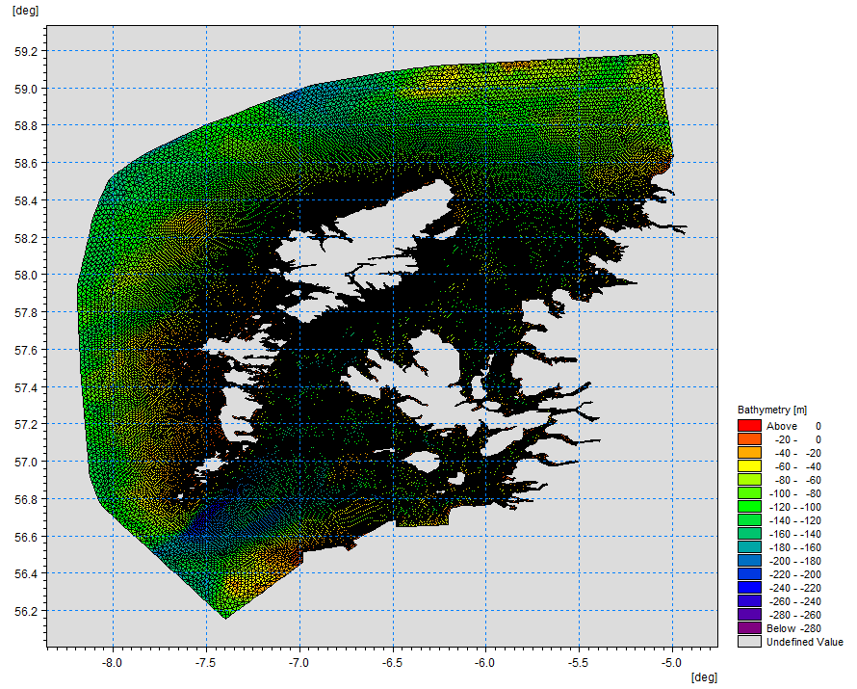
Figure 1. East Coast Lewis and Harris (ECLH) model grid.

Screening modelling

Site proposal
Screening modelling has been carried out for a proposal for a new farm: Strome Mor (SMOR1). The proposal is to site the farm at location: 187614, 836109 (Easting, Northing). The proposed weight of fish to be farmed is 2750t. The existing sites West Strome (WSTR1) with a biomass of 2000t and Strome (MSTR1) with a biomass of 687t, will be both surrendered should this application be approved.
For the screening modelling presented here all relevant licenced sites and current applications have been modelled in conjunction with the proposed site.

Accuracy of model in the area surrounding the proposal
The East Coast, Lewis and Harris model used for screening modelling has a relatively low resolution in this area. Comparison against various sources of observed current meter data indicates that the model provides a poor description of the physical processes in the vicinity of the proposed site. The model seems to overpredict the current speeds compared to the observed currents. The observed currents speeds are significantly slower than the predicted speeds.

Dispersion and erosion capacity maps
Modelled water movement in a sea area can be analysed and presented to show the capacity of the water to move and disperse discharged substances. It is also possible to show the capacity available to erode substances from the seabed. This information is a useful guide to the potential size of a marine fin fish aquaculture farm at a particular location.

Marine fin fish aquaculture farms using open-net pens will benefit from operating in locations where there are strong, repeating, water currents to erode and disperse waste.
For the purposes of screening we consider locations which meet the following water flow criteria to be generally suitable for larger farms:
Locations with average water flow speeds of greater than, or equal to, 0.12 metres per second (0.23 knots)
Locations where water flow speeds are often above the threshold of 0.095 meters per second (0.18 knots).
Locations with these properties are likely to disperse discharged material rapidly, and regularly erode sediment discharged to the seabed. In general, we would look for these properties to be maintained over a large area around a proposed site.
The thresholds stated above are indicative.
A map of modelled average water flow speed for the area surrounding the proposed site is shown in Figure 2. The average water flow speed in each cell of the model grid has been assigned a shade. The key for the shading is shown in the top left of the figure. Grid cells that have average speeds less than 0.12m/s (metres per second) are marked on the figure. The greater the shading, the slower the average current speed and the lower the capacity for dispersion.
Figure 3 is a map of the percentage of time the modelled water flow speed in a grid cell is above 0.095m/s (metres per second). The greater the shading, the lower the capacity for material to be eroded from the seabed.
Licenced aquaculture farms in the vicinity of the proposed site are also marked on Figure 2 and Figure 3. Discharges of material from these sites have been included in the screening modelling.
Based on the maps of the modelled water flow properties we can make the following observations about the proposed site location:
- It lies in a high dispersion area.
- It lies in an area where water flow has a high capacity to erode material on the seabed.
However, available current meter data from the site suggests this is not the case and dispersion is likely to be lower.

Sediment influence maps and analysis
Modelled particles in a sea area can be analysed for each modelled grid cell and presented to show the potential influence of discharged sediment on the surrounding sea area.
Figure 4 shows a map of the modelled average sediment intensity over one month (time average) for the proposed site only. Grid cells within the model that are influenced by modelled sediment are shaded according to the intensity of the influence in grams per square metre (g/m²).
Values less than 1g/m2 have been excluded from the map and subsequent calculations. These low concentration cells are produced by the particle tracking approach but they are not considered to be representative of the main influence of a discharge.

- The shading key is shown in the top left of the figure. Cells which are shaded black are similar to the average intensity in the total area of influence shown in the map. Cells shaded pink are similar to the median (middle value in the range) intensity value shown on the map. White shaded cells are similar to the minimum intensity value shown on the map.
  - The average and median sediment intensity over the area of influence is 9.56g/m² and 2.44g/m² respectively.
  - A small number of cells influenced by the proposed site appear to lie close to other modelled farm sites.

Figure 5 shows a map of the modelled average sediment intensity over one month for the proposed site and other relevant sites. Grid cells within the model that are influenced by modelled sediment are shaded according to the intensity of the influence in grams per square metre (g/m²). The shading key is shown in the top left of the figure and is in a similar format as that shown in Figure 4. The average sediment intensity, after including all relevant sites, is slightly increased.
- The average and median sediment intensity over the area of influence is 9.79g/m² and 2.91g/m² respectively.
- Cells influenced by other modelled sites do not appear to lie close to the proposed site. However, this might be a result due to the overprediction of current speeds in the area.

Sediment influence analysis
Model grid cells can be analysed to estimate the size and concentration of the potential sediment influence from the modelled sites.
- The total area of sediment influenced by the twelve sites modelled is estimated to be 17.28 square kilometres (km²).
- As shown in Figure 5, the average and median intensity over this area is 9.79 and 2.91g/m² respectively.
- The total weight of fish that generates this modelled influence is 28,049 tonnes.

Table 1: Sediment influence information for each site.

Site Name | Average Intensity (g/m2) | Area of Influence (km2) | Median Intensity (g/m2) | Max Weight of Fish (Tonnes)
SMOR1 | 9.56 | 2.02 | 2.44 | 2750
AAC3 | 2.89 | 3.86 | 2.19 | 1900
ACH1 | 4.94 | 2.05 | 1.92 | 1299
ARDT1 | 3.13 | 4.72 | 2.56 | 2500
BEIS1 | 1.77 | 1.04 | 1.63 | 600
CDP2 | 4.31 | 2.79 | 3.00 | 1600
DUI1 | 5.33 | 3.06 | 2.57 | 2500
KIO1 | 3.66 | 3.65 | 3.05 | 1713
MSTR1 | 8.36 | 0.79 | 4.49 | 687 (to be surrendered)
SRO1 | 2.42 | 6.04 | 1.80 | 2500
WSTR1 | 8.73 | 1.57 | 2.40 | 2000 (to be surrendered)
STRF1 | 4.46 | 7.98 | 2.33 | 8000
There are no Environmental Standards for sediment intensity. However, we consider that:
• underneath farm pens, an intensity of 2000g/m2 or less is likely to lead to an acceptable sea bed ecological outcome
• at the edge of the mixing zone, an intensity of 250g/m2 or less is likely to lead to an acceptable sea bed mixing zone outcome
The estimate of influence detailed above is indicative. The values presented are lower than the sediment intensity values given above. However, we recognise that low sediment concentrations may be useful for the identification of risks.

Bath medicine influence maps and analysis
Modelled particles in a sea area can be analysed for each modelled grid cell and presented to show the potential influence of discharged bath medicine on the surrounding sea area. Results presented are for the AZA medicine (see section Bath medicine influence analysis).
Figure 6 shows a map of the modelled average AZA concentration over four days for the proposed site only. Grid cells within the model which experience an AZA influence are shaded according to the concentration of AZA in nanograms per litre (ng/l).
Values less than 10ng/l have been excluded from the map and subsequent calculations. These low concentration cells are produced by the particle tracking approach but they are not considered to be representative of the main influence of a discharge.
Please note that the Environmental Standard for Azamethiphos with the lowest concentration is 40ng/l. This must be met 72 hours after the material has been discharged. The estimate of influence detailed here is precautionary. In the information presented below areas of influence above 40ng/l have been quoted. However the average and median concentrations are quoted for the entire area of influence above 10ng/l.
The shading key is shown in the top left of the figure. Cells which are shaded black are similar to the average concentration in the total area of influence shown in the map. Cells shaded pink are similar to the median (middle value in the range) concentration shown on the map. White shaded cells are similar to the minimum concentration value shown on the map.
- The average and median concentration over the total area of influence is 17ng/l and 15.83ng/l respectively.
- Cells influenced by the proposed site appear to lie close to WSTR1 and MSTR1, these sites will be surrendered as part of this application.

Figure 7 shows a map of the modelled average AZA influence over four days for the proposed site and other relevant sites. The average AZA influence, after including all relevant sites, is increased.
- The average and median AZA concentration over the total area of influence is 23.45ng/l and 23.62ng/l respectively.
- A number of cells are influenced by other modelled sites appear to lie close to the proposed site.

Bath medicine influence analysis
Model grid cells can be analysed to estimate the size and concentration of the potential AZA influence from the modelled sites.
- The area of AZA influenced above 40ng/l from all sites modelled is estimated to be 2.89 square kilometres (km2).
- As shown in Figure 7, the average and median concentration over the total area of influence is 23.45ng/l and 23.62ng/l respectively.
- The total weight of fish that generates this modelled influence is 28,049 tonnes.
Table 2: Azamethiphos influence information for each site.

Site Name | Average Concentration (ng/l) | Area of Influence Above 40 ng/l (km2) | Median Concentration (ng/l) | Weight of Fish (Tonnes)
SMOR1 | 17.00 | 0 | 15.83 | 2750
AAC3 | 14.32 | 0 | 12.73 | 1900
ACH1 | 11.63 | 0 | 11.70 | 1299
ARDT1 | 24.59 | 0 | 25.05 | 2500
BEIS1 | 0 | 0 | 0 | 600
CDP2 | 11.44 | 0 | 11.44 | 1600
DUI1 | 18.57 | 0 | 17.66 | 2500
KIO1 | 17.11 | 0.30 | 12.18 | 1713
MSTR1 | 15.38 | 0 | 13.85 | 687 (to be surrendered)
SRO1 | Less than 10 | 0 | Less than 10 | 2500
WSTR1 | 12.21 | 0 | 11.75 | 2000 (to be surrendered)
STRF1 | 22.79 | 0.72 | 21.61 | 8000
Please note that the Environmental Standard for Azamethiphos with the lowest concentration is 40ng/l. This must be met 72 hours after the material has been discharged. The estimate of influence detailed above is precautionary. The values presented are close to the 40ng/l standard. Detailed modelling will be required to demonstrate compliance with all Environmental Standards.

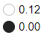
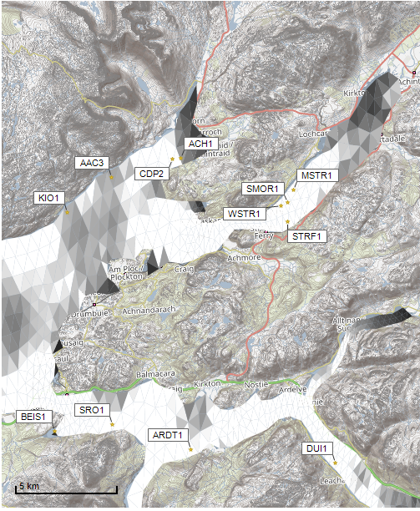
©Crown copyright. All rights reserved. SEPA lic. no. 100016991 (2019).
Average water speed (m/s)
Figure 2: Modelled average water speed (metres per second – m/s) in the sea area surrounding the proposed site Strome Mor (SMOR1); WSTR1 and MSTR1 are to be surrendered.

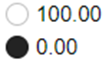
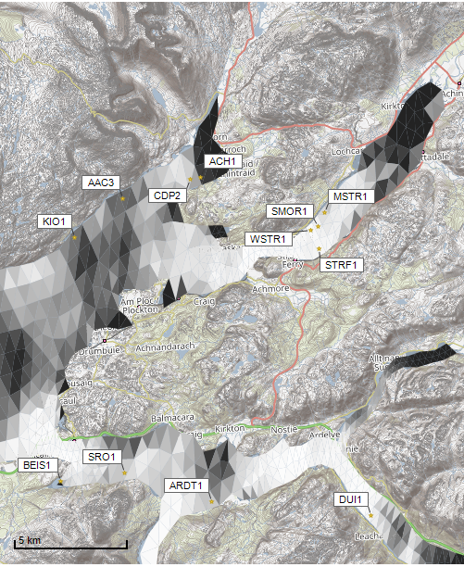
©Crown copyright. All rights reserved. SEPA lic. no. 100016991 (2019).
Percentage time (%)
Figure 3: Modelled percentage of time the water flow speed is above 0.095m/s in the sea area surrounding the proposed site Strome Mor (SMOR1); WSTR1 and MSTR1 are to be surrendered.

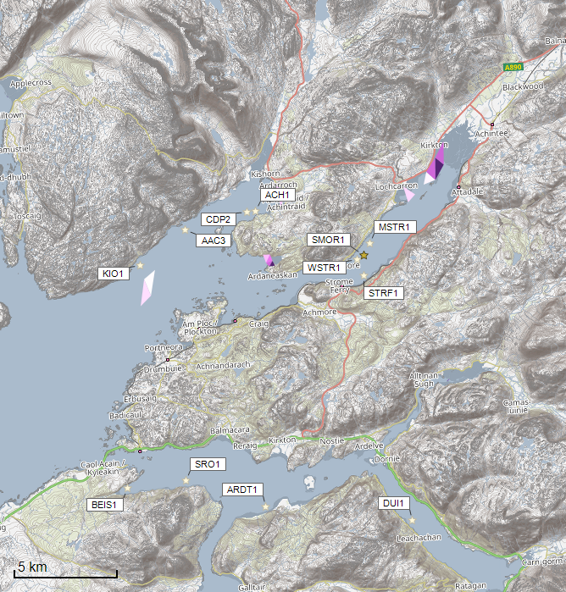
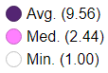
Sediment Intensity (g/m2)

Sediment intensity values presented on this map are low and are presented for information only.

©Crown copyright. All rights reserved. SEPA lic. no. 100016991 (2019).

Figure 4: Modelled average sediment intensity over one month for the proposed site only Strome Mor (SMOR1).

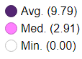
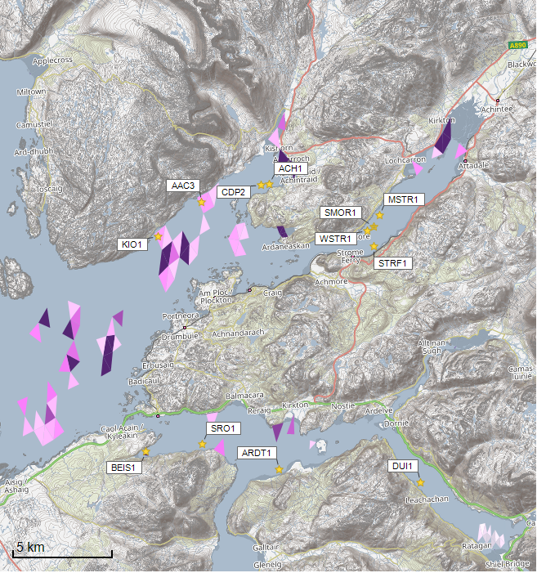
Sediment Intensity (g/m2)

Sediment intensity values presented on this map are low and are presented for information only.

©Crown copyright. All rights reserved. SEPA lic. no. 100016991 (2019).

Figure 5: Modelled average sediment intensity over one month for the proposed site (Strome Mor (SMOR1)) and other relevant sites; WSTR1 and MSTR1 are to be surrendered.

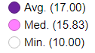
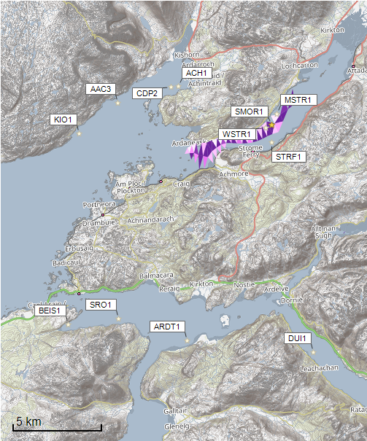
©Crown copyright. All rights reserved. SEPA lic. no. 100016991 (2019).
Concentrations of AZA presented on this map are less than the 40 ng/l Environmental Standard and are presented for information only.
Azamethiphos Conc. (ng/l)

Figure 6: Modelled average Azamethiphos concentration over four days from neap tide release for the proposed site Strome Mor (SMOR1) only.
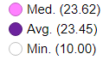
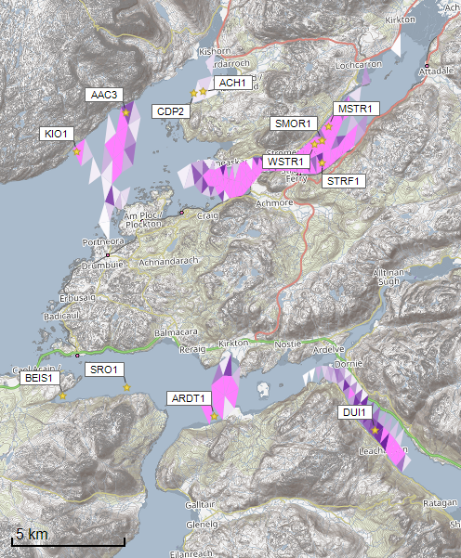
Azamethiphos Conc. (ng/l)

©Crown copyright. All rights reserved. SEPA lic. no. 100016991 (2019).
Concentrations of AZA presented on this map are less than the 40 ng/l Environmental Standard and are presented for information only.
Figure 7: Modelled average Azamethiphos concentration over four days from neap tide release for the proposed site (Strome Mor (SMOR1)) and other relevant sites; WSTR1 and MSTR1 are to be surrendered.

Sea Lice Screening
Sea lice screening was carried out using our standard method with the translated Scottish Shelf ECLH (East Coast Lewis & Harris) sub area model. This method is outlined in in Appendix 4 of the May 2023 second consultation document: Managing interactions between sea lice from finfish farms and wild salmonids, Proposed new regulatory framework, May 2023.

Modelled Sea Lice Concentration Map – SMOR1
Figure 8 shows a map of the average modelled lice concentration over the simulated April and May period (in lice/m²) within the top two meters of the sea area. Model grid cells (triangles) are coloured according to the amount of sea lice particles within them. Concentrations of sea lice below 0.01 lice/m² have been excluded from the map (but not from the fish track analysis below). The more intense the colour, the closer the concentration is to the 90th percentile of all the concentrations in the model cells. Both mapping choices are intended to bring focus on the areas of highest potential influence. The map is an indicative estimate of the potential extent and intensity of sea lice which may be released from the proposed site, in isolation, under average tidal and weather conditions. It is provided for information only and the critical analysis of exposure to fish tracks within WSPZs is the basis for the final screening conclusion. The 90th percentile of the lice concentration is 0.41 lice/m² and the median is 0.07 lice/m². The average 90th percentile of modelled concentration of all sites modelled at baseline is 0.04 lice/m². The main influence of modelled concentrations occurs in an area of the East Skye WSPZ. The modelled influence is high.

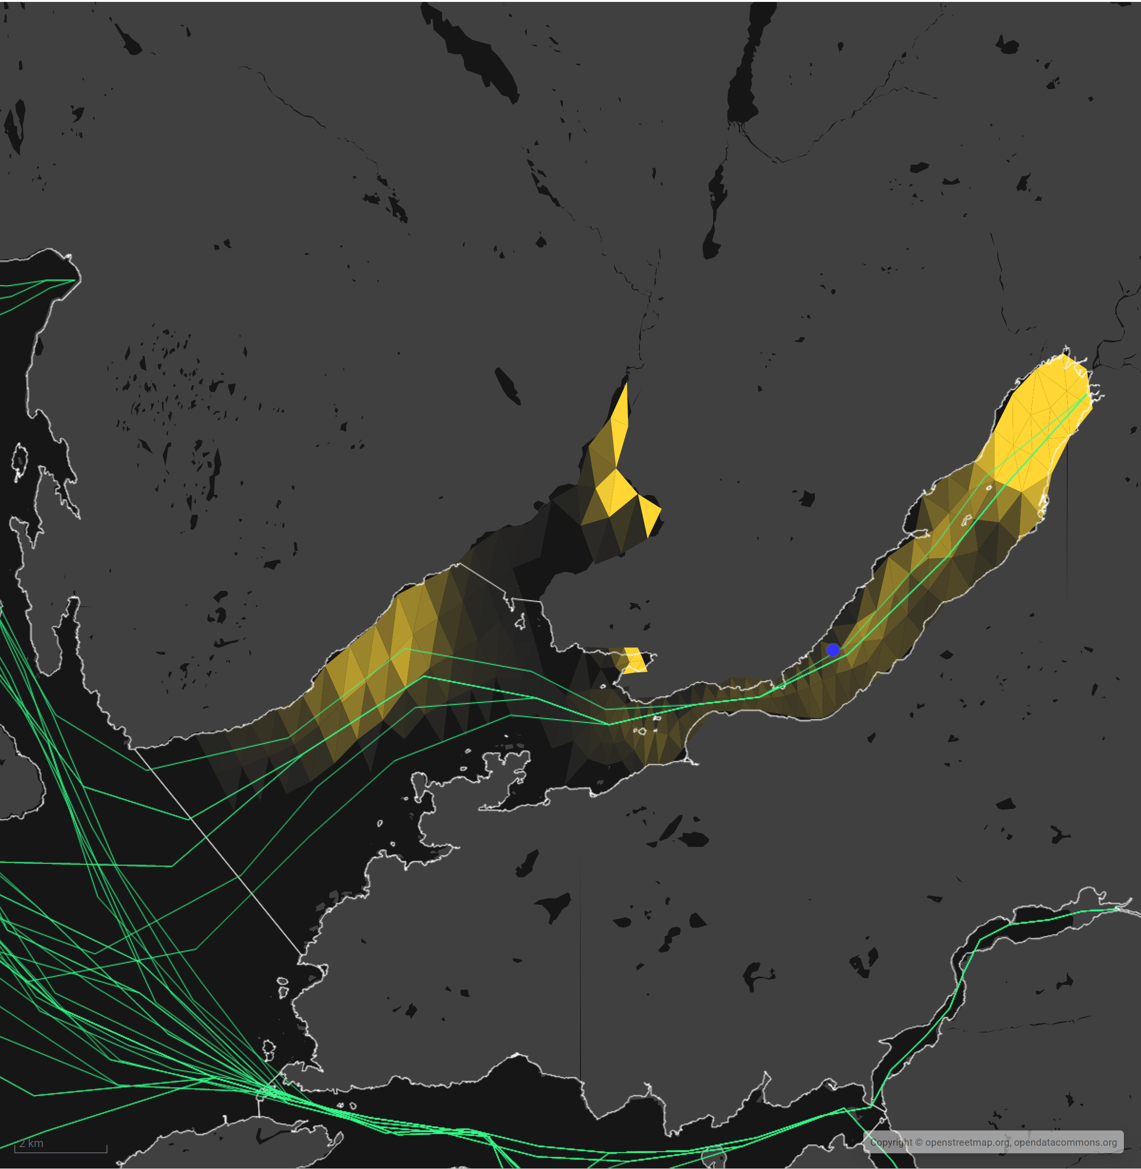
Sea Lice Conc. (lice/m²)
90th %ile (0.41)
Min. (0.01)
Figure 8. Map of the average modelled lice concentration over the simulated April and May period (in lice/m²) within the top two meters of the sea area. SMOR1 site location shown as a circle. Fish tracks are shown as several lines with the WSPZs, which are highlighted by white boundary lines across the waterbody.

Modelled Sea Lice Concentrations – Single Site Influence on Exposure – SMOR1
Table 3 shows information relating to the influence of modelled lice concentrations, from SMOR1 alone, on fish track exposure levels within the relevant WSPZs.
Table 3. Influence of modelled sea lice from SMOR1 on exposure in the relevant affected WSPZs.
Wild Salmon Protection Zone (WSPZ) | 95th %ile of Fish Track Exposure (lice/m² days) | % of Exposure Threshold (0.7 lice/m² days)
East Skye | 0.35 | 47.01

One WSPZ is affected, the influence is high. No other WSPZs are influenced, even to an extremely low degree. Note that the percentage of the exposure threshold is shown to illustrate the scale of a single site influence. The exposure influence of all sites is not simply the sum of the individual site percentages. The overlapping influence of all sites on modelled screening exposure is shown below.
An assessment matrix is presented on page 57 of the SEPA December 2023 response to consultation feedback: Managing interactions between sea lice from finfish farms and wild salmonids, SEPA response to consultation feedback, December 2023.
Using the fish track exposure method, we establish the location of SMOR1 within the assessment matrix framework of WSPZ screening capacity and site contribution. To assess the capacity influence, we take the WSPZ which experiences the greatest influence, in this case it is East Skye. Table 4 shows that SMOR1 lies within cell D3 (Substantial, Little or none).

Table 4. Location of SMOR1 within the assessment matrix framework of WSPZ capacity and site contribution.
Contribution to infective-stage sea lice exposure | Remaining available capacity in WSPZ
 | Large (1) | Intermediate (2) | Little or none (3)
Negligible (A) | A1 | A2 | A3
Small (B) | B1 | B2 | B3
Moderate (C) | C1 | C2 | C3
Substantial (D) | D1 | D2 | D3 SMOR1
Table Cell Colour Key (Permit conditions controlling on farm sea lice levels (19th March to 31st May)
A1 to A3, B1 to B2, C1 | No sea lice limit conditions.
B3, C2, D1 | Sea lice limits proposed by the developer and used in the screening assessment.
C3, D2 | Sea lice limits derived from an appropriate modelling assessment demonstrating that the farm will not compromise achievement of the sea lice exposure threshold.
D3 | Sea lice limits derived from an appropriate modelling assessment demonstrating that the farm will not compromise achievement of the sea lice exposure threshold.

Combined Influence of SMOR1 on all Wild Salmon Protection Zones
Using the fish track exposure method, we can calculate the latest combined influence of all sources on the exposure threshold within all WSPZs, including the proposed at the time of its submission. SMOR1 only affects the East Skye WSPZ. The new proposed site is the consolidation of two existing sites: WSTR1 (2000t) and MSTR1 (687t). At the time of its submission the SMOR1 site was included in screening and WSTR1 and MSTR1 were removed. SMOR1 has a greater influence on the East Skye WSPZ than the combined influence of WSTR1 and MSTR1. This has the effect of reducing some of the remaining screening capacity in the East Skye WSPZ (SMOR1 WSPZ Capacity: 94.21%, WSTR1&MSTR1 WSPZ Capacity: 92.70 %). However, this change does not, on its own, cause the exposure threshold upper limit to be exceeded.

Risk Identification
The screening modelling output summarised in the “Screening modelling” section is compared against available information on features of interest (see section “Identified features which require attention”). Features which require attention are presented with any additional comments. Identified features will need to be considered during the pre-application phase.
These should be addressed in the applicant “Method Statement”. Please refer to the Modelling Method Statement section on the SEPA Website.

Identified features which require attention

Table of identified features
Based on screening output the following features of interest have been identified.
Table 5: Table of identified features

 | Feature Name | Feature Type | Location (Easting, Northing) | Brief Reason for Identification
1 | Flame Shell beds | PMF | Shapefile  (Figure 9) | At risk from sediment and bath influence
2 | Horse Mussel beds | PMF | Shapefile &  (183688, 834988)  (Figure 10) | At risk from sediment and bath influence
3 | Maerl beds | PMF | Shapefile  (Figure 11) | At risk from sediment and bath influence
4 | Northern Feather star | PMF | (185518, 835375)  (Figure 12) | At risk from sediment and bath influence
5 | Kelp and Seaweed communities | PMF | Shapefile  (Figure 13) | At risk from sediment and bath influence

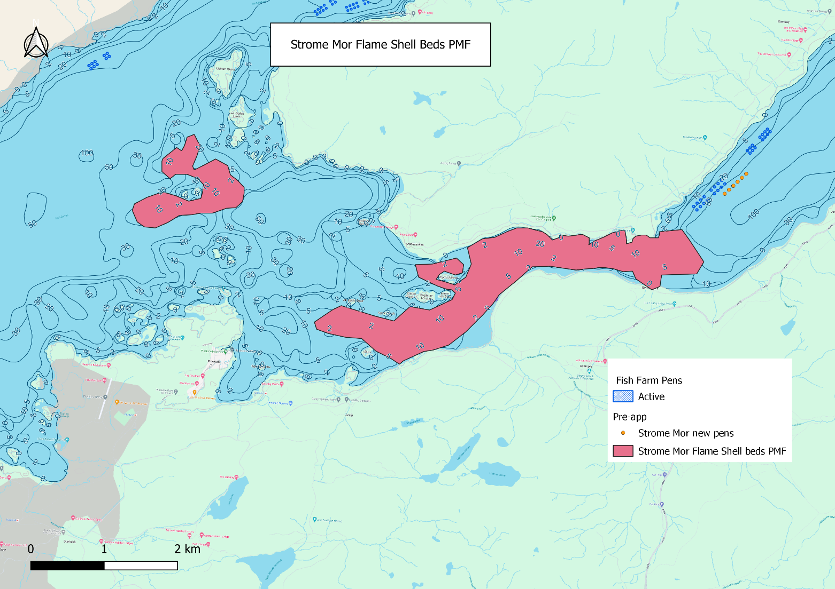
©Crown copyright. All rights reserved. SEPA lic. no. 100016991 (2019).
Figure 9. Identified sensitive PMFs of Flame Shell beds around the proposed site Strome Mor (SMOR1), in orange; WSTR1 and MSTR1 (in blue) are to be surrendered.
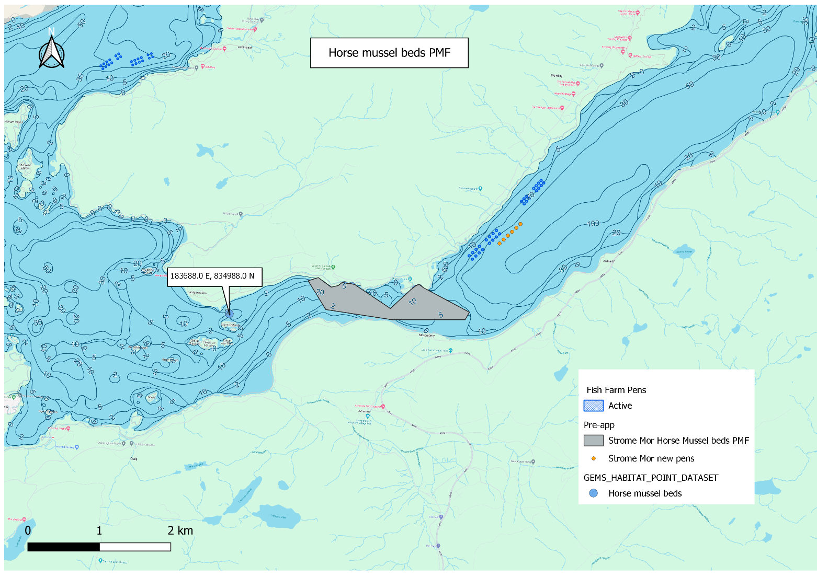
©Crown copyright. All rights reserved. SEPA lic. no. 100016991 (2019).
Figure 10. Identified sensitive PMFs of Horse Mussels around the proposed site Strome Mor (SMOR1), in orange; WSTR1 and MSTR1 (in blue) are to be surrendered.
©Crown copyright. All rights reserved. SEPA lic. no. 100016991 (2019).
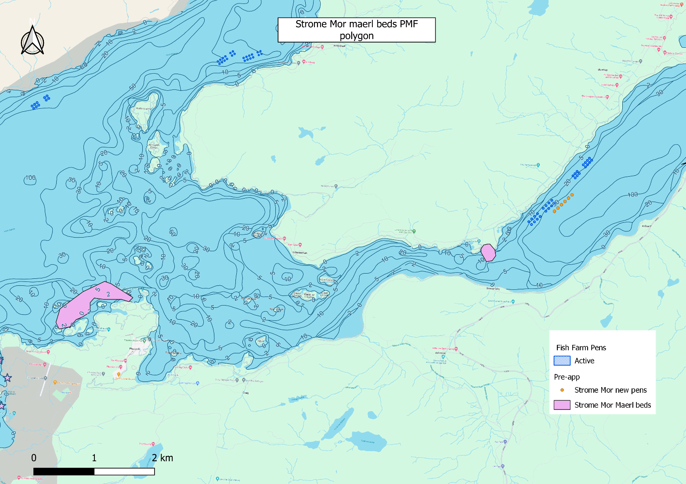
©Crown copyright. All rights reserved. SEPA lic. no. 100016991 (2019).
Figure 11. Identified sensitive PMFs of Maerl Beds around the proposed site Strome Mor (SMOR1), in orange; WSTR1 and MSTR1 (in blue) are to be surrendered.

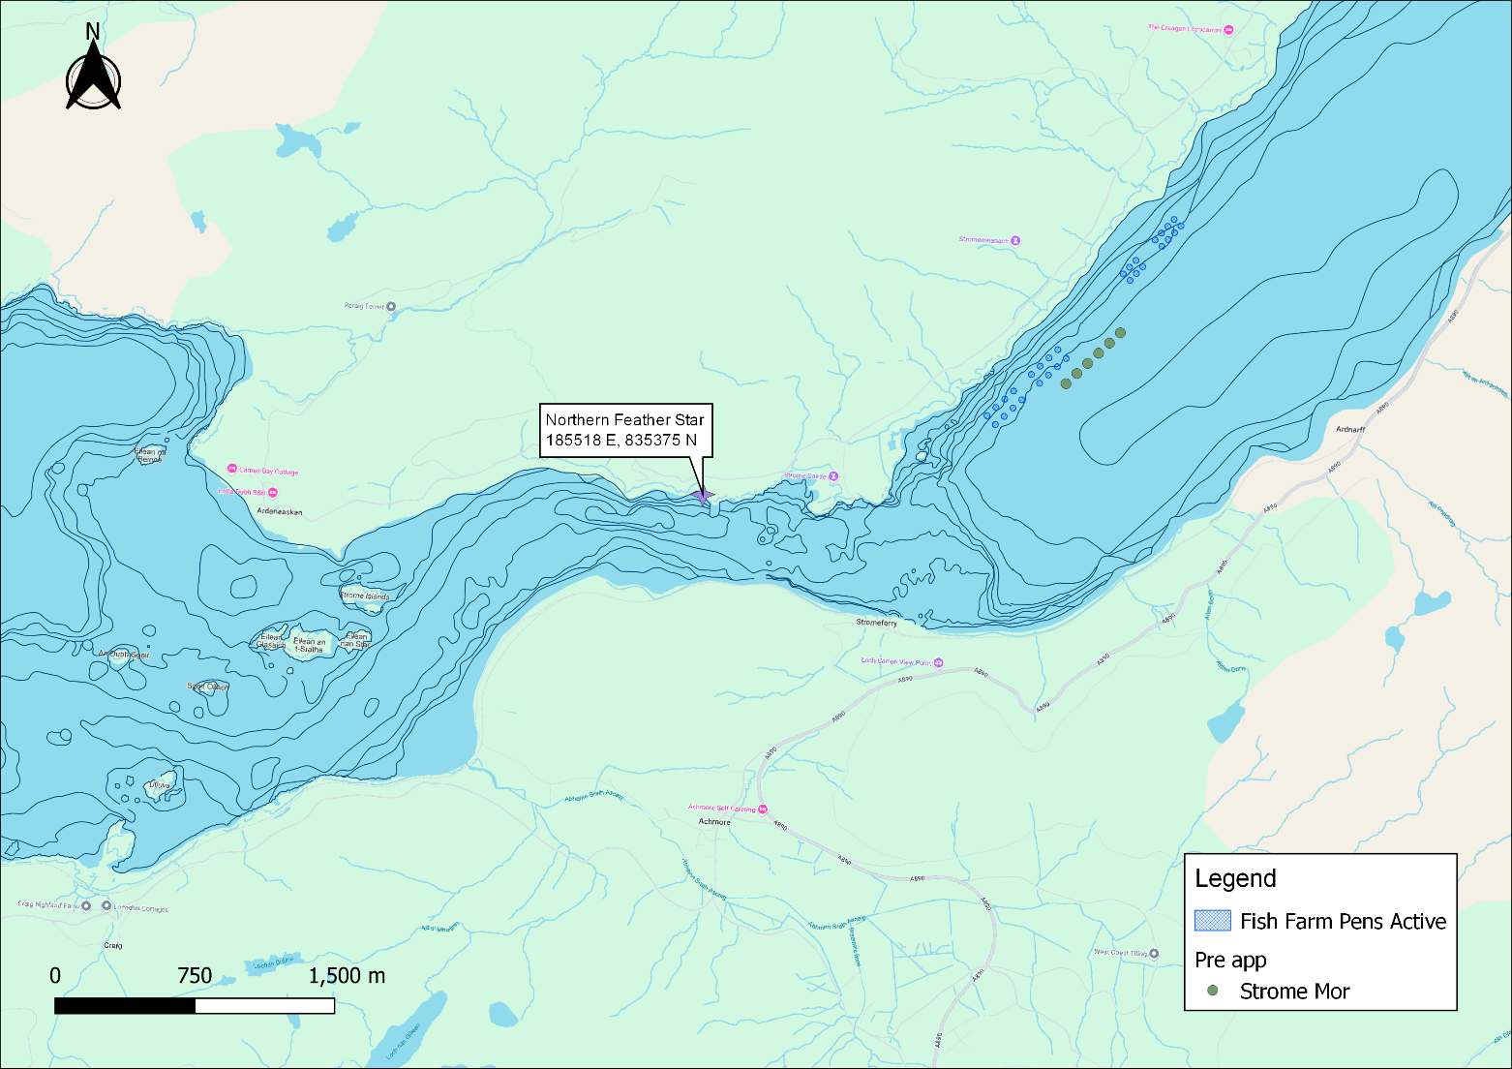
©Crown copyright. All rights reserved. SEPA lic. no. 100016991 (2019).
Figure 12. Identified sensitive PMFs of Northern Feather star near the proposed site Strome Mor (SMOR1), SMOR in green; WSTR1 and MSTR1 (in blue) are to be surrendered.

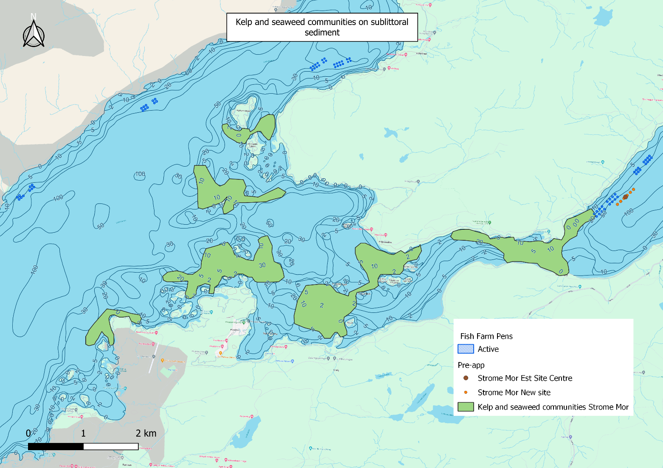
©Crown copyright. All rights reserved. SEPA lic. no. 100016991 (2019).
Figure 13. Identified sensitive PMFs of Kelp and seaweed communities close to the proposed site Strome Mor (SMOR1), in orange; WSTR1 and MSTR1 (in blue) are to be surrendered.

Additional comments on identified features
Whilst screening modelling does not predict any significant sediment influence from Strome Mor (SMOR1), this proposed site lies just outside the Loch Carron MPA and is near to several PMFs which are deemed to be at risk from sediment influence. As SEPA has the responsibility of ensuring the national status of the PMFs are not significantly affected by the proposed site, this proximity combined with the uncertainty in the model performance means higher resolution marine modelling of sediment will be required. Particular focus should be on the identified features. Discharges of sediment from all identified sites will need to be included in this modelling, to determine the combined risk on these features. As MSTR1 and WSTR1 are to be surrendered, these sites do not need to be included in the sediment modelling.
Should marine modelling be used instead of BathAuto to get a less conservative bath medicine quantity, then the sensitive features identified in table 5 should be included in the bath modelling. Cumulative modelling of baths is however not required.
In the adjacent waterbody, about 10km from the site lies the Marine Scotland Cat 2. waterbody of Kishorn (Fig. 13). As the existing sites are being replaced by a similar sized farm, additional solid/nutrient loads won’t be expected in this waterbody and therefore nutrient modelling is not needed.
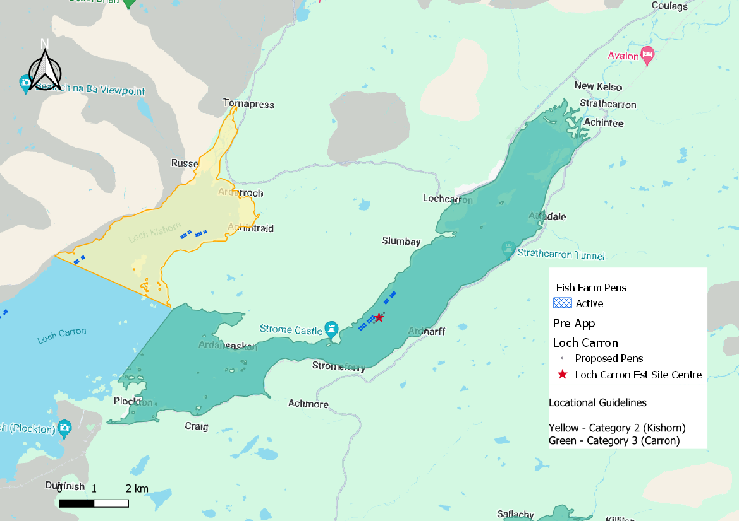
©Crown copyright. All rights reserved. SEPA lic. no. 100016991 (2019).
Figure 14. Figure showing locations of nearby Cat 2. (yellow) waterbody. Red star depicts SMOR1. WSTR1 and MSTR1 (in blue) are to be surrendered.

Risks identified from contextual site data
Should this application proceed, the total licenced biomass in this area would be 28,049 t.
Sites BEIS1, SRO1, ARDT1 and DUI1 are not to be included in cumulative modelling, due to the lack of interaction at screening with the proposed farm/material. MSTR1 and WSTR1 are not to be included either, as they will be surrendered.

Table 6: Table of licenced biomass from farms identified as likely to add to cumulative risks.
Site Name | Location (Easting, Northing) | Biomass (Tonnes) | Last production Cycle | Include in solids marine modelling?
SMOR1 | 187614, 836109 | 2750 | Proposed | Yes
AAC3 | 178970, 837800 | 1900 | Fish last on site Sep 2023 | Yes
ACH1 | 182466, 838551 | 1299 | Fish last on site Jan 2016 | Yes
ARDT1 | 182184, 824125 | 2500 | Currently Stocked (since Feb 2023) | Not to be included
BEIS1 | 175500, 825400 | 600 | Not stocked since records began (2002) | Not to be included
CDP2 | 182028, 838527 | 1600 | Fish last on site Aug 23 | Yes
DUI1 | 189305, 823100 | 1600 | Currently Stocked (since Feb 2023) | Not to be included
KIO1 | 176700, 836192 | 1713 | Fish last on site Sep 2023 | Yes
MSTR1 | 187930, 836700 | 687 | Fish last on site Aug 2019  Site to be surrendered | Not to be included
SRO1 | 178363, 825599 | 2500 | Currently Stocked (since Feb 2023) | Not to be included
STRF1 | 187580,835120 | 8000 | Pre-application | Yes
WSTR1 | 187270, 835945 | 2000 | Currently Stocked (since Sep 2022)  Site to be surrendered | Not to be included

As this is the new site, Default NewDepomod was used to establish an allowable biomass of 2750t, which passed both the pen and mixing zone standards.

Comparison between the existing two sites MSTR1 and WSTR1 with the proposed site SMOR1
An assessment has been conducted to compare the potential impact or risk from the two existing sites MSTR1 and WSTR1 against the applied for single site (SMOR1). SMOR1 is to replace the two existing sites, which will be relinquished. In the first instance modelled cumulative sediment impact from MSTR1 and WSTR1 and other sites in the vicinity were assessed and then compared to modelled cumulative sediment impact from SMOR1 and other sites. The comparisons show little difference between the two setups. The average cumulative intensity of the existing setup is 8.75g/m² and the average cumulative intensity of the proposed setup is 8.63g/m². The median of the existing setup is 3.06g/m² and the median of the proposed setup is 2.91g/m². These values are taking all the surrounding farms depicted in table 4 into consideration (minus the existing or proposed farm according to corresponding scenario). The values show, the modelled intensities are all very low and the values don’t differ very much from each other. Neither scenario poses a large risk to the environment.
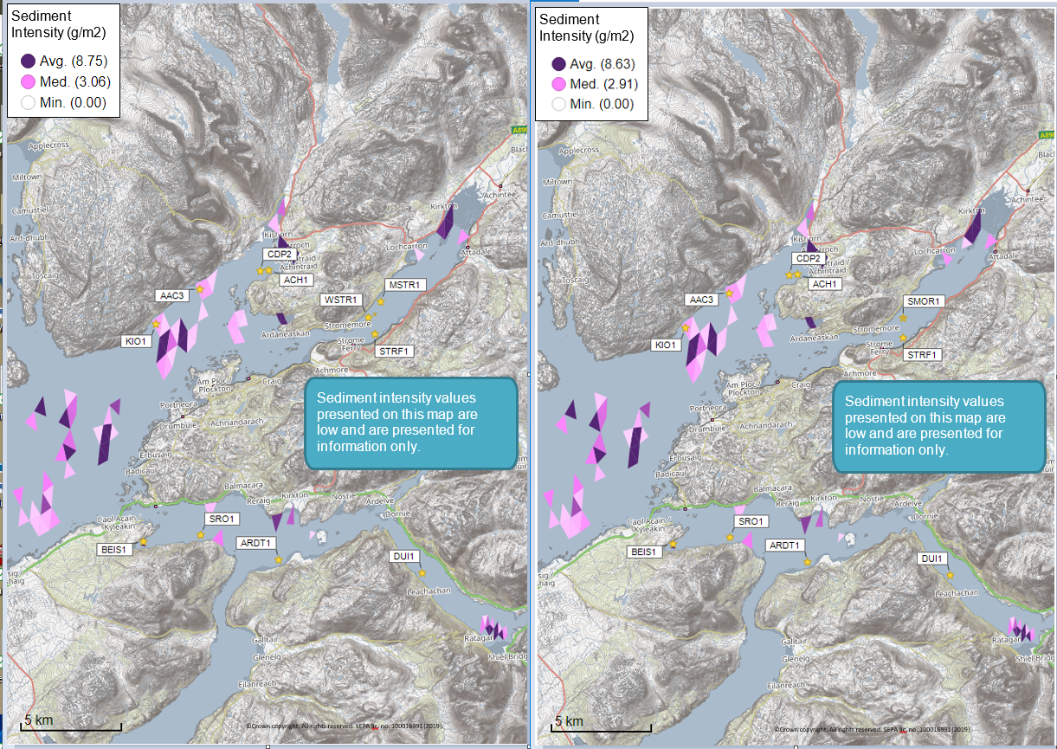
Figure 15. Left figure: modelled average sediment intensity over one month for the existing two sites (MSTR1 and WSTR1) and other relevant sites. Right figure: modelled average sediment intensity over one month for the proposed site (SMOR1) and other relevant sites.

Conclusions of screening modelling and risk identification
Following screening modelling and risk identification we make a number of conclusions and recommendations.

Conclusions

Screening Modelling
- According to screening modelling, the proposed site (Strome Mor (SMOR1)) is in an area of high dispersion and has a relatively high capacity for erosion of material on the seabed, however available current meter data from the site suggests this is not the case and dispersion is lower, therefore:
- From sediment and bath treatment modelling:
    - Information presented in the “Screening modelling” section indicates that the relative influence of Strome Mor (SMOR1) is likely to be similar to other sites for a similar tonnage.
    - The influence on the surrounding sea area from Strome Mor (SMOR1) is likely to be moderate.
    - The areas of influence from Strome Mor (SMOR1), and other sites modelled do not appear to interact. The sites Strome Mor (SMOR1) would potentially interact with are MSTR1 and WSTR1, however, these sites are to be surrendered along with this application.
    - It is likely that discharges of bath medicines from Strome Mor (SMOR1) will be dispersed to moderate levels over a moderate area.
Strome Mor (SMOR1) is likely to be of similar influence and occupying the same areas as the existing sites in the total influence of all sites modelled. Due to relinquishing of MSTR1 and WSTR1, which have a similar combined biomass to the proposed site, nutrient discharges from Strome Mor (SMOR1) are unlikely to have a significant additional influence on the surrounding sea area.
Sea Lice Screening Modelling
Detailed information has been provided in the section called Sea Lice Screening, above.
      - Sea lice screening was carried out using our standard method with the translated Scottish Shelf ECLH (East Coast Lewis & Harris) sub area model.
      - The site lies within the high priority East Skye Wild Salmon Protection Zone (as outlined in Annex II of the response to the second consultation, released in Dec 2023: sepa_response_to_consultation_feedback_december_2023-2.
      - Information in the Annex II, linked above, also shows that the existing West Strome site (which will be superseded by this proposal) has been identified in the Highest Relative Risk category.
      - The outcome of current screening is that this site will need a lice permit condition. In this case this could be a commitment to ensure lice levels are kept to the those currently maintained at West Strome CAR/L/1100544, considering the increased fish numbers, which will require a lower lice per fish level. Additionally, the lice permit condition could include a mitigation measure to reduce the risk to wild fish during the Sea Lice Regulatory Framework (SLRF) reporting period.
      - Alternatively, the lice permit condition may be derived using detailed modelling. This will require the deployment of sentinel cages for model evaluation and all sites within the WSPZ will have to be modelled.
A detailed method will need to be agreed before this work starts.

Risk identification
Although the modelled influence from Strome Mor (SMOR1) appears to be low, several features of interest have been identified, which require further attention during pre-application work. These are outlined in the “Risk Identification: Identified features which require attention” section. Further detailed 2D modelling will need to demonstrate that the influence on these features is low.
Cumulative modelling of identified sites will be required for solids but not for baths.

Recommendations

Site suitability
Consideration of screening modelling and risk identification suggests that it is possible that discharges from the proposed site will be able to comply with the relevant aspects of the SEPA Aquaculture Regulatory Framework. This must be demonstrated with a detailed marine model.
Submitted Default NewDepomod solids modelling suggests the site should be able to comply with our mixing zone regulatory framework.
Features at risk, identified at this stage, do not appear to influence the feasibility of the proposed site, with respect to the regulatory framework. These risks should be examined using a detailed marine model.
Following the engagement meeting(s), this report will be revised, and this should allow the applicant to submit a method statement which addresses the issues raised in this document.

Further modelling
- Due to the identified risks, 2D marine modelling should be carried out.
- The size of the marine model should include discharges from all sites identified in this report. Cumulative modelling including the identified sites (except for sites MSTR1 and WSTR1 that will be surrendered, as well as BEIS1, SRO1, ARDT1 and DUI1 which showed no interaction with the proposed farm/ material) will be required for solids, but not baths.
- The resolution of the marine model should be relatively fine around the proposed site and identified features at risk.
- NewDepomod modelling has been undertaken for the proposed site. (It is strongly recommended that default NewDepomod modelling is undertaken prior to any marine modelling, to ensure the local impacts of the proposed biomass are acceptable.)
- Sea lice screening has shown permit conditions will be required for this site to ensure lice levels are kept to the levels currently maintained at West Strome CAR/L/1100544.

References
[1] Pre-application | Scottish Environment Protection Agency (SEPA) (Hydrographic Data Guidance for Aquaculture, New Depomod Modelling Guidance, Marine Modelling Guidance for Aquaculture Applications).
[2] The wider domain Scottish Shelf Model

Appendices – Responses to pre-app consultation.
For the avoidance of doubt the SEPA Aquaculture Modelling Screening and Risk Identification report has been assessed on the number of marine pens and biomass proposed to SEPA for the purposes of application for authorisation under the Water Environment (Controlled Activities) (Scotland) Regulations 2011.
The number of marine pens and biomass included in the application to the local authority for planning permission may be different.
When submitting responses to be included in the appendices stakeholders had not seen the sea lice screening provided by SEPA. If any stakeholders wish to amend their response after this report has been published please contact SEPA.

Appendix 1 – Highland Council, Planning Department

Description of Proposal and Summary of Key Points
BFS Loch Carron Consolidation - The Proposed Development is a consolidation of two existing sites, West Strome, (currently licensed for 16 x 100m pens with a maximum biomass of 2000T) & Strome (currently licensed for 8 x 100m pens with a maximum biomass of 687T). The new site will be located between the two existing sites & will be comprised of 6 x 160m pens, with 15m deep nets & a proposed maximum biomass of between 2500 - 2750T (biomass to be confirmed).
Based on the information submitted it is likely that a case officer recommendation for approval could be made. However the site has a long history of noise complaints from residents on the southern shore of the loch and any application must contain sufficient information to show that the noise profile of the proposed development and its envisaged operations address these problems satisfactorily.
The application must also respond to the adoption of NPF4 as a new part of the development plan. In particular the application must respond positively to the new requirements of community wealth building (Policy 25) and biodiversity enhancement (Policy 3).
You are advised that the following consent(s) will be required for the proposed development:
- Planning Permission.

Planning History

Table 7. Table showing planning history
Reference | Description | Date of Decision | Outcome
12/00674/FUL | Marine Fish Farm - Atlantic Salmon - New site consisting of 16 cages each 100m circumference and an automated feed barge adjacent to existing site. | 6 July 2012 | Application Refused
13/01278/SCRE | EIA Screening - Marine Fish Farm - Atlantic Salmon - new site comprising 16 x 100m circumference circular cages in 2 groups (2 x 4, 2 x 4). in a 65m mooring grid with automated feed barge, adjacent to existing site. | 4 June 2013 | Screening Application. EIA Required
13/01277/SCOP | EIA Scoping - Marine Fish Farm - Atlantic Salmon - new site comprising 16 x 100m circumference circular cages in 2 groups (2 x 4, 2 x 4). in a 65m mooring grid with automated feed barge, adjacent to existing site. | 4 June 2013 | Scoping Application. Decision Issued
17/02476/SCRE | EIA Screening: Marine fish farm - Atlantic Salmon, new site consisting 16X100m circumference cages moored in 2 groups with feedbarge. | 30 May 2017 | Screening Application. EIA Required
17/02534/SCOP | EIA Scoping: Marine fish farm - Atlantic Salmon, new site consisting 16X100m circumference cages moored in 2 groups with feedbarge. | 26 June 2017 | Scoping Application. Decision Issued
18/04819/FUL | Marine Fish Farm - Installation and operation of an Atlantic salmon fish farm adjacent to the existing Strome farm - consisting of 16 circular pens each 100m circumference and an accompanying feed-barge. | 5 August 2019 | Permission Granted
23/00552/PNO | Replacement of feed barge. | 2 May 2023 | Application Withdrawn
23/00922/PNO | Replacement of feed barge with one of the same capacity. | 2 March 2023 | Application Returned
23/02128/FUL | Marine Fish Farm - Atlantic Salmon: Modification to replacement feed barge with one of the same capacity. |  | Pending Consideration
24/02126/PNO | Replace the existing bird nets and hamster wheel style bird net supports with new bird nets, to be suspended from poles. Bird nets will be replaced on all pens at the West Strome fish farm. |  | Pending Consideration
24/02790/PNO | Replacement of existing barge with one of the same capacity. There is no change proposed to the location. |  | Pending Consideration

Planning Policy
National Planning Framework 4 (NPF4) (2023):
Policy 1 - Tackling the Climate and Nature Crises
Policy 2 - Climate Mitigation and Adaptation
Policy 3 - Biodiversity
Policy 4 - Natural Places
Policy 7 - Historic Assets and Places
Policy 25 - Community Wealth Building
Policy 28 - Retail
Policy 29 - Rural Development
Policy 32 - Aquaculture
Highland-wide Local Development Plan (HwLDP) (2012):
28 - Sustainable Design
29 - Design Quality & Place-making
36 - Development in the Wider Countryside
50 - Aquaculture
57 - Natural, Built & Cultural Heritage
58 - Protected Species
59 - Other important Species
60 - Other Importance Habitats
61 - Landscape
72 – Pollution

West Highland and Islands Local Development Plan (WestPlan) (2019)
No specific policies

Highland Council Supplementary Guidance
Aquaculture
Biodiversity Enhancement Planning Guidance (May 2024)
Highland Historic Environment Strategy (Jan 2013)
Highland's Statutorily Protected Species (March 2013)
Assessment
Policy Position
The proposal is likely to gain solid ‘in principle’ support from the most relevant development plan policies – NPF4 Policy 32 Aquaculture (+ HwLDP Policy 50). NPF4 Policy 29 Rural Development is also supportive in respect of the proposal’s potential contribution to local employment and the rural economy in general.
Policy 32 is heavily caveated in respect of impacts upon marine biology, of course, and this ties in with the thrust of Policies 1 and 3 in terms of addressing the nature crisis and the need for biodiversity enhancement. Further advice from SEPA, NatureScot and the Marine Directorate will be definitive in this respect, although it is recognised that impacts upon wild fish populations now fall within the regulatory remit of SEPA.
Consideration should also be given to NPF4 Policy 25 and the requirement for development proposals to contribute to local or regional community wealth building strategies and to be consistent with local economic priorities.

Siting, Design and External Appearance
Appropriate visualisations of the current and proposed visual and landscape impacts of the farm arrangements will be required. However, it appears that a strong case can be made that the replacement of the existing 24 x 100m pen arrangement in two groups with a single group of 6 x 160m pens will result in an overall reduction of visual impact from most viewpoints. Such viewpoints should be chosen to best represent the most vulnerable visual receptors.
The design of feed barge to serve the new arrangement will be important although it is assumed the existing barge has the capacity to serve the proposed farm.

Neighbour Amenity, Noise, Lighting and Operating Hours
The improved visual impact of the proposal should be matched by its proposed neighbour amenity impacts. Given a history of complaints from a number of neighbouring properties, it seems likely that any application will be met with objections on these grounds and there is a risk these could convince the authority that permission should not be granted.
It is understood that the consolidation to fewer, larger pens offers the prospect of reduced fish health treatments and this, in turn, could reduce the level of wellboat activity associated with the farm. The application should show how this will quantifiably relate to reduced noise and light emissions from farm operations and also to a reduction in the need to operate outwith normal hours.
If evening and nighttime working is still going to be required, the application should be upfront about this and include details of how often and how late such working is proposed to take place. It may be possible to incorporate such details into a planning condition that offers operational flexibility and neighbour amenity certainty and so meets the needs of both the operator and neighbours.
The application should be submitted with a comprehensive noise impact assessment and this
assessment should acknowledge the current situation and provide some quantitative data in respect of current operations and noise impacts. And so, hopefully, be able to show improvement with the proposed scheme.

Community Wealth Building
To the extent that there are negative amenity impacts on the local population and community, this new concept in NPF4 offers the prospect of ‘off-setting’ harm against other positive impacts on the community as a whole. As examples of what might be taken into account it states,
“...This could include for example improving community resilience and reducing inequalities; increasing spending within communities; ensuring the use of local supply chains and services; local job creation; supporting community led proposals, including creation of new local firms and enabling community led ownership of buildings and assets...”.
Any application should embrace this new emphasis on the advantages of the development for the community and include a range of pro-active examples both existing and envisaged.

Protected Species and Biodiversity Enhancement
The Loch Carron Marine Protected Area and its flame shell beds will be a material consideration for this application. As the greatest risk is from benthic deposition from the farm, it is assumed that SEPA will also address this issue and the planning authority will seek and follow their advice.
In respect of sea-lice, SEPA are also likely to be the lead regulator in respect of their new risk assessment framework. It appears unlikely that an EMP of the type currently operating would be required for a future proposal. SEPA may introduce their own wild fish monitoring proposals in the future.
The planning authority is more likely to focus upon proposals for biodiversity enhancement. Again, this is a new NPF4 concept although not a new concept in its own right. Indeed, it is known that in the past these sites have provided support for re-stocking and riparian habitat improvement in the Carron river system. The planning authority would encourage the applicant to look at something similar with this application. Initiatives aimed at improving the capacity of the river system to provide breeding habitat for salmonids would not only tick the biodiversity enhancement box but also that of mitigation for any identified negative impacts of the proposal on the wild salmonid population of the loch. Some form of biodiversity enhancement plan is likely to be required by condition on any consent granted – a proactive approach by the applicant will assist in this regard.

Environmental Impact Assessment (EIA)
It is noted that the previous application - 18/04819/FUL – was considered to be EIA development. However, this does not automatically mean that this proposal would be regarded in the same way. Once further detail for the proposal has been finalised, it is recommended that a formal EIA screening application is made to the authority.

Consultees For Any Future Application
The following will likely be consulted on any planning application submitted. On occasion it may be necessary to involve consultees who are not listed below as an application progresses.
Highland Council Consultees:
- Environmental Health

External Consultees:
- SEPA
- Marine Directorate
- NatureScot
- Northern Lighthouse Board

Additional Information Required For Any Future Application
Based on the information provided, you are advised to submit the following additional information with any future application for formal permission. If you choose not to follow our advice and do not submit one or more of the documents, then you should provide a clear justification for doing so.
- Noise Impact Assessment

Making a Formal Application
Online application forms and guidance
Disclaimer
This advice is based on the information submitted and is given without prejudice to the future consideration of and decision on any application received by The Highland Council.
Pre-application case files are not publicly available but can be the subject of Freedom of Information and Environmental Information Regulations requests.

Appendix 2 – Nature.Scot

Please find below our advice regarding the proposed consolidation of two existing fish farm sites in Loch Carron.

Background
The consolidated site is proposed to be located between the two existing sites and will consist of 6 x 160m pens, with 15m deep nets and a proposed maximum biomass of between 2500 – 2750T (biomass to be confirmed). It is unclear to us from the submitted information how the existing sites are currently operated and what the maximum biomass from the two existing sites has been. It would also be helpful to clarify how chemical usage for the proposed compares to the existing sites. The locations for the feed barge and the mooring grid information have not been provided at this stage.

Summary
Our advice is, on the basis of the limited information which has been provided, that there are no definite “show-stoppers” with regards to natural heritage interests within our remit. However, provision of new data will be required in relation to a number of natural heritage sensitivities in order to allow us to fully assess the likely impacts of this proposal.

Gannet & Seabird SPAs
Gannets have been recorded becoming entrapped/entangled in pole mounted top nets at fish farms in Scotland. The foraging distance of gannets means there is connectivity with a number of SPAs (e.g. Seas off St Kilda). Guidance on top net mesh sizes and reporting is provided in our briefing note. This guidance is currently being reviewed but in the meantime the interim guidance should continue to be used.

Loch Carron NC MPA
The proposed site would be approximately 0.7km from Loch Carron NC MPA, protected for its Maerl beds and Flame shell beds (see map below). SEPA and THC will be required to consider the effect of the proposal on the MPA as part of the CAR and Planning processes respectively. The application will need to contain sufficient detail to inform those assessments.
The proposed site is less than 1km from the Strome narrows Flame shell bed at its most western point. Both Flame shell beds and Maerl beds have a high sensitivity to organic enrichment and smothering and may also have an elevated sensitivity to some fish farm chemicals. We wish to understand the deposition patterns and concentration (including any resuspension) and how they compare to the patterns from the existing farms. More details regarding what is required can be found at the end of the next section.

Benthic - PMFs
In addition, the proposed farm would also be in the vicinity of a range of PMFs, including Ocean Quahog, Burrowed Mud including tall seapens, Kelp and seaweed communities on sublittoral sediment and Tide swept algal communities.
To assess the application and its likely impacts on benthic habitats, we will require the following information:
- Updated maps showing the footprint of the site including moorings and feed barge.
- The deposition modelling report.
- A comparison of the predicted deposition of carbon and chemicals between the existing and proposed layouts.
- An appropriate seabed survey in and around the farm’s predicted area of impact which details the extent of any PMFs and the qualification of the composition and quality of any PMFs that will potentially be affected by the proposal e.g. assessment of density and biodiversity. This should include both visual and grab sample data.
- A description of measures to avoid, prevent, reduce or offset significant adverse effects on PMF habitats/species.
If required, a full description of measures to avoid impacts if surveys and benthic modelling indicates potential impacts on qualifying features of Loch Carron MPA (Maerl beds and Flame shell beds).
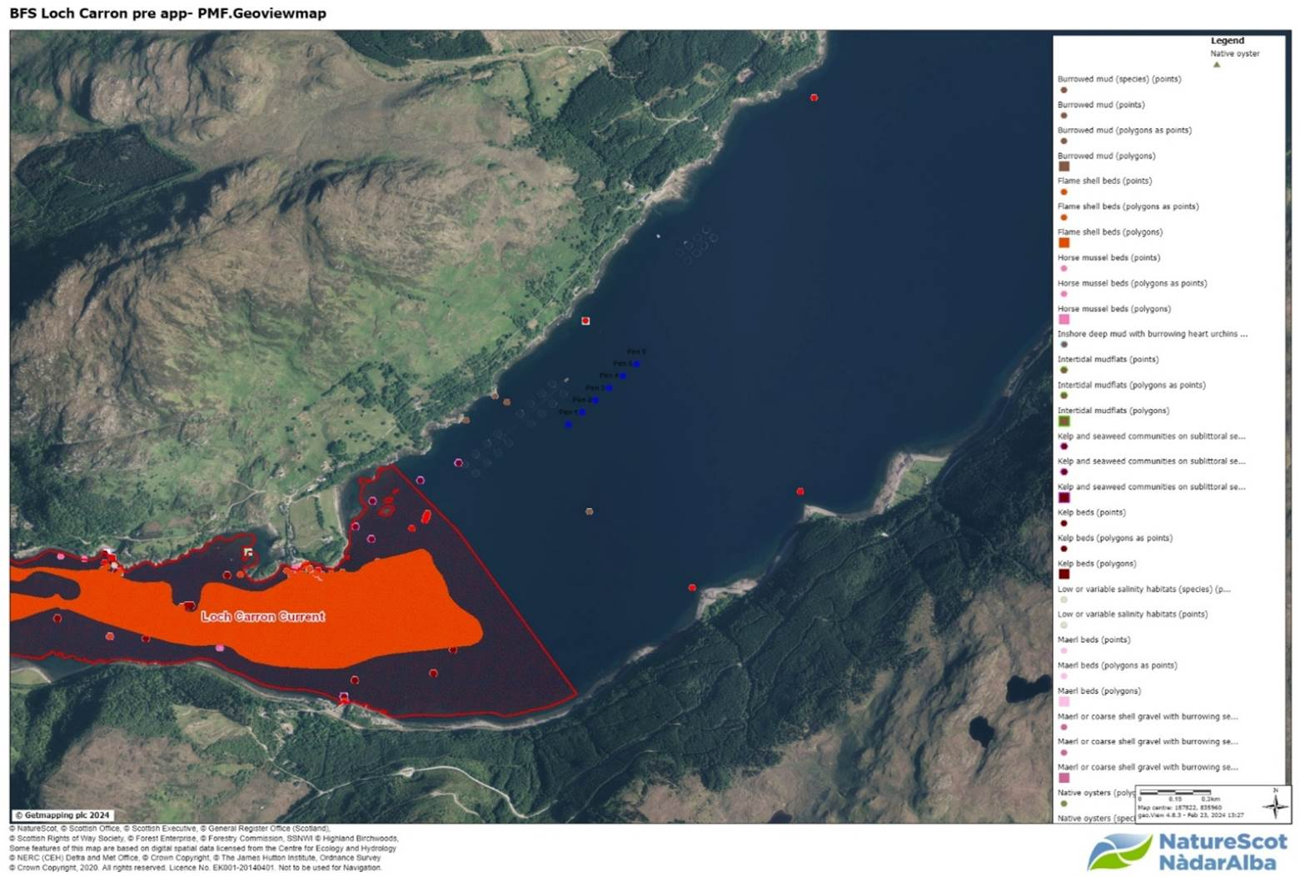
Figure 16. Figure showing Loch Carron PMFs.

Site biomass
We note that the results of seabed surveys taken during periods of peak biomass at Mid and West Strome (as shown here) highlights five cycles in a row for Mid Strome where the peak biomass surveys being conducted were classified as “unsatisfactory” (CAR/L/1004069). West Strome has received a “satisfactory” seabed survey in 2021, at a peak biomass of 1480t. Although the two sites are proposed to be consolidated, it appears that neither site has been active during the same operation period, as shown in the Biomass graphs. The highest biomass was 1688t in 2020 which is well below the proposed tonnage for the consolidated farm. Given this background, there is concern that an increase in permitted biomass at the site could lead to the EQS not being met. We would be happy to discuss this further in a meeting with SEPA if beneficial.

Atlantic Salmon and sea trout PMFs; Freshwater Pearl Mussel
No designated sites with a wild fish interest are likely to be impacted by the proposal, but both Atlantic salmon and sea trout are Priority Marine Features (PMFs) and there are rivers within relatively close proximity to this proposal which support populations of both species. Marine Directorate would normally provide advice on this aspect.
There is also a freshwater pearl mussel (FWPM) population in the local area, which could be indirectly affected by the proposal. Freshwater pearl mussel populations require healthy juvenile salmonid populations to complete their life cycle. Further information on FWPM can be found on our website.

Landscape
We advise that the siting and design of the proposed development follows our published guidance, specifically:
- The siting and design of aquaculture in the landscape: visual and landscape considerations
- Guidance on Landscape/Seascape Capacity for Aquaculture
Early production of a ZTV would assist with the identification of key viewpoints (such as the elevated viewpoint on the A890), and wirelines from agreed VPs would be useful in assessing the various siting and design options for both cages and feed barge (including considering coastal alignment). Early consideration of the colour of the feed barge is also recommended as this can draw attention to the farm and barges are difficult to repaint once installed. For instance, a dark matt colour can help it to recede as much as possible into the landscape. However, in principle, a single sensitively designed farm would be expected to have less of an impact on landscape than the current layout.
Please let me know if you require any clarification on the above.

Appendix 3 – Marine Directorate - Licensing Operations Team (MD-LOT)
Thank you for contacting Marine Directorate – Licensing Operations Team (MD-LOT), the regulator of licensable marine activities on behalf of the Scottish Ministers under the Marine (Scotland) Act 2010. Under the Marine (Scotland) Act 2010 s. 21, it is a licensable marine activity to deposit any substance or object within the Scottish marine area, either in the sea or on or under the seabed, from any of the following (a) a vehicle, vessel, aircraft or marine structure, (b) a container floating in the sea, or (c) a structure on land constructed or adapted wholly or mainly for the purpose of depositing solids in the sea. This includes deposit of fish farm equipment.
Article 12 “Propagation and cultivation of fish – deposits” of the Marine Licensing (Exempted Activities) (Scottish Inshore Region) Order 2011 however states that the deposit of any trestle, raft, cage, pole, rope, line or within controlled waters, any substance which is liable to cause pollution of the water environment, in the course of the propagation or cultivation of fish is an exempted activity, provided that the relevant conditions are met. The conditions are that the deposit is not made for the purpose of disposal; not made for the purpose of creating, altering or maintaining an artificial reef; or that it causes or is likely to cause obstruction or danger to navigation. It is the applicant's responsibility to ensure they meet the conditions if they intend to apply the exemption to their activities.
MD-LOT does not carry out any assessments about the suitability of the location for a fish farm, nor does it assess impacts on environment, human health or legitimate uses of the sea during the pre-application stage. Any such assessments are carried out at marine licence application determination stage, if required, and rely on stakeholder consultation. A marine licence can only be granted after planning permission for the farm has been granted.
To facilitate the pilot pre-application process and to advise other relevant authorities and the developer, MD-LOT has carried out a Geographic Information System (GIS) check for sensitivities and features of interest in the vicinity of the proposed farm. The results of the GIS check are shown below and are based on the data currently available to MD-LOT. This is not an exhaustive list of all relevant sensitivities, and this information alone should not be used to determine what issues the developer may need to consider during the application process. MD-LOT is providing this information to the other relevant authorities and the developer in good faith and without pre-judgement of any potential application. MD-LOT does not intend to carry out further analysis of the suitability of the proposal based on these findings.
We hope this information is helpful.
Kind regards,

Summary of GIS checks
Previously licensed sites: 0 (only the 2 sites to be consolidated within the area)
Seal haul out sites: 0
Sea deposit sites: 0
Wrecks: 0
No other issues identified

Appendix 4 – Historic Environment Scotland

Loch Carron - Consolidation of West Strome and Strome Fish Farms Pre-application consultation
We have received the above consultation on 16 February 2024 from the applicant under the fish farm consenting pilots. We have reviewed the information in terms of our historic environment interests. This covers world heritage sites, scheduled monuments and their settings, category A-listed buildings and their settings, inventory gardens and designed landscapes, inventory battlefields and historic marine protected areas (HMPAs).
The Highland Council’s archaeological and conservation advisors will also be able to offer advice for their interests. This may include undesignated archaeological sites, category B- and C-listed buildings and conservation areas.

Our Advice
From the current information provided we have not identified any likely significant effects or “showstoppers” on our interests as a result of the proposals. We therefore have no comments to make regarding the proposals.
We hope this is helpful.

Appendix 5 – Northern Lighthouse Board
To whom it may concern,
The NLB have reviewed the initial documents sent through for the plans in Loch Carron. As the merging of the two existing sites will retain largely the same footprint and aspect, barring any changes to the plans, should permission be granted for this site by the local authority, we don’t see any issues from a navigation point of view that cannot be mitigated by the development of a lighting and marking solution and submission of the site design and coordinates to the UKHO for inclusion in appropriate charts of the area.
At the point when we are consulted as part of the planning process, there should be no issues in providing you with a lighting and marking stipulation for the site.
Regards

Appendix 6 – Maritime and Coastguard Agency
Thank you for the opportunity to comment on the pre-application documents for the pilot at Loch Carron / Strome Mor. The Maritime and Coastguard Agency (MCA) has an interest in the works associated with the marine environment, and the potential impact on the safety of navigation, access to ports, harbours and marinas and any impact on our search and rescue obligations.
I can confirm that the MCA has no concerns to raise at this stage on the proposals from the shipping and safe navigation perspective. This is based on the current information provided. I note that there are two existing fish farm sites which I believe are depicted on the nautical charts and known to marine users. The proposal is to merge the fish farms onto one site, which remains largely within the existing fish farm area.
We are content on this occasion that any increase in risk to other marine users can likely be mitigated through suitably worded conditions and/or advisories at formal marine licence application stage. We would of course expect notification to the UK Hydrographic Office for the update of nautical charts and publications, lighting and marking as per NLB requirements and the relevant local notifications. There will be additional risk mitigation measures required at marine licence application stage.
Kind regards

Appendix 7 – Marine Directorate - FF Planning

Pre-application request through the new consenting pilot for consolidation of West Strome and Strome sites, Loch Carron by Bakkafrost Scotland Ltd

Scottish Government’s Marine Directorate (SGMD) (previously known as Marine Scotland) have reviewed the application submitted and offer the following comment as amended from our original response dated 26/03/2024:
Based on the limited information available, no specific showstoppers have been identified.
Further information may be requested covering the following:

Environmental Impacts
Benthic impacts – including information demonstrating the acceptability of the proposal should the existing West Strome and Strome CAR licences be retained.
Water column impacts – Loch Carron is currently a Locational Guidelines Category 3 area. Further information is likely to be requested in relation to the plans to either retain or relinquish the CAR licences for the existing West Strome and Strome sites, however SGMD can advise that Loch Carron would become a Category 2 loch should the maximum consented biomass in the loch increase to 5437T. Relevant nutrient impact calculations will be required that account for all consented biomass in the categorised area.

Aquaculture Animal Health
The proposed consolidated Strome site, located at E187258, N835951, will continue to be included in disease management area (DMA) 14a Carron, Kishorn, Alsh, Duich and will not change the current boundary of this existing DMA.
In addition to the usual information requirements, the applicant will also be required to provide;
- details of the infrastructure in place for handling 160m pens including details of staff knowledge and experience.
As further details of the proposal are confirmed, more specific information may be required.

Wild Fisheries
The current consolidation plan situates the consolidated site between the two existing sites of West Strome and Strome. Considering the biomasses of the existing sites at West Strome and Strome (2,000 and 687 tonnes respectively), any biomass under 2,687 tonnes would not be considered an increased risk to the local sea trout population.

EMP (Environment Management Plan)
We note that in the supporting information supplied for the pre-application, no mention was made by Bakkafrost of the expected timescale for the submission of a planning application for the site consolidation. In the aim of capturing the project under the relevant consenting regime at the time of pre-application, we advised on the potential requirement for an EMP for sea trout.
To clarify the statements made in the Aquaculture Pre-App Risk Identification Report: STROME MOR (SMOR1), an EMP would only be requested if the finalised biomass of the consolidated site is above the existing consented biomass for the two existing farms (2,687 tonnes) and if the planning application is submitted/determined prior to the implementation of the SEPA sea lice framework for sea trout (expected March 2025). We advise in our comments that any EMP produced ahead of the framework adoption should have an option to undergo early review, to transition to the framework when available.

Since the applicant expects to submit the planning application after the launch of the national framework, no EMP will be necessary.
Sea lice efficacy – a sea lice efficacy statement including the relevant modelling reports.

Notes to applicants
The Aquatic Animal Health (Scotland) Regulations 2009 requires the authorisation of all Aquaculture Production Businesses (APB's) in relation to animal health requirements for aquaculture animals and products thereof, and on the prevention and control of certain diseases in aquatic animals. The authorisation procedure is undertaken on behalf of the Scottish Ministers by the Fish Health Inspectorate (FHI) at the Marine Directorate Marine Laboratory. To apply for authorisation for an APB or to amend details of an existing APB or any site that an APB is authorised to operate at, you are advised to contact the FHI as follows: Fish Health Inspectorate, Marine Directorate Marine Laboratory, 375 Victoria Road, Aberdeen, AB11 9DB. Tel: 0131 244 3498; Email: ms.fishhealth@gov.scot.

All marine farms, whether finfish, shellfish or algal, are required to apply for a marine licence under Part 4 of the Marine (Scotland) Act 2010. To apply for a marine licence, or to amend details of an existing marine licence (formally Coast Protection Act 1949 – Section 34 consent), please visit the Scottish Government’s website at Marine environment: licensing and consenting requirements where application forms and guidance can be found. Alternatively you can contact the Marine Directorate Licensing Operations Team (MD-LOT) by emailing MS.MarineLicensing@gov.scot; or calling 0300 244 5046.

Yours sincerely

Marine Directorate of the Scottish Government

For information on accessing this document in an alternative format or language, please contact SEPA by emailing equalities@sepa.org.uk
If you are a user of British Sign Language (BSL), the Contact Scotland BSL service gives you access to an online interpreter, enabling you to communicate with us using sign language. contactscotland-bsl.org

