

# Aquaculture Modelling Screening and Risk Identification Report: Kirknoust (BOH2)

Report date: October 2024

## Scope of report

As part of the SEPA Aquaculture Regulatory Framework it is recommended that a proposed application for a marine fin fish aquaculture site should undergo a Screening Modelling and Risk Identification process. SEPA carries out this work and this is described on the SEPA aquaculture website [**Pre-application section**](https://www.sepa.org.uk/regulations/water/aquaculture/pre-application/)

This report presents information arising from that process. Screening modelling methods are outlined and maps and tables describing the modelled impacts are shown. Risks arising from consideration of the model output are listed. Conclusions and recommendations are made regarding the proposed site.

## Executive summary

SEPA has received a proposal to vary an existing marine fin fish aquaculture site called Kirknoust (BOH2). The site is located in the Rousay Sound, Orkney at location: 345036.5 1029056.7 (Easting, Northing). The existing maximum biomass is 500t at this location and the proposed weight of fish to be farmed is 1200t.

Following screening modelling and risk identification we have concluded the following:

* Calibrated NewDepomod modelling using 4 transect monitoring is required at this site, in addition to Standard default NewDepomod modelling. NewDepomod modelling should also be carried out using the current permitted consent amounts to determine the difference in footprint of the current and proposed sites. It is recommended that NewDepomod modelling is undertaken prior to any other modelling work. Due to the proximity of Maerl beds to the northeast of the site, NatureScot have advised an increase in footprint may result in this application being rejected.
* Due to this site’s location in Wyre and Rousay Sounds MPA(NC) and proximity to the qualifying sensitive and protected marine features, SEPA and NatureScot require marine modelling for solids to determine level of impact. BathAuto is the default assessment approach for bath medicines, however, should a less conservative amount be required at this site, then marine modelling of bath medicines will be required. The resolution of the marine model should be relatively fine around the proposed site and identified features at risk.
* Cumulative modelling is required for solids, but not bath medicines.
* Kirknoust (BOH2) may be suitable to progress to the next stage of the pre-application process outlined on the SEPA website, however, the tolerance of marine protected species around this site to deposition of solids and exposure to chemicals is very low. On the advice of NatureScot, if modelling predicts an increased impact on these features, it will likely be considered significant, and this application will be rejected.

## List of abbreviations

SEPA Scottish Environment Protection Agency

## List of chemical abbreviations

AZA Azamethiphos

Contents

Aquaculture Modelling Screening and Risk Identification Report: Kirknoust (BOH2) 1

Scope of report 2

Executive summary 2

List of abbreviations 4

List of chemical abbreviations 4

List of Figures 6

List of Tables 7

Introduction 8

Screening modelling 14

Risk Identification 28

Conclusions of screening modelling and risk identification 32

References 35

## List of Figures

Figure 1. Pentland Firth and Orkney Waters model grid 13

Figure 2: Modelled average water speed (metres per second – m/s) in the sea around the proposed site (Kirknoust (BOH2)). 22

Figure 3: Modelled percentage of time the water flow speed is above 0.095 m/s in the sea area surrounding the proposed site (Kirknoust (BOH2)). 23

Figure 4: Modelled average sediment intensity over one month for the proposed site only (Kirknoust (BOH2)). 24

Figure 5: Modelled average sediment intensity over one month for the proposed site (Kirknoust (BOH2)) and other relevant sites. 25

Figure 6: Modelled average Azamethiphos concentration over four days from neap tide release for the proposed site only (Kirknoust (BOH2)). 26

Figure 7: Modelled average Azamethiphos concentration over four days from neap tide release for the proposed site (Kirknoust (BOH2)) and other relevant sites. 27

Figure 8: Location of proposed pen layout change, MPA and PMF polygons and points. 30

## **List of Tables**

Table 1: Sediment influence information for each site. 18

Table 2: Azamethiphos influence information for each site. 20

Table 3: Table of identified features 29

Table 4: Table of licenced biomass from farms identified as likely to add to cumulative risks. 31

## Introduction

Screening Modelling and Risk Identification are important steps in the SEPA regulatory framework for marine pen fish farms. They are carried out by SEPA at the [**pre-application stage**](https://www.sepa.org.uk/regulations/water/aquaculture/pre-application/)**.**

This document briefly describes the objectives of screening and risk identification and summarises the methods used. Screening output for the proposed site is then presented with comments. Risks identified from the screening output are detailed. Conclusions and recommendations about the suitability of the proposed site are then made.

### The objectives of screening modelling and risk identification

A summary of the modelling methods employed during screening modelling is outlined in the screening modelling methods section. The objectives of screening modelling and risk identification are outlined below.

#### Screening modelling

Marine Modelling technology can be used to simulate and predict the potential influence of discharges on the marine environment. Marine modelling can also be used at an earlier stage to provide an initial estimate of the influence of material discharged from a proposed site, which is discussed in this report.

SEPA will require the majority of proposed farms to conduct detailed marine modelling, as outlined in our Aquaculture Modelling guidance [1] and on the SEPA Website. The screening and risk identification stage will assess the need for detailed modelling.

SEPA will carry out marine modelling at the screening and risk identification stage. This is a simplified version of the detailed modelling required of the applicant. However, it will be sufficient to perform an initial risk assessment of a proposal. Screening marine modelling will also include discharges from other relevant aquaculture sites and major sources.

The objectives of the simplified screening modelling are to:

* Produce maps of the predicted dispersive and erosive capacity of the sea areas in the vicinity of aquaculture sites
* Produce maps of the predicted spread of sediment discharged from aquaculture sites
* Produce maps of the predicted spread of bath treatment medicines from aquaculture sites
* Present an analysis of the potential influence of sediment and bath treatment discharges from the proposed site alongside existing sites within the surrounding sea area
* Present information on the sensitive features and sites of interest within the surrounding sea area, which must be addressed during pre-application work
* Present a summary of the suitability of the proposal with respect to the dispersal of waste and how this may be modelled.

#### Risk identification

Maps and analysis of screening output will be compared to information relating to sensitive features and relevant areas of interest. These may include:

* Marine Protected Area (MPA)
* Special Area of Conservation (SAC)
* Priority Marine Feature (PMF)
* Any site identified via consideration of other permitted or regulatory activities.

SEPA Staff will meet to discuss screening model output and the relevant sensitive features information. Following this meeting, a list of identified risks will be added to this report.

#### Conclusion of screening modelling and risk identification

Following the identification of risks, SEPA will present a summary of the suitability of the proposal with respect to the:

* Dispersal of waste from the proposed site and other sources
* Risks posed to sensitive features
* Likely level of modelling that will be required to address the risks identified.

### Screening modelling methods

Marine models divide the sea up into a “grid” of boxes or triangles (often called cells). Each of these is given a water depth. For the screening modelling presented in this report the Marine Scotland “Pentland Firth and Orkney Waters” (PFOW) has been used. An image of the PFOW model grid is shown in Figure 1. This grid has been set up within a marine modelling software package called MIKE 21 which is manufactured by the company DHI A/S (https://www.dhigroup.com/).

Marine models carry out calculations across a grid to work out how seawater moves and mixes in response to tidal and weather forces. Marine models can also be used to simulate how seawater moves and mixes due to salinity and temperature differences across an area, particularly in response to inputs of freshwater from rivers. For pollutant influence assessments the mixing (dispersion) of dissolved (bath medicine) and particulate (sediment) pollutants can also be estimated. Calculations within a marine model can be performed in three dimensions (3D), where the grid is split into layers to better represent how properties of the sea change with depth. Two dimensional (2D) models can also be created where processes over the water depth are simplified. The amount of mixing in a marine model can be varied using settings in the software.

Screening modelling is currently carried out with 2D models using average mixing settings in the model software. In many areas, this approach will be sufficient to make an initial estimate of the influence of a proposed site. Our screening assessment will take into account factors which may limit a 2D approach. We will also consider whether a particular location is adequately represented by the available models.

#### Water movement and mixing modelling

Water movement and mixing modelling (hydrodynamics) has been carried out to generate one month of results. The boundaries (edge(s) of) the model have been driven using the “wider domain” Scottish Shelf Model [2]. Wind forces and freshwater inputs have been applied to the model from the same source. The results generated are an estimate of the average water movement and mixing conditions within the model area.

#### Sediment waste modelling

Screening modelling provides a precautionary and indicative estimate of the size, location and intensity of waste organic material released from aquaculture sites.

The release of sediment from sources within the model area is simulated using one month of hydrodynamic results along with particle tracking modelling technology. Virtual particles are continually introduced to the model grid to represent the potential dispersion of sediment from the sources. Particles in the model are moved and mixed by the hydrodynamics. Additionally, particles are assigned simplified properties, which allow them to settle through the water and be re-suspended (eroded and lifted) from the seabed.

#### Bath medicine modelling

Screening modelling provides a precautionary and indicative estimate of the size, location and concentration of bath medicine releases.

The release of bath treatment medicine from sources within the model area is simulated using hydrodynamic results along with particle tracking modelling technology. Virtual particles are introduced to the model grid to represent the potential dispersion of bath medicines from the sources. Particles in the model are moved and mixed by the hydrodynamics. Releases of bath medicines are simulated under worst case mixing (dispersion) conditions, which occur under neap tides. The maximum treatment amount likely to be used at each site is released into the model at the same time and plumes are tracked over the following 96 hours (4 days). Treatment amounts used at screening have been derived from an analysis of historical data. Additionally, all bath medicine particles are concentrated within the top 5 m of the sea area. As all bath medicines are likely to disperse in a similar way, only Azamethiphos (AZA) has been modelled at the screening stage.

#### Nutrient assessment

Whilst nutrients are not directly modelled during screening, the dispersion of bath medicine releases will give an indication of the likely level of nutrient dispersion. This will be considered alongside any pre-existing nutrient assessment information that may be available.

#### Analysis of modelling output

SEPA processes the screening modelling output and places it into a standard analysis application built in TIBCO Spotfire. The application allows for the production of standard maps and tables, which are presented below.

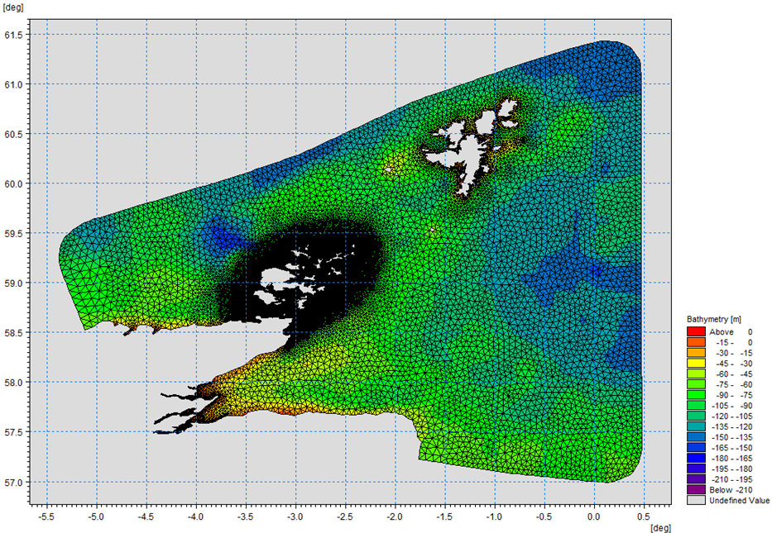

Figure 1. Pentland Firth and Orkney Waters model grid

## Screening modelling

### Site proposal

Screening modelling has been carried out for a proposal to vary an existing farm: Kirknoust (BOH2). The proposal is to site the farm at location: 345036.5 1029056.7 (Easting, Northing). The existing maximum biomass is 500t at this location and the proposed weight of fish to be farmed is 1200t. For the screening modelling presented here all relevant licenced sites and current applications have been modelled in conjunction with the proposed site.

#### Accuracy of model in the area surrounding the proposal

The Pentland Firth and Orkney Waters model used for screening modelling has a moderately high resolution in this area. Comparison against observational current meter data indicates that the model slightly overestimates speeds in the vicinity of the proposed site.

### Dispersion and erosion capacity maps

Modelled water movement in a sea area can be analysed and presented to show the capacity of the water to move and disperse discharged substances. It is also possible to show the capacity available to erode substances from the seabed. This information is a useful guide to the potential size of a marine fin fish aquaculture farm at a particular location.

Marine fin fish aquaculture farms using open-net pens will benefit from operating in locations where there are strong, repeating, water currents to erode and disperse waste.

For the purposes of screening we consider locations which meet the following water flow criteria to be generally suitable for larger farms:

Locations with average water flow speeds of greater than, or equal to, 0.12 metres per second (0.23 knots)

Locations where water flow speeds are often above the threshold of 0.095 meters per second (0.18 knots).

Locations with these properties are likely to disperse discharged material rapidly, and regularly erode sediment discharged to the seabed. In general, we would look for these properties to be maintained over a large area around a proposed site.

The thresholds stated above are indicative.

A map of modelled average water flow speed for the area surrounding the proposed site is shown in Figure 2. The average water flow speed in each cell of the model grid (see Screening modelling methods section) has been assigned a shade. The key for the shading is shown in the top left of the figure. Grid cells that have average speeds less than 0.12 m/s (metres per second) are marked on the figure. The greater the shading, the slower the average current speed and the lower the capacity for dispersion.

Figure 3 is a map of the percentage of time the modelled water flow speed in a grid cell is above 0.095 m/s (metres per second). The greater the shading, the lower the capacity for material to be eroded from the seabed.

Licenced aquaculture farms in the vicinity of the proposed site are also marked on Figure 2 and Figure 3. Discharges of material from these sites have been included in the screening modelling.

Based on the maps of the modelled water flow properties we can make the following observations about the proposed site location:

* It lies in a high dispersion area.
* It lies in an area where water flow has a high capacity to erode material on the seabed.

### Sediment influence maps and analysis

Modelled particles in a sea area can be analysed for each modelled grid cell and presented to show the potential influence of discharged sediment on the surrounding sea area.

Figure 4 shows a map of the modelled average sediment intensity over one month (time average) for the proposed site only. Grid cells within the model that are influence by modelled sediment are shaded according to the intensity of the influence in grams per square metre (g/m2).

Values less than 1 g/m2 have been excluded from the map and subsequent calculations. These low concentration cells are produced by the particle tracking approach, but they are not considered to be representative of the main influence of a discharge.

* The shading key is shown in the top left of the figure. Cells which are shaded black are similar to the average intensity in the total area of influence shown in the map. Cells shaded pink are similar to the median (middle value in the range) intensity value shown on the map. White shaded cells are similar to the minimum intensity value shown on the map.
  + The average and median sediment intensity over the area of influence is 0 g/m2 and 0 g/m2 respectively.
  + No cells are influence by the proposed site.

Figure 5 shows a map of the modelled average sediment intensity over one month for the proposed site and other relevant sites. Grid cells within the model that are influenced by modelled sediment are shaded according to the intensity of the influence in grams per square metre (g/m2). The shading key is shown in the top left of the figure and is in a similar format as that shown in Figure 4. The average sediment intensity, after including all relevant sites, is increased.

* The average and median sediment intensity over the area of influence is 4.59 g/m2 and 1.69 g/m2 respectively.
* A small number of cells are influenced by other modelled sites, but they do not lie close to the proposed site.

#### Sediment influence analysis

Model grid cells can be analysed to estimate the size and concentration of the potential sediment influence from the modelled sites.

* The total area of sediment influenced by the four sites modelled is estimated to be 0.26 square kilometres (km2).
* As shown in Figure 5, the average and median sediment intensity over the area of influence is 4.59 g/m2 and 1.69 g/m2 respectively.
* The total weight of fish that generates this modelled influence is 6797.2 tonnes.

Table 1 shows the information for each individual site modelled. It is important to note that the total area of influence for all sites is not the sum of the numbers in Table 1. The total area of influence worked out above takes into account that the individual areas of influence from different sites will overlap.

Table 1: Sediment influence information for each site.

| **Kirknoust** | **Average intensity (g/m2)** | **Area of influence (km2)** | **Median intensity (g/m2)** | **Max weight of fish (tonnes)** |
| --- | --- | --- | --- | --- |
| **BOH2** | 0 | 0 | 0 | 1200 |
| **BOH1** | 0 | 0 | 0 | 187.5 |
| **BOV1** | 0 | 0 | 0 | 1000 |
| **GAIR1** | 1.69 | 0.04 | 1.69 | 1909.7 |
| **VEA2** | 5.11 | 0.22 | 3.04 | 2500 |
|  |  |  |  | There are no Environmental Standards for sediment intensity. However, we consider that:  • underneath farm pens, an intensity of 2000 g/m2 or less is likely to lead to an acceptable seabed ecological outcome  • at the edge of the mixing zone, an intensity of 250 g/m2 or less is likely to lead to an acceptable seabed mixing zone outcome  The estimate of influence detailed above is indicative. The values presented are lower than the sediment intensity values given above. However, we recognise that low sediment concentrations may be useful for the identification of risks. |

### Bath medicine influence maps and analysis

Modelled particles in a sea area can be analysed for each modelled grid cell and presented to show the potential influence of discharged bath medicine on the surrounding sea area. Results presented are for the AZA medicine (see *Bath medicine modelling* section).

Figure 6 shows a map of the modelled average AZA concentration over four days for the proposed site only. Grid cells within the model which experience an AZA influence are shaded according to the concentration of AZA in nanograms per litre (ng/l).

Values less than 10 ng/l have been excluded from the map and subsequent calculations. These low concentration cells are produced by the particle tracking approach, but they are not considered to be representative of the main influence of a discharge.

Please note that the Environmental Standard for Azamethiphos with the lowest concentration is 40 ng/l. This must be met 72 hours after the material has been discharged. The estimate of influence detailed here is precautionary. In the information presented below areas of influence above 40 ng/l have been quoted. However, the average and median concentrations are quoted for the entire area of influence above 10 ng/l.

The shading key is shown in the top left of the figure. Cells which are shaded black are similar to the average concentration in the total area of influence shown in the map. Cells shaded pink are similar to the median (middle value in the range) concentration shown on the map. White shaded cells are similar to the minimum concentration value shown on the map.

* The average and median concentration over the total area of influence is 11.91 ng/l and 11.97 ng/l respectively.
* Cells influenced by the proposed site do not appear to lie close to other modelled farm sites.

Figure 7 shows a map of the modelled average AZA influence over four days for the proposed site and other relevant sites. The average AZA influence, after including all relevant sites, is increased.

* The average and median AZA concentration over the total area of influence is 17.12 ng/l and 15.12 ng/l respectively.
* Cells influenced by other modelled sites lie close to the proposed site.

#### Bath medicine influence analysis

Model grid cells can be analysed to estimate the size and concentration of the potential AZA influence from the modelled sites.

* The area of AZA influenced above 40 ng/l from all sites modelled is estimated to be 3.99 square kilometres (km2).
* As shown in Figure 7, the average and median concentration over the total area of influence is 17.12 ng/l and 15.12 ng/l respectively.
* The total weight of fish that generates this modelled influence is 6797.2 tonnes.

Table 2 shows the information for each individual site modelled. It is important to note that the total area of influence above 40 ng/l for all sites quoted above is not the sum of the numbers in Table 2. The total area of influence worked out above takes into account that the individual areas of influence above 40 ng/l from different sites will overlap.

Table 2: Azamethiphos influence information for each site.

| **Kirknoust** | **Average concentration (ng/l)** | **Area of influence above 40 ng/l (km2)** | **Median concentration (ng/l)** | **Weight of fish (tonnes)** |
| --- | --- | --- | --- | --- |
| **BOH2** | 11.91 | 0.12 | 11.97 | 1200 |
| **BOH1** | 16.99 | 3.10 | 15.18 | 187.5 |
| **BOV1** | 0 | 0 | 0 | 1000 |
| **GAIR1** | 0 | 0 | 0 | 1909.7 |
| **VEA2** | 17.32 | 0.85 | 15.13 | 2500 |

Please note that the Environmental Standard for Azamethiphos with the lowest concentration is 40 ng/l. This must be met 72 hours after the material has been discharged. The estimate of influence detailed above is precautionary. Detailed modelling will be required to demonstrate compliance with all Environmental Standards.

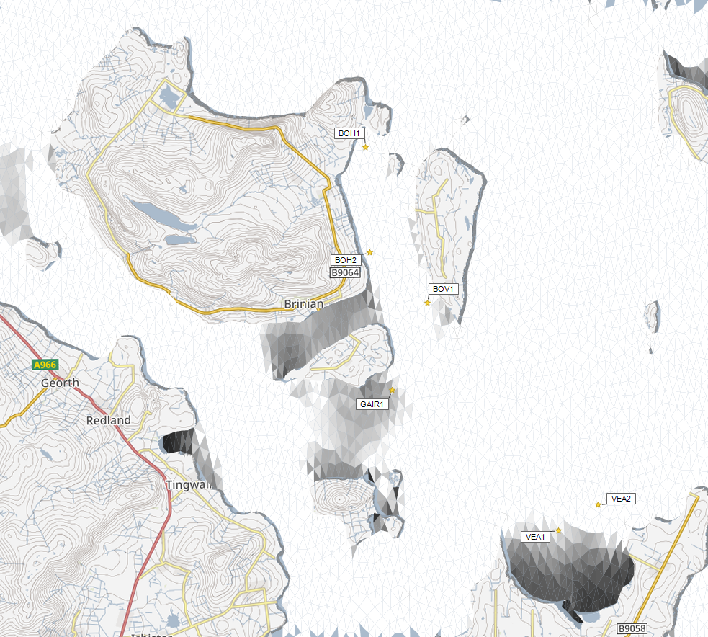



Average water speed (m/s)

©Crown copyright. All rights reserved. SEPA lic. no. 100016991 (2019).

Figure 2: Modelled average water speed (metres per second – m/s) in the sea around the proposed site (Kirknoust (BOH2)).

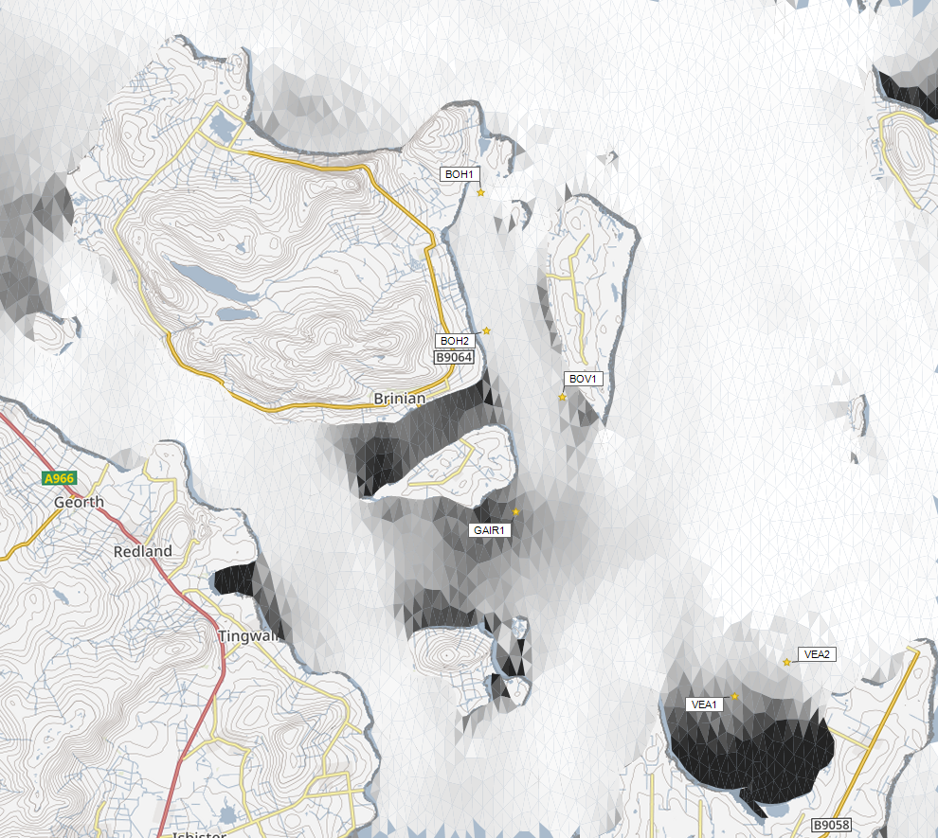

©Crown copyright. All rights reserved. SEPA lic. no. 100016991 (2019).

Percentage time (%)

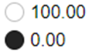

Figure 3: Modelled percentage of time the water flow speed is above 0.095 m/s in the sea area surrounding the proposed site (Kirknoust (BOH2)).

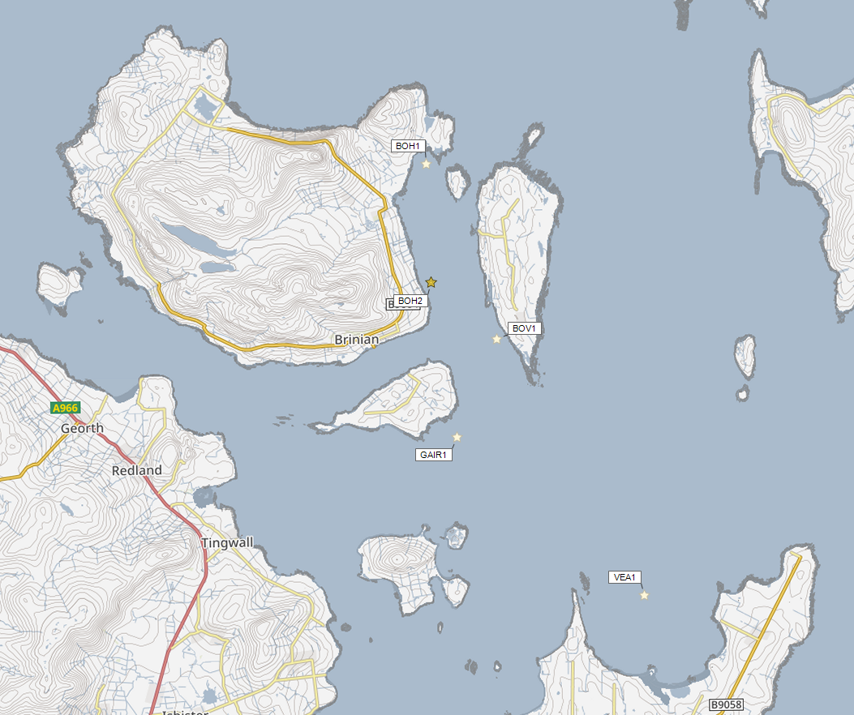

Sediment Intensity (g/m2)

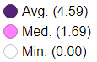

Sediment intensity is very low for the proposed site and this map is presented for information only.

©Crown copyright. All rights reserved. SEPA lic. no. 100016991 (2019).

Figure 4: Modelled average sediment intensity over one month for the proposed site only (Kirknoust (BOH2)).

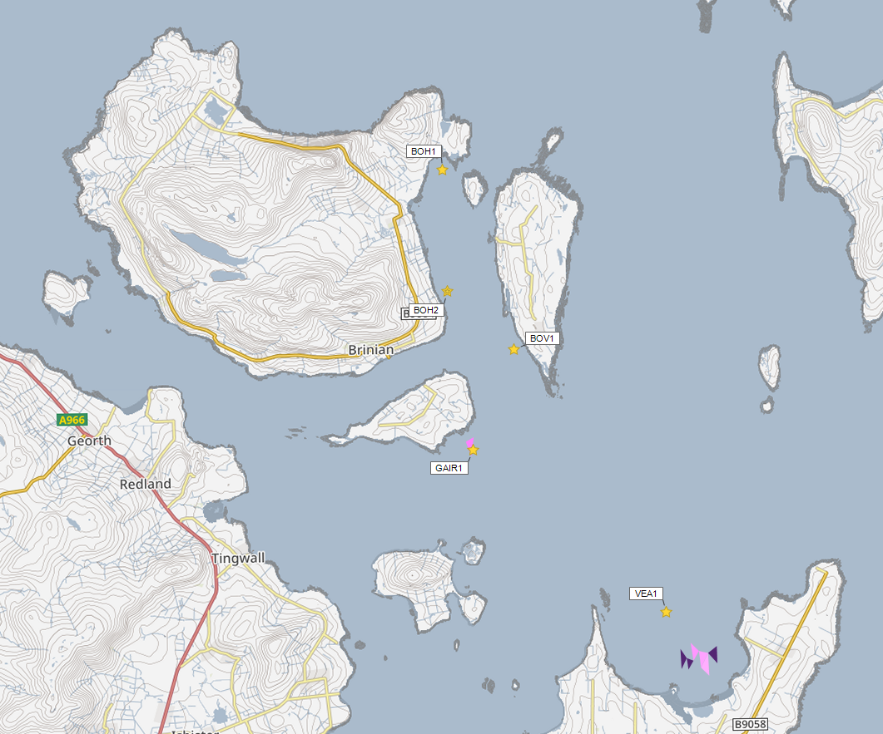

Sediment Intensity (g/m2)



Sediment intensity values presented on this map are low and are presented for information only.

Figure 5: Modelled average sediment intensity over one month for the proposed site (Kirknoust (BOH2)) and other relevant sites.

©Crown copyright. All rights reserved. SEPA lic. no. 100016991 (2019).

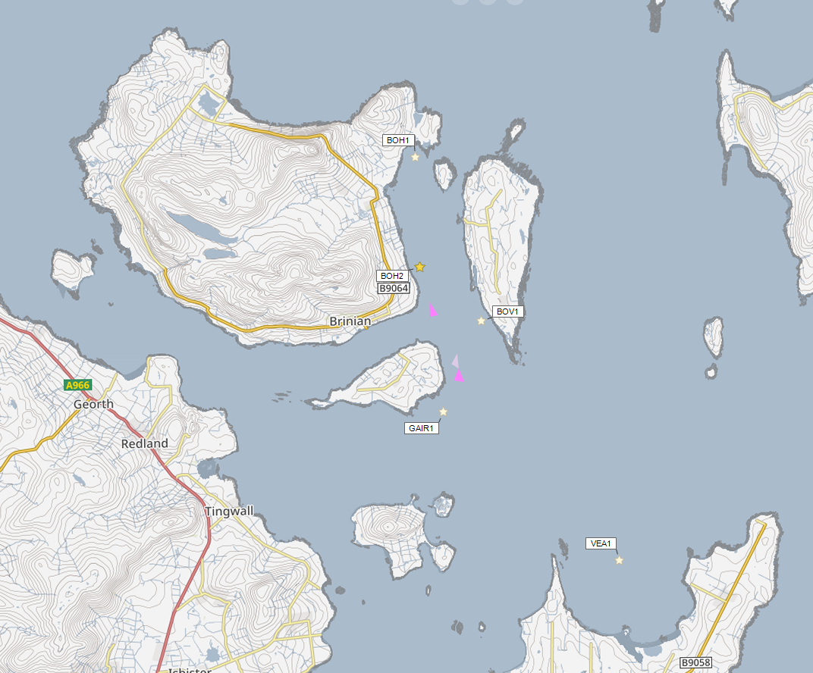

Concentrations of AZA presented on this map are less than the 40 ng/l Environmental Standard and are presented for information only.

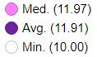

Azamethiphos Conc. (ng/l)

Figure 6: Modelled average Azamethiphos concentration over four days from neap tide release for the proposed site only (Kirknoust (BOH2)).

©Crown copyright. All rights reserved. SEPA lic. no. 100016991 (2019).

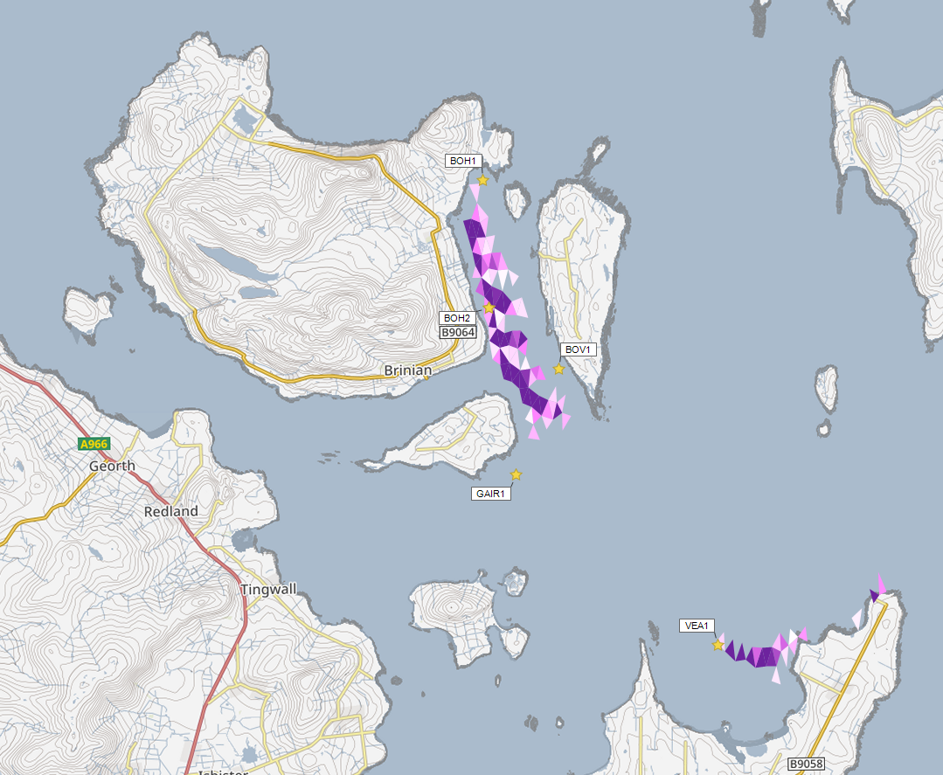

Azamethiphos Conc. (ng/l)

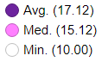

Concentrations of AZA presented on this map are less than the 40 ng/l Environmental Standard and are presented for information only.

©Crown copyright. All rights reserved. SEPA lic. no. 100016991 (2019).

Figure 7: Modelled average Azamethiphos concentration over four days from neap tide release for the proposed site (Kirknoust (BOH2)) and other relevant sites.

## Risk Identification

The screening modelling output summarised in the *Screening modelling* section is compared against available information on features of interest (see section *Identified features which require attention*). Features which require attention are presented with any additional comments. Identified features will need to be considered during the pre-application phase.

These should be addressed in the applicant “Method Statement”. Please refer to the [Modelling Method Statement section](https://www.sepa.org.uk/regulations/water/aquaculture/pre-application/) on the SEPA Website.

### Identified features which require attention

#### Table of identified features

Sensitive features in the area have been assessed, those considered at risk and therefore requiring additional consideration, can be found in Table 3.

Table 3: Table of identified features

|  |  |  |  |  |
| --- | --- | --- | --- | --- |
|  | **Feature name** | **Feature type** | **Location (easting, northing)** | **Brief reason for identification** |
| **1** | Wyre and Rousay Sounds | MPA(NC) | Location in Map 1 | At risk from sediment and bath influence |
| **2** | Maerl Bed | PMF/MPA qualifying feature | Location in Map 1 | At risk from sediment, bath and other chemical influence |
| **3** | Kelp and seaweed communities on sublittoral sediment | PMF/MPA qualifying feature | Location in Map 1 | At risk from sediment, bath and other chemical influence |
| **4** | Seagrass beds | PMF | |  |  | | --- | --- | | 346185.1 | 1030587 | | 346111.6 | 1030542 | | 343482.7 | 1026382 | | 343343.3 | 1026348 | | 343238.8 | 1026235 | | 342317.4 | 1026301 | | 342189.6 | 1026224 | | At risk from sediment, bath and other chemical influence |

Whilst screening modelling does not predict any significant sediment influence from Kirknoust (BOH2), this site is located in the Wyre and Rousay Sounds MPA(NC), within close proximity to a significant number of PMFs which are deemed to be at risk from both sediment and baths influence. SEPA and NatureScot require that marine modelling of solids and bath chemicals (should BathAuto not be used) be carried out to assess the relative impact of the proposed site on these Qualifying features, and other sensitive PMFs in the vicinity. Due to the dispersive nature of this area, discharges of sediment from all sites identified in Table 4 will need to be included in the solids modelling, to determine the combined risk on these features. Should solids modelling demonstrate an impact on the PMFs at this site, it is likely comparison modelling with the existing impact will be required.

NewDepomod Modelling will be used to determine impact on the immediate area surrounding the site. Calibrated NewDepomod modelling using 4 transect monitoring must be undertaken, and a comparison between the footprints of the current and proposed sites should be presented. Any increased impact of the footprint on the Maerl beds or Kelp and seaweed communities shapefiles highlighted in Table 3 and Map 1 may result in this application being rejected.

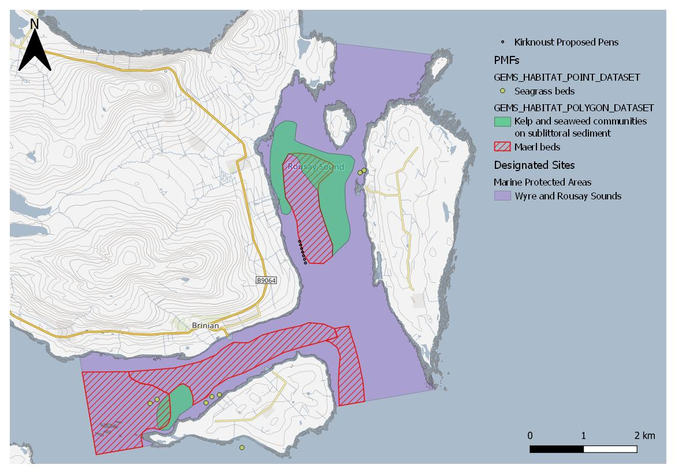

Figure 8: Location of proposed pen layout change, MPA and PMF polygons and points.

### Risks identified from contextual site data

Should this application proceed, the total licenced biomass in this area would be 6797.2t.

Table 4: Table of licenced biomass from farms identified as likely to add to cumulative risks.

| **Kirknoust** | **Location (easting, northing)** | **Biomass (tonnes)** | **Last production cycle** |
| --- | --- | --- | --- |
| **BOH2** | 345036.5, 1029056.7 | 1200 | Proposed |
| **BOH1** | 344954, 1031915 | 187.5 | Last stocked January 2015 |
| **BOV1** | 346598, 1027654 | 1000 | Currently stocked (Since February 2024) |
| **GAIR1** | 345600, 1025300 | 1909.7 | Currently stocked (Since September 2023) |
| **VEA1** | 350100, 1021400 | 2500 | Currently stocked (Since May 2023) |

The results from the 2023 seabed survey, following a peak biomass of 491t, was classified as Compliant as the area of less than good status around the farm was less than half of its AMZ. The 2022 survey results, following a peak biomass of 495t, also showed compliance with the seabed standards.

## Conclusions of screening modelling and risk identification

Following screening modelling and risk identification we make a number of conclusions and recommendations.

### Conclusions

#### Screening Modelling

* According to screening modelling, the proposed site Kirknoust (BOH2) is in an area of high dispersion and has a relatively high capacity for erosion of material on the seabed.
* The screening model provides a reasonable performance in the vicinity of the site when compared to observational data.
* From sediment and bath treatment modelling:
  + - Information presented in the *Screening modelling* section indicates that the relative influence of Kirknoust (BOH2) is likely to be less intense and less widespread than other sites for a similar tonnage.
    - The influence on the surrounding sea area from Kirknoust (BOH2) is likely to be low.
    - Bath influences from Kirknoust (BOH2), and other sites modelled appear to have low interaction. Solids influences are not expected to interact.
    - It is likely that discharges of bath medicines from Kirknoust (BOH2) will be dispersed to low levels over a small area.
    - Kirknoust (BOH2) is likely to result in a small increase in the total influence of all sites modelled, but any impact is expected to interact with areas of influence generated by existing site to the north.
* The proximity to locational guidelines waterbodies has been assessed and not considered a risk, however the standard ECE calculation will still be required.

#### Risk identification

Although the modelled influence from Kirknoust (BOH2) appears to be low, the location of this site within the Wyre and Rousay Sounds MPA(NC), and its proximity to several marine features has been highlighted by NatureScot as an area of concern. These features require careful attention during pre-application work and are outlined in the Risk Identification section. Further detailed modelling will need to demonstrate that no additional influence will occur on these features.

### Recommendations

#### Site suitability

Due to a significant extent of features at risk being identified at this stage, the feasibility of the proposed site is likely to be impacted; with respect to the SEPA Aquaculture regulatory framework, Modelling will need to demonstrate that this site will not increase the impact on the protected features within the Wyre and Rousay Sounds MPA(NC).

It is possible that the site will be able to comply with our mixing zone regulatory framework. This will need to be demonstrated using the NewDepomod model.

Following the engagement meeting(s), this report will be revised, and this should allow to the applicant to submit a method statement which address the issues raised in this document.

#### Further modelling

* Due to the identified risks, SEPA and NatureScot require 2D marine modelling of solids and baths (if BathAuto is not used) to be carried out.
* The size of the marine model should include discharges from all sites identified in this report. Cumulative modelling including these identified sites will be required for solids, but not baths.
* The resolution of the marine model should be relatively fine around the proposed site and identified features at risk.
* Should solids modelling demonstrate an impact on the protected features at this site, it is likely comparison modelling with the existing impact will be required.
* Timeseries depth profiles at the identified features should be presented in the modelling, showing maximum and average concentrations within the shapefiles and at the point locations given in Table 3.
* Calibrated NewDepomod modelling using 4 transect monitoring is required at this site, in addition to Standard default NewDepomod modelling. NewDepomod modelling should also be carried out using the current layout and permitted consent amounts to determine the difference in footprint of the current and proposed sites. Due to proximity of maerl to the northeast of the site, it should be noted that, on the advice of NatureScot, if modelling predicts an increased impact on these features, it will likely be considered significant, and this application will be rejected. Therefore, it is recommended that NewDepomod modelling is undertaken and submitted prior to the marine modelling.

## References

[1] *Marine Modelling Guidance for Aquaculture Applications*. *Published on SEPA website.*

[2] http://marine.gov.scot/information/wider-domain-scottish-shelf-model.

For information on accessing this document in an alternative format or language, please contact SEPA by emailing [equalities@sepa.org.uk](mailto:equalities@sepa.org.uk)

If you are a user of British Sign Language (BSL), the Contact Scotland BSL service gives you access to an online interpreter, enabling you to communicate with us using sign language. [contactscotland-bsl.org](http://contactscotland-bsl.org/)