

# Aquaculture Modelling Screening and Risk Identification Report: Tabhaigh East (TABE1)

Report date: November 2024

## Scope of report

As part of the SEPA Aquaculture Regulatory Framework it is recommended that a proposed application for a marine fin fish aquaculture site should undergo a Screening Modelling and Risk Identification process. SEPA carries out this work and this is described on the SEPA aquaculture website [**Pre-application section**](https://www.sepa.org.uk/regulations/water/aquaculture/pre-application/)**.**

This report presents information arising from that process. Screening modelling methods are outlined and maps and tables describing the modelled impacts are shown. Risks arising from consideration of the model output are listed. Conclusions and recommendations are made regarding the proposed site.

## Executive summary

SEPA has received a proposal for a new marine fin fish aquaculture site called Tabhaigh East (TABE1) located in Loch Erisort. In the proposal two possible pen locations were given. SEPA modelled the midpoint between the two at 142320.5E, 923345.5N. Location option 1: 142251E, 923426N (Easting, Northing). Location option 2 (preferred option): 142338E, 923253N (Easting, Northing). The proposed weight of fish to be farmed is 2500t. It is proposed that the site Northshore West (Erisort 3, ERI3) with a biomass of 1625t will be surrendered should this application be approved.

Following screening modelling and risk identification we have concluded the following:

* Standard default NewDepomod modelling is required.
* Marine modelling for solids is not required.
* BathAuto is the default assessment approach for bath medicines, however marine modelling is an option that the applicant may choose to use instead to get a less conservative bath medicine quantity.
* If marine modelling of baths is undertaken, the resolution of the marine model should be relatively fine around the proposed site and identified features at risk.
* Cumulative modelling is not required for either solids or bath medicines.
* An ECE calculation should be carried out to ensure nutrient enhancement levels from this farm are acceptable.
* Sea lice screening has shown a very small effect on the exposure risk. No criteria for further work have been triggered. The outcome of current screening is that this site will not require a lice permit condition. No further modelling work is required, at this time.
* Tabhaigh East (TABE1) is suitable to progress to the next stage of the pre-application process outlined on the SEPA website.

## List of abbreviations

SEPA Scottish Environment Protection Agency

## List of chemical abbreviations

AZA Azamethiphos

Contents

Aquaculture Modelling Screening & Risk Identification Report: Tabhaigh East (TABE1) 1

Scope of report 2

Executive summary 2

List of abbreviations 4

List of chemical abbreviations 4

List of Figures 6

List of Tables 7

Introduction 8

Screening modelling 14

Sea Lice Screening 28

Risk Identification 32

Conclusions of screening modelling and risk identification 36

References 40

## List of Figures

Figure 1. East Coast Lewis and Harris model grid 11

Figure 2: Modelled average water speed (metres per second – m/s) in the sea loch around the proposed site, Tabhaigh East (TABE1). 16

Figure 3: Modelled percentage of time the water flow speed is above 0.095m/s in the sea area surrounding the proposed site, Tabhaigh East (TABE1). 17

Figure 4: Modelled average sediment intensity over one month for the proposed site only, Tabhaigh East (TABE1). 19

Figure 5: Modelled average sediment intensity over one month for the proposed site (Tabhaigh East (TABE1) and other relevant sites 21

Figure 6: Modelled average Azamethiphos concentration over four days from neap tide release for the proposed site only, Tabhaigh East (TABE1). 24

Figure 7: Modelled average Azamethiphos concentration over four days from neap tide release for the proposed site Tabhaigh East (TABE1) and other relevant sites. 25

Figure 8: Map of the average modelled lice concentration over the simulated April and May period (in lice/m2) within the top two meters of the sea area. TABE1 site location shown as a blue circle. Fish tracks are shown as green lines with the WSPZs, which are highlighted by a white boundary. 29

Figure 9: Loch Erisort is a MS locational guidelines category 2 water body, containing shellfish waters, shellfish farms and fin fish farms 33

## **List of Tables**

Table 1: Sediment influence information for each site. 22

Table 2: Azamethiphos influence information for each site. 27

Table 3: Influence of modelled sea lice from TABE1 on exposure in the relevant affected WSPZs. 30

Table 4: Location of TABE1 within the assessment matrix framework of WSPZ capacity and site contribution. 31

Table 5: Table of identified sensitive features 33

Table 6: Table of licenced biomass from farms identified as likely to add to cumulative risks 35

## Introduction

Screening Modelling and Risk Identification are important steps in the SEPA regulatory framework for marine pen fish farms. They are carried out by SEPA at the [**pre-application stage**](https://www.sepa.org.uk/regulations/water/aquaculture/pre-application/)**.**

This document briefly describes the objectives of screening and risk identification and summarises the methods used. Screening output for the proposed site is then presented with comments. Risks identified from the screening output are detailed. Conclusions and recommendations about the suitability of the proposed site are then made.

### The objectives of screening modelling and risk identification

A summary of the modelling methods employed during screening modelling is outlined in the screening modelling methods section. The objectives of screening modelling and risk identification are outlined below.

#### Screening modelling

Marine Modelling technology can be used to simulate and predict the potential influence of discharges on the marine environment. Marine modelling can also be used at an earlier stage to provide an initial estimate of the influence of material discharged from a proposed site, which is discussed in this report.

SEPA will require the majority of proposed farms to conduct detailed marine modelling, as outlined in our Aquaculture Modelling guidance [1] and on the SEPA Website. The screening and risk identification stage will assess the need for detailed modelling.

SEPA will carry out marine modelling at the screening and risk identification stage. This is a simplified version of the detailed modelling required of the applicant. However, it will be sufficient to perform an initial risk assessment of a proposal. Screening marine modelling will also include discharges from other relevant aquaculture sites and major sources.

The objectives of the simplified screening modelling are to:

* Produce maps of the predicted dispersive and erosive capacity of the sea areas in the vicinity of aquaculture sites.
* Produce maps of the predicted spread of sediment discharged from aquaculture sites.
* Produce maps of the predicted spread of bath treatment medicines from aquaculture sites.
* Present an analysis of the potential influence of sediment and bath treatment discharges from the proposed site alongside existing sites within the surrounding sea area.
* Present information on the sensitive features and sites of interest within the surrounding sea area, which must be addressed during pre-application work.
* Present a summary of the suitability of the proposal with respect to the dispersal of waste and how this may be modelled.

#### Risk identification

Maps and analysis of screening output will be compared to information relating to sensitive features and relevant areas of interest. These may include:

* Marine Protected Area (MPA)
* Special Area of Conservation (SAC)
* Priority Marine Feature (PMF)
* Any site identified via consideration of other permitted or regulatory activities.

SEPA Staff will meet to discuss screening model output and the relevant sensitive features information. Following this meeting, a list of identified risks will be added to this report.

#### Conclusion of screening modelling and risk identification

Following the identification of risks, SEPA will present a summary of the suitability of the proposal with respect to the:

* Dispersal of waste from the proposed site and other sources.
* Risks posed to sensitive features.
* Likely level of modelling that will be required to address the risks identified.

### Screening modelling methods

Marine models divide the sea up into a “grid” of boxes or triangles (often called cells). Each of these is given a water depth. For the screening modelling presented in this report the Marine Scotland “East Coast Lewis and Harris” (ECLH) has been used. An image of the ECLH model grid is shown in Figure 1. This grid has been set up within a marine modelling software package called MIKE 21 which is manufactured by the company [DHI A/S](https://www.dhigroup.com/).

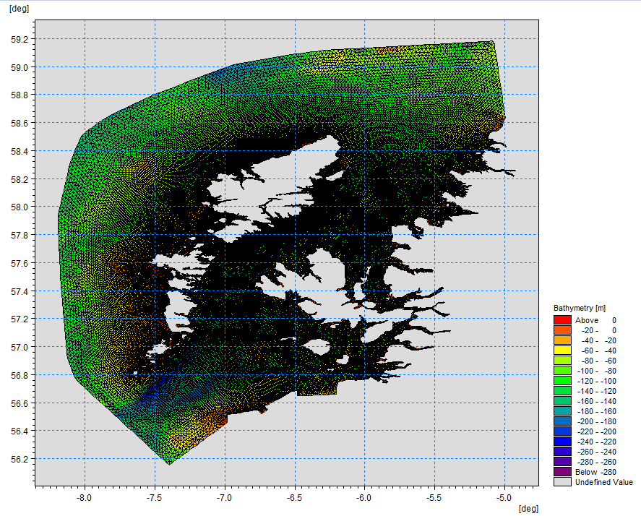

Figure 1. East Coast Lewis and Harris model grid

Marine models carry out calculations across a grid to work out how seawater moves and mixes in response to tidal and weather forces. Marine models can also be used to simulate how seawater moves and mixes due to salinity and temperature differences across an area, particularly in response to inputs of freshwater from rivers. For pollutant influence assessments the mixing (dispersion) of dissolved (bath medicine) and particulate (sediment) pollutants can also be estimated. Calculations within a marine model can be performed in three dimensions (3D), where the grid is split into layers to better represent how properties of the sea change with depth. Two dimensional (2D) models can also be created where processes over the water depth are simplified. The amount of mixing in a marine model can be varied using settings in the software.

Screening modelling is currently carried out with 2D models using average mixing settings in the model software. In many areas, this approach will be sufficient to make an initial estimate of the influence of a proposed site. Our screening assessment will take into account factors which may limit a 2D approach. We will also consider whether a particular location is adequately represented by the available models.

#### Water movement and mixing modelling

Water movement and mixing modelling (hydrodynamics) has been carried out to generate one month of results. The boundaries (edge(s) of) the model have been driven using the “wider domain” Scottish Shelf Model [2]. Wind forces and freshwater inputs have been applied to the model from the same source. The results generated are an estimate of the average water movement and mixing conditions within the model area.

#### Sediment waste modelling

Screening modelling provides a precautionary and indicative estimate of the size, location and intensity of waste organic material released from aquaculture sites.

The release of sediment from sources within the model area is simulated using one month of hydrodynamic results along with particle tracking modelling technology. Virtual particles are continually introduced to the model grid to represent the potential dispersion of sediment from the sources. Particles in the model are moved and mixed by the hydrodynamics. Additionally, particles are assigned simplified properties, which allow them to settle through the water and be re-suspended (eroded and lifted) from the seabed.

#### Bath medicine modelling

Screening modelling provides a precautionary and indicative estimate of the size, location and concentration of bath medicine releases.

The release of bath treatment medicine from sources within the model area is simulated using hydrodynamic results along with particle tracking modelling technology. Virtual particles are introduced to the model grid to represent the potential dispersion of bath medicines from the sources. Particles in the model are moved and mixed by the hydrodynamics. Releases of bath medicines are simulated under worst case mixing (dispersion) conditions, which occur under neap tides. The maximum treatment amount likely to be used at each site is released into the model at the same time and plumes are tracked over the following 96 hours (4 days). Treatment amounts used at screening have been derived from an analysis of historical data. Additionally, all bath medicine particles are concentrated within the top 5m of the sea area. As all bath medicines are likely to disperse in a similar way, only Azamethiphos (AZA) has been modelled at the screening stage.

#### Nutrient assessment

Whilst nutrients are not directly modelled during screening, the dispersion of bath medicine releases will give an indication of the likely level of nutrient dispersion. This will be considered alongside any pre-existing nutrient assessment information that may be available.

#### Analysis of modelling output

SEPA processes the screening modelling output and places it into a standard analysis application built in TIBCO Spotfire. The application allows for the production of standard maps and tables, which are presented below.

## Screening modelling

### Site proposal

Screening modelling has been carried out for a proposal for a new farm: Tabhaigh East (TABE1) in Loch Erisort. In the proposal two possible pen locations were given. SEPA modelled the midpoint between the two at 142320.5E, 923345.5N. Location option 1: 142251E, 923426N (Easting, Northing). Location option 2 (preferred option): 142338E, 923253N (Easting, Northing) The proposed weight of fish to be farmed is 2500t. It is proposed that the site Northshore West (Erisort 3, ERI3) with a biomass of 1625t will be surrendered should this application be approved. For the screening modelling presented here all relevant licenced sites and current applications have been modelled in conjunction with the proposed site. A number of the licensed sites included within the screening modelling are historic and have been non-operational for a number of years.

#### Accuracy of model in the area surrounding the proposal

The East Coast Lewis and Harris model used for screening modelling has a relatively low resolution in this area. Comparison against observational current meter data indicates that the model provides a reasonable performance of the physical processes in the vicinity of the proposed site.

### Dispersion and erosion capacity maps

Modelled water movement in a sea area can be analysed and presented to show the capacity of the water to move and disperse discharged substances. It is also possible to show the capacity available to erode substances from the seabed. This information is a useful guide to the potential size of a marine fin fish aquaculture farm at a particular location.

Marine fin fish aquaculture farms using open-net pens will benefit from operating in locations where there are strong, repeating, water currents to erode and disperse waste.

For the purposes of screening, we consider locations which meet the following water flow criteria to be generally suitable for larger farms:

Locations with average water flow speeds of greater than, or equal to, 0.12 metres per second (0.23 knots).

Locations where water flow speeds are often above the threshold of 0.095 meters per second (0.18 knots).

Locations with these properties are likely to disperse discharged material rapidly, and regularly erode sediment discharged to the seabed. In general, we would look for these properties to be maintained over a large area around a proposed site.

The thresholds stated above are indicative.

A map of modelled average water flow speed for the area surrounding the proposed site is shown in Figure 2. The average water flow speed in each cell of the model grid has been assigned a shade. The key for the shading is shown in the top left of the figure. Grid cells that have average speeds less than 0.12 m/s (metres per second) are marked on the figure. The greater the shading, the slower the average current speed and the lower the capacity for dispersion.

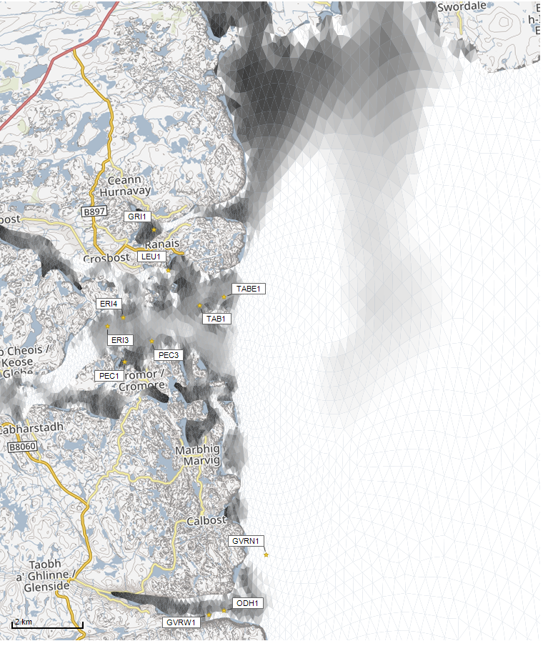

©Crown copyright. All rights reserved. SEPA lic. no. 100016991 (2019).



Average water speed (m/s)

Figure 2: Modelled average water speed (metres per second – m/s) in the sea loch around the proposed site, Tabhaigh East (TABE1).

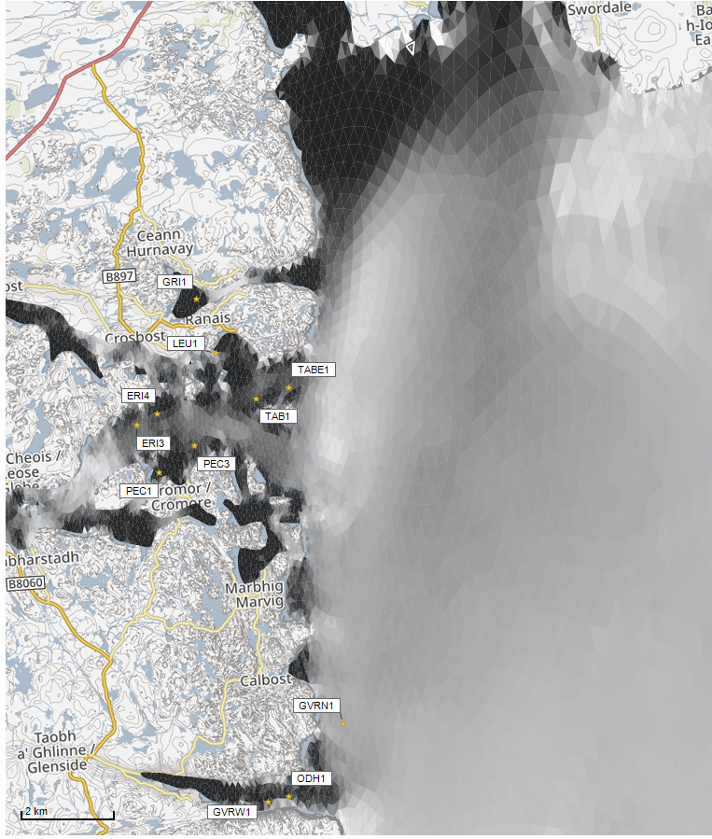Figure 3 is a map of the percentage of time the modelled water flow speed in a grid cell is above 0.095m/s. The greater the shading, the lower the capacity for material to be eroded from the seabed.

©Crown copyright. All rights reserved. SEPA lic. no. 100016991 (2019).

Percentage time (%)

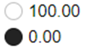

Figure 3: Modelled percentage of time the water flow speed is above 0.095m/s in the sea area surrounding the proposed site, Tabhaigh East (TABE1).

Licenced aquaculture farms in the vicinity of the proposed site are also marked on Figure 2 and Figure 3. Discharges of material from these sites have been included in the screening modelling.

Based on the maps of the modelled water flow properties we can make the following observations about the proposed site location:

* It lies in a moderate dispersion area.
* It lies in an area where water flow has a moderate capacity to erode material on the seabed.

### Sediment influence maps and analysis

Modelled particles in a sea area can be analysed for each modelled grid cell and presented to show the potential influence of discharged sediment on the surrounding sea area.

Figure 4 shows a map of the modelled average sediment intensity over one month (time average) for the proposed site only. Grid cells within the model that are influence by modelled sediment are shaded according to the intensity of the influence in grams per square metre (g/m2).

Values less than 1g/m2 have been excluded from the map and subsequent calculations. These low concentration cells are produced by the particle tracking approach, but they are not considered to be representative of the main influence of a discharge.

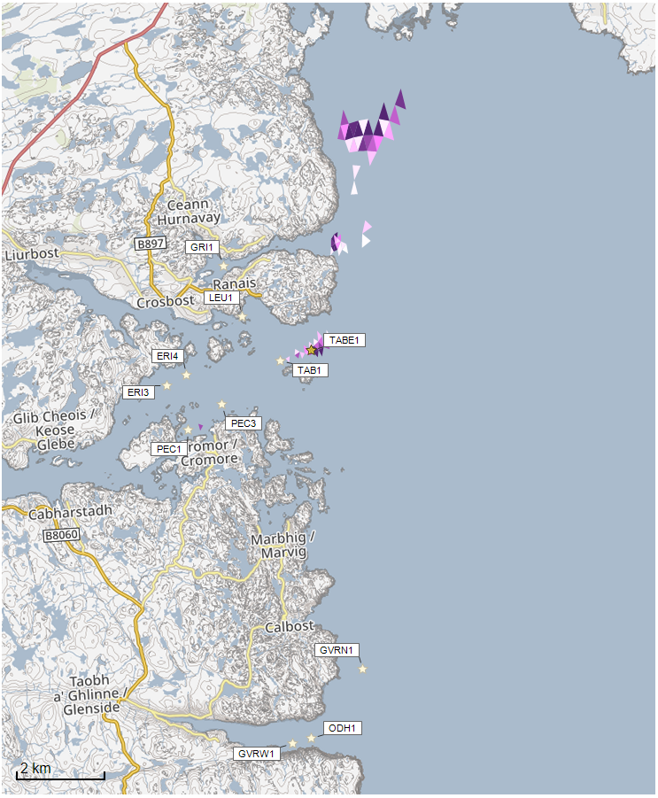

©Crown copyright. All rights reserved. SEPA lic. no. 100016991 (2019).

Sediment intensity values presented on this map are very small and are presented for information only.

Sediment Intensity (g/m2)

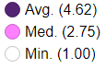

Figure 4: Modelled average sediment intensity over one month for the proposed site only, Tabhaigh East (TABE1).

* The shading key is shown in the top right of the figure. Cells which are shaded black are similar to the average intensity in the total area of influence shown in the map. Cells shaded pink are similar to the median (middle value in the range) intensity value shown on the map. White shaded cells are similar to the minimum intensity value shown on the map.
  + The average and median sediment intensity over the area of influence is 4.62g/m2 and 2.75g/m2 respectively.
  + A few cells influenced by the proposed site lie close to Tabhaigh (TAB1), but in very low quantity. The majority of impact travels north along the coast in the Minch.

Figure 5 shows a map of the modelled average sediment intensity over one month for the proposed site and other relevant sites. Grid cells within the model that are influenced by modelled sediment are shaded according to the intensity of the influence in grams per square metre. The shading key is shown in the top right of the figure and is in a similar format as that shown in Figure 4. The average sediment intensity, after including all relevant sites, is increased.

* The average and median sediment intensity over the area of influence is 15.01g/m2 and 3.66g/m2 respectively.
* A number of cells influenced by other modelled sites appear to lie close to the proposed site.

#### Sediment influence analysis

Model grid cells can be analysed to estimate the size and concentration of the potential sediment influence from the modelled sites.

* The total area of sediment influenced by the 11 sites modelled is estimated to be 6.25 square kilometres (km2).
* As shown in Figure 5, the average and median intensity over this area is 15.01g/m2 and 3.66g/m2, respectively.
* The total weight of fish that generates this modelled influence is 19,379.9 tonnes.

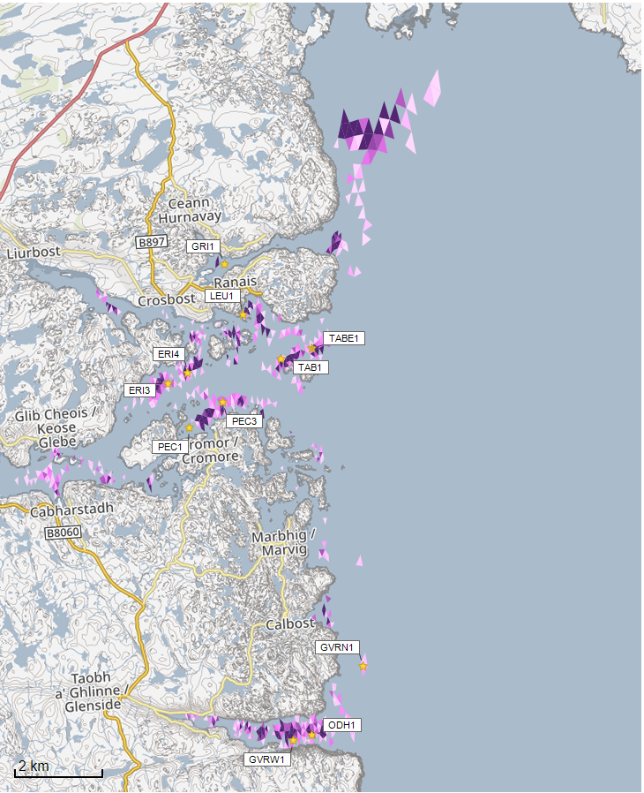

©Crown copyright. All rights reserved. SEPA lic. no. 100016991 (2019).

Sediment intensity values presented on this map are low and are presented for information only.

Sediment Intensity (g/m2)

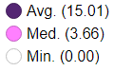

Figure 5: Modelled average sediment intensity over one month for the proposed site (Tabhaigh East (TABE1) and other relevant sites.

Table 1 shows the information for each individual site modelled. It is important to note that the total area of influence for all sites is not the sum of the numbers in Table 1. The total area of influence worked out above takes into account that the individual areas of influence from different sites will overlap.

Table 1: Sediment influence information for each site.

| **Site Name** | **Average Intensity (g/m2)** | **Area of Influence (km2)** | **Median Intensity (g/m2)** | **Max Weight of Fish (Tonnes)** |
| --- | --- | --- | --- | --- |
| **TABE1** | 4.62 | 1.33 | 2.75 | 2500 |
| **TAB1** | 7.16 | 1.59 | 2.56 | 2500 |
| **ERI3\*** | 5.01 | 1.77 | 2.07 | 1650 |
| **ERI4** | 8.70 | 2.26 | 2.35 | 2400 |
| **GRI1** | 604.02 | 0.01 | 635.75 | 622 |
| **GVRN1** | 4.06 | 1.54 | 1.96 | 4680 |
| **GVRW1** | 6.39 | 0.47 | 2.69 | 515.7 |
| **LEU1** | 8.74 | 0.77 | 3.06 | 625 |
| **ODH1** | 8.74 | 1.52 | 3.66 | 2285.2 |
| **PEC1** | 1.27 | 0.01 | 1.27 | 2 |
| **PEC3** | 8.17 | 1.23 | 2.43 | 1600 |

(* Sites to be surrendered should TABE1 be granted)

There are no Environmental Standards for sediment intensity. However, we consider that:

• Underneath farm pens, an intensity of 2000g/m2 or less is likely to lead to an acceptable seabed ecological outcome.

• At the edge of the mixing zone, an intensity of 250g/m2 or less is likely to lead to an acceptable seabed mixing zone outcome.

The estimate of influence detailed above is indicative. The values presented are much lower than the sediment intensity values given above. However, we recognise that low sediment concentrations may be useful for the identification of risks.

### Bath medicine influence maps and analysis

Modelled particles in a sea area can be analysed for each modelled grid cell and presented to show the potential influence of discharged bath medicine on the surrounding sea area. Results presented are for the AZA medicine (see section: Bath medicine influence analysis).

Figure 6 shows a map of the modelled average AZA concentration over four days for the proposed site only. Grid cells within the model which experience an AZA influence are shaded according to the concentration of AZA in nanograms per litre (ng/l).

The shading key is shown in the top right of the figure. Cells which are shaded black are similar to the average concentration in the total area of influence shown in the map. Cells shaded pink are similar to the median (middle value in the range) concentration shown on the map. White shaded cells are similar to the minimum concentration value shown on the map.

* The average and median concentration over the total area of influence is 21.44ng/l and 18.85ng/l respectively.
* Cells influenced by the proposed site do not appear to lie close to other modelled farm sites.

Values less than 10ng/l have been excluded from the map and subsequent calculations. These low concentration cells are produced by the particle tracking approach, but they are not considered to be representative of the main influence of a discharge.

Please note that the Environmental Standard for Azamethiphos with the lowest concentration is 40ng/l. This must be met 72 hours after the material has been discharged. The estimate of influence detailed here is precautionary. In the information presented below areas of influence above 40ng/l have been quoted. However, the average and median concentrations are quoted for the entire area of influence above 10ng/l.

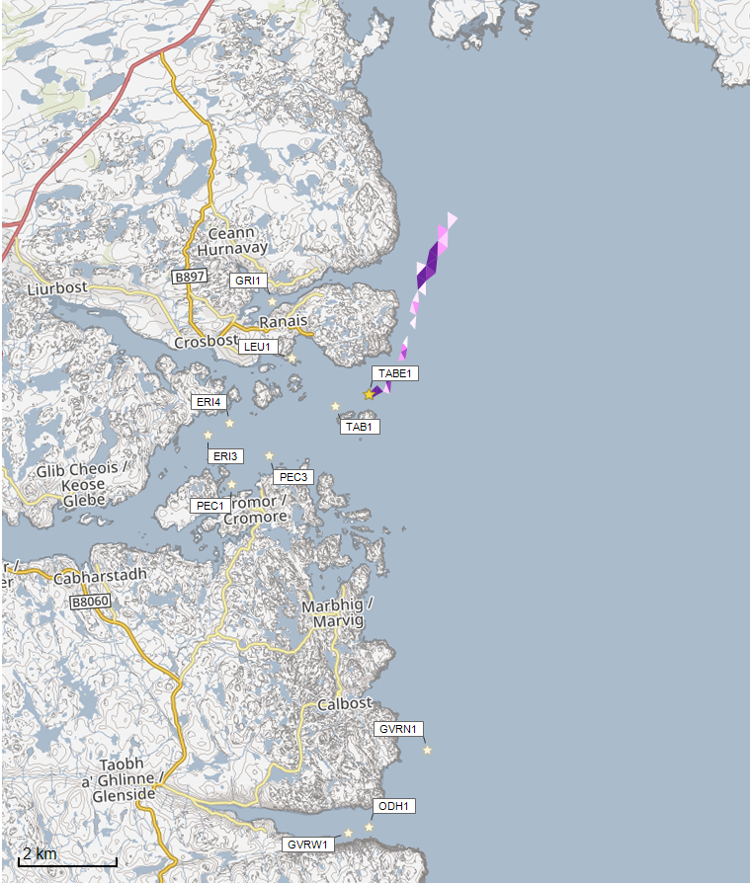

©Crown copyright. All rights reserved. SEPA lic. no. 100016991 (2019).

Concentrations of AZA presented on this map are less than the 40 ng/l Environmental Standard and are presented for information only.

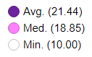

Azamethiphos Conc. (ng/l)

Figure 6: Modelled average Azamethiphos concentration over four days from neap tide release for the proposed site only, Tabhaigh East (TABE1).

Figure 7 shows a map of the modelled average AZA influence over four days for the proposed site and other relevant sites. The average AZA influence, after including all relevant sites, is decreased.

©Crown copyright. All rights reserved. SEPA lic. no. 100016991 (2019).

Concentrations of AZA presented on this map are less than the 40 ng/l Environmental Standard and are presented for information only.

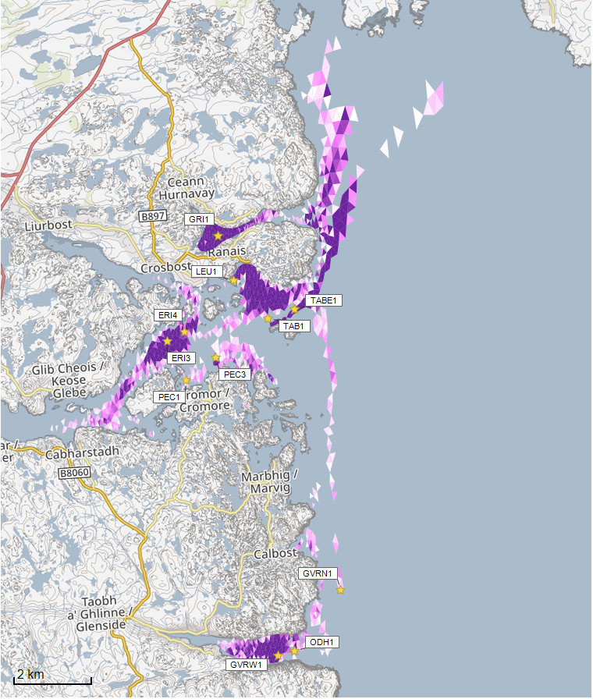

Azamethiphos Conc. (ng/l)

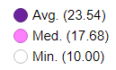

Figure 7: Modelled average Azamethiphos concentration over four days from neap tide release for the proposed site Tabhaigh East (TABE1) and other relevant sites.

©Crown copyright. All rights reserved. SEPA lic. no. 100016991 (2019).

* The average and median AZA concentration over the total area of influence is 23.54ng/l and 17.68ng/l respectively.
* A number of cells influenced by other modelled sites appear to lie close to the proposed site.

#### Bath medicine influence analysis

Model grid cells can be analysed to estimate the size and concentration of the potential AZA influence from the modelled sites.

* The area of AZA influenced above 40ng/l from all sites modelled is estimated to be 12.83 square kilometres (km2).
* As shown in Figure 7, the average and median concentration over the total area of influence is 23.54 and 17.68ng/l respectively.
* The total weight of fish that generates this modelled influence is 19,380 tonnes.

Table 2 shows the information for each individual site modelled. It is important to note that the total area of influence above 40ng/l for all sites quoted above is not the sum of the numbers in Table 2. The total area of influence worked out above takes into account that the individual areas of influence above 40ng/l from different sites will overlap.

Table 2: Azamethiphos influence information for each site.

| **Site Name** | **Average Concentration (ng/l)** | **Area of Influence Above 40 ng/l (km2)** | **Median Concentration (ng/l)** | **Weight of Fish (Tonnes)** |
| --- | --- | --- | --- | --- |
| **TABE1** | 21.44 | 0.58 | 18.85 | 2500 |
| **TAB1** | 23.11 | 1.76 | 22.66 | 2500 |
| **ERI3\*** | 19.25 | 1.93 | 14.63 | 1650 |
| **ERI4** | 17.36 | 1.54 | 14.61 | 2400 |
| **GRI1** | 37.55 | 0.70 | 29.62 | 622 |
| **GVRN1** | 14.91 | 3.48 | 13.69 | 4680 |
| **GVRW1** | 23.42 | 1.67 | 18.13 | 515.7 |
| **LEU1** | 28.66 | 1.95 | 21.30 | 625 |
| **ODH1** | Less than 10 | 0 | Less than 10 | 2285.2 |
| **PEC1** | Less than 10 | 0 | Less than 10 | 2 |
| **PEC3** | 15.22 | 0.78 | 14.83 | 1600 |

(* Sites to be surrendered should TABE1 be granted)

Please note that the Environmental Standard for Azamethiphos with the lowest concentration is 40ng/l. This must be met 72 hours after the material has been discharged. The estimate of influence detailed above is precautionary. Detailed modelling will be required to demonstrate compliance with all Environmental Standards.

## Sea Lice Screening

Sea lice screening was carried out using our standard method with the translated Scottish Shelf ECLH (East Coast Lewis & Harris) sub area model. This method is outlined in in Appendix 4 of the May 2023 second consultation document: [Managing interactions between sea lice from finfish farms and wild salmonids, Proposed new regulatory framework, May 2023.](https://consultation.sepa.org.uk/regulatory-services/detailed-proposals-for-protecting-wild-salmon/)

### Modelled Sea Lice Concentration Map – TABE1

Figure 8 shows a map of the average modelled lice concentration over the simulated April and May period (in lice/m2) within the top two meters of the sea area. Model grid cells (triangles) are coloured according to the amount of sea lice particles within them.

#### Indicative Influence

The map serves as an indicative influence under average tidal and weather conditions. The focus is on areas of potential high influence for further fish track analysis within WSPZs.

#### Exclusion of Low Concentrations

Any grid cells with concentrations below 0.01 lice/m² are not shown on the map. This exclusion helps focus on more influential concentrations on the fish track analysis and WSPZs. However, these concentrations are not excluded from fish track exposure analysis below.

#### Colour Intensity, 90th Percentile and Median Concentrations

The more intense the colour in the grid cells, the closer the concentration is to the 90th percentile of all concentrations within the model cells. This brings attention to areas of higher modelled influence. The 90th percentile of sea lice concentrations is 0.02 lice/m², meaning that 90% of the concentrations are below this value. The median concentration is 0.01 lice/m², suggesting that half of the values are below this number. At baseline (before the introduction of the proposed site), the average 90th percentile concentration across modelled sites was 0.04 lice/m².

#### Focus Area

The fish track exposure assessment, on which the screening outcome is based, is on the zone where the influence is highest. In this case, the highest modelled influence occurs in the Loch a Tuath WSPZ. However, this influence is extremely low.

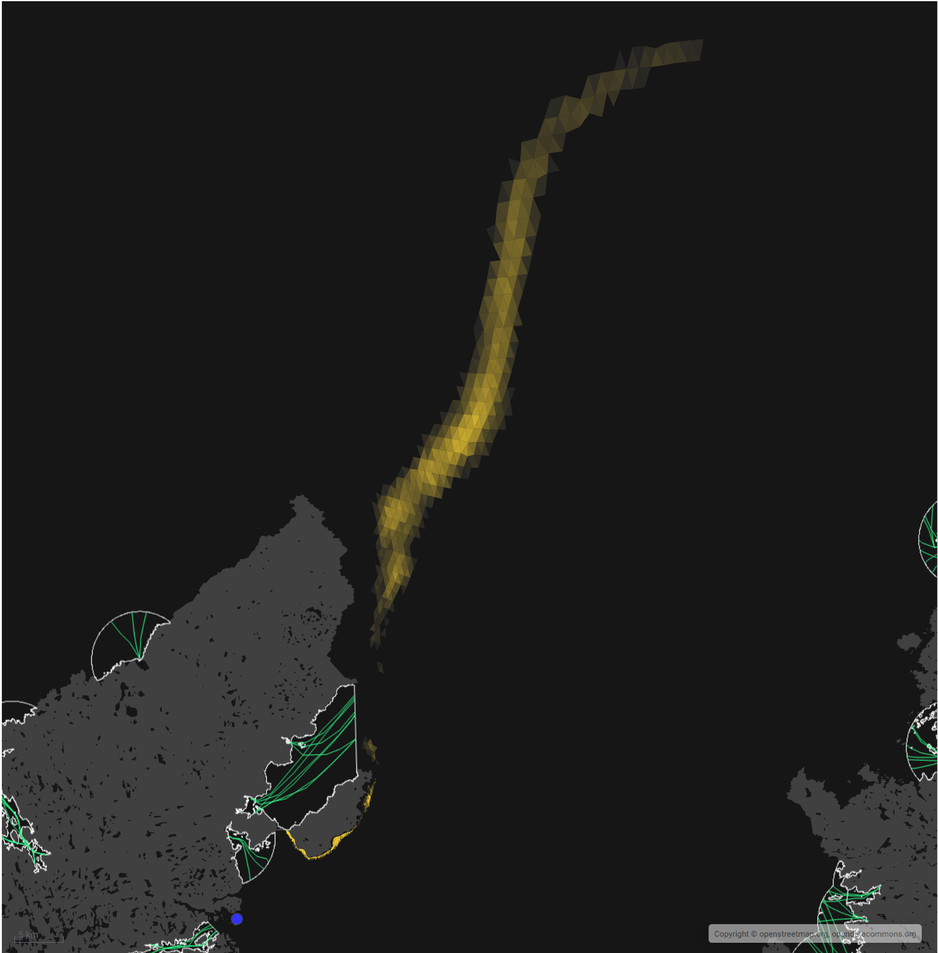

Sea Lice Conc. (lice/m2)



90th %ile (0.02)

Min. (0.01)

Figure 8: Map of the average modelled lice concentration over the simulated April and May period (in lice/m2) within the top two meters of the sea area. TABE1 site location shown as a circle.

Fish tracks are shown as green lines with the WSPZs, which are highlighted by a white boundary.

### Modelled Sea Lice Concentrations – Single Site Influence on Exposure – TABE1

Table 3 shows information relating to the influence of modelled lice concentrations, from TABE1 alone, on fish track exposure levels within the relevant WSPZs.

Table 3: Influence of modelled sea lice from TABE1 on exposure in the relevant affected WSPZs.

| **Wild Salmon Protection Zone (WSPZ)** | **95th %ile of Fish Track Exposure (lice/m2 days)** | **% of Exposure Threshold (0.7 lice/m2 days)** |
| --- | --- | --- |
| Loch a Tuath | 0.008 | 1.01 |

#### WSPZ Influence

One WSPZ is influenced to an extremely low degree. No other WSPZs are influenced.

#### Exposure Threshold

The percentage of the exposure threshold is shown to illustrate the scale of a single site influence. The exposure influence of all sites is not simply the sum of the individual site percentages. The overlapping influence of all sites on modelled screening exposure is shown below.

#### Assessment Matrix

An assessment matrix is presented on page 57 of the SEPA December 2023 response to consultation feedback: Managing interactions between sea lice from finfish farms and wild salmonids, SEPA response to [consultation feedback](https://consultation.sepa.org.uk/regulatory-services/detailed-proposals-for-protecting-wild-salmon/), December 2023.

Using the fish track exposure method, we establish the location of TABE1 within the assessment matrix framework of WSPZ screening capacity and site contribution. To assess the capacity influence, we take the WSPZ which experiences the greatest influence, in this case it is the Loch a Tuath WSPZ. Table 4 shows that TABE1 lies within cell A1 (Negligible, Large).

Table 4: Location of TABE1 within the assessment matrix framework of WSPZ capacity and site contribution.

| **Contribution to infective-stage sea lice exposure** | **Remaining available capacity in WSPZ** | | |
| --- | --- | --- | --- |
| **Large (1)** | **Intermediate (2)** | **Little or none (3)** |
| **Negligible (A)** | A1 **TABE1** | A2 | A3 |
| **Small (B)** | B1 | B2 | B3 |
| **Moderate (C)** | C1 | C2 | C3 |
| **Substantial (D)** | D1 | D2 | D3 |
| **Table Cell Colour Key (Permit conditions controlling on farm sea lice levels (19th March to 31st May)** | | | |
| A1 to A3, B1 to B2, C1 | No sea lice limit conditions. | | |
| B3, C2, D1 | Sea lice limits proposed by the developer and used in the screening assessment. | | |
| C3, D2 | Sea lice limits derived from an appropriate modelling assessment demonstrating that the farm will not compromise achievement of the sea lice exposure threshold. | | |
| D3 | Sea lice limits derived from an appropriate modelling assessment demonstrating that the farm will not compromise achievement of the sea lice exposure threshold. | | |

### Combined Influence of TABE1 on all Wild Salmon Protection Zones

Using the fish track exposure method, we can calculate the latest combined influence of all sources on the exposure threshold within all WSPZs, including the proposed site at the time of its submission. TABE1 mainly affects the Loch a Tuath WSPZ. Its inclusion has reduced some of the remaining capacity in Loch a Tuath, but does not, on its own, cause the exposure threshold upper limit to be exceeded. TABE1 has not reduced the screening capacity in any nearby WSPZs.

### Conclusion of Sea Lice Screening

The outcome of current screening is that this site will not require a lice permit condition. No further modelling work is required, at this time.

## Risk Identification

The screening modelling output summarised in the “Screening modelling” section is compared against available information on features of interest (see section “Identified features which require attention”). Features which require attention are presented with any additional comments. Identified features will need to be considered during the pre-application phase.

These should be addressed in the applicant “Method Statement”. Please refer to the [Modelling Method Statement section](https://www.sepa.org.uk/regulations/water/aquaculture/pre-application/) on the SEPA Website.

### Identified features which require attention

#### Table of identified features

The shellfish waters, shellfish farms and fin fish farms found within Loch Erisort have been assessed, with all found to be at minimal risk from this proposed new farm.

Table 5: Table of identified sensitive features

|  | **Feature Name** | **Feature Type** | **Location (Easting, Northing)** | **Brief Reason for Identification** |
| --- | --- | --- | --- | --- |
| **1** | **N/A/** |  |  |  |

A number of Priority Marine Features (PMFs) were also identified in the area; however, as none are known to be of national importance in this area, marine modelling will not be required.

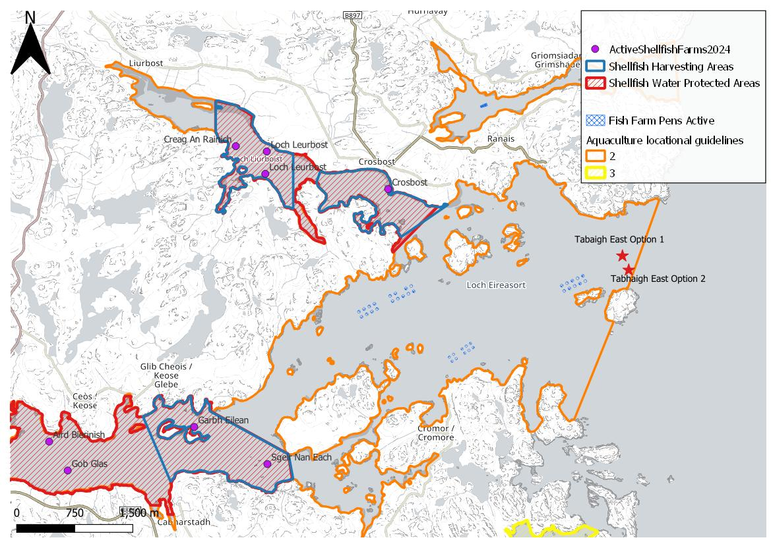



Figure 9: Loch Erisort is a MS locational guidelines category 2 water body, containing shellfish waters, shellfish farms and fin fish farms.

### Additional comments on identified features

Screening modelling predicts solids will be deposited immediately below the pens and is unlikely to significantly impact the wider environment.

The conservative nature of the simple BathAuto model in areas of high current speeds, means quantities of bath medicines may be limited to impractical amounts for this site. Use of marine modelling of bath influence will enable more realistic bath medicine treatment quantities to be determined. Due to the very dispersive nature of this area, discharges from all sites in the screening modelling will need to be included for solids, to ensure interactions between these sites are low, however dye/drogue calibration will not be required.

This proposed site is within a Marine Scotland Cat 2. Waterbody (Erisort/ Leurbost) (Figure 9). The addition of the site (Tabhaigh East (TABE1) with the proposed relinquishment of North Shore West (ERI3) would lead to an overall licenced biomass increase of 850t.

An ECE calculation should be carried out to ensure nutrient enhancement levels from this new farm are acceptable.

### Risks identified from contextual site data

Should this application proceed, the total licenced biomass (approved under CAR) in this area would be 19,380 tonnes. However, if ERI3 is surrendered, the total licenced biomass in this area would be 17,730 tonnes.

Table 6: Table of licenced biomass from farms identified as likely to add to cumulative risks.

| **Site Name** | **Location (Easting, Northing)** | **Biomass (Tonnes)** | **Last Production Cycle** |
| --- | --- | --- | --- |
| **TABE1** | Location option 1: 142251, 923426 **Location option 2** (preferred option): 142338, 923253 | 2500 | Proposed |
| **TAB1** | 141621, 923083 | 2500 | Currently stocked (since September 2022) |
| **ERI3** | 138970, 922730 | 1650 | Currently stocked (since June 2023)  Site to be surrendered |
| **ERI4** | 139400, 922950 | 2400 | Currently stocked (since December 2022) |
| **GRI1** | 140457, 925378 | 622 | No record of fish on site since they began in January 2011 |
| **GVRN1** | 143036, 915999 | 4680 | Application |
| **GVRW1** | 141310, 914410 | 515.7 | Fish last on site October 2023 |
| **LEU1** | 140800, 924200 | 625 | Fish last on site December 2012 |
| **ODH1** | 141750, 914500 | 2285.2 | Fish last on site October 2023 |
| **PEC1** | 139400, 921700 | 2 | No record of fish on site since they began in January 2011 |
| **PEC3** | 140200, 922230 | 1600 | Fish last on site June 2014 |

Given this is a new site, default NewDepomod modelling will be required. It is highly recommended that NewDepomod modelling is undertaken prior to proceeding further with this application.

## Conclusions of screening modelling and risk identification

Following screening modelling and risk identification we make a number of conclusions and recommendations.

### Conclusions

#### Screening Modelling

* According to screening modelling, the proposed site (Tabhaigh East (TABE1) is in an area of moderate dispersion and has a moderate capacity for erosion of material on the seabed.
* The screening model provides a reasonable performance in the vicinity of the site when compared to observational data.
* From sediment and bath treatment modelling:
  + - Information presented in the “Screening modelling” section indicates that the relative influence of Tabhaigh East (TABE1) is likely to be lower than other sites for a similar tonnage.
    - The influence on the surrounding sea area from Tabhaigh East (TABE1) is likely to be low.
    - Tabhaigh East (TABE1), does seem to influence Tabhaigh (TAB1) in low concentrations, and material dispersed from Tabhaigh (TAB1) seems to influence Tabhaigh East (TABE1).
    - It is likely that discharges of bath medicines from Tabhaigh East (TABE1) will be dispersed in low concentrations over a moderate area. Material seems to be transported out of Loch Erisort.
    - Tabhaigh East (TABE1) is likely to result in a very small increase in the total influence of all modelled sites. Any impact is expected to only marginally influence Tabhaigh (TAB1), however, Tabhaigh will have a larger influence on Tabhaigh East (TABE1).
    - Apart from Tabhaigh (TAB1), Tabhaigh East (TABE1) will mostly remain separate from other areas of influence generated by existing sites.
    - Should this application be granted, North Shore West (Erisort 3, ERI3) will be relinquished. North Shore West (ERI3) has a larger influence on Loch Erisort than Tabhaigh East (TABE1).
    - The site is in a Cat. 2 waterbody and the standard ECE calculation will still be required.

#### Sea Lice Screening Modelling

Detailed information for TABE1 has been provided in the section called Sea Lice Screening, above.

* Sea lice screening was carried out using our standard method with the translated Scottish Shelf ECLH (East Coast Lewis & Harris) sub area model.
* Sea lice screening has shown a very small effect on the exposure risk. No criteria for further work have been triggered. The outcome of current screening is that this site will not require a lice permit condition. No further modelling work is required, at this time.

#### Risk identification

While the modelled influence on the wider environment from Tabhaigh East (TABE1) appears to be low, with no sensitive features identified to be at risk from solids or baths, the mean impact below the pens still has to be assessed. NewDepomod modelling is required to ensure the proposed biomass is sustainable at this site.

Due to the low influence on surrounding areas, it is expected that BathAuto will be used at this site. The conservative nature of BathAuto means cumulative effects from multiple farms is not of concern. However, should marine modelling be undertaken to gain less conservative bath medicine amounts, then further detailed modelling will need to demonstrate that the influence on these features is low (cumulative modelling will not be required).

### Recommendations

#### Site suitability

The results presented in this report suggest that it is possible that discharges from the proposed site will be able to comply with the relevant aspects of the SEPA Aquaculture Regulatory Framework.

It is also possible that the site will be able to comply with our mixing zone regulatory framework. This will need to be demonstrated using the NewDepomod model. Since this site is in a high wave exposure area, the thresholds of “impact area no bigger than 120% of the Allowable Mixing Zone and the under cage deposition not more than 4000g/m2/year” should be used.

Due to few features at risk being identified at this stage, the feasibility of the proposed site is not expected to be impacted, with respect to the regulatory framework.

Following the engagement meeting(s), this report will be revised and this should allow to the applicant to submit a method statement which address the issues raised in this document.

#### Further modelling

* Due to the size of this farm and lack of identified risks, marine modelling is not required for this site, unless marine modelling for baths is to be undertaken.
* The resolution of the marine model, if used, should be relatively fine around the proposed site and identified features at risk.
* Flow speeds are moderate at this location and standard default NewDepomod must be undertaken prior to any marine modelling to demonstrate the proposed biomass can be supported. Conditions at this site, mean high wave exposure modelling standards (impact area no bigger than 120% of the Allowable Mixing Zone and the under-cage deposition not more than 4000g/m2/year) should be met.
* An ECE calculation should be carried out to ensure nutrient enhancement levels from this farm are acceptable.
* Sea lice screening has shown a very small effect on the exposure risk. No criteria for further work have been triggered. The outcome of current screening is that this site will not require a lice permit condition. No further modelling work is required, at this time.

## References

[1] [Pre-application | Scottish Environment Protection Agency (SEPA)](https://www.sepa.org.uk/regulations/water/aquaculture/pre-application/) (Hydrographic Data Guidance for Aquaculture, New Depomod Modelling Guidance, Marine Modelling Guidance for Aquaculture Applications published on SEPA website).

[2] Wider domain Scottish Shelf model: [The wider domain Scottish Shelf Model | marine.gov.scot](https://marine.gov.scot/information/wider-domain-scottish-shelf-model)

For information on accessing this document in an alternative format or language, please contact SEPA by emailing [equalities@sepa.org.uk](mailto:equalities@sepa.org.uk)

If you are a user of British Sign Language (BSL), the Contact Scotland BSL service gives you access to an online interpreter, enabling you to communicate with us using sign language. [contactscotland-bsl.org](http://contactscotland-bsl.org/)