

# Aquaculture Modelling Screening and Risk Identification Report: Etive 3 (Port na Mine) (FFMC84)

Report date: November 2024

## Scope of report

As part of the SEPA Aquaculture Regulatory Framework it is recommended that a proposed application for a marine fin fish aquaculture site should undergo a Screening Modelling and Risk Identification process. SEPA carries out this work and this is described on the SEPA aquaculture website [**Pre-application section**](https://www.sepa.org.uk/regulations/water/aquaculture/pre-application/)**.**

This report presents information arising from that process. Screening modelling methods are outlined and maps and tables describing the modelled impacts are shown. Risks arising from consideration of the model output are listed. Conclusions and recommendations are made regarding the proposed site.

## Executive summary

SEPA has received a proposal to vary an existing marine fin fish aquaculture site called Etive 3 (Port na Mine) (FFMC84). The site is located in Loch Etive, at location: 203364, 733204 (Easting, Northing). The existing maximum biomass is 458.4t at this location and the initially proposed weight of fish to be farmed is 708.4t. Subsequent NewDepomod modelling showed a biomass of 700t can be supported at this site. It is proposed that nearby site Etive 2 (Inverawe) (FFMC32) with a biomass of 250t will be surrendered should this application be approved.

Following screening modelling and risk identification we have concluded the following:

* Standard default NewDepomod modelling has been undertaken and is passing for 700t.
* Marine modelling is not required for solids.
* BathAuto is the default assessment approach for bath medicines, however marine modelling is an option that the applicant may choose to use instead to get a less conservative bath medicine quantity.
* If marine modelling of baths is undertaken, the resolution of the marine model should be relatively fine around the proposed site.
* Cumulative modelling is not required for either solids or bath medicines.
* Sea lice screening has been undertaken for this proposed site and has shown a small effect on the exposure risk. No criteria for further work have been triggered. The outcome of current screening is that this site will not require a lice permit condition. No further modelling work is currently required.
* Etive 3 (Port na Mine) (FFMC84) is suitable to progress to the next stage of the pre-application process outlined on the SEPA website.

## List of abbreviations

SEPA Scottish Environment Protection Agency

WSPZ Wild Salmon Protection Zone

## List of chemical abbreviations

AZA Azamethiphos

Contents

Aquaculture Modelling Screening & Risk Identification Report: Etive 3 (Port na Mine) (FFMC84) 1

Scope of report 2

Executive summary 2

List of abbreviations 4

List of chemical abbreviations 4

List of Figures 6

List of Tables 7

Introduction 8

Screening modelling 14

Sea Lice Screening 28

Risk Identification 32

Conclusions of screening modelling and risk identification 34

References 38

## List of Figures

Figure 1. Wider Loch Linnhe System model grid 13

Figure 2: Modelled average water speed (metres per second – m/s) in the sea loch around the proposed site (Etive 3 (Port na Mine) (FFMC84)). (Red star is site FFMC32 which is to be surrendered). 22

Figure 3: Modelled percentage of time the water flow speed is above 0.095 m/s in the sea area surrounding the proposed site (Etive 3 (Port na Mine) (FFMC84)). (Red star is site FFMC32 which is to be surrendered). 23

Figure 4: Modelled average sediment intensity over one month for the proposed site only (Etive 3 (Port na Mine) (FFMC84)). (Red star is site FFMC32 which is to be surrendered). 24

Figure 5: Modelled average sediment intensity over one month for the proposed site (Etive 3 (Port na Mine) (FFMC84)) and other relevant sites. (Red star is site FFMC32 which is to be surrendered). 25

Figure 6: Modelled average Azamethiphos concentration over four days from neap tide release for the proposed site only (Etive 3 (Port na Mine) (FFMC84)). (Red star is site FFMC32 which is to be surrendered). 26

Figure 7: Modelled average Azamethiphos concentration over four days from neap tide release for the proposed site (Etive 3 (Port na Mine) (FFMC84)) and other relevant sites. (FFMC32 is to be surrendered). 27

Figure 8: Map of the average modelled lice concentration over the simulated April and May period (in lice/m2) within the top two meters of the sea area. FFMC84 site location shown as a blue circle. Fish tracks are shown as green lines with the WSPZs, which are highlighted by a white boundary. 29

## **List of Tables**

Table 1: Sediment influence information for each site. 18

Table 2: Azamethiphos influence information for each site. 21

Table 3: Influence of modelled sea lice from FFMC84 on exposure in the relevant affected WSPZs. 30

Table 4: Location of FFMC84 within the assessment matrix framework of WSPZ capacity and site contribution. 31

Table 5: Table of licenced biomass from farms identified as likely to add to cumulative risks. 33

## Introduction

Screening modelling and risk identification are important steps in the SEPA regulatory framework for marine pen fish farms. They are carried out by SEPA at the [**pre-application stage**](https://www.sepa.org.uk/regulations/water/aquaculture/pre-application/)**.**

This document briefly describes the objectives of screening and risk identification and summarises the methods used. Screening output for the proposed site is then presented with comments. Risks identified from the screening output are detailed. Conclusions and recommendations about the suitability of the proposed site are then made.

### The objectives of screening modelling and risk identification

A summary of the modelling methods employed during screening modelling is outlined in the screening modelling methods section. The objectives of screening modelling and risk identification are outlined below.

#### Screening modelling

Marine Modelling technology can be used to simulate and predict the potential influence of discharges on the marine environment. Marine modelling can also be used at an earlier stage to provide an initial estimate of the influence of material discharged from a proposed site, which is discussed in this report.

SEPA will require the majority of proposed farms to conduct detailed marine modelling, as outlined in our Aquaculture Modelling guidance [1] and on the SEPA Website. The screening and risk identification stage will assess the need for detailed modelling.

SEPA will carry out marine modelling at the screening and risk identification stage. This is a simplified version of the detailed modelling required of the applicant. However, it will be sufficient to perform an initial risk assessment of a proposal. Screening marine modelling will also include discharges from other relevant aquaculture sites and major sources.

The objectives of the simplified screening modelling are to:

* Produce maps of the predicted dispersive and erosive capacity of the sea areas in the vicinity of aquaculture sites.
* Produce maps of the predicted spread of sediment discharged from aquaculture sites.
* Produce maps of the predicted spread of bath treatment medicines from aquaculture sites.
* Present an analysis of the potential influence of sediment and bath treatment discharges from the proposed site alongside existing sites within the surrounding sea area.
* Present information on the sensitive features and sites of interest within the surrounding sea area, which must be addressed during pre-application work.
* Present a summary of the suitability of the proposal with respect to the dispersal of waste and how this may be modelled.

#### Risk identification

Maps and analysis of screening output will be compared to information relating to sensitive features and relevant areas of interest. These may include:

* Marine Protected Area (MPA).
* Special Area of Conservation (SAC).
* Priority Marine Feature (PMF).
* Any site identified via consideration of other permitted or regulatory activities.

SEPA Staff will meet to discuss screening model output and the relevant sensitive features information. Following this meeting, a list of identified risks will be added to this report.

#### Conclusion of screening modelling and risk identification

Following the identification of risks, SEPA will present a summary of the suitability of the proposal with respect to the:

* Dispersal of waste from the proposed site and other sources.
* Risks posed to sensitive features.
* Likely level of modelling that will be required to address the risks identified.

### Screening modelling methods

Marine models divide the sea up into a “grid” of boxes or triangles (often called cells). Each of these is given a water depth. For the screening modelling presented in this report the Marine Scotland “Wider Loch Linnhe System” (WLLS) has been used. An image of the WLLS model grid is shown in Figure 1. This grid has been set up within a marine modelling software package called MIKE 21 which is manufactured by the company [DHI A/S](https://www.dhigroup.com/).

Marine models carry out calculations across a grid to work out how seawater moves and mixes in response to tidal and weather forces. Marine models can also be used to simulate how seawater moves and mixes due to salinity and temperature differences across an area, particularly in response to inputs of freshwater from rivers. For pollutant influence assessments the mixing (dispersion) of dissolved (bath medicine) and particulate (sediment) pollutants can also be estimated. Calculations within a marine model can be performed in three dimensions (3D), where the grid is split into layers to better represent how properties of the sea change with depth. Two dimensional (2D) models can also be created where processes over the water depth are simplified. The amount of mixing in a marine model can be varied using settings in the software.

Screening modelling is currently carried out with 2D models using average mixing settings in the model software. In many areas, this approach will be sufficient to make an initial estimate of the influence of a proposed site. Our screening assessment will take into account factors which may limit a 2D approach. We will also consider whether a particular location is adequately represented by the available models.

#### Water movement and mixing modelling

Water movement and mixing modelling (hydrodynamics) has been carried out to generate one month of results. The boundaries (edge(s) of) the model have been driven using the “wider domain” Scottish Shelf Model [2]. Wind forces and freshwater inputs have been applied to the model from the same source. The results generated are an estimate of the average water movement and mixing conditions within the model area.

#### Sediment waste modelling

Screening modelling provides a precautionary and indicative estimate of the size, location and intensity of waste organic material released from aquaculture sites.

The release of sediment from sources within the model area is simulated using one month of hydrodynamic results along with particle tracking modelling technology. Virtual particles are continually introduced to the model grid to represent the potential dispersion of sediment from the sources. Particles in the model are moved and mixed by the hydrodynamics. Additionally, particles are assigned simplified properties, which allow them to settle through the water and be re-suspended (eroded and lifted) from the seabed.

#### Bath medicine modelling

Screening modelling provides a precautionary and indicative estimate of the size, location and concentration of bath medicine releases.

The release of bath treatment medicine from sources within the model area is simulated using hydrodynamic results along with particle tracking modelling technology. Virtual particles are introduced to the model grid to represent the potential dispersion of bath medicines from the sources. Particles in the model are moved and mixed by the hydrodynamics. Releases of bath medicines are simulated under worst case mixing (dispersion) conditions, which occur under neap tides. The maximum treatment amount likely to be used at each site is released into the model at the same time and plumes are tracked over the following 96 hours (4 days). Treatment amounts used at screening have been derived from an analysis of historical data. Additionally, all bath medicine particles are concentrated within the top 5 metres of the sea area. As all bath medicines are likely to disperse in a similar way, only Azamethiphos (AZA) has been modelled at the screening stage.

#### Nutrient assessment

Whilst nutrients are not directly modelled during screening, the dispersion of bath medicine releases will give an indication of the likely level of nutrient dispersion. This will be considered alongside any pre-existing nutrient assessment information that may be available.

#### Analysis of modelling output

SEPA processes the screening modelling output and places it into a standard analysis application built in TIBCO Spotfire. The application allows for the production of standard maps and tables, which are presented below.

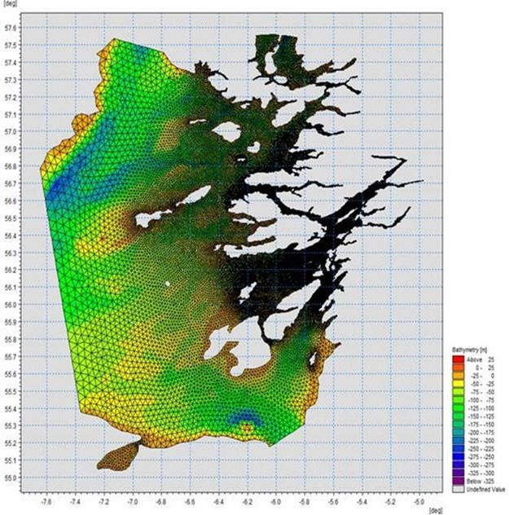

Figure 1. Wider Loch Linnhe System model grid

## Screening modelling

### Site proposal

SEPA has received a proposal to vary an existing marine fin fish aquaculture site called Etive 3 (Port na Mine, FFMC84). The site is located in Loch Etive, at location: 203364, 733204 (Easting, Northing). The existing maximum biomass is 458.4t at this location and the proposed weight of fish to be farmed is 708.4t. It is proposed that nearby site Etive 2 (Inverawe) (with a biomass of 250t) will be surrendered should this application be approved.

#### Accuracy of model in the area surrounding the proposal

The Wider Loch Linnhe System model used for screening modelling has been compared against various sources of observed current meter data. This comparison indicates that the model provides a fairly poor description of the physical processes in the vicinity of the proposed site, as the screening model is depth averaged and therefore cannot replicate the highly stratified waters in the area around the farm. This means the screening model output will be treated with caution, and other data will also be considered when determining likely risks.

### Dispersion and erosion capacity maps

Modelled water movement in a sea area can be analysed and presented to show the capacity of the water to move and disperse discharged substances. It is also possible to show the capacity available to erode substances from the seabed. This information is a useful guide to the potential size of a marine fin fish aquaculture farm at a particular location.

Marine fin fish aquaculture farms using open-net pens will benefit from operating in locations where there are strong, repeating, water currents to erode and disperse waste.

For the purposes of screening we consider locations which meet the following water flow criteria to be generally suitable for larger farms:

Locations with average water flow speeds of greater than, or equal to, 0.12 metres per second (0.23 knots).

Locations where water flow speeds are often above the threshold of 0.095 meters per second (0.18 knots).

Locations with these properties are likely to disperse discharged material rapidly, and regularly erode sediment discharged to the seabed. In general, we would look for these properties to be maintained over a large area around a proposed site.

The thresholds stated above are indicative.

A map of modelled average water flow speed for the area surrounding the proposed site is shown in Figure 2. The average water flow speed in each cell of the model grid has been assigned a shade. The key for the shading is shown in the top left of the figure. Grid cells that have average speeds less than 0.12m/s (metres per second) are marked on the figure. The greater the shading, the slower the average current speed and the lower the capacity for dispersion.

Figure 3 is a map of the percentage of time the modelled water flow speed in a grid cell is above 0.095m/s. The greater the shading, the lower the capacity for material to be eroded from the seabed.

Licenced aquaculture farms in the vicinity of the proposed site are also marked on Figure 2 and Figure 3. Discharges of material from these sites have been included in the screening modelling.

Based on the maps of the 2-dimensional modelled water flow properties we can make the following observations about the proposed site location, however the area of the modelled farm is highly stratified with fast currents at the surface and in mid depths and slow currents at the bed:

* It lies in a high dispersion area.
* It lies in an area where water flow has a high capacity to erode material on the seabed.

### Sediment influence maps and analysis

Modelled particles in a sea area can be analysed for each modelled grid cell and presented to show the potential influence of discharged sediment on the surrounding sea area.

Figure 4 shows a map of the modelled average sediment intensity over one month (time average) for the proposed site only. Grid cells within the model that are influence by modelled sediment are shaded according to the intensity of the influence in grams per square metre (g/m2).

Values less than 1g/m2 have been excluded from the map and subsequent calculations. These low concentration cells are produced by the particle tracking approach, but they are not considered to be representative of the main influence of a discharge.

* The shading key is shown in the top left of the figure. Cells which are shaded black are similar to the average intensity in the total area of influence shown in the map. Cells shaded pink are similar to the median (middle value in the range) intensity value shown on the map. White shaded cells are similar to the minimum intensity value shown on the map.
  + The average and median sediment intensity over the area of influence is 5.36g/m2 and 2.70g/m2 respectively.
  + Cells influenced by the proposed site do not appear to lie close to other modelled farm sites, apart from FFMC32, which is to be relinquished.

Figure 5 shows a map of the modelled average sediment intensity over one month for the proposed site and other relevant sites. Grid cells within the model that are influenced by modelled sediment are shaded according to the intensity of the influence in grams per square metre (g/m2). The shading key is shown in the top left of the figure and is in a similar format as that shown in Figure 4. The average sediment intensity, after including all relevant sites, is increased.

* The average and median sediment intensity over the area of influence is 11.51g/m2 and 3.82g/m2 respectively.
* Cells are not influenced by other modelled sites, as FFCM 32, which does have an influence, is to be relinquished.

#### Sediment influence analysis

Model grid cells can be analysed to estimate the size and concentration of the potential sediment influence from the modelled sites.

* The total area of sediment influenced by the six sites modelled is estimated to be 5.59 square kilometres (km2).
* As shown in Figure 5, the average and median intensity over this area is 11.51g/m2 and 3.82g/m2, respectively.
* The total weight of fish that generates this modelled influence is 6603.83 tonnes.

Table 1 shows the information for each individual site modelled. It is important to note that the total area of influence for all sites is not the sum of the numbers in Table 1. The total area of influence worked out above takes into account that the individual areas of influence from different sites will overlap.

Table 1: Sediment influence information for each site.

| **Site Name** | **Average Intensity (G/M2)** | **Area Of Influence (Km2)** | **Median Intensity (G/M2)** | **Max Weight Of Fish (Tonnes)** |
| --- | --- | --- | --- | --- |
| **FFMC84** | 5.36 | 1.43 | 2.70 | 708.4 |
| **FFMC32\*** | 2.94 | 0.71 | 1.83 | 250 |
| **FFMC11** | 4.65 | 0.34 | 1.89 | 250 |
| **FFMC27** | 5.36 | 3.76 | 2.20 | 2350 |
| **APT1** | 6.95 | 2.35 | 3.51 | 1545.3 |
| **SAR1** | 6.16 | 2.49 | 3.04 | 1500 |
|  |  |  |  |  |

(* Site to be surrendered should FFMC84 be granted)

There are no Environmental Standards for sediment intensity. However, we consider that:

• underneath farm pens, an intensity of 2000g/m2 or less is likely to lead to an acceptable seabed ecological outcome.

• at the edge of the mixing zone, an intensity of 250g/m2 or less is likely to lead to an acceptable seabed mixing zone outcome.

The estimate of influence detailed above is indicative. The values presented are lower than the sediment intensity values given above. However, we recognise that low sediment concentrations may be useful for the identification of risks.

### Bath medicine influence maps and analysis

Modelled particles in a sea area can be analysed for each modelled grid cell and presented to show the potential influence of discharged bath medicine on the surrounding sea area. Results presented are for the AZA medicine (see *Bath medicine modelling* section).

Figure 6 shows a map of the modelled average AZA concentration over four days for the proposed site only. Grid cells within the model which experience an AZA influence are shaded according to the concentration of AZA in nanograms per litre (ng/l).

Values less than 10ng/l have been excluded from the map and subsequent calculations. These low concentration cells are produced by the particle tracking approach, but they are not considered to be representative of the main influence of a discharge.

Please note that the Environmental Standard for Azamethiphos with the lowest concentration is 40ng/l. This must be met 72 hours after the material has been discharged. The estimate of influence detailed here is precautionary. In the information presented below areas of influence above 40ng/l have been quoted. However, the average and median concentrations are quoted for the entire area of influence above 10ng/l.

The shading key is shown in the top left of the figure. Cells which are shaded black are similar to the average concentration in the total area of influence shown in the map. Cells shaded pink are similar to the median (middle value in the range) concentration shown on the map. White shaded cells are similar to the minimum concentration value shown on the map.

* The average and median concentration over the total area of influence is 14.88ng/l and 13.15ng/l respectively.
  + Cells influenced by the proposed site do not appear to lie close to other modelled farm sites, apart from FFMC32, which is to be relinquished.

Figure 7 shows a map of the modelled average AZA influence over four days for the proposed site and other relevant sites. The average AZA influence, after including all relevant sites, is decreased.

* The average and median AZA concentration over the total area of influence is 32.05ng/l and 24.28ng/l respectively.
* Cells are not influenced by other modelled sites, as FFCM32, which does have an influence, is to be relinquished.

#### Bath medicine influence analysis

Model grid cells can be analysed to estimate the size and concentration of the potential AZA influence from the modelled sites.

* The area of AZA influenced above 40 ng/l from all sites modelled is estimated to be 7.39 square kilometres (km2).
* As shown in Figure 7, the average and median concentration over the total area of influence is 32.05 and 24.28ng/l, respectively.
* The total weight of fish that generates this modelled influence is 6603.83 tonnes.

Table 2 shows the information for each individual site modelled. It is important to note that the total area of influence above 40ng/l for all sites quoted above is not the sum of the numbers in Table 2. The total area of influence worked out above takes into account that the individual areas of influence above 40ng/l from different sites will overlap.

Table 2: Azamethiphos influence information for each site.

| **Site Name** | **Average Concentration (Ng/l)** | **Area Of Influence Above 40 Ng/L (Km2)** | **Median Concentration (Ng/l)** | **Weight Of Fish (Tonnes)** |
| --- | --- | --- | --- | --- |
| **FFMC84** | 14.88 | 1.29 | 13.15 | 708.4 |
| **FFMC32\*** | 31.37 | 4.27 | 24.61 | 250 |
| **FFMC11** | Less than 10 | 0 | Less than 10 | 250 |
| **FFMC27** | 29.90 | 3.83 | 21.94 | 2350 |
| **APT1** | 21.35 | 1.66 | 18.48 | 1545.3 |
| **SAR1** | 17.97 | 1.13 | 15.57 | 1500 |

(* Site to be surrendered should FFMC84 be granted)

Please note that the Environmental Standard for Azamethiphos with the lowest concentration is 40ng/l. This must be met 72 hours after the material has been discharged. The estimate of influence detailed above is precautionary. Detailed modelling will be required to demonstrate compliance with all Environmental Standards.

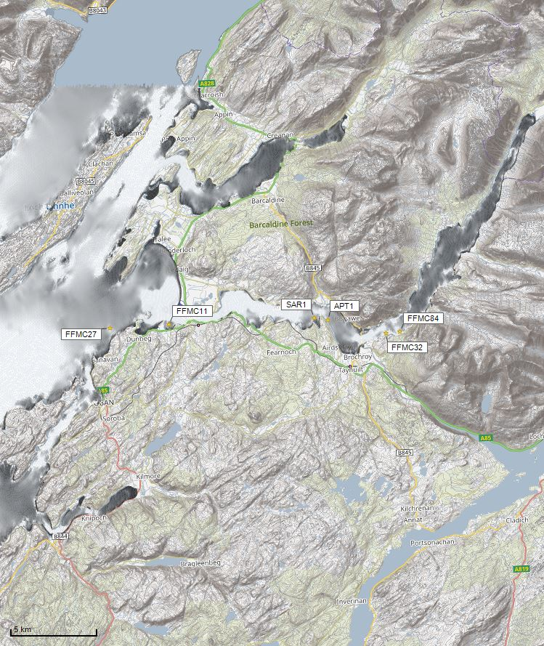



Average water speed (m/s)

©Crown copyright. All rights reserved. SEPA lic. no. 100016991 (2019).

Figure 2: Modelled average water speed (metres per second – m/s) in the sea loch around the proposed site (Etive 3 (Port na Mine) (FFMC84)). Red star indicates the site FFMC32 which is to be surrendered.

©Crown copyright. All rights reserved. SEPA lic. no. 100016991 (2019).

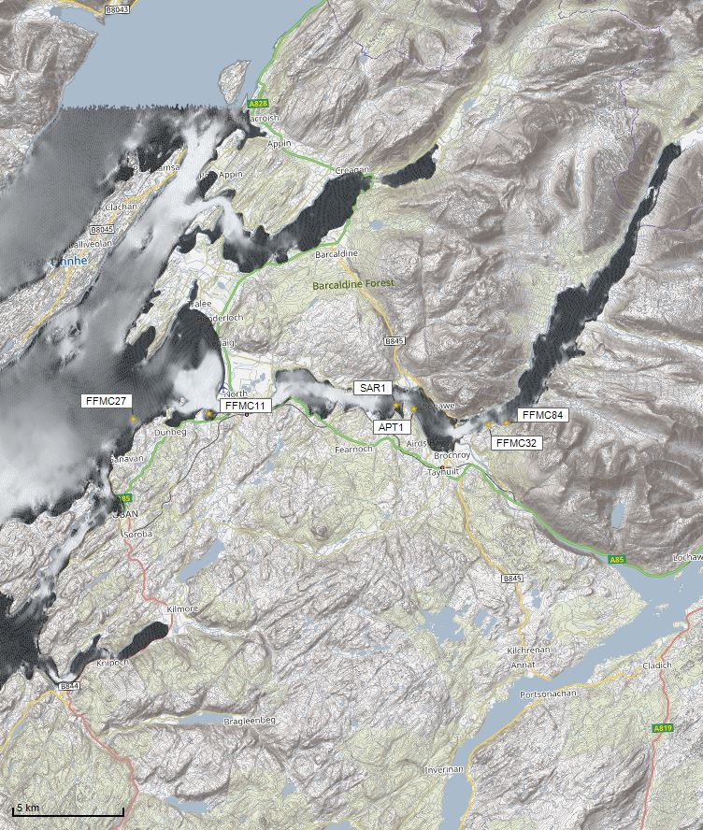

Percentage time (%)

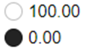

Figure 3: Modelled percentage of time the water flow speed is above 0.095m/s in the sea area surrounding the proposed site (Etive 3 (Port na Mine) (FFMC84)). Red star indicates the site FFMC32 which is to be surrendered.

©Crown copyright. All rights reserved. SEPA lic. no. 100016991 (2019).

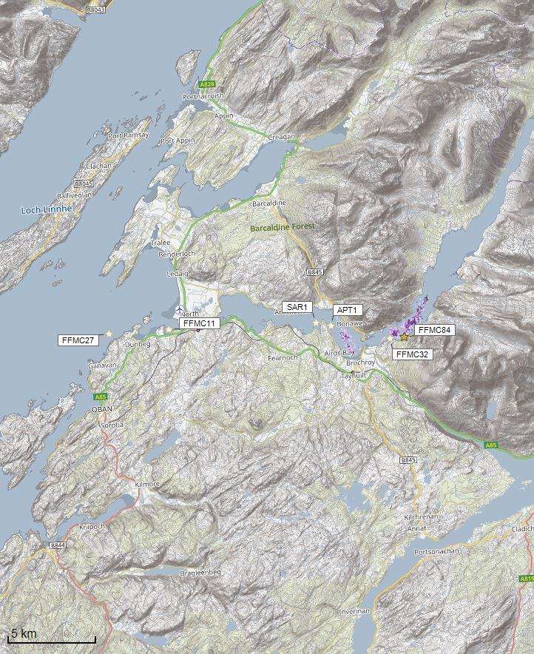

Sediment intensity values presented on this map are low and are presented for information only.

Sediment Intensity (g/m2)

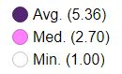

©Crown copyright. All rights reserved. SEPA lic. no. 100016991 (2019).

Figure 4: Modelled average sediment intensity over one month for the proposed site only (Etive 3 (Port na Mine) (FFMC84)). Red star indicates the site FFMC32 which is to be surrendered.

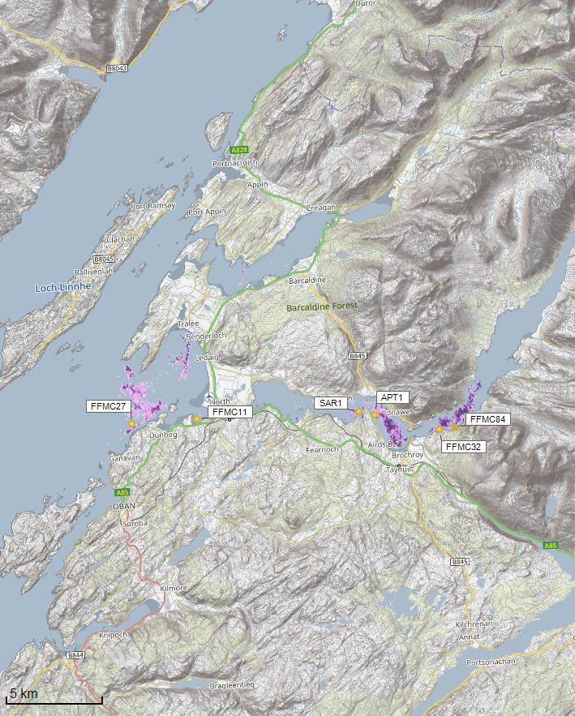Figure 5: Modelled average sediment intensity over one month for the proposed site (Etive 3 (Port na Mine) (FFMC84)) and other relevant sites. Red star indicates the site FFMC32 which is to be surrendered.

Sediment intensity values presented on this map are low and are presented for information only.

Sediment Intensity (g/m2)

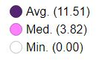

©Crown copyright. All rights reserved. SEPA lic. no. 100016991 (2019).

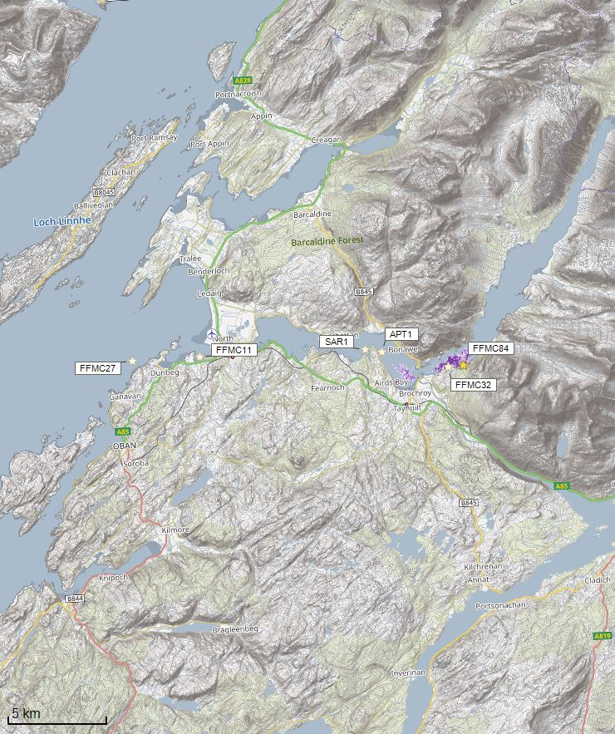Figure 6: Modelled average Azamethiphos concentration over four days from neap tide release for the proposed site only (Etive 3 (Port na Mine) (FFMC84)). Red star indicates the site FFMC32 which is to be surrendered.

Concentrations of AZA presented on this map are less than the 40ng/l Environmental Standard and are presented for information only.

©Crown copyright. All rights reserved. SEPA lic. no. 100016991 (2019).

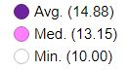

Azamethiphos Conc. (ng/l)

Concentrations of AZA presented on this map are less than the 40ng/l Environmental Standard and are presented for information only.

©Crown copyright. All rights reserved. SEPA lic. no. 100016991 (2019).

Azamethiphos Conc. (ng/l)

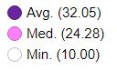

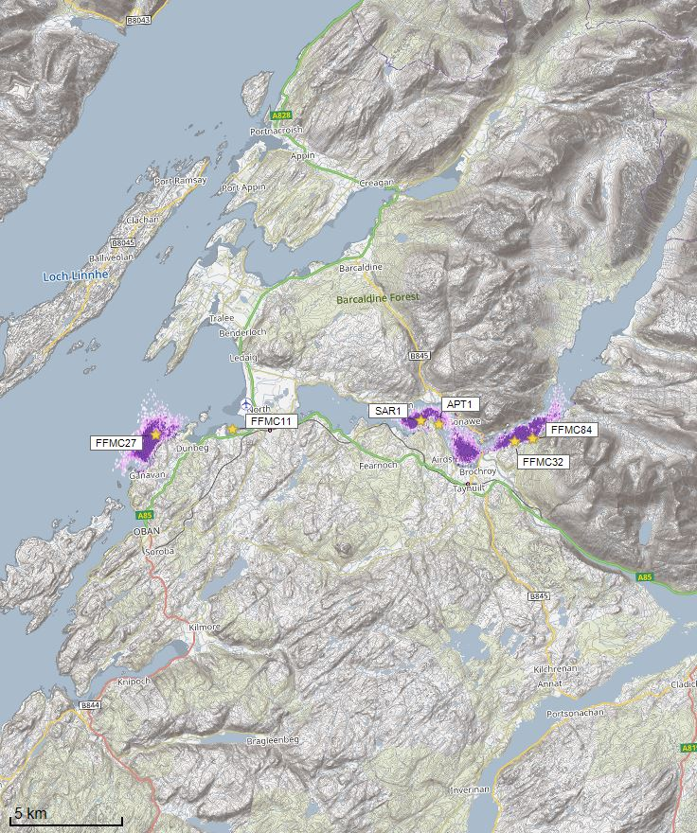Figure 7: Modelled average Azamethiphos concentration over four days from neap tide release for the proposed site (Etive 3 (Port na Mine) (FFMC84)) and other relevant sites. FFMC32 is to be surrendered.

©Crown copyright. All rights reserved. SEPA lic. no. 100016991 (2019).

## Sea Lice Screening

Sea lice screening was carried out using our standard method with the translated Scottish Shelf WLLS (Wider Loch Linnhe System) sub area model. This method is outlined in in Appendix 4 of the May 2023 second consultation document: [Managing interactions between sea lice from finfish farms and wild salmonids, proposed new regulatory framework, May 2023.](https://consultation.sepa.org.uk/regulatory-services/detailed-proposals-for-protecting-wild-salmon/)

### Modelled Sea Lice Concentration Map – FFMC84

Figure 8 shows a map of the average modelled lice concentration over the simulated April and May period (in lice/m2) within the top two meters of the sea area. Model grid cells (triangles) are coloured according to the amount of sea lice particles within them.

#### Indicative Influence

The map serves as an indicative influence under average tidal and weather conditions. The focus is on areas of potential high influence for further fish track analysis within WSPZs.

#### Exclusion of Low Concentrations

Any grid cells with concentrations below 0.01 lice/m² are not shown on the map. This exclusion helps focus on more influential concentrations on the fish track analysis and WSPZs. However, these concentrations are not excluded from fish track exposure analysis below.

#### Colour Intensity, 90th Percentile and Median Concentrations

The more intense the colour in the grid cells, the closer the concentration is to the 90th percentile of all concentrations within the model cells. This brings attention to areas of higher modelled influence. The 90th percentile of sea lice concentrations is 0.04 lice/m², meaning that 90% of the concentrations are below this value. The median concentration is 0.02 lice/m², suggesting that half of the values are below this number. At baseline (before the introduction of the proposed site), the average 90th percentile concentration across modelled sites was 0.04 lice/m².

#### Focus Area

The highest modelled influence occurs in the Linnhe WSPZ.

Figure 8 The average modelled sea lice concentration over a simulated period during April and May. The concentration is measured in lice per square meter within the top two meters of the sea. Two key colour indicators are used: yellow represents areas where the sea lice concentration is in the 90th percentile (0.04 lice/m²), and black represents the minimum observed concentration (0.01 lice/m²).

Fish tracks are displayed as green lines, indicating paths the fish may take through the region. The image also highlights certain areas enclosed by white boundaries, labelled as WSPZs (Wild Salmon Protection Zones). The location of a specific site, referred to as FFMC84, is marked with a blue circle.

The sea lice concentration appears to be highest in a yellow-orange zone near the centre of the map, where the fish tracks also converge or pass through. The rest of the region displays lower concentrations, indicated by darker tones and sparser yellow areas.Figure 8: Map of the average modelled lice concentration over the simulated April and May period (in lice/m2) within the top two meters of the sea area. FFMC84 site location shown as a blue circle. Fish tracks are shown as green lines with the WSPZs, which are highlighted by a white boundary.

Sea Lice Conc. (lice/m2)



90th %ile (0.04)

Min. (0.01)

### Modelled Sea Lice Concentrations – Single Site Influence on Exposure (FFMC84)

Table 3 shows information relating to the influence of modelled lice concentrations, from FFMC84 alone, on fish track exposure levels within the relevant WSPZs.

Table 3: Influence of modelled sea lice from FFMC84 on exposure in the relevant affected WSPZs.

| **Wild Salmon Protection Zone (WSPZ)** | **95th percentile of fish track exposure (lice/m2 days)** | **Percentage of exposure threshold (0.7 lice/m2 days)** |
| --- | --- | --- |
| Linnhe | 0.06 | 8.54 |

#### WSPZ Influence

One WSPZ is influenced to a low degree. Three other WSPZs are influenced to an extremely low degree. Exclusion of these from the table brings focus on the areas of highest influence. However, these influences are included in the combined exposure analysis below.

#### Exposure Threshold

The percentage of the exposure threshold is shown to illustrate the scale of a single site influence. The exposure influence of all sites is not simply the sum of the individual site percentages. The overlapping influence of all sites on modelled screening exposure is shown below.

#### Assessment Matrix

An assessment matrix is presented on page 57 of the SEPA December 2023 response to consultation feedback: Managing interactions between sea lice from finfish farms and wild salmonids, SEPA response to [consultation feedback](https://consultation.sepa.org.uk/regulatory-services/detailed-proposals-for-protecting-wild-salmon/), December 2023.

Using the fish track exposure method, we establish the location of FFMC84 within the assessment matrix framework of WSPZ screening capacity and site contribution. To assess the capacity influence, we take the WSPZ which experiences the greatest influence, in this case it is the Linnhe WSPZ. Table 4 shows that FFMC84 lies within cell A3 (Negligible, Little or none).

Table 4: Location of FFMC84 within the assessment matrix framework of WSPZ capacity and site contribution.

| **Contribution to infective-stage sea lice exposure** | **Remaining available capacity in WSPZ** | | |
| --- | --- | --- | --- |
| **Large (1)** | **Intermediate (2)** | **Little or none (3)** |
| **Negligible (A)** | A1 | A2 | A3  **FFMC84** |
| **Small (B)** | B1 | B2 | B3 |
| **Moderate (C)** | C1 | C2 | C3 |
| **Substantial (D)** | D1 | D2 | D3 |
| **Table Cell Colour Key (Permit conditions controlling on farm sea lice levels (19th March to 31st May)** | | | |
| A1 to A3, B1 to B2, C1 | No sea lice limit conditions. | | |
| B3, C2, D1 | Sea lice limits proposed by the developer and used in the screening assessment. | | |
| C3, D2 | Sea lice limits derived from an appropriate modelling assessment demonstrating that the farm will not compromise achievement of the sea lice exposure threshold. | | |
| D3 | Sea lice limits derived from an appropriate modelling assessment demonstrating that the farm will not compromise achievement of the sea lice exposure threshold. | | |

### Combined influence of FFMC84 on all Wild Salmon Protection Zones

Using the fish track exposure method, we can calculate the latest combined influence of all sources on the exposure threshold within all WSPZs, including the proposed at the time of its submission. FFMC84 mainly affects the Linnhe WSPZ. Its inclusion has reduced some of the remaining capacity in Linnhe, but does not, on its own, cause the exposure threshold upper limit to be exceeded. FFMC84 has also reduced the screening capacity in a number of nearby WSPZs, but to a very small degree.

### Conclusion of Sea Lice Screening

The outcome of current screening is that this site will not require a lice permit condition. No further modelling work is required, at this time.

## Risk Identification

The screening modelling output summarised in the *Screening modelling* section is compared against available information on features of interest (see section *Identified features which require attention*). Features which require attention are presented with any additional comments. Identified features will need to be considered during the pre-application phase.

These should be addressed in the applicant “Method Statement”. Please refer to the [Modelling Method Statement section](https://www.sepa.org.uk/regulations/water/aquaculture/pre-application/) on the SEPA Website.

### Identified features which require attention

Sensitive features in the area have been assessed. There are no sensitive features that are at risk and since there is no increase in the overall biomass, marine modelling is not required.

NewDepomod modelling has been used to set the biomass of this site at 700t and determine area of impact.

### Additional comments on identified features

Screening modelling does not predict any significant sediment or bath influence from (Etive 3 (Port na Mine) (FFMC84)). Should marine modelling be used instead of BathAuto to get a less conservative bath medicine quantity, the modelling needs to demonstrate it meets EQS standards. Cumulative modelling of baths is however not required.

### Risks identified from contextual site data

Should the application proceed, FFMC32 would also be surrendered, therefore the total licenced biomass (licensed under CAR) in this area would remain at 6353.83 tonnes.

Table 5: Table of licenced biomass from farms identified as likely to add to cumulative risks.

| **Site Name** | **Location (Easting, Northing)** | **Biomass (Tonnes)** | **Last Production Cycle** |
| --- | --- | --- | --- |
| **FFMC84** | 203307, 733131 | 708.4 | Proposed. Currently stocked |
| **FFMC32** | 202509, 733068 | 250 | Fish last on site January 2024  To be surrendered |
| **FFMC11** | 189900, 734200 | 250 | No record of fish on site since they began in January 2011 |
| **FFMC27** | 186472, 734141 | 2350 | Currently stocked (since January 2024) |
| **APT1** | 199157, 733978 | 1545.43 | Currently stocked (since January 2024) |
| **SAR1** | 198350, 734165 | 1500 | Currently stocked (since April 2020) |

## Conclusions of screening modelling and risk identification

Following screening modelling and risk identification we make a number of conclusions and recommendations.

### Conclusions

#### Screening Modelling

* According to screening modelling, the proposed site Etive 3 (Port na Mine) (FFMC84) is in an area of high dispersion and has a relatively high capacity for erosion of material on the seabed. However, the observed data shows the site is in an area of strong stratification, with high current speeds in the surface and middle of the water column, but with low current speeds at the bed.
* The screening model provides a poor performance in the vicinity of the site when compared to observational data.
* From sediment and bath treatment modelling:
  + - Information presented in the Screening modelling section indicates that the relative influence of Etive 3 (Port na Mine) (FFMC84) is likely to be similar to other sites for a similar tonnage.
    - The influence on the surrounding sea area from Etive 3 (Port na Mine) (FFMC84) is likely to be low.
    - The areas of influence from Etive 3 (Port na Mine) (FFMC84), and other sites modelled do not appear to interact, apart from FFMC32, which is to be surrendered.
    - It is likely that discharges of bath medicines from Etive 3 (Port na Mine) (FFMC84) will be dispersed to low levels over a small area.
    - Etive 3 (Port na Mine) (FFMC84) is unlikely to result in an increase in the total influence of all sites modelled. Any impact is expected to remain separate from areas of influence generated by existing sites.
* The proximity to locational guidelines waterbodies has been assessed and not considered a risk, however the standard ECE calculation will still be required.

#### Sea Lice Screening Modelling

Detailed information has been provided in the section called Sea Lice Screening, above.

* Sea lice screening was carried out using our standard method with the translated Scottish Shelf WLLS (Wider Loch Linnhe System) sub area model.
* Sea lice screening has been undertaken for this proposed site and has shown a small effect on the exposure risk. No criteria for further work have been triggered. The outcome of current screening is that this site will not require a lice permit condition. No further modelling work is required, at this time.

#### Risk identification

The modelled influence on the wider environment from Etive 3 (Port na Mine) (FFMC84) appears to be low, with no sensitive features identified as at risk from solids or baths. Standard default NewDepomod modelling has been undertaken and suggests a biomass of 700t is sustainable at this site.

Due to the low proposed biomass, BathAuto is appropriate for this site. However, should marine modelling be undertaken to gain less conservative bath medicine amounts, then further detailed modelling will need to demonstrate they meets EQS standards (cumulative modelling will not be required).

### Recommendations

#### Site suitability

The results presented in this report suggest that it is possible that discharges from the proposed site will be able to comply with the relevant aspects of the SEPA Aquaculture Regulatory Framework.

It is also possible that the site will be able to comply with our mixing zone regulatory framework. This will need to be demonstrated using the NewDepomod model, using the low wave exposure thresholds (impact area no bigger than 100% of the Allowable Mixing Zone and the under cage deposition not more than 2000 g/m2/year).

Due to no features at risk being identified at this stage, the feasibility of the proposed site is not expected to be impacted, with respect to the regulatory framework.

Following the engagement meeting(s), this report will be revised and this should allow to the applicant to submit a method statement which address the issues raised in this document.

#### Further modelling

* Due to the size of this farm and lack of identified risks, marine modelling is not required for this site, unless marine modelling for baths is to be undertaken.
* The resolution of the marine model, if used, should be relatively fine around the proposed site.
* Standard default NewDepomod has been undertaken demonstrating a biomass of 700t can be supported. Conditions at this site, mean low wave exposure modelling standards (impact area no bigger than 100% of the Allowable Mixing Zone and the under-cage deposition not more than 2000 g/m2/year) are met for 700t.
* An ECE calculation should be carried out to ensure nutrient enhancement levels from this new farm are acceptable.
* Sea lice screening has been undertaken for this proposed site and has shown minimal effect on the exposure risk. No criteria for further work have been triggered and the site does not need a permit condition at this time.

## References

[1] [Pre-application | Scottish Environment Protection Agency (SEPA)](https://www.sepa.org.uk/regulations/water/aquaculture/pre-application/) (Hydrographic Data Guidance for Aquaculture, New Depomod Modelling Guidance, Marine Modelling Guidance for Aquaculture Applications).

[2] Wider domain Scottish Shelf model: [The wider domain Scottish Shelf Model | marine.gov.scot](https://marine.gov.scot/information/wider-domain-scottish-shelf-model)

For information on accessing this document in an alternative format or language, please contact SEPA by emailing [equalities@sepa.org.uk](mailto:equalities@sepa.org.uk)

If you are a user of British Sign Language (BSL), the Contact Scotland BSL service gives you access to an online interpreter, enabling you to communicate with us using sign language. [contactscotland-bsl.org](http://contactscotland-bsl.org/)